INTRODUCING MYRON ELKINS, DEBUT SINGLE “HANDS TO MYSELF” OUT TODAY
PRODUCED BY DAVE COBB
SIGNS WITH LOW COUNTRY SOUND/ ELEKTRA RECORDS
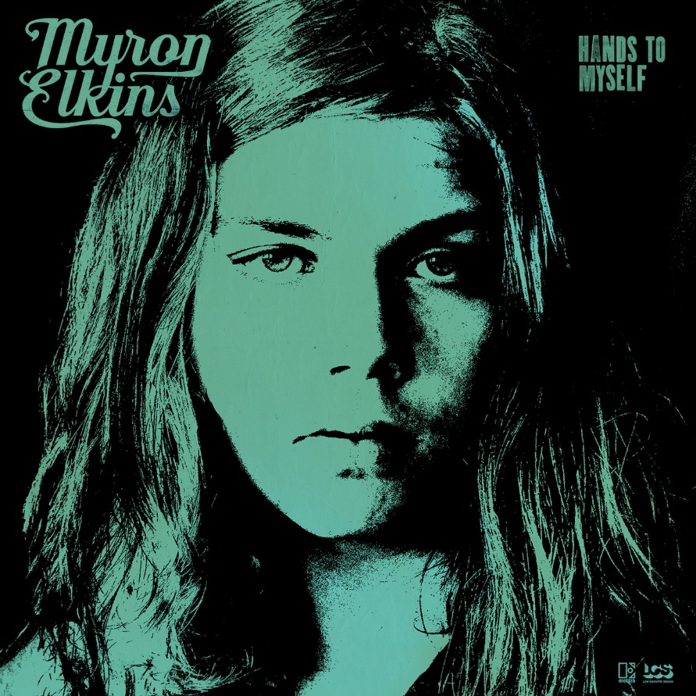
single art
September 23, 2022—“Hands to Myself,” the debut single from Myron Elkins, is out today (listen/share HERE). Produced by Grammy Award-winning producer Dave Cobb and recorded at Nashville’s historic RCA Studio A, the song is the first unveiled from Elkins’ forthcoming debut album, which will be released next year on Low Country Sound/Elektra Records.
Of the song, Elkins shares, “A few years back, my mom took in a woman from her work that was in a not-so-good situation. It’ll probably be the misunderstood song on this album, as the lyrics are a lot darker than the music, I feel, but that’s why I like the way it turned out. Dave really helped bring the song to life in the studio, and it’s probably my favorite song on the album.”
Born and raised in Otsego, Michigan, the 21-year-old musician spent the years following high school learning welding and working professionally in the trade before crossing paths with Cobb and deciding to pursue music full-time. Already known for his grassroots touring, Elkins has performed with ZZ Top, Kaleo, Lucero, Blackberry Smoke, Marcus King Band, 49 Winchester and Ward Davis as well as at AmericanaFest, Pilgrimage Music and Cultural Festival, Born & Raised, BeachLife Ranch Festival and more. New tour dates will be announced soon.
MYRON ELKINS CONFIRMED TOUR DATES
October 15—Seaside, CA—Monterey County Fair and Event Center
November 18—San Diego, CA—Wonderfront Music Arts Festival
April 20—Miramar Beach, FL—Seascape Resort

www.myronelkins.com
For more information, please contact Asha Goodman 615.320.7753,
Catherine Snead 615.320.7753 or Carla Sacks 212.741.1000 at Sacks & Co.,
asha.goodman@sacksco.com, catherine.snead@sacksco.com or carla@sacksco.com.

