GAMES WE PLAY RELEASES MAJOR LABEL DEBUT EP, GET A JOB
OUT TODAY VIA FUELED BY RAMEN/DCD2 RECORDS | LISTEN HERE
TITLE TRACK “GET A JOB” AVAILABLE NOW
LISTEN HERE | WATCH THE VISUALIZER HERE

ANNOUNCES FIRST NORTH AMERICAN HEADLINE TOUR
TICKETS ON SALE NOW
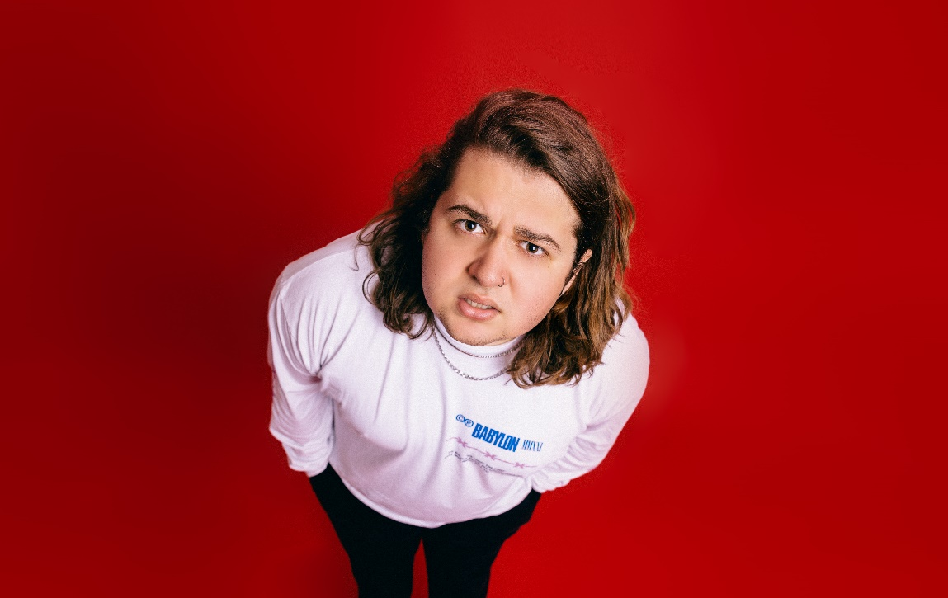
Photo credit: Alice Baxley
DOWNLOAD HI-RED PRESS IMAGE HERE

“Big, catchy hooks and lyrics that are equal parts spiteful and playful” Consequence

“Emotionally self-aware lyrics, big heavy riffs and a brilliantly fun attitude” Rock Sound

“Radiating pop-punk-esque melodies that provide a mesmerizing atmosphere paired with glowing crisp vocals” New Noise

“Games We Play is going to be massive. Just a talented musician who has it all — catchy music, fun lyrics and an amazing stage presence.” LOUDWIRE

August 26, 2022 - Miami-born and Los Angeles-based singer, songwriter, multi-instrumentalist, producer, and pop-punk provocateur Games We Play (a.k.a Emmyn Calleiro) has released his major label debut EP, Get A Job. The five-track collection is out today via Fueled By Ramen/DCD2 Records, and is available now on all streaming platforms. Chantable title track “Get A Job” and companion visualizer are out now. Listen HERE / Watch HERE.

“I am super excited to put out this record. I feel like all the songs, especially ‘Get a Job’, embody exactly who I am,” explains Emmyn. “From dropping out, to looking like Channing Tatum, to ultimately proving my wife’s parents wrong (we’re cool now btw)…I am stoked this is out.”

The Get A Job EP was introduced with viral breakout single “I Hope You’re Happy” and anthemic track “St. Girlfriend” - the latter of which Emmyn wrote about his friend pooping his pants on a date. Earlier this summer, Games We Play announced his Fueled By Ramen/DCD2 Records signing in an exclusive interview with Consequence. Watch how Games We Play signed featuring DCD2 Records Founder and Fall Out Boy bassist and visionary Pete Wentz HERE. To herald the announcement, Games We Play unveiled an official music video for his viral breakout single “I Hope You’re Happy”. Watch it on Fueled By Ramen’s official YouTube channel HERE. In the clip, Emmyn’s contagious enthusiasm, bold personality, and hilarious sense of humor come to life on screen as the magnetic pop-punk refrain resounds with chantable turn-of-the-century bliss.

Fresh off a 17-city U.S. tour supporting The Band CAMINO and select dates on Sad Summer Festival 2022, Games We Play recently announced his first ever headline tour. The nine-date North American headline run kicks off on November 7th in Toronto, ON, with stops in Chicago, New York, Nashville, and more. Games We Play will also be joining State Champs on select dates of their ‘Kings of the New Age Tour’. A complete list of upcoming tour dates can be found below. For tickets and more information on Games We Play’s upcoming tour dates visit gamesweplay.co.

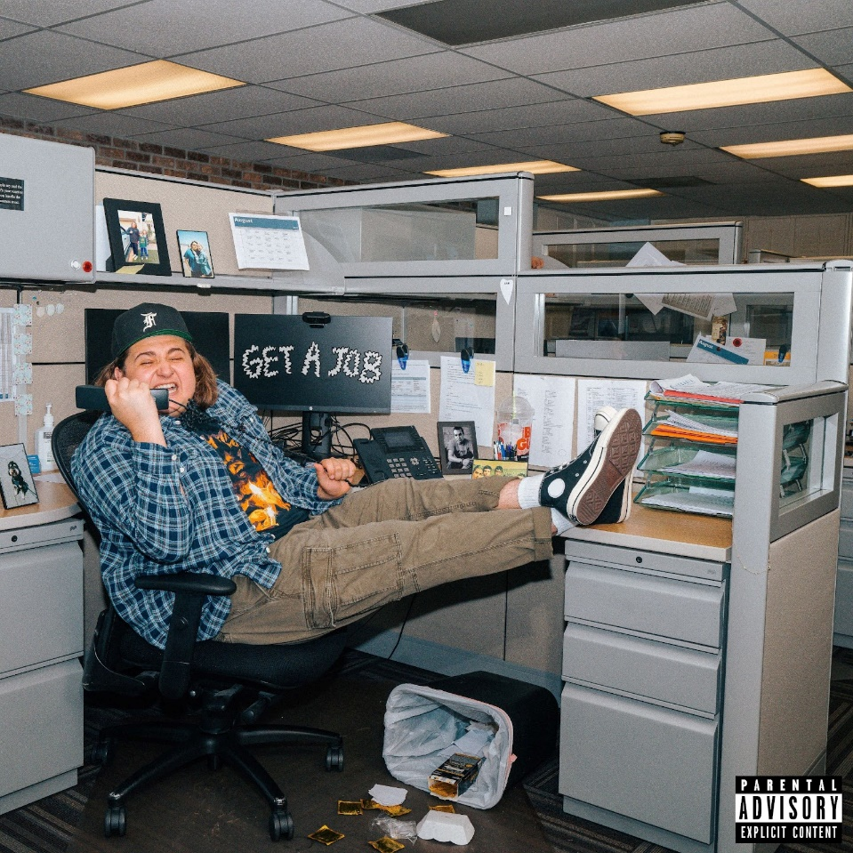

Get A Job EP Tracklisting
1. Get A Job
2. I Hope You’re Happy
3. Kristina
4. St. Girlfriend
5. Deadbeat

Games We Play Tour Dates
September 10, 2022 - Pittsburgh, PA - Four Chords Music Festival ^
September 23, 2022 - Birmingham, AL - Furnace Fest ^
November 7, 2022 - Toronto, ON - Hard Luck Bar †
November 9, 2022 - Chicago, IL - Beat Kitchen †
November 10, 2022 - Columbus, OH - Ace of Cups †
November 12, 2022 - Ferndale, MI - The Loving Touch †
November 14, 2022 - New York, NY - Mercury Lounge †
November 15, 2022 - Washington, D.C - Songbyrd †
November 17, 2022 - Atlanta, GA - Vinyl ATL †
November 18, 2022 - Durham, NC - Motorco Music Hall †
November 19, 2022 - Nashville, TN - The End †
November 22, 2022 - Englewood, CO - Gothic Theatre*
November 23, 2022 - Salt Lake, City, UT - The Union Event Center*
November 25, 2022 - Anaheim, CA - House of Blues*
November 26, 2022 - San Diego , CA - House of Blues*
November 27, 2022 - Phoenix, AZ - The Van Buren*
November 29, 2022 - Austin, TX - Empire Garage*
November 30, 2022 - Dallas, TX - South Side Music Hall*

^ Festival Performance
† Headline Show
* Supporting State Champs

ABOUT GAMES WE PLAY:
Practically predestined to play pop punk, Games We Play a.k.a. Emmyn Calleiro sings the kinds of hooks you text your ex (and not because you still care or anything!) and rotates between instruments with quiet confidence. The Miami-born and Los Angeles-based singer, songwriter, multi-instrumentalist, and producer turns up with an upbeat and undeniable sound—like a one-man Warped Tour, but with a propensity for 21st century virality. He’s not afraid to be honest about his ups and downs, representing the feelings of every kid (and adult) who doesn’t have it easy. After falling in love with pop punk by way of Blink-182, Emmyn learned bass and drums in church as he simultaneously perfected his guitar and vocal skills. Dropping out in eighth grade, mom and dad even let him fly to New York at 15-years-old for his first recording session. Eventually, the family relocated to Nashville where Emmyn could focus on music. Games We Play made waves with the Senior Year EP during 2018. Getting married and moving in with his wife Dani, she pushed him to go all out. In 2021, he unleashed “Deadbeat” and organically attracted an audience on TikTok with a series of highly candid and utterly hilarious posts. A preview for the hyper-charged punkified banger “I Hope You’re Happy” exploded, amassing millions of views, and leading to a record deal with Fueled By Ramen/DCD2 Records. Allow him to introduce himself on his 2022 major label debut Get A Job EP.

Instagram | Twitter | Facebook | YouTube | TikTok

Press contacts:
Collin Citron / collincitron@elektra.com
Sydney Worden / sydneyworden@elektra.com

