

**For Immediate Release**

**BAILEY ZIMMERMAN WILL “NEVER LEAVE” HIS FANS UNANSWERED,**

**DEBUT EP *LEAVE THE LIGHT ON* AVAILABLE EVERYWHERE 10/14**

([PRE-ORDER/SAVE HERE](https://baileyzimmerman.lnk.to/preorder-leavethelighton))

**New Song “Never Leave” Out Today**

([LISTEN HERE](https://baileyzimmerman.lnk.to/neverleave))

**Current Single “Fall In Love” Top 15 at Country Radio**

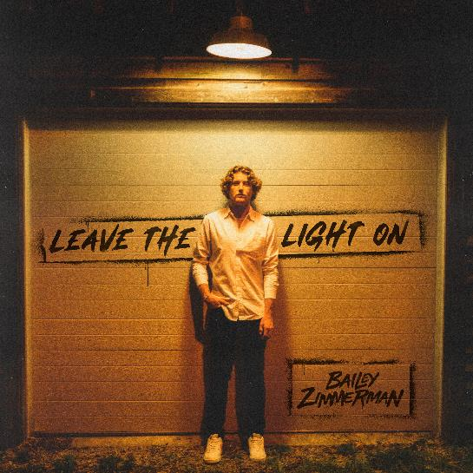

[Download Hi-Res Here](https://warnermusicgroup.box.com/s/s2qocdh92hc2v3wmgfro1cdi8cztr88s)

**NASHVILLE, Tenn. – (September 15, 2022) –**Skyrocketing breakout country artist **Bailey Zimmerman**has proven time and time again his dedication to putting fans first. After discovering a rough, unfinished demo of the song “**Never Leave**” online, social media followers of the rising country star quickly began sharing it with friends. The organic groundswell created such a buzz that Zimmerman decided to finish the song and share it with excited listeners today ([LISTEN HERE](https://baileyzimmerman.lnk.to/neverleave)), alongside the announcement of his debut EP, ***Leave The Light On****,* available everywhere October 14th ([PRE-ORDER/SAVE HERE](https://baileyzimmerman.lnk.to/preorder-leavethelighton)).

“I was in a pretty weird part of a relationship at the time, and just wanted to write something that expressed how I felt about the situation,” Zimmerman explained. “When I came into the room with Gavin Lucas, Mary Kutter, and my man Chris Sligh, I knew I could be really honest!”

In addition, Zimmerman’s current hit single, “**Fall In Love,**” is now within the Top 15 at country radio. Propelled by nearly 250 million streams to date worldwide, it is the 11th most-streamed country song of the year and currently Top 10 on *Billboard*’s Hot Country Songs chart. Zimmerman also continues to “forge new territory for a modern country crossover” (*Billboard*), having recently announced that every single date on his first-ever headlining trek is now completely sold out. He has earned a constantly rising total of more than half a billion global streams to date and currently ranks Top 10 on *Billboard’s* Country Songwriters chart and Top 30 on their all-genre Artist 100 Chart.

Before his whirlwind rise since releasing his very first song in 2021, the twenty-two-year-old was born and raised in the small town of Louisville, IL. He grew up listening to hour after hour of country radio on long hauls across state lines with his father, who owned a trucking business, while back at home his mom instilled in him a life-long appreciation for the power chords and edgy vocals of 80’s hair rock. But it was time spent at the family’s car dealership where he learned the art of telling stories, listening to Grandpa Zimmerman and his oldest friends, who would sit and tell stories capture people’s attention with their words.

At the age of sixteen, Zimmerman got his first job at the local meat processing plant and hasn’t stopped working since. From long hours on the gas pipeline, to late nights of backbreaking roadwork, he embodies the old school American values of hard work and dependability and applies the same steadfast mentality to his music. Through his plainspoken charm, contagious enthusiasm and genuine portrayal of life on the back roads, the up-and-comer has already attracted a loyal and passionate fan base. With more new music on the horizon, featuring the grit and gravel of his unmistakably Southern drawl, Zimmerman will continue to showcase the straightforward authenticity for which he is known and loved.

***LEAVE THE LIGHT ON* TRACK LISTING**

1. Intro

2. Never Leave

3. Waiting

4. House On Fire

5. From The Fall

6. Trainwreck

7. Fall In Love

8. Rock And A Hard Place

9. Where It Ends