SAD NIGHT DYNAMITE RETURN WITH BRAND NEW SINGLE
“WHAT DOES THAT MAKE ME?”
LISTEN HERE

NORTH AMERICAN HEADLINE TOUR KICKS OFF NOVEMBER 4
TICKETS AVAILABLE HERE

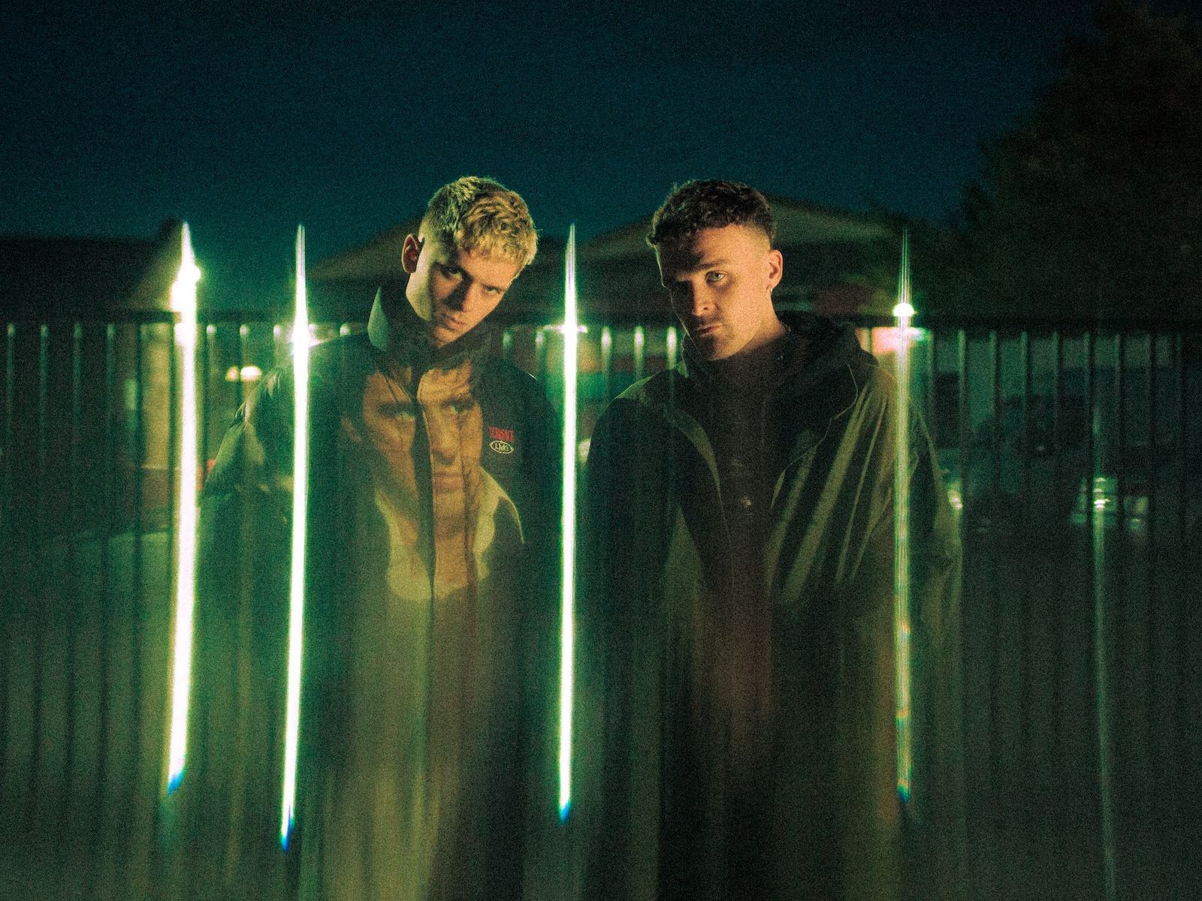
Photo credit: Angus Steele

“…a career that should be long, fruitful and full of game-changing experimentation" – COMPLEX

“their enigmatic sound … blends a life-long love of hip-hop with electronic overtones and a strong sensibility for hypnotic and surreal visuals” – HYPEBEAST

“Impressive…soundtracking our not-so-distant dystopian future” – THE FACE

"Monstrously good…the future will sound however Sad Night Dynamite want it to" – NME

August 3, 2022 – Genre-bending duo Sad Night Dynamite have unveiled their brand new single “What Does That Make Me?”. The song is available to stream and download beginning today HERE via Elektra Records/Parlophone Records.

With its hip-hop groove and psychedelic textures, “What Does That Make Me?” is Sad Night Dynamite as close as they get to summer-mode: or in the band’s own words, “a brief lapse in the nightmare that is SND.” At its heart, “What Does That Make Me?” is in fact an existential anthem about those moments when “you’re pranging out, wondering what people would think of you if they saw the way you were behaving. Would you act the same way if someone was watching you? Would they think differently of you? Therefore, should you look at yourself differently? Who’s the real you? The version people see, or the person you are behind closed doors?”

Sad Night Dynamite continue to rise as one of the UK’s most exciting and unusual breakout bands. Across their Volume I and Volume II mixtapes, childhood friends Archie Blagden and Josh Greacen have built a distinct sound - and surreal world - which, on “What Does That Make Me?,” they continue to push into exciting new territories. Having previously collaborated with the likes of IDK and Moonchild Sanelly and earned an impassioned global audience, Sad Night Dynamite explore the space between dystopia and escapism, home truths and grim fantasy. They may not claim to know the answers, but “What Does That Make Me?” is Sad Night Dynamite exploring such questions in their own idiosyncratic way.

A project birthed entirely in lockdown, Sad Night Dynamite have since been praised for their energetic, uninhibited live shows. Earlier this year, the pair supported Glass Animals’ US tour and made their hometown festival debut at Glastonbury. The band is set to appear at numerous UK/European festivals later this summer. This fall, Sad Night Dynamite will embark on a North American headline tour that kicks off on November 4 in Vancouver, BC, and wraps on November 29 in New York, NY. A complete list of upcoming live dates and ticket information can be found HERE.

Sad Night Dynamite are hard at work on new music that continues to evolve (and surprise). Be on the lookout for more from the duo soon.

SAD NIGHT DYNAMITE
“WHAT DOES THAT MAKE ME?”
AVAILABLE NOW

Sad Night Dynamite North American Tour Dates
August 05, 2022 - Denver, CO - Vortex 2022
September 24, 2022 - San Francisco, CA - Portola Festival
November 04, 2022 - Vancouver, Canada - Fox Cabaret
November 05, 2022 - Seattle, WA - Madame Lou’s
November 08, 2022 - Portland, OR - Holocene
November 10, 2022 - San Francisco, CA - Great American Music Hall
November 11, 2022 - Los Angeles, CA - The Roxy Theatre
November 12, 2022 - San Diego, CA - House of Blues
November 13, 2022 - Phoenix, AZ - Valley Bar
November 17, 2022 - Dallas, TX - The Studio At The Factory
November 18, 2022 - Austin, TX - Parish
November 20, 2022 - Mexico City, Mexico - Corona Capital 2022
November 23, 2022 - Chicago, IL - Lincoln Hall
November 24, 2022 - Toronto, Canada - Velvet Underground
November 25, 2022 - Cambridge, MA - The Sinclair
November 26, 2022 - Washington, DC - Union Stage
November 29, 2022 - New York, NY - Bowery Ballroom

CONNECT WITH SAD NIGHT DYNAMITE
FACEBOOK | TWITTER | INSTAGRAM | YOUTUBE | WEBSITE

For US press inquiries, please contact:
Collin Citron / collin.citron@300elektra.com
Sarah Goldstein / sarah.goldstein@300elektra.com

