Quarters of Change Release Debut Album
Into the Rift
LISTEN HERE
+Contributions from the legendary Tom Lord-Alge & Mikey Freedom Hart+
+Leg 2 of The Rift Tour SOLD OUT (NYC, CHI, LA)+
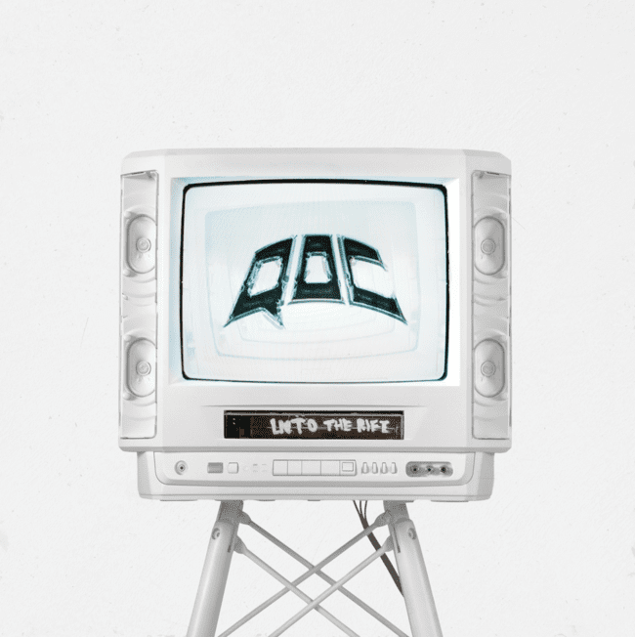
New York, NY (July 29, 2022) – Today, Lower East Side quartet Quarters of Change unveil their debut album Into The Rift. Listen HERE.
Featuring eleven electric and cathartic tracks, the album introduces and solidifies Quarters of Change as a standout quartet going beyond the typical conventions and traditional boundaries of genre to take the rock scene by storm. The breakout rockers have already seen an exponential rise in all areas, including a 350% increase in streaming consumption year-to-date. Shoutouts from celebrity fans such as Joe Jonas, Fred Durst, and Lewis Capaldi have also helped catapult the group into the limelight.
From standalone singles such as "T Love" and "Dead" to never before heard tracks such as "Ms. Dramatic," the versatile debut body of work is as tempestuous as it is melodic. Previously released single "Dead" meshes an upbeat chorus with the group's quintessential shredding guitar while "Sex" is a groovy display of emotional lyrics. "Ms. Dramatic" leads the way with an infectious refrain that's sure to have you tapping your feet and singing at the top of your lungs. The product is a debut album that successfully encapsulates the contrived chaos that is Quarters of Change.
Quarters of Change recently concluded the second leg of The Rift tour with sold out performances in New York, Los Angeles, and Chicago. Catch the group's undeniable stage presence at an upcoming live show - keep your eye on soon to be announced tour dates HERE.
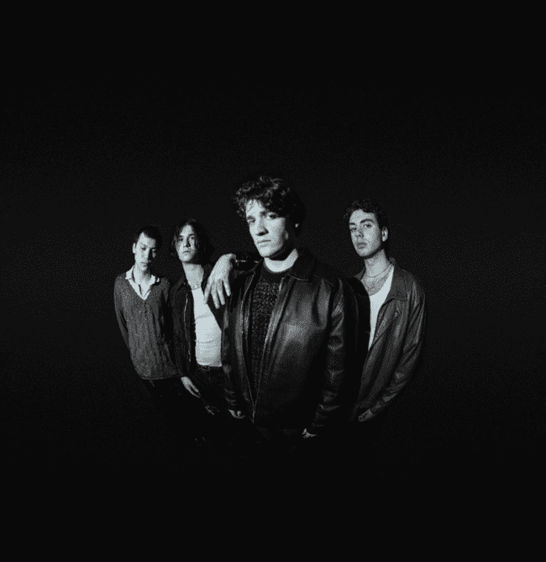
Photo Credit: Amyas Ryan
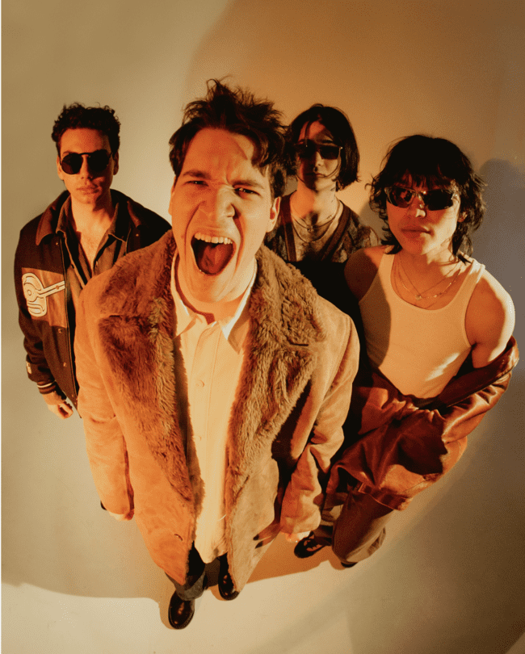
ABOUT QUARTERS OF CHANGE
Quarters of Change is the Lower-East-Side quartet leading the charge on New York City’s rock resurgence, and redefining what it means to be a rock star.
Composed of Ben Acker, Attila Anrather, Jasper Harris, and Ben Roter, Quarters of Change started in 2017 as a high school cover band, performing iconic rock songs of the 90s and 00s. It wasn’t until their junior year that they began writing original material, pulling influence from groups like The Strokes and Rage Against The Machine, and creating their own original sound. Within a year, the band had signed a deal with Warner/300 Entertainment, released streaming favorites like “Kiwi," and played sold out shows at renown venues like Bowery Ballroom and Webster Hall.
Now, armed with a record deal and an undeniable slew of songs, Quarters of Change is poised to be alternative rock’s next big thing. Keep an eye out for their self-written debut LP, Into The Rift, with contributions from legendary producers Tom Lord-Alge and Mikey Freedom Hart (Bleachers), out now
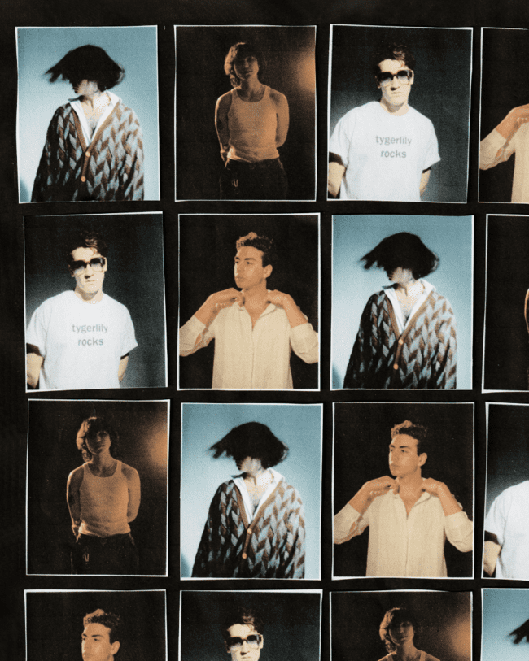
KEEP UP WITH QUARTERS OF CHANGE
TikTok | Instagram | Twitter

