Fresh Off His “Exuberant” (Rolling Stone) Lollapalooza Performance grandson Releases The Suicide Squad Remix of “Oh No!!!” With Vic Mensa and Masked Wolf – Listen Here

“Oh No!!!” Is Featured As The End Title on The Suicide Squad - James Gunn’s All-New Superhero Action Adventure Film That’s Out Today

Remix Follows “Rain” (with Jessie Reyez) – grandson’s first collab with The Suicide Squad – Watch Here

Listen Here

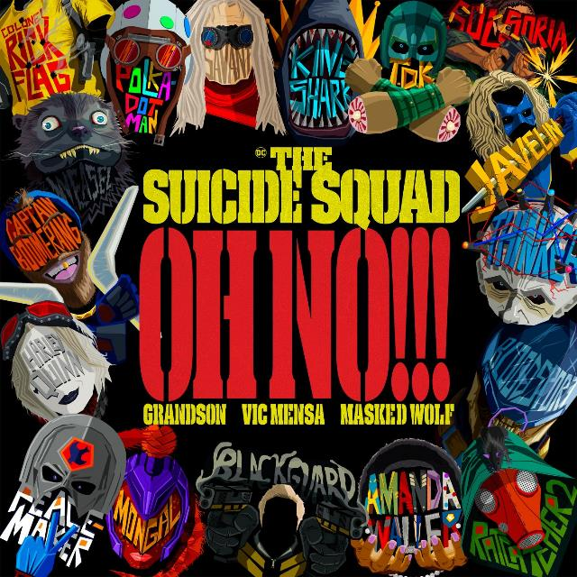

Today, platinum-selling alt-rocker grandson joins forces with Chicago rapper Vic Mensa and Australian rapper Masked Wolf for The Suicide Squad remix of “Oh No!!!” The track is featured on the end titles sequence of James Gunn’s all-new superhero action-adventure film, Warner Bros. Pictures’ The Suicide Squad, that’s out today. Adding a sense of pointed urgency to the song that’s already dripping with political angst, Masked Wolf and Vic Mensa’s verses perfectly compliment grandson’s “personal tug-of-war between blind optimism and the anxiety-inducing reality.” (Interview Magazine)

“Vic Mensa has been unapologetically expressing his views and switching genres since I first began making music,” says grandson. “I reached out over social media to him and to Masked Wolf, who’s a label mate that has exploded onto the music scene this year, and both artists were down to collaborate. Since James Gunn was a fan of the song and used it as the end credits roll on The Suicide Squad, it suddenly has this new life and so we got to reimagine it in this new way.”

[QUOTE FROM VIC MENSA]

“So glad to jump on the track with grandson and Vic, and also be a part of such an epic movie!” says Masked Wolf.

Listen here: https://grandson.lnk.to/ohno_TSS

Masked Wolf, Vic Mensa and grandson

“Oh No!!!” (from The Suicide Squad) follows grandson’s collaboration with Grammy-nominated singer/songwriter Jessie Reyez, “Rain,” an exclusive single from The Suicide Squad, and its earth-shattering official music video. Electric neon lighting highlights the fierce and sultry Reyez and grandson as they fight their way out of getting captured like true Super-Villains. ﻿Clips from the film — including ones of Harley Quinn (Margot Robbie), Bloodsport (Idris Elba), Peacemaker (John Cena), and more — are expertly integrated into the video to make it seem like Reyez and grandson are a part of the Squad. Jessie harnesses her inner Harley Quinn as the scene explodes into a sea of flowers, and the visual ends, fittingly, with the Squad strutting through a cascade of rain.

Watch the “Rain” video here and read more via Rolling Stone

“Rain” was recorded by Reyez and grandson exclusively for The Suicide Squad and the “cinematic, stadium-ready anthem” (Ones To Watch) is featured in the latest trailer for the film.

Listen to “Rain” in The Suicide Squad’s official trailer: https://www.youtube.com/watch?v=eg5ciqQzmK0

grandson was joined by Vic Mensa and Jessie Reyez at Lollapalooza to perform their respective tracks from The Suicide Squad and Rolling Stone praised the alt rocker’s exuberant performance.

Read more via Rolling Stone and Forbes

grandson, whose “buzzsaw of righteous poetry” (Billboard) shines on stage, is set to play several other prestigious festivals throughout the rest of this year. See grandson’s full tour routing here.

Praise for grandson:

“buzzsaw of righteous poetry”
— Billboard

“a soundtrack for a society on the edge of collapse”
— NME

“rock ‘n’ roll rebel who is strident and crystal clear”
— Alternative Press

“explores the area between hope and apathy, urgent anger and frustration”
— Under the Radar

“rock’s new leader of the resistance”
— Rock Sound

ABOUT GRANDSON:
grandson is the pseudonym of Canadian/American alternative artist Jordan Benjamin. He takes elements of his rock and roll, hip hop, and electronic music roots and combines them to tell stories of reclaiming power over one’s life, confronting social issues facing his generation, and opening up about struggles with addiction and mental health. Since releasing his Modern Tragedy EP series, grandson has toured extensively across North America, Russia, and Europe, accumulated hundreds of millions of streams online, and received co-signs from the biggest names in rock and roll and progressive politics, from Tom Morello to Bernie Sanders. grandson’s debut album, Death Of An Optimist, is a body of work that conflates personal anxieties with political realities. As the protagonist, grandson simultaneously explores the dark underbelly of his unrelenting optimism for change, by creating an antagonist, X. An ambitious project, grandson delivers a subtle A-side/B-side structure totaling twelve tracks, following grandson and X’s dueling world views. Through DOAO, grandson delivers an overwhelming urgency to do something, “After the hardest year of our lives, it’s time to confront the reflection staring back at you, because only in doing so can you know who you truly are," he says. “Showcasing a conflicted soul for intense scrutiny has the benefit of not dictating what is right or wrong. It just shows that we’re in this together.”

GRANDSON ON THE WEB:
http://www.grandsonmusic.com
https://www.instagram.com/grandson
https://www.tiktok.com/grandson
https://facebook.com/grandsonmusic
https://twitter.com/grandson
https://grandson.lnk.to/spotify

ABOUT VIC MENSA:
Raised on the South Side of Chicago, VIC MENSA rose to public awareness as a member of the eclectic hip-hop band Kids These Days and founder of the Chicago collective SAVEMONEY alongside Chance The Rapper and other local upstart Joey Purp. His solo debut mixtape INNANETAPE dropped in 2013, igniting immediate accolades (including a spot on the XXL Freshman cover in 2014), and a fortuitous introduction to JAY-Z that led to a record deal with Roc Nation. Mensa went on to help Kanye West pen his esoteric song “Wolves” from The Life of Pablo, drop three critically acclaimed EPs (2016’s There’s A Lot Going On, 2018’s Hooligans, & 2020’s V TAPE) and his debut full length The Autobiography (2017), as well as furthering social causes in his hometown through his nonprofit SAVEMONEYSAVELIFE.

VIC MENSA ON THE WEB:
INSTAGRAM
TWITTER
FACEBOOK

ABOUT MASKED WOLF:
Transforming from a mild-mannered man by day into an unrestrained beast in the studio, Masked Wolf (aka, Harry Michael) has unassumingly established himself as a powerful, passionate, and primal hip-hop force. After graduating from school, the Sydney, Australia native tirelessly worked in sales to fund recording. He even took out a loan to build a home studio as he cut hundreds of songs and logged thousands of hours in the lab. In 2018, he dropped his independent debut “Speed Racer.” It gathered millions of streams and turned heads across Australia. Following “Night Rider” and “Water Walkin,” he unveiled “Astronaut In The Ocean.” Awash in airy guitar, jagged 808s, neon keys, and deft wordplay, he submerged himself in honest lyricism, facing depression head-on. Re-released via Elektra Records at the top of 2021, “Astronaut In The Ocean” has become a global phenomenon, amassing over a BILLION streams to date and hitting #1 in 8 countries around the world. Masked Wolf recently released his follow-up single “Say So” and buzz track “Gravity Glidin’” with much more music to come.

MASKED WOLF ON THE WEB:
YouTube
Instagram
Twitter
Facebook
MaskedWolf.com

ABOUT THE SUICIDE SQUAD:
From the horribly beautiful mind of writer/director James Gunn comes Warner Bros. Pictures’ superhero action adventure The Suicide Squad, featuring a collection of the most degenerate delinquents in the DC lineup.

The film stars Margot Robbie, Idris Elba, John Cena, Joel Kinnaman, Jai Courtney, Peter Capaldi, David Dastmalchian, Daniela Melchior, Michael Rooker, Alice Braga, Pete Davidson, Joaquín Cosio, Juan Diego Botto, Storm Reid, Nathan Fillion, Steve Agee, Sean Gunn, Mayling Ng, Flula Borg, Jennifer Holland and Tinashe Kajese, with Sylvester Stallone, and Viola Davis. Gunn directed from his own screenplay, based on characters from DC. The film was produced by Charles Roven and Peter Safran, with Zack Snyder, Deborah Snyder, Walter Hamada, Chantal Nong Vo, Nikolas Korda and Richard Suckle executive producing.

Warner Bros. Pictures Presents An Atlas Entertainment/A Peter Safran Production, A James Gunn Film, The Suicide Squad. The film is distributed worldwide by Warner Bros. Pictures. It is in theaters and IMAX nationwide today and available on HBO Max on the Ad-Free plan in UHD, HDR10, Dolby Vision and Dolby Atmos on supported devices for 31 days from theatrical release.

