GRANDSON’S DEBUT ALBUM DEATH OF AN OPTIMIST OUT TODAY VIA FUELED BY RAMEN

FEATURING PRODUCTION FROM BLINK-182’S TRAVIS BARKER & LINKIN PARK’S MIKE SHINODA

LISTEN HERE

ANNOUNCES ONE-NIGHT ONLY LIVESTREAM EVENT — DEATH OF AN OPTIMIST: THE MOVIE ON DECEMBER 17TH AT 5 PM PT/ 8 PM ET VIA NOCAP

WATCH THE TEASER HERE

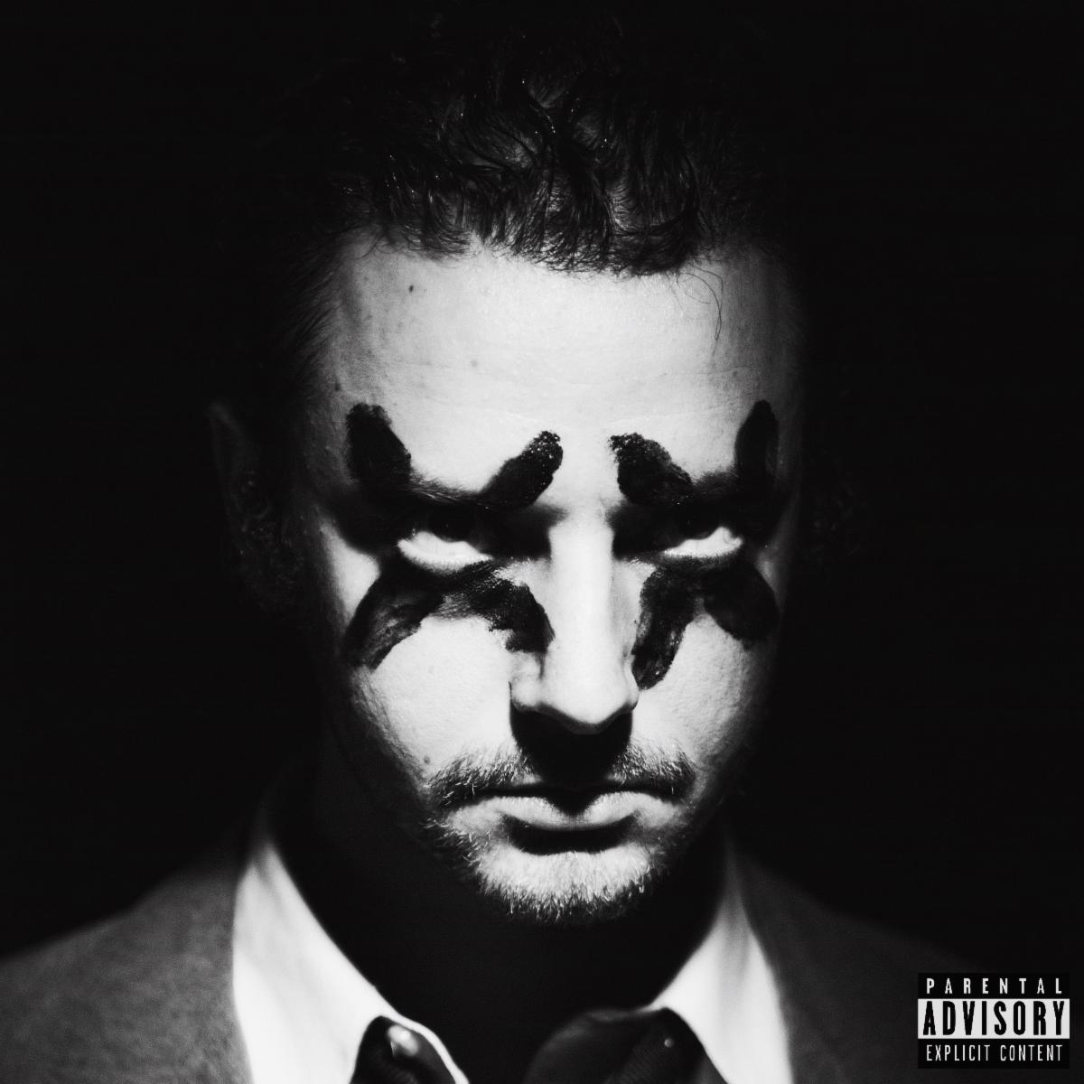

DECEMBER 4, 2020 - Today, grandson releases his debut album Death Of An Optimist via Fueled by Ramen. The comprehensive body of work articulates the tension between grandson’s hope for the future and the challenges he faces.

Described by the alt-rocker as a “horror story with a happy ending,” the cohesive record brings together an eclectic group of collaborators including engineer Andrew Dawson (Kanye West), Linkin Park’s Mike Shinoda, Blink-182’s Travis Barker, producer Krupa (Zero 9:36), and Boonn (grandson’s longtime musical partner).

“It’s about my personal dilemma of whether or not to keep fighting,” grandson says about the album. “It really represents my own personal crossroads on if I can continue to preach agency and change in a time where there is so much fear-mongering and doom scrolling to suggest it could all be for nothing, ultimately.”

Listen here: https://grandson.lnk.to/doao

As the protagonist, grandson simultaneously explores the dark underbelly of his unrelenting optimism for change, by creating an antagonist, X, and the 12-track collection delivers a subtle A-side/B-side structure, following the opposing forces’ dueling worlds.

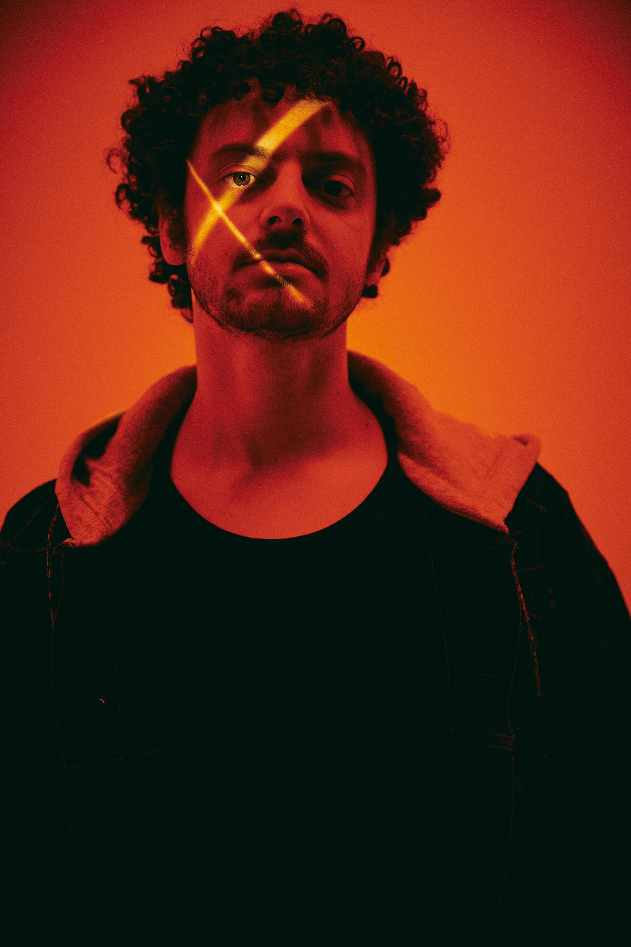
Photo Credit: Jonathan Weiner

Grandson also announces his one-night-only livestream event, Death Of An Optimist: The Movie, set for Thursday, December 17th at 5 pm PT/8 pm ET via NoCap. The one-of-a-kind show pulls back the curtain on grandson’s music, art, and activism, showcasing the live debut of the new album in its entirety, interwoven with never before seen footage from the studio, the road, the grandkids, and more.

Watch the teaser here: https://youtu.be/0WAW0tq6c3s
Purchase tickets here: grandson.nocapshows.com

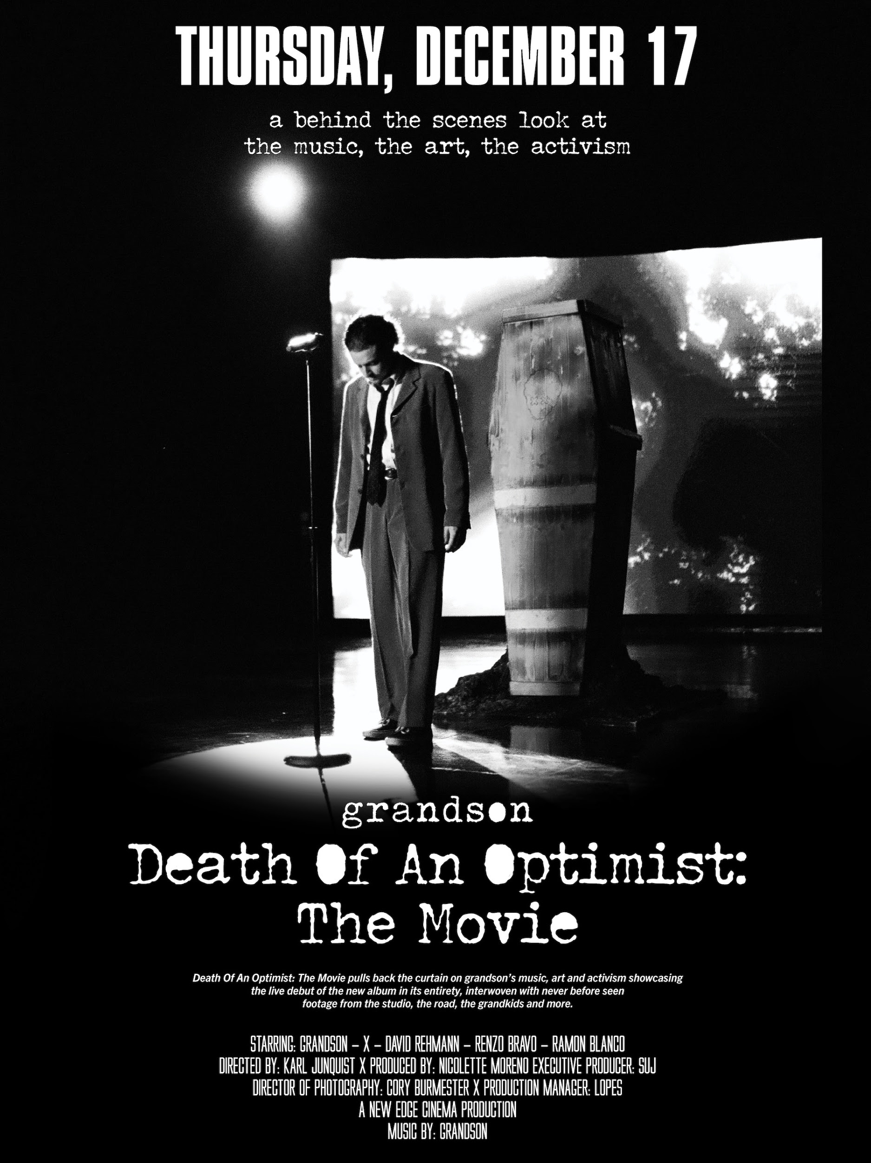

Previously released singles from the album include “We Did It!!!” (“cathartic and anthemic” - Under the Radar), “Dirty,” (“an elbow to the ribs to anybody who’s watching today’s apocalyptic political theater” - Buzzbands LA), “Identity,” (“Explosive” - NME) and “Riptide,” (thought-provoking - RockSound.TV) which was co-produced by Linkin Park’s Mike Shinoda.

Death Of An Optimist tracklisting:
1. Death of an Optimist // Intro
2. In Over My Head
3. Identity
4. Left Behind
5. Dirty
6. The Ballad of G and X // Interlude
7. We Did It!!!
8. WWIII
9. Riptide
10. Pain Shopping
11. Drop Dead
12. Welcome to Paradise // Outro

PRAISE FOR GRANDSON:

“BUZZSAW OF RIGHTEOUS POETRY”
— BILLBOARD

“A SOUNDTRACK FOR A SOCIETY ON THE EDGE OF COLLAPSE”
— NME

“ROCK ‘N’ ROLL REBEL WHO IS STRIDENT AND CRYSTAL CLEAR”
— ALT PRESS

“EXPLORES THE AREA BETWEEN HOPE AND APATHY, URGENT ANGER AND FRUSTRATION”
— UNDER THE RADAR

“ROCK’S NEW LEADER OF THE RESISTANCE”
— ROCKSOUND.TV

ABOUT GRANDSON:
Grandson is the pseudonym of Canadian/American alternative artist Jordan Benjamin. He takes elements of his rock and roll, hip hop and electronic music roots and combines them to tell stories of reclaiming power over one’s life, confronting social issues facing his generation, and opening up about struggles with addiction and mental health. Since releasing his Modern Tragedy EP series, grandson has toured extensively across North America, Russia, and Europe, accumulated hundreds of millions of streams online, and received co-signs from the biggest names in rock and roll and progressive politics, from Tom Morello to Bernie Sanders.

Now, grandson has released his debut album, Death Of An Optimist. This body of work conflates personal anxieties with political realities. As the protagonist, grandson simultaneously explores the dark underbelly of his unrelenting optimism for change, by creating an antagonist, X. An ambitious project, grandson delivers a subtle A-side/B-side structure totaling twelve tracks, following grandson and X’s dueling world views. Through DOAO, grandson delivers an overwhelming urgency to do something, “After the hardest year of our lives, it’s time to confront the reflection staring back at you, because only in doing so can you know who you truly are," he says. Showcasing a conflicted soul for intense scrutiny has the benefit of not dictating what is right or wrong. It just shows that we’re in this together.”

GRANDSON ON THE WEB:
https://twitter.com/grandson/
https://www.instagram.com/grandson/
https://www.facebook.com/grandsonmusic/

