GRANDSON RELEASES “DIRTY” LIVE

ORIGINAL VERSION OF “DIRTY” BREAKS TOP TEN ON ALTERNATIVE RADIO

HIT SINGLE “BLOOD // WATER” GOES PLATINUM

“XX LIVE” YOUTUBE LIVE SERIES EVERY SUNDAY

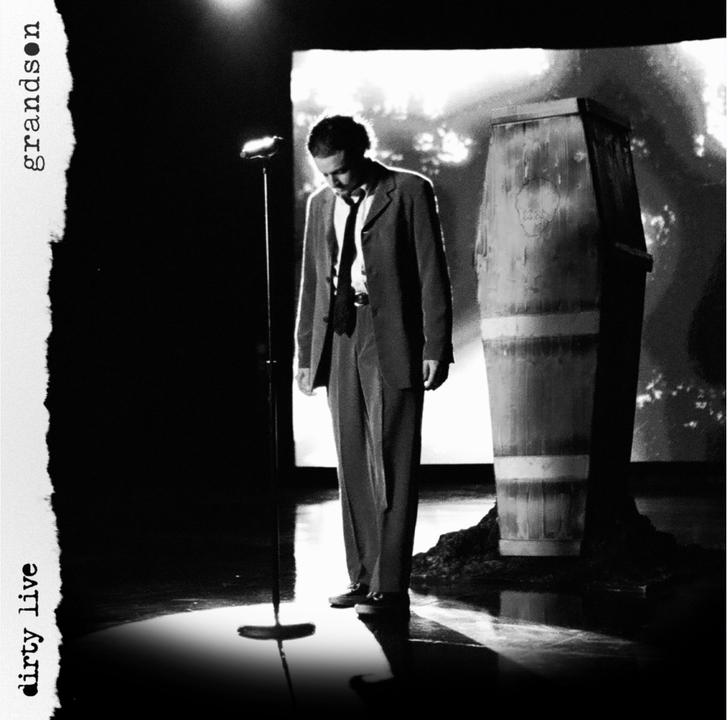

Today, alt-rocker grandson releases a live rendition of “Dirty,” the top ten alternative radio single. Off his recent album, Death of an Optimist (Fueled by Ramen), the new version is from grandson’s performance in Death of an Optimist: The Movie — his one-of-a-kind show — that premiered in December 2020 and will re-air later this year.

Watch the “Dirty” (LIVE) video here: https://youtu.be/pgrBe5heXsY

“Dirty” has been steadily rising on the Alternative Radio Charts since its release and is currently sitting at #XXXXX. Additionally, Grandson’s hit single “Blood // Water” was recently RIAA platinum-certified.

Grandon’s debut album, Death of an Optimist, articulates the tension between grandson’s hope for the future and the challenges he faces. Described by the alt-rocker as a “horror story with a happy ending,” the cohesive record brings together an eclectic group of collaborators including engineer Andrew Dawson (Kanye West), Linkin Park’s Mike Shinoda, Blink-182’s Travis Barker, producer Krupa (Zero 9:36), and Boonn (grandson’s longtime musical partner). As the protagonist, grandson simultaneously explores the dark underbelly of his unrelenting optimism for change, by creating an antagonist, X, and the 12-track collection delivers a subtle A-side/B-side structure, following the opposing forces’ dueling worlds.

Listen here: https://grandson.lnk.to/doao

Grandson has also been going LIVE on YouTube every Sunday of 2021 at 12pm PT to play an acoustic track, talk about music and politics and answer fan questions via his series, XX LIVE.

Watch past XX LIVE episodes here:
https://www.youtube.com/c/grandson/videos

PRAISE FOR GRANDSON:

“BUZZSAW OF RIGHTEOUS POETRY”
— BILLBOARD

“A SOUNDTRACK FOR A SOCIETY ON THE EDGE OF COLLAPSE”
— NME

“ANGST-DRIPPED, POLEMICAL SONGWRITING, EXPLORING THE TUG-OF-WAR BETWEEN BLIND OPTIMISM AND ANXIETY-INDUCING RELATIY”
— INTERVIEW MAGAZINE

“ROCK ‘N’ ROLL REBEL WHO IS STRIDENT AND CRYSTAL CLEAR”
— ALT PRESS

“EXPLORES THE AREA BETWEEN HOPE AND APATHY, URGENT ANGER AND FRUSTRATION”
— UNDER THE RADAR

“ROCK’S NEW LEADER OF THE RESISTANCE”
— ROCK SOUND

ABOUT GRANDSON:
Grandson is the pseudonym of Canadian/American alternative artist Jordan Benjamin. He takes elements of his rock and roll, hip hop, and electronic music roots and combines them to tell stories of reclaiming power over one’s life, confronting social issues facing his generation, and opening up about struggles with addiction and mental health. Since releasing his Modern Tragedy EP series, grandson has toured extensively across North America, Russia, and Europe, accumulated hundreds of millions of streams online, and received co-signs from the biggest names in rock and roll and progressive politics, from Tom Morello to Bernie Sanders.

Now, grandson has released his debut album, Death Of An Optimist. This body of work conflates personal anxieties with political realities. As the protagonist, grandson simultaneously explores the dark underbelly of his unrelenting optimism for change, by creating an antagonist, X. An ambitious project, grandson delivers a subtle A-side/B-side structure totaling twelve tracks, following grandson and X’s dueling world views. Through DOAO, grandson delivers an overwhelming urgency to do something, “After the hardest year of our lives, it’s time to confront the reflection staring back at you, because only in doing so can you know who you truly are," he says. Showcasing a conflicted soul for intense scrutiny has the benefit of not dictating what is right or wrong. It just shows that we’re in this together.”

GRANDSON ON THE WEB:
https://shorefire.com/roster/grandson
https://twitter.com/grandson/
https://www.instagram.com/grandson/
https://www.facebook.com/grandsonmusic/

