ZERO 9:36
RELEASES LIVE FROM SIRIUSXM EP

AVAILABLE TODAY ON ALL STREAMING PLATFORMS

ON TOUR SUPPORTING POP EVIL & SHINEDOWN THIS SUMMER

NEW SINGLE “ADRENALINE” APPROACHING TOP 5 AT ACTIVE ROCK RADIO

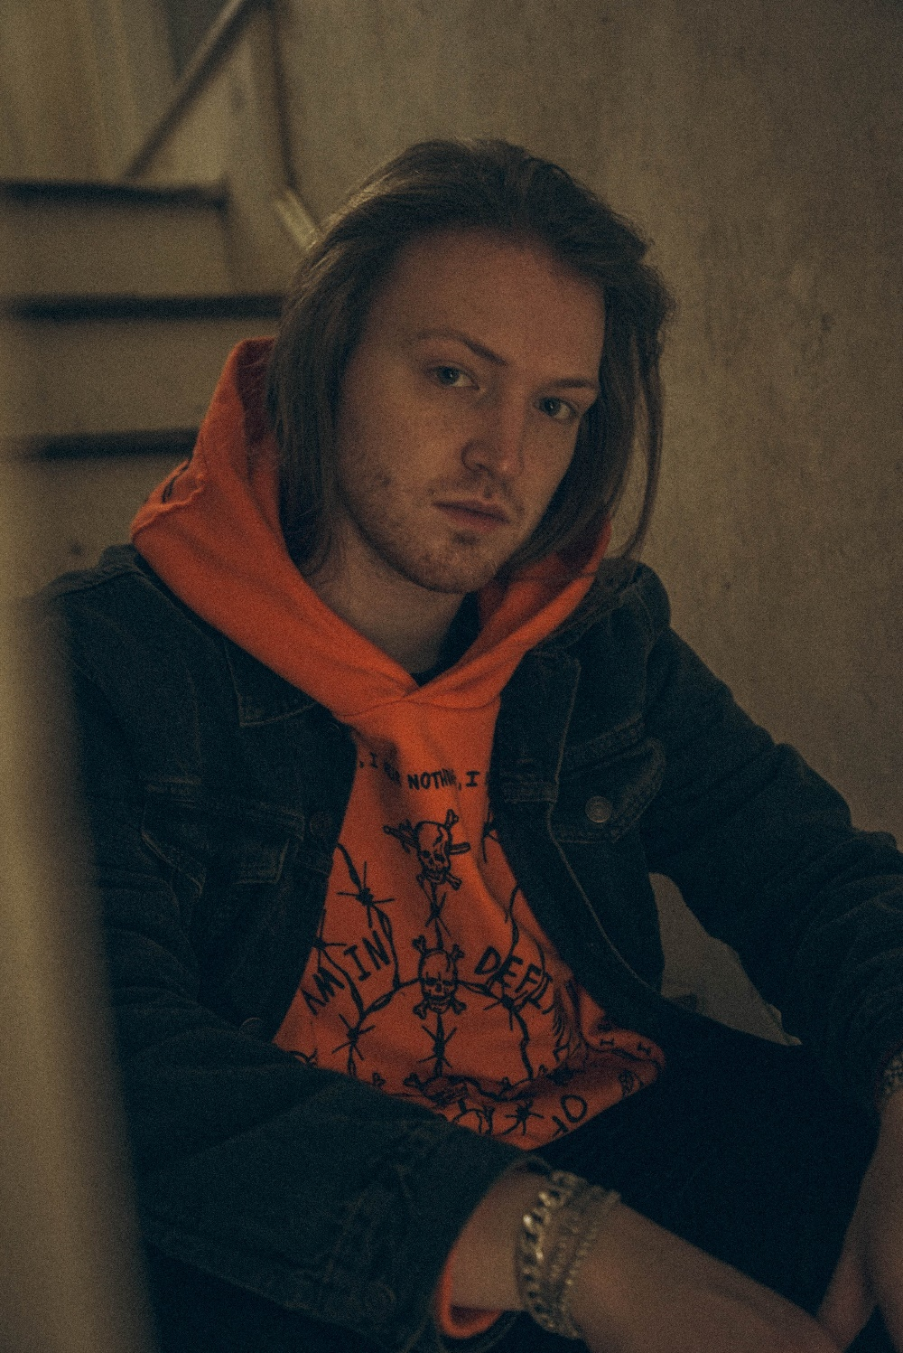

JUNE 22, 2021 – ATCO Records artist Zero 9:36 has released Live from SiriusXM, a brand-new live EP featuring performances of his singles “Adrenaline,” “The End,” and “In My Hands,” which were recorded for SiriusXM’s Octane. Live from SiriusXM is available now all streaming platforms with each track from the EP arriving accompanied by an official live performance video on Zero 9:36’s YouTube channel.

Live From SiriusXM follows Zero 9:36’s celebrated EP, …If You Don’t Save Yourself, which sees him presenting a peerless sonic collage of alternative, rock, hip-hop, and glitch. Architected by hand, Zero 9:36 bulldozed the way for the EP with a series of scorching tracks including “In My Hands” [feat. Travis Barker & Clever], “The End,” and “Adrenaline” which is currently approaching Top 5 at the Active Rock radio format.

Furthermore, Zero 9:36 will hit the road this July for a series of summer tour dates. Kicking things off on July 18th, Zero 9:36 will embark on a U.S tour supporting Pop Evil which is set to traverse the country through mid-September. After that he is slated for a string of dates opening up for Shinedown which will get underway on September 18th [see itinerary below]. For tickets and more information on Zero 9”36’s upcoming tour dates, visit www.zero936.com.

In 2019, Zero 9:36 shared his debut EP, You Will Not Be Saved – the first release on the newly relaunched ATCO Records. The EP includes lead single “Leave The Light On” – produced by Mark Jackson and Ian Scott (Bishop Briggs) with Boonn (grandson), and is also accompanied by an official video directed by Matthew Gold. Following the EP release Zero 9:36 shared the collaborative single with No Love For The Middle Child titled “Come Thru,” and linked up with Fueled By Ramen artist grandson on his track “Again” (Text Voter XX to 40649). More recently, Zero 9:36 released Barebones Vol. 1, an eight song all acoustic EP featuring stripped back performances of fan favorites “WWYDF,” “Reset,” and more.

ZERO 9:36
2021 TOUR DATES
7/18 – 9/16 supporting Pop Evil
9/18 – 9/26 supporting Shinedown and The Struts
* Festival Date

July 18 - Des Moines, IA - Wooly's
July 20 - Minot, ND - The Original Bar and Nightclub
July 21 - Billings, MT - Pub Station
July 23 - Salt Lake City, UT - The Depot
July 24 - Grand Junction, CO - Mesa Theater
July 25 - Phoenix, AZ - The Marquee
July 27 - Lubbock, TX - Jake's Sports Café
July 29 - Houston, TX - Warehouse Live
July 30 - Dallas, TX - Gas Monkey Live
July 31 - Kansas City, MO - Truman Theatre
August 1 - Sauget, IL - Pop's
August 3 - Lincoln, NE - Bourbon Theater
August 4 - Bloomington, IL - The Castle Theater
August 5 - Fort Wayne, IN - Pierre's
August 8 - Evansville, IN - KC's Marina Pointe
August 15 - Denver, CO - Oriental Theater
August 18 - Fargo, ND - Sanctuary Events Center
August 20 - Joliet, IL - The Forge
August 21 - Nashville, TN - Brooklyn Bowl
August 23 - Savannah, GA - Victory North
August 24 - Asheville, NC - Orange Peel
August 25 - Jacksonville, NC - Hooligans Music Hall
August 27 - Virginia Beach, VA - Elevation 27
September 8 - Detroit, MI - St. Andrews Hall
September 9 - Flint, MI - Machine Shop
September 10 - Harrisburg, PA - XL Live
September 15 - Baltimore, MD - Rams Head Live
September 16 - Sayreville, NJ - Starland Ballroom
September 18 - Milwaukee, WI - Eagles Ballroom Club Stage
September 21 - Kansas City, MO - Azura Amphitheater
September 22 - Lincoln, NE - Pinewood Bowl
September 23 - Louisville, KY - Louder Than Life*
September 24 - Oklahoma City, OK - Zoo Amphitheater
September 26 - Rogers, AR - Walmart Amphitheater

ABOUT ZERO 9:36
Siphoning precise raps through a battlefield of distorted guitars and glitchy hues, Zero 9:36 holds up a mirror in his music and beckons reflection. The Philadelphia post-genre sonic insurgent, singer, creative, and rapper rhymes with the force and fire of a prizefighter as he lands hard-hitting hooks meant to explode on impact. After grinding under-the-radar for years and augmenting his signature style with cybernetic beats and guitar transmissions from frequent collaborator and producer No Love For The Middle Child, he caught the attention of ATCO Records in 2019. Signed personally by C.E.O. and industry legend Pete Ganbarg as the relaunched label’s flagship act, he metamorphosized again. Powered by highlights such as “Leave The Light On” and “WWYDF,” the You Will Not Be Saved EP introduced him as it generated 25 million-plus streams.
On its heels, he joined forces with grandson on “Again (Text Voter XX to 40649)” in addition to dropping the acoustic Barebones Vol. 1 EP in 2020. Zero 9:36 unleashed “The End” and its companion remix “The End/Undead” [feat. Hollywood Undead] and the anthemic “Adrenaline,” racking up another 9 million cumulative streams. Adapting to any setting, he’s amassed 50 million-plus streams and collaborated with everyone from PnB Rock to grandson and Theory of a Deadman. Zero 9:36 proudly occupies a lane of his own on the 2021 EP, …IF YOU DON’T SAVE YOURSELF [ATCO Records], led by the single “In My Hands” [feat. Travis Barker & Clever].

FOR MORE INFORMATION ON ZERO 9:36:
WEBSITE
FACEBOOK
INSTAGRAM
TWITTER
SPOTIFY
APPLE MUSIC
AMAZON

CONTACT:
ROSS ANDERSON
ROSSANDERSON@ELEKTRA.COM

