ZERO 9:36 RELEASES NEW SINGLE “ADRENALINE”

AVAILABLE NOW ON ALL STREAMING PLATFORMS

WATCH THE “ADRENALINE” OFFICIAL MUSIC VIDEO HERE

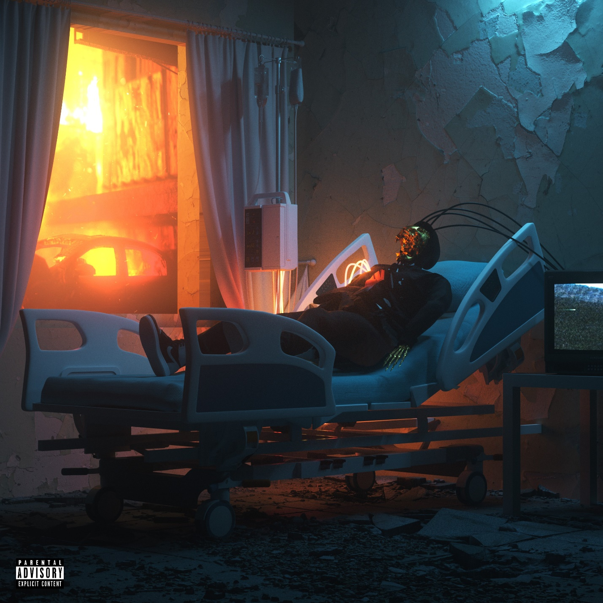

OCTOBER 2, 2020 – Philadelphia, PA’s Zero 9:36 has shared a brand-new single, “Adrenaline,” which is the first taste of new music from a forthcoming EP, expected to arrive later this year. The track is accompanied by an Andrew Joffe directed official music video, which features Zero himself on a high-tension chase through an industrial wasteland. “Adrenaline” is available now on all streaming platforms.
Most recently, Zero shared a new version of his single “The End,” that features special guests Hollywood Undead, aptly titled “The End / Undead.” Last year Zero 9:36 shared his debut EP, You Will Not Be Saved – the first release on the newly relaunched ATCO Records. The EP includes lead single “Leave The Light On” – produced by Mark Jackson and Ian Scott (Bishop Briggs) with Boonn (grandson), and is also accompanied by an official video directed by Matthew Gold. Following the EP release Zero 9:36 shared the collaborative single with No Love For The Middle Child titled “Come Thru,” and linked up with Fueled By Ramen artist grandson on his track “Again” (Text Voter XX to 40649). More recently Zero 9:36 released Barebones Vol. 1, an eight song all acoustic EP featuring stripped back performances of fan favorites “WWYDF,” “Reset,” and more.
Growing up in the city of Brotherly Love, Zero 9:36 took to music at an early age. He entered his first studio at 10 years old and never looked back. The alternative artist has since amassed over 20 Million streams through a prolific body of work.

FOR MORE INFORMATION ON ZERO 9:36:
WEBSITE
FACEBOOK
INSTAGRAM
TWITTER
SPOTIFY
APPLE MUSIC
AMAZON

CONTACT:
ROSS ANDERSON
ROSSANDERSON@ELEKTRA.COM

