WHITE REAPER
SCORE FIRST #1 AT ALTERNATIVE RADIO WITH “MIGHT BE RIGHT”

NORTH AMERICAN TOUR BEGINS THIS WEEK

STREAM WHITE REAPER’S NEW ALBUM YOU DESERVE LOVE NOW

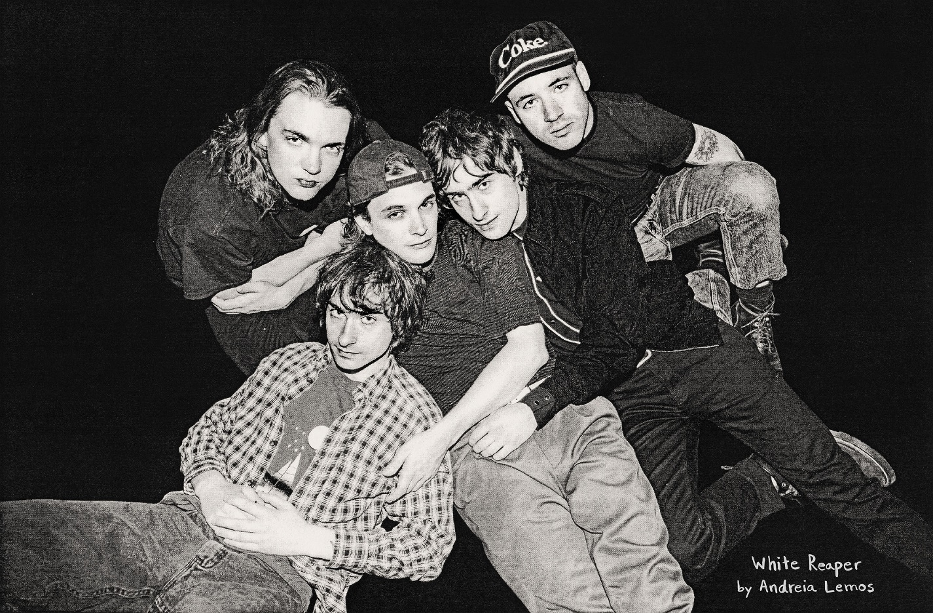
PHOTO CREDIT: ANDREIA LEMOS

WHITE REAPER – “MIGHT BE RIGHT” [OFFICIAL VIDEO]
YOUTUBE: https://youtu.be/31jvtk3Z8AU
EMBED: <iframe width="560" height="315" src="https://www.youtube.com/embed/31jvtk3Z8AU" frameborder="0" allow="accelerometer; autoplay; encrypted-media; gyroscope; picture-in-picture" allowfullscreen></iframe>

FEBRUARY 10, 2020 – On the heels of an explosive late-night television debut and widespread acclaim, White Reaper’s single “Might Be Right” emerges as the #1 Alternative Song in the Country this week. The Louisville, Kentucky band capture the top spot at Alternative Radio, marking the band’s very first #1 on the Mediabase chart. “Might Be Right” is the debut single from the group’s Elektra Records debut album, You Deserve Love - available now.

The band commented on the moment stating, “It’s a really special feeling to see your name at the top of the list. Big thank you to everyone who has supported us and continue to support us. This is for y’all.”

Last month, the guys took the stage at Jimmy Kimmel LIVE! for their very first TV performance. They ignited “Might Be Right” and “Real Long Time.” Of the set, Consequence of Sound wrote, “We’ve long known the Louisville rockers are fantastic at delivering their undeniable power pop version of rock and roll, so it was about time TV audiences learned as well.”

Canvasing the world throughout 2020, the band launch a marathon of touring on February 14th with four dates supporting Motion City Soundtrack. Shortly after, they begin their coast-to-coast headliner—which will feature support from The Aquadolls and Young Guv on select dates - February 20th at Omaha, NE’s Slowdown before stopping at Los Angeles’ Troubadour (3/08), Brooklyn’s Music Hall of Williamsburg (3/24), and more [see itinerary below].

White Reaper were also recently announced as support on select dates of Pearl Jam’s 2020 European Tour. Their dates with Pearl Jam get underway July 7th at Vienna, Austria’s Wiener Stadthalle and continue through a performance on July 23rd at Ziggo Dome in Amsterdam, Holland. For full tour dates and ticket information, visit www.whitereaperusa.com.

Recorded with producer Jay Joyce in Nashville, Tennessee, You Deserve Love, incited enthusiasm among tastemakers with The New York Times noting, “The Kentucky quintet White Reaper blends the winking gravitas of ‘70s arena rock with garge-y power pop… enjoy the trip back.” “Tony Esposito’s vocals still spike and crackle like a live wire over big, brash guitars,” stated PASTE Magazine with Consequence of Sound declaring, “It’s still loud, it’s still a little snotty, and it’s still White Reaper.” GQ applauded “Might Be Right” affirming, “This new single from Kentucky boys White Reaper is the perfect companion for all your nice weather fun,” while UPROXX commended “Real Long Time” and it’s Lance Bangs directed video attesting, “White Reaper have made one of the year’s catchiest rock songs.” FLOOD Magazine avowed, “’Might Be Right’ falls directly in line with the ambitious, arena-bound power pop with more than a hint of glam of their previous efforts, doing plenty to further the cause Cheap Trick wanted us to want forty years ago.” AV Club put it simply: “’Real Long Time,’ especially, is bliss,” with Stereogum attesting, “These tracks illustrate a more keyed-up version of White Reaper.”

Nurturing arena-sized ambitions, Louisville's White Reaper remind us that "fun as hell" is a primary purpose of music. Equal parts glam and grit, You Deserve Love finds the band expanding on the songcraft laid down on 2017’s critically acclaimed The World’s Best American Band, which landed on Noisey’s “100 Best Albums of 2017” and Pitchfork’s “20 Best Rock Albums of 2017,” earning an 8.0 album score. Comprised of Tony Esposito (guitar / vocals), Ryan Hater (keyboards), Sam Wilkerson (bass), Nick Wilkerson (drums), and Hunter Thompson (guitar), White Reaper have spent the last two years living on the road, headlining and supporting some of their idols - Spoon, Weezer, and The Killers – while making festival appearances at Ohana, Lollapalooza, Austin City Limits and more.

(Tour Itinerary Below)
WHITE REAPER
ON TOUR 2020

Feb 14 - Milwaukee, WI - The Rave
Feb 15 - Minneapolis, MN - The Fillmore
Feb 16 - Minneapolis, MN - The Fillmore
Feb 17 - Minneapolis, MN - The Fillmore
Feb 20 - Omaha, NE - Slowdown
Feb 22 - Kansas City, MO - The Truman
Feb 23 - Tulsa, OK - Vanguard
Feb 26 - El Paso, TX - Lowbrow Palace
Feb 28 - Las Vegas, NV - Bunkhouse Saloon
Mar 1 - San Luis Obispo, CA - Slo Brew
Mar 3 - Santa Barbara, CA - Soho
Mar 6 - San Diego, CA - Casbah
Mar 7 - Pomona, CA - Glasshouse
Mar 8 - Los Angeles, CA - Troubadour
Mar 10 - Tempe, AZ - Tempe Marketplace
Mar 12 - Albuquerque, NM - Launchpad
Mar 14 - Oklahoma City, OK - 89th Street
Mar 17 - Columbia, SC - New Brookland Tavern
Mar 18 - Carrboro, NC - Cat's Cradle
Mar 20 - Baltimore, MD - Metro Gallery
Mar 21 - Asbury Park, NJ - Wonder Bar
Mar 24 - Brooklyn, NY - Music Hall of Williamsburg
Mar 27 - Newport, KY - Southgate House
Mar 28 - Lexington, KY - The Burl
Apr 26 - Panama City Beach, FL - Sand Jam*
May 1 - Atlanta, GA - Shaky Knees*
May 4 - Lansing, MI - The Loft
May 6 - Fort Wayne, IN - Clyde Theatre
May 7 - Green Bay, WI - Meyer Theatre
May 8 - Sioux Falls, SD - The District
May 10 - Fargo, ND - Sanctuary Events Center
May 11 - Winnipeg, MB - Burton Cummings Theatre
May 12 - Saskatoon, SK - Coors Event Center
May 14 - Edmonton, AB - Midway Music Arcade Kitchen
May 15 - Red Deer, AB - Bo's Bar and Stage
May 16 - Calgary, AB - The Palace Theatre
May 18 - Vancouver, BC - Commodore Ballroom
May 19 - Bend, OR - Midtown Ballroom
May 22 - Napa, CA - Bottlerock Napa Valley*
Jun 19 - Dover, DE - Firefly Festival*
Jul 7 - Vienna, Austria - Wiener Stadthalle
Jul 10 - London, England - American Express presents BST Hyde Park
Jul 13 - Krakow, Poland - Tauron Arena
Jul 15 - Budapest, Hungary - Budapest Arena
Jul 17 - Zurich, Switzerland - Hallenstadion
Jul 22 - Amsterdam, Holland - Ziggo Dome
Jul 23 - Amsterdam, Holland - Ziggo Dome

2/14 - 2/17: supporting Motion City Soundtrack
2/20 - 3/08: with The Aquadolls
3/12 - 3/28: with Young Guv
5/05 - 5/19: supporting Jimmy Eat World
7/07 - 7/22: supporting Pearl Jam
* Festival Date

CONNECT WITH WHITE REAPER:
WEBSITE / FACEBOOK / TWITTER / INSTAGRAM / YOUTUBE / SPOTIFY / APPLE MUSIC

CONTACT:
GLENN FUKUSHIMA / ROSS ANDERSON / COLLIN CITRON / SARAH GOLDSTEIN

