BRAND NEW EP VICTORIA OUT NOW

LEAD SINGLE “VICTORIA” ACCOMPANIED BY OFFICIAL VIDEO STARRING BRIDGERTON’S CHARITHRA CHANDRAN

FIRST-EVER U.S. HEADLINE TOUR DATES KICK OFF
MARCH 24TH IN NEW YORK CITY

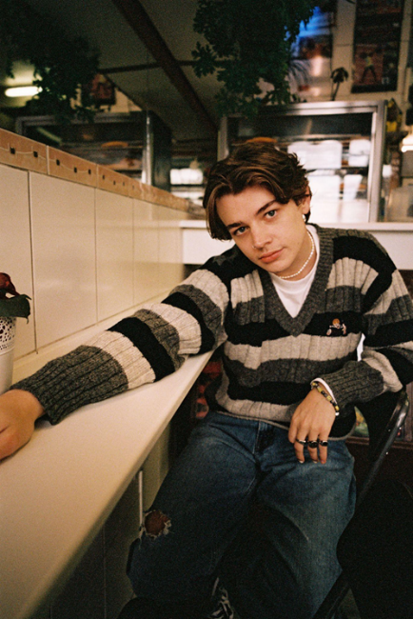
DOWNLOAD PRESS ASSETS HERE

"pop prodigy" – NOTION

“fast rising star” – DIY

"alt-pop A-list" – DORK

“bubbling new bedroom pop” – CLASH

“I’ve written the ‘Victoria’ EP over the course of 6 months in a bunch of different places. Musically it’s somewhere I’ve always wanted to be and I’m really glad that I’ve done it with this record. It’s basically a look into my diary over the past half-year. It’s been quite a big step for me, putting out songs that are super honest and mean so much to me, but it feels great and I hope there’s a teenager somewhere experiencing what I did making this EP and relates to it in the same way.” - Thomas Headon

MARCH 11, 2022 –Thomas Headon has shared his highly anticipated new EP, Victoria. The EP arrives alongside an official video for the title track starring Thomas and Bridgerton’s new star Charithra Chandran. Streaming now on the artist’s official YouTube channel, the video depicts the nostalgia for how Thomas and his first love created their own little world within the four walls of Thomas' first ever car, from the innocence and the secrecy to the arguments and the euphoric highs.

Channeling memories of the past few months of living in London into five inimitable tracks that evoke the sense of having nothing but the whole world ahead of you, Thomas has an ability to capture youthful romance in all its forms. Radio 1-playlisted “Strawberry Kisses” documents the euphoria of spending the night with someone you think is out of your league, while “Nobody Has To Know” explores a secret teen-fling, “How Do I Know?” navigates the confusing feelings of young love and “The Most Beautiful Thing” was written in 10 minutes of admiration for the girl he just spent the whole night with. Title track “Victoria” is about Thomas’ first ever love.

“The 'Victoria' music video is my favorite one from my Victoria EP. It feels honest and pays homage
to what the song is about really nicely, and because of that is a push in quite an emotional direction that I haven’t been in before. Compared to the other songs on this EP, this is quite a dark story so the director Jordan Curtis-Hughes and myself felt we had to make something that is true to the lyrics, yet relatable to so many people my age who’ll be able to watch it and instantly think of someone they have a similar relationship with.” - Thomas Headon

Later this month, Thomas will head out on his first-ever North American headline tour, which kicks off March 24th at New York City’s Mercury Lounge and wraps up April 6th at Echo in Los Angeles, CA (tour itinerary attached). For up-to-date ticketing information, please visit www.thomasheadon.com.

Born in London and raised in Melbourne, Thomas Headon dreamed of moving back to the city to pursue music and was told by his mom that he had a year to get a “proper job,” otherwise he would have to return home. Arriving in London just before the pandemic hit, Thomas started to build a community online – blowing up on TikTok with 16M likes and nearly 450K followers to date – with his off-kilter live sessions, tongue-in-cheek charm and remarkable songwriting ability. Learning to write and produce on his own in his late teens, Thomas has already released self-written and self-produced debut EP, The Greatest Hits, and dropped The Goodbye EP last year, amassing 55 million streams worldwide, all before his 21st birthday.

Building an incredibly loyal fanbase over lockdown, Thomas’ blend of playful alternative pop that speaks to the Gen-Z experience has been compared to the likes of the 1975’s Matty Healy, and critically praised by Triple J, naming him a “seriously impressive force in pop music.” Thomas performed a charmingly energetic live session on Jack Saunders’ BBC Radio 1 show, which followed his “Living Room Shows” tour, where he played an intimate acoustic series to thousands of fans across the UK. The 21-year-old has also collaborated with American singer-songwriter Lizzy McAlpine on his single “Bored,” as well as Chloe Moriondo and Alfie Templeton on the brilliant “Dizzy,” which racked up praise from Billboard, E!, Entertainment Tonight, FLOOD Magazine and more.

THOMAS HEADON
2022 NORTH AMERICAN HEADLINE TOUR DATES
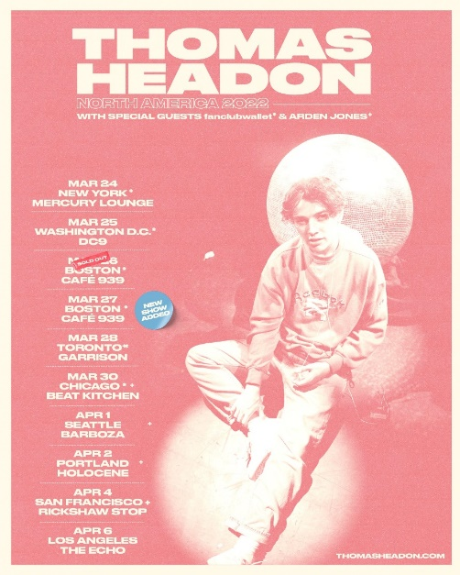

March 24 New York, NY Mercury Lounge
March 25 Washington, DC DC9
March 26 Boston MA Café 939 SOLD OUT
March 27 Boston MA Café 939
March 30 Chicago, IL Beat Kitchen
April 1 Seattle, WA Barboza
April 2 Portland, OR Holocene
April 4 San Francisco, CA Rickshaw
April 6 Los Angeles, CA Echo

THOMAS HEADON
VICTORIA EP
AVAILABLE NOW

CONNECT WITH THOMAS HEADON
WEBSITE | INSTAGRAM | TIKTOK | TWITTER | YOUTUBE

For US press inquiries, please contact:
Sarah Goldstein
sarahgoldstein@elektra.com

