TRIVIUM RELEASE NEW SONG "IN THE COURT OF THE DRAGON"

OFFICIAL MUSIC VIDEO STREAMING NOW — WATCH

BAND TOURING WITH MEGADETH & LAMB OF GOD THIS SUMMER

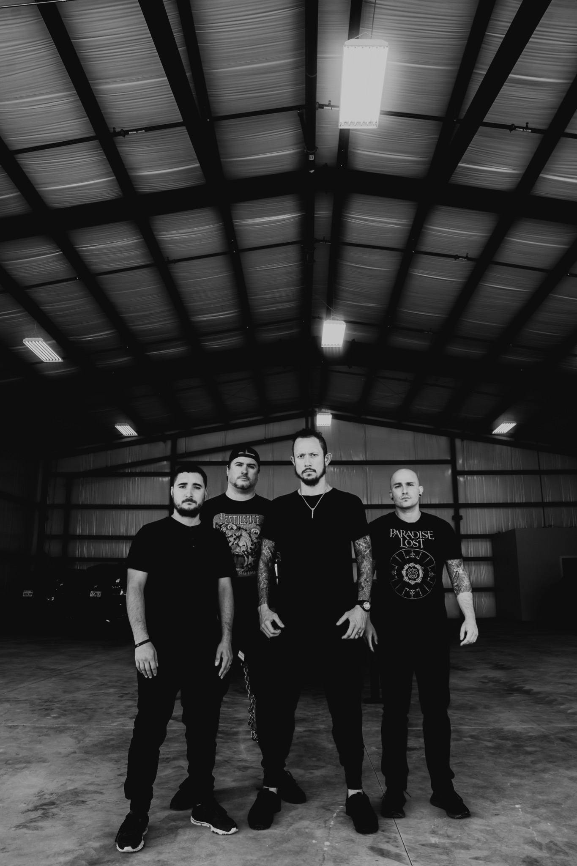

JULY 9, 2021 - Florida-based, Grammy-nominated band TRIVIUM — Matt Heafy [vocals, guitar], Corey Beaulieu [guitar], Paolo Gregoletto [bass], and Alex Bent [drums] — have shared the brand new single "In the Court of the Dragon." The song is available at all DSPs and is accompanied by an official short film music video directed by Ryan Mackfall. Watch it here.

The song represents everything fans have come to know and love about Trivium. It's a summit of masterful melodies, miles of riffs and solos, thought-provoking lyrics, intricate storytelling, and a tiered vocal attack.

"We started putting together the riffs for what would become 'In the Court of the Dragon' last year with no touring on the horizon," shares Gregoletto about the song's earliest origins during the COVID-19 pandemic and lockdown. "We decided to use the uncertainty to our advantage and to create without any of the limitations and commitments that would normally be eating away at our time in the jam room."

About the deeper meaning, he continues, "The title of the song came from a short story by Robert W. Chambers. The story is filled with dread and uncertainty, and that felt fitting for the times we've all been living in for the last year. Rather than a direct re-telling, we decided to go a different route and build our own narrative around the music that we were creating."

He finishes, "Similar to some of our past songs and albums, this song began with lyrics rooted in mythology. But unlike the past, we decided to create our own myth to fit the music. Being free to create the story and write the music without a deadline, due to a once-in-a-lifetime event, really led to one of the most rewarding writing and recording experiences we have ever had. We hope it lives up to your expectations."

Heafy weighed in about the single's artwork and its unique relationship to the track, saying, "While the music of 'In the Court of the Dragon’ was taking shape, we knew we needed epic artwork of the type that you might see on the wall of an important museum from a long-dead renaissance master."

The track and video also feature an epic intro composed and orchestrated by Ihsahn (Emperor).

Trivium continue to work on new material for their upcoming tenth album. Stay tuned for more information about their next full-length.

In other Trivium news, the band will make its long-awaited return to the road this summer with Megadeth, Lamb of God, and In Flames. All dates are below.

“IN THE COURT OF THE DRAGON”
SINGLE ARTWORK

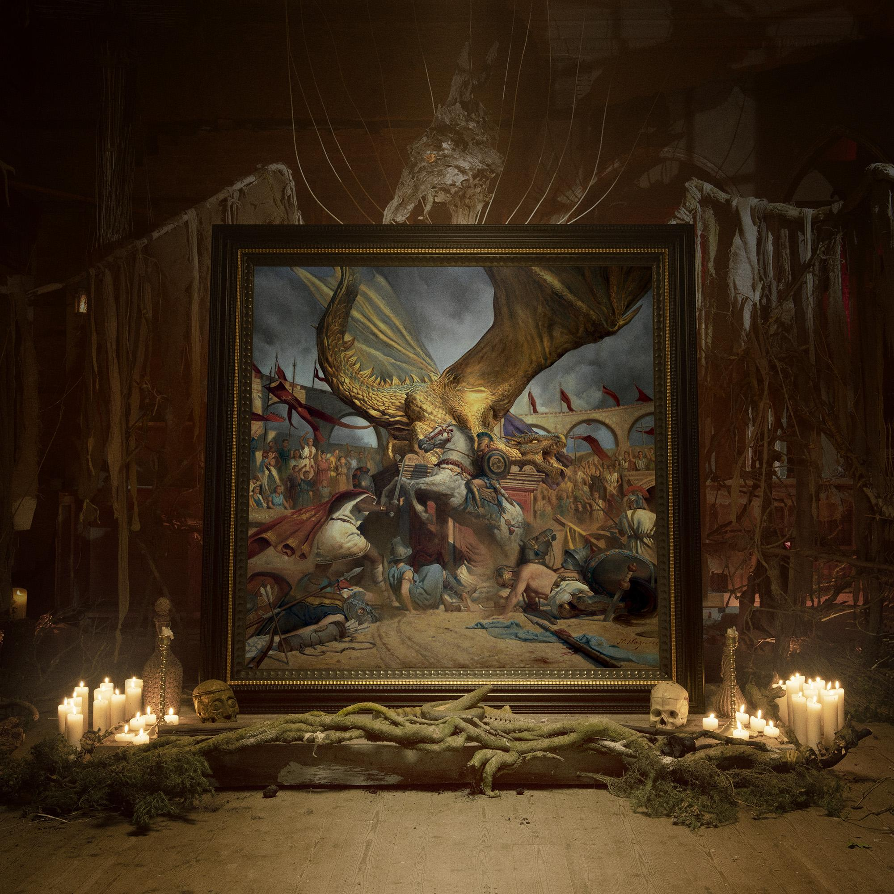
TRIVIUM ON TOUR:
8/20 — Austin, TX — Germania Insurance Amphitheater
8/21 — Irving, TX — The Pavilion at Toyota Music Factory
8/22 — Woodlands, TX — The Cynthia Woods Mitchell Pavilion presented by Huntsman
8/24 — El Paso, TX — Don Haskins Center
8/25 — Albuquerque, NM — Isleta Amphitheater
8/26 - Wichita, KS - Cotillion Ballroom (headline)
8/27 — Denver, CO — Ball Arena
8/29 — Phoenix, AZ — Arizona Federal Theatre
8/31 — Reno, NV — Reno Events Center
9/1 — Irvine, CA — FivePoint Amphitheatre
9/2 — Concord, CA — Concord Pavilion
9/4 — Portland, OR — Moda Center
9/5 — Auburn, WA — White River Amphitheatre
9/6 - Boise, ID, Revolution Concert House (headline)
9/9 — Tinley Park, IL — Hollywood Casino Amphitheatre - Chicago
9/10 - Pittsburgh, PA — Stage AE w/ Black Label Society
9/11 — Danville, VA — Blue Ridge Festival*
9/12 — Wantagh, NY — Northwell Health at Jones Beach Theater
9/13 — Boston, MA — Leader Bank Pavilion
9/15 — Camden, NJ — BB&T Pavilion
9/16 — Holmdel, NJ — PNC Bank Arts Center
9/18 — Noblesville, IN — Ruoff Music Center
9/19 — Clarkston, MI — DTE Energy Music Theatre
9/20 — Cincinnati, OH — PNC Pavilion
9/22 — Rogers, AR — Walmart AMP
9/24 — Mount Pleasant, MI — Soaring Eagle Casino Amphitheatre
9/25 - Des Moines, IA - Knotfest Iowa*
9/26 — St. Louis, MO — Hollywood Casino Amphitheatre - St. Louis
9/28 — Minneapolis, MN — Armory
9/30 — Toronto, ON — Budweiser Stage
10/1 — Laval, QC — Place Bell
10/2 — Quebec City, QC — Centre Videotron
*Festival Date featuring all 4 bands.

ABOUT TRIVIUM:
Trivium released their ninth full-length, What The Dead Men Say, through Roadrunner Records in 2020. The album was produced by Trivium and Josh Wilbur and debuted at #35 on the Billboard Top 200; at #2 on the Top Current Albums Chart, and at #3 on both the Hard Rock Albums Chart and Top Rock Albums Chart. The band and album were praised by and featured in mainstream outlets like The New York Times, NPR, Forbes, Billboard, TechCrunch, and Kotaku, as well as Guitar World, Revolver, Alternative Press, and more.
Trivium released its now-canonical album Ascendancy in 2005. It was recognized as KERRANG!’s "Album of the Year," achieved a gold certification in the UK, and eclipsed sales of 500,000 worldwide. Metal Hammer placed it in the Top 15 of "The 100 Greatest Metal Albums of the 21st Century." It ignited a string of six consecutive Top 25 debuts on the Billboard Top 200 and five straight Top 3 debuts on the Top Hard Rock Albums Chart, culminating on 2017's benchmark The Sin And The Sentence. That album elevated the group's total stream tally past a quarter-of-a-billion. Additionally, "Betrayer" received a GRAMMY® Award nomination in the category of "Best Metal Performance." Unanimous acclaim followed from Decibel, Loudwire, Ultimate Guitar, MetalSucks, and Metal Hammer who dubbed them, "quite simply one of the best bands in modern metal." Not to mention, they performed alongside Metallica, Black Sabbath, Iron Maiden, and many others and graced the main stages of Download, Bloodstock, KNOTFEST, and more. After two decades, eight albums, and hundreds of sold out shows, Trivium actualize the all-encompassing ambition they first set in motion back in 1999.
TRIVIUM ONLINE:
FACEBOOK
TWITTER
WEBSITE
INSTAGRAM
YOUTUBE

