TRIVIUM
SHARE NEW SONG "AMONGST THE SHADOWS & THE STONES" — LISTEN

NEW ALBUM WHAT THE DEAD MEN SAY ARRIVES APRIL 24 THROUGH ROADRUNNER RECORDS

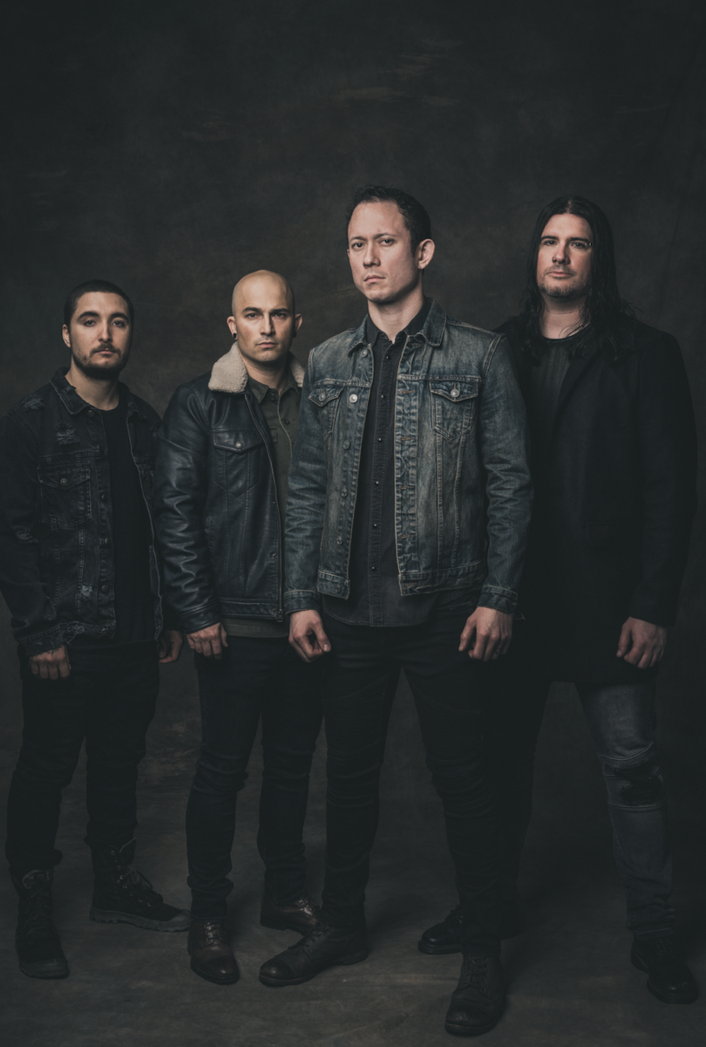
APRIL 16, 2020 - Grammy-nominated band TRIVIUM — Matt Heafy [vocals, guitar], Corey Beaulieu [guitar], Paolo Gregoletto [bass], and Alex Bent[drums] — will release their ninth full length, What The Dead Men Say, through Roadrunner Records on April 24. The album, which was produced by Trivium and Josh Wilbur, is available for pre-order here.
Today, the band has shared the new song "Amongst The Shadows & The Stones." Listen here. The track is now available at all DSPs.
"The inspiration for the song started when a war history website that I follow posted a story of a soldier visiting the graves of his fallen comrades and he described it as walking 'amongst the shadows and the stones," says Beaulieu. "The first thing I came up with was 'The ghosts of war will haunt my bones, amongst the shadows and the stones,' which then inspired the music for the song. But the lyrical subject became something totally different as we got deeper into the songwriting, but that was the spark. Now 'Amongst The Shadows & The Stones' captures elements of the heaviest material Trivium has done across our entire catalog."
Trivium are also setting up a virtual in-store which they will livestream on April 27 at 3PM ET at www.trivium.org. Starting today, fans can pre-order a CD copy of What The Dead Men Say and have it personalized by the band, who will be signing copies of the album live during the virtual event.
Previously, Trivium shared a video for the first single "Catastrophist" and the title track, the latter of which was shot under quarantine circumstances.
Heafy spoke exclusively to Forbes about the new album and how he effectively utilizes the Twitch platform here. He also spoke to gaming site Kotaku about his Twitch activity during the COVID-19 pandemic.
WHAT THE DEAD MEN SAY TRACK LISTING:
"IX"
"What The Dead Men Say"
"Catastrophist"
"Amongst The Shadows & The Stones"
"Bleed Into Me"
"The Defiant"
"Sickness Unto You"
"Scattering The Ashes"
"Bending The Arc To Fear"
"The Ones We Leave Behind"

ABOUT TRIVIUM:
Trivium released its now-canonical album Ascendancy in 2005. It was recognized as KERRANG!’s "Album of the Year," achieved a gold certification in the UK, and eclipsed sales of 500,000 worldwide. Metal Hammer placed it in the Top 15 of "The 100 Greatest Metal Albums of the 21st Century." It ignited a string of six consecutive Top 25 debuts on the Billboard Top 200 and five straight Top 3 debuts on the Top Hard Rock Albums Chart, culminating on 2017's benchmark The Sin And The Sentence. That album elevated the group's total stream tally past a quarter-of-a-billion. Additionally, "Betrayer" received a GRAMMY® Award nomination in the category of "Best Metal Performance." Unanimous acclaim followed from Decibel, Loudwire, Ultimate Guitar, MetalSucks, and Metal Hammer who dubbed them, "quite simply one of the best bands in modern metal." Not to mention, they performed alongside Metallica, Black Sabbath, Iron Maiden, and many others and graced the main stages of Download, Bloodstock, KNOTFEST, and more. After two decades, eight albums, and hundreds of sold out shows, Trivium actualize the all-encompassing ambition they first set in motion back in 1999. On their ninth full-length album, What The Dead Men Say [Roadrunner Records], the Florida quartet ascend to an inimitable nexus of masterful melody and hooks, tight thrash, black metal scope, and cinematic extremity.

TRIVIUM ONLINE:
https://www.facebook.com/Trivium
https://twitter.com/TriviumOfficial
http://www.trivium.org
https://www.instagram.com/triviumband/
https://www.youtube.com/user/trivium

