FOR IMMEDIATE RELEASE
JANUARY 30, 2020

TRAVIS BARKER SHARES NEW VIDEO FEATURING LIL WAYNE AND RICK ROSS
WATCH "GIMME BRAIN" NOW

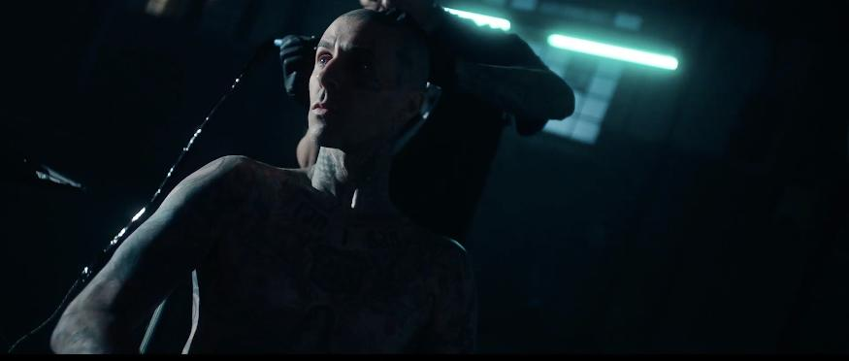
"Gimme Brain" video still

"Gimme Brain" feat. Lil Wayne and Rick Ross
WATCH: https://youtu.be/EXj_23pCUmE
LISTEN: https://dtarecords.lnk.to/GimmeBrain

What the press is saying about "Gimme Brain":

"The love between Travis Barker and the hip-hop world is undeniably mutual"
Complex

"Unapologetically boisterous"
Hot New Hip Hop

"A speaker-shaking mix of drums and bass peppered with twisty synth lines"
Rolling Stone

"Wonky synths, a clapping electronic drum beat, and booming bass"
Uproxx

After launching his new record label DTA Records last year, Travis Barker is sharing the video for the label's first single "Gimme Brain," which he produced and recruited hip-hop giants Lil Wayne and Rick Ross to deliver bars for. "Gimme Brain" represents a continuation of Barker's passion for beat making and production, especially within hip-hop, and the Andrew Sandler video features a hodge-podge of cultural movers and shakers such as rapper Trippie Redd, UFC champion Nate Diaz, tattoo artist Chuey Quintanar, and a limited edition 2015 La Ferrari with a three million dollar asking price.
The release of "Gimme Brain" in 2019 coincided with the launch of Barker's new record label, DTA Records, which operates as a worldwide joint venture with Elektra Music Group and serves as Barker's outlet for his many genre-crossing collaborations as well as a home for artist development under his tutelage. "Gimme Brain" acted as a cap off to a busy year where amongst other projects, Barker collaborated with many of today's most exciting artists such as Lil Nas X, $uicideboy$, XXXTentacion, Halsey, Lil Peep, YUNGBLUD, Pharrell, 03 Greedo, Fever 333, nothing.nowhere, and more.
Travis Barker's multi-faceted career has placed him at the epicenter of culture for the past two decades. Today, he's a full-time member of both Blink-182 and Transplants, and the exclusive on-album drummer for Goldfinger and FEVER 333 (whose 2018 Grammy-nominated "Made An America" he produced). In addition to releasing a new record with Blink-182, in 2019 alone Barker recorded and/or released work with Lil Nas X, $uicideboy$, Halsey, Machine Gun Kelly, Korn, YUNGBLUD, XXXTentacion ft. Kanye West, Lil Peep, Pharrell, The Game, UnoTheActivist, Ghostemane, Yelawolf, nothing,nowhere, 03 Greedo, and others.
Watch "Gimme Brain" above and stay tuned for more new music from Travis Barker and DTA Records coming soon.
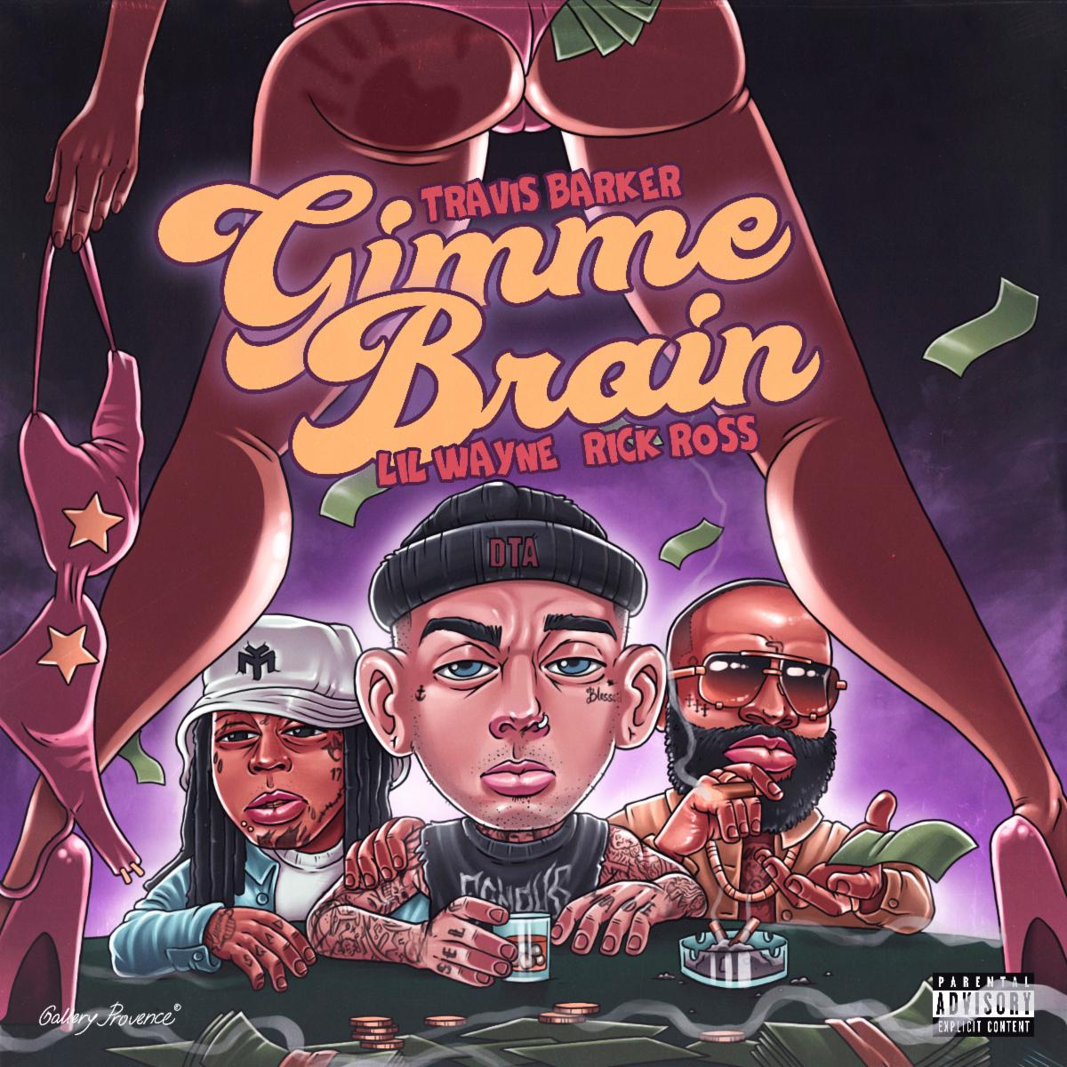
"Gimmie Brain" single art

About Elektra Music Group:
Elektra Music Group was launched in 2018 as a stand-alone music company within Warner Music Group. Its roots extend back to 1950, when Jac Holzman launched the iconic Elektra label in his college dorm room. Today, that same entrepreneurial, independent spirit is the driving force behind each of the unique labels that make up the core of the Elektra Music Group: Elektra, Fueled By Ramen, and Roadrunner. The company's adventurous, eclectic roster includes culture-defining artists such as Brandi Carlile, Coheed and Cambria, Fitz and the Tantrums, Gojira, Kaleo, Korn, Panic! At The Disco, Paramore, Slipknot, Sturgill Simpson, Tones and I, Twenty One Pilots, and others.

(Download hi-res assets HERE)

For DTA Records and project inquires please contact Duncan Will at Orienteer -
Duncan@orienteer.us

For Travis Barker inquiries please contact Jenni Weinman at The Current Co. -
Weinman@thecurrentco.com

For all DTA Records/Elektra Music Group inquiries please contact Glenn Fukushima -
GlennFukushima@elektra.com

