FOR IMMEDIATE RELEASE

MAY 26, 2021

**THE SNUTS ANNOUNCE FALL US HEADLINE TOUR**

**TICKETS AVAILABLE NOW**[**HERE**](https://nam04.safelinks.protection.outlook.com/?url=https%3A%2F%2Fthesnuts.tix.to%2Fustour&data=04%7C01%7CSydneyWorden%40elektra.com%7Cff3ef891150745abc3dd08d92067c3fb%7C8367939002ec4ba1ad3d69da3fdd637e%7C0%7C0%7C637576452321536750%7CUnknown%7CTWFpbGZsb3d8eyJWIjoiMC4wLjAwMDAiLCJQIjoiV2luMzIiLCJBTiI6Ik1haWwiLCJXVCI6Mn0%3D%7C1000&sdata=iKrESDkvILe%2Fixe%2FRG%2BQS0wQPTz2%2Fz2OHpZhPrg89Ag%3D&reserved=0)

**CRITICALLY ACCLAIMED DEBUT ALBUM *W.L.*AVAILABLE NOW**[**HERE**](https://nam04.safelinks.protection.outlook.com/?url=https%3A%2F%2Fthesnuts.lnk.to%2FW-L&data=04%7C01%7CSydneyWorden%40elektra.com%7Cff3ef891150745abc3dd08d92067c3fb%7C8367939002ec4ba1ad3d69da3fdd637e%7C0%7C0%7C637576452321546736%7CUnknown%7CTWFpbGZsb3d8eyJWIjoiMC4wLjAwMDAiLCJQIjoiV2luMzIiLCJBTiI6Ik1haWwiLCJXVCI6Mn0%3D%7C1000&sdata=WpjGm6tRZ5tv3wP%2FqYyPKDo9C%2B6fMXJKenDU6igh%2FSc%3D&reserved=0)

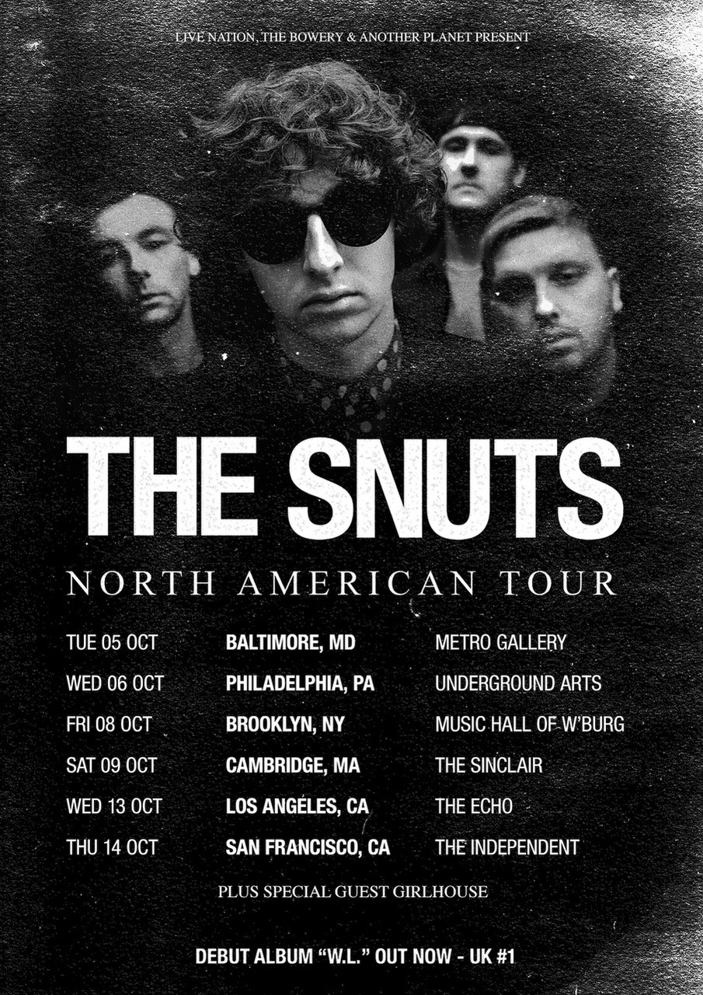

Rising Scottish indie rockers **The Snuts** have announced they will embark on their first ever US headline tour this Fall. The tour will kick off on October 05 in Baltimore, MD, and wrap on October 14 in San Francisco, CA. girlhouse will provide support. Tickets for all dates are on sale beginning today [HERE](https://nam04.safelinks.protection.outlook.com/?url=https%3A%2F%2Fthesnuts.tix.to%2Fustour&data=04%7C01%7CSydneyWorden%40elektra.com%7Cff3ef891150745abc3dd08d92067c3fb%7C8367939002ec4ba1ad3d69da3fdd637e%7C0%7C0%7C637576452321546736%7CUnknown%7CTWFpbGZsb3d8eyJWIjoiMC4wLjAwMDAiLCJQIjoiV2luMzIiLCJBTiI6Ik1haWwiLCJXVCI6Mn0%3D%7C1000&sdata=QJkHF5bTSu3UmLRDLg83AptgpgZ4tR3M73TtSMFRvAg%3D&reserved=0).

Last month, The Snuts released their critically acclaimed debut album *W.L.*The album debuted at Number 1 in the UK, and marked the biggest debut from a British band in five years. Additionally, The Snuts became the first Scottish band to achieve a UK Number 1 with their debut album in 14 years. *W.L.*is available physically and digitally via Parlophone Records/Elektra Records now [HERE](https://nam04.safelinks.protection.outlook.com/?url=https%3A%2F%2Fthesnuts.lnk.to%2FW-L&data=04%7C01%7CSydneyWorden%40elektra.com%7Cff3ef891150745abc3dd08d92067c3fb%7C8367939002ec4ba1ad3d69da3fdd637e%7C0%7C0%7C637576452321556734%7CUnknown%7CTWFpbGZsb3d8eyJWIjoiMC4wLjAwMDAiLCJQIjoiV2luMzIiLCJBTiI6Ik1haWwiLCJXVCI6Mn0%3D%7C1000&sdata=3GM%2Fd0aDUJb5vfZX%2FnMMmHUvu%2BadQqKhySxvPOVxEng%3D&reserved=0).

*W.L.*is highlighted by current single “[Glasgow](https://nam04.safelinks.protection.outlook.com/?url=https%3A%2F%2Fyoutu.be%2FdQ7awG2ZGrA&data=04%7C01%7CSydneyWorden%40elektra.com%7Cff3ef891150745abc3dd08d92067c3fb%7C8367939002ec4ba1ad3d69da3fdd637e%7C0%7C0%7C637576452321556734%7CUnknown%7CTWFpbGZsb3d8eyJWIjoiMC4wLjAwMDAiLCJQIjoiV2luMzIiLCJBTiI6Ik1haWwiLCJXVCI6Mn0%3D%7C1000&sdata=Ij1DCxF%2F8X%2Bcgw0ANiGViNe7tTnaxHRRn6k2dxcug4E%3D&reserved=0)”, heartfelt ballad “[Somebody Loves You](https://nam04.safelinks.protection.outlook.com/?url=https%3A%2F%2Fthesnuts.lnk.to%2FSLYVideo&data=04%7C01%7CSydneyWorden%40elektra.com%7Cff3ef891150745abc3dd08d92067c3fb%7C8367939002ec4ba1ad3d69da3fdd637e%7C0%7C0%7C637576452321556734%7CUnknown%7CTWFpbGZsb3d8eyJWIjoiMC4wLjAwMDAiLCJQIjoiV2luMzIiLCJBTiI6Ik1haWwiLCJXVCI6Mn0%3D%7C1000&sdata=jhrP0WXD5G9nt1c1ov1pNXA15dOFSKEHWoN3SSCgdcw%3D&reserved=0)”, the hip-hop driven “[Elephants](https://nam04.safelinks.protection.outlook.com/?url=https%3A%2F%2Fyoutu.be%2FZoxPiTHA6nA&data=04%7C01%7CSydneyWorden%40elektra.com%7Cff3ef891150745abc3dd08d92067c3fb%7C8367939002ec4ba1ad3d69da3fdd637e%7C0%7C0%7C637576452321566723%7CUnknown%7CTWFpbGZsb3d8eyJWIjoiMC4wLjAwMDAiLCJQIjoiV2luMzIiLCJBTiI6Ik1haWwiLCJXVCI6Mn0%3D%7C1000&sdata=c3foA%2F58O19qNi4kcqfCtViH1oDnHiFAxbmNmZVABr4%3D&reserved=0)”, the anthemic “[Always](https://nam04.safelinks.protection.outlook.com/?url=https%3A%2F%2Fyoutu.be%2F9K1OOkjTkek&data=04%7C01%7CSydneyWorden%40elektra.com%7Cff3ef891150745abc3dd08d92067c3fb%7C8367939002ec4ba1ad3d69da3fdd637e%7C0%7C0%7C637576452321566723%7CUnknown%7CTWFpbGZsb3d8eyJWIjoiMC4wLjAwMDAiLCJQIjoiV2luMzIiLCJBTiI6Ik1haWwiLCJXVCI6Mn0%3D%7C1000&sdata=z6wT%2BFuhhLQXF3JeFDR2lQrefW4xbD3yY10YUd84I%2B4%3D&reserved=0)”, and festival-ready track, “[All Your Friends](https://nam04.safelinks.protection.outlook.com/?url=https%3A%2F%2Fwww.youtube.com%2Fwatch%3Fv%3Dfx1yds6FVKQ%26feature%3Dyoutu.be&data=04%7C01%7CSydneyWorden%40elektra.com%7Cff3ef891150745abc3dd08d92067c3fb%7C8367939002ec4ba1ad3d69da3fdd637e%7C0%7C0%7C637576452321576727%7CUnknown%7CTWFpbGZsb3d8eyJWIjoiMC4wLjAwMDAiLCJQIjoiV2luMzIiLCJBTiI6Ik1haWwiLCJXVCI6Mn0%3D%7C1000&sdata=abCx79EXnlJdvyPd6pIIr68NKJQwNADow%2Bkxu1MG%2FpU%3D&reserved=0)”. *Dork Magazine*praised, “*W.L.*is a masterclass in ballads and risk-taking that proves music works best when it comes from the heart.” *NME*proclaimed “The Scottish rockers are creating an arsenal of anthes for festival season’s return.” *Atwood Magazine* hailed, “The four-piece have rewritten the songsheet for British indie bands with their open-ended and genre-merging record.”

Hailing from Whitburn, West Lothian, The Snuts have truly found their stride on *W.L.*. Produced by Tony Hoffer (Beck, Phoenix, M83) and recorded at the Firepit London, the album encapsulates the band’s journey from four working class kids growing up with a dream, to becoming one of the UK’s most exciting new bands.

Adored for their uninhibited, sweat-drenched live shows, the band will also embark on a largely sold out tour of the UK and Ireland this Fall. The massive trek will include a run of special unplugged dates, as well as three sold out hometown shows at Glasgow’s Barrowland. A complete list of upcoming live dates and ticket information can be found [HERE](https://nam04.safelinks.protection.outlook.com/?url=http%3A%2F%2Fthesnuts.co.uk%2F&data=04%7C01%7CSydneyWorden%40elektra.com%7Cff3ef891150745abc3dd08d92067c3fb%7C8367939002ec4ba1ad3d69da3fdd637e%7C0%7C0%7C637576452321576727%7CUnknown%7CTWFpbGZsb3d8eyJWIjoiMC4wLjAwMDAiLCJQIjoiV2luMzIiLCJBTiI6Ik1haWwiLCJXVCI6Mn0%3D%7C1000&sdata=yUUwYv%2BJ%2FMTOE56gHF9awxADonp0LHQ0EMgB7p3Jgkg%3D&reserved=0).

**The Snuts US Tour Dates - *JUST ANNOUNCED***

October 05, 2021 - BALTIMORE, MD - Metro Gallery

October 06, 2021 - PHILADELPHIA, PA - Underground Arts

October 08, 2021 - NEW YORK, NY - Music Hall of Williamsburg

October 09, 2021 - CAMBRIDGE, MA - The SInclair

October 13, 2021 - LOS ANGELES, CA - The Echo

October 14, 2021 - SAN FRANCISCO, CA - The Independent

**The Snuts UK and Ireland Tour Dates**

September 01, 2021 - GLASGOW - Oran Mor Auditorium (17:30)* - **SOLD OUT**

September 01, 2021 - GLASGOW - Oran Mor Auditorium (20:00)* - **SOLD OUT**

September 02, 2021 - GLASGOW - Oran Mor Auditorium (17:30)* - **SOLD OUT**

September 02, 2021 - GLASGOW - Oran Mor Auditorium (20:00)* - **SOLD OUT**

September 07, 2021 - EDINBURGH - The Caves* - **SOLD OUT**

September 08, 2021 - EDINBURGH - The Caves* - **SOLD OUT**

September 12, 2021 - MANCHESTER - Blues Kitchen* - **SOLD OUT**

September 13, 2021 - LEEDS - Wardrobe* - **SOLD OUT**

September 14, 2021 - KINGSTON - Pryzm* - **SOLD OUT**

September 20, 2021 - GLASGOW - Barrowland - **SOLD OUT**

September 21, 2021 - GLASGOW - Barrowland - **SOLD OUT**

September 22, 2021 - GLASGOW - Barrowland - **SOLD OUT**

September 28, 2021 - ABERDEEN - Tunnels* - **SOLD OUT**

September 29, 2021 - ABERDEEN - Tunnels* - **SOLD OUT**

September 30, 2021 - DUNDEE - Church* - **SOLD OUT**

October 03, 2021 - DUNDEE - Church* - **SOLD OUT**

October 16, 2021 - BIRMINGHAM - O2 Institute

October 24, 2021 - DUBLIN - Button Factory - **SOLD OUT**

October 25, 2021 - BELFAST - Empire

October 28, 2021 - EDINBURGH - Corn Exchange - **SOLD OUT**

November 02, 2021 - EXETER - Phoenix

November 03, 2021 - CARDIFF - Globe - **SOLD OUT**

November 04, 2021 - LONDON - O2 Forum Kentish Town

November 06, 2021 - DERBY - The Venue - **SOLD OUT**

November 07, 2021 - OXFORD - O2 Academy

November 08, 2021 - NORWICH - Waterfront

November 13, 2021 - HULL - Asylum

November 14, 2021 - LEEDS - Stylus - **SOLD OUT**

November 15, 2021 - BRISTOL - Fleece

November 18, 2021 - MIDDLESBROUGH - Town Hall Crypt - **SOLD OUT**

November 19, 2021 - SHEFFIELD - Leadmill - **SOLD OUT**

November 22, 2021 - BRIGHTON - Concorde 2

November 23, 2021 - COLCHESTER - Arts Centre

November 24, 2021 - BLACKPOOL - Waterloo - **SOLD OUT**

November 26, 2021 - MANCHESTER - O2 Ritz - **SOLD OUT**

* Unplugged with strings



*Photo credit: Gary Williamson*

**The Snuts** are: Jack Cochrane (vocals/guitar), Joe McGillveray (guitar), Callum ‘29’ Wilson (bass) and Jordan ‘Joko’ Mackay (drums).

[https://www.thesnuts.co.uk/](https://nam04.safelinks.protection.outlook.com/?url=https%3A%2F%2Fwww.thesnuts.co.uk%2F&data=04%7C01%7CSydneyWorden%40elektra.com%7Cff3ef891150745abc3dd08d92067c3fb%7C8367939002ec4ba1ad3d69da3fdd637e%7C0%7C0%7C637576452321586712%7CUnknown%7CTWFpbGZsb3d8eyJWIjoiMC4wLjAwMDAiLCJQIjoiV2luMzIiLCJBTiI6Ik1haWwiLCJXVCI6Mn0%3D%7C1000&sdata=tP2CbZKGbp4zgKYCXDl7361oZAt7NAnZczAeezn7PtQ%3D&reserved=0) / [Twitter](https://nam04.safelinks.protection.outlook.com/?url=https%3A%2F%2Ftwitter.com%2Fthesnuts&data=04%7C01%7CSydneyWorden%40elektra.com%7Cff3ef891150745abc3dd08d92067c3fb%7C8367939002ec4ba1ad3d69da3fdd637e%7C0%7C0%7C637576452321586712%7CUnknown%7CTWFpbGZsb3d8eyJWIjoiMC4wLjAwMDAiLCJQIjoiV2luMzIiLCJBTiI6Ik1haWwiLCJXVCI6Mn0%3D%7C1000&sdata=Sztz4YD6cMtpCMQSxCRJEpTS8trISaamJBqGXX7hCr8%3D&reserved=0) / [Instagram](https://nam04.safelinks.protection.outlook.com/?url=https%3A%2F%2Finstagram.com%2Fthesnuts%2F&data=04%7C01%7CSydneyWorden%40elektra.com%7Cff3ef891150745abc3dd08d92067c3fb%7C8367939002ec4ba1ad3d69da3fdd637e%7C0%7C0%7C637576452321596706%7CUnknown%7CTWFpbGZsb3d8eyJWIjoiMC4wLjAwMDAiLCJQIjoiV2luMzIiLCJBTiI6Ik1haWwiLCJXVCI6Mn0%3D%7C1000&sdata=Tu8KazDlQRMAO8o5%2BaU7yXg701jUsEPuaWwSqzkYRAI%3D&reserved=0) / [Facebook](https://nam04.safelinks.protection.outlook.com/?url=https%3A%2F%2Fwww.facebook.com%2FTheSnutsOfficial%2F&data=04%7C01%7CSydneyWorden%40elektra.com%7Cff3ef891150745abc3dd08d92067c3fb%7C8367939002ec4ba1ad3d69da3fdd637e%7C0%7C0%7C637576452321596706%7CUnknown%7CTWFpbGZsb3d8eyJWIjoiMC4wLjAwMDAiLCJQIjoiV2luMzIiLCJBTiI6Ik1haWwiLCJXVCI6Mn0%3D%7C1000&sdata=e1zo9qw45DR65s%2Ffa3NiTUokEYvivjLeNiolhzX6q08%3D&reserved=0) /[TikTok](https://nam04.safelinks.protection.outlook.com/?url=http%3A%2F%2Ftiktok.com%2F%40thesnuts&data=04%7C01%7CSydneyWorden%40elektra.com%7Cff3ef891150745abc3dd08d92067c3fb%7C8367939002ec4ba1ad3d69da3fdd637e%7C0%7C0%7C637576452321606702%7CUnknown%7CTWFpbGZsb3d8eyJWIjoiMC4wLjAwMDAiLCJQIjoiV2luMzIiLCJBTiI6Ik1haWwiLCJXVCI6Mn0%3D%7C1000&sdata=GDfcRqSI9g4XV2JKVZyCfv4PtrsJq%2FUTkvx9prydMbs%3D&reserved=0) /[YouTube](https://nam04.safelinks.protection.outlook.com/?url=https%3A%2F%2Fwww.youtube.com%2Fchannel%2FUC0aftMT8dWPpF2M_v82N7hw&data=04%7C01%7CSydneyWorden%40elektra.com%7Cff3ef891150745abc3dd08d92067c3fb%7C8367939002ec4ba1ad3d69da3fdd637e%7C0%7C0%7C637576452321606702%7CUnknown%7CTWFpbGZsb3d8eyJWIjoiMC4wLjAwMDAiLCJQIjoiV2luMzIiLCJBTiI6Ik1haWwiLCJXVCI6Mn0%3D%7C1000&sdata=QBsZ0zADSTkLXw938cgCwJMYNZ8%2BjYWMe76vWtJZj%2BE%3D&reserved=0)

**Press Contact:**

Collin Citron / [CollinCitron@Elektra.com](mailto:CollinCitron@Elektra.com)