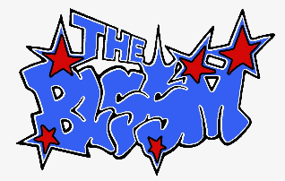
THE BLSSM RELEASES EFFERVESCENT SOPHOMORE EP,
PURE ENERGY
LISTEN HERE | WATCH THE NEW “I HATE SUNDAY” MUSIC VIDEO HERE
CURRENTLY ON TOUR WITH ROLE MODEL IN NORTH AMERICA
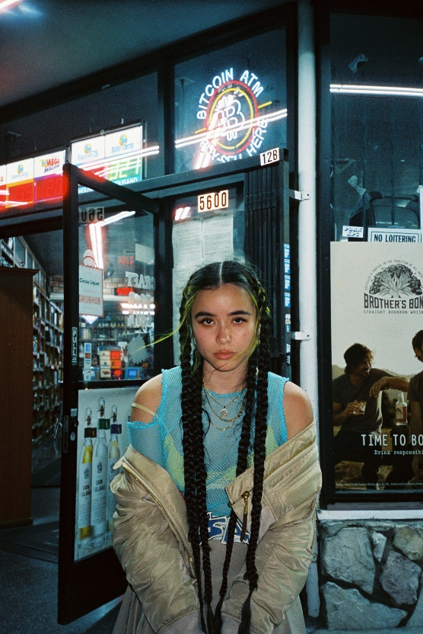
Photo Credit: Christina Bryson
Download Hi-Res HERE
“…fantastic pop music… the project has just enough energy (pure energy, at that) to bloom into what Lizotte has always dreamed of.” –ALTERNATIVE PRESS
“Last spring we fell in love with The BLSSM’s debut EP, 97 Blossom, and Lily Lizotte has only been on a steady rise since then.” –UPROXX
“…splitting and fun, while also unabashedly honest and kinetic” –HYPEBEAST
“‘NOT TODAY’ is a fearless, sassy banger. The bombastic, anthemic instrumentation highlights THE BLSSM’s signature genre-bending style” –CONSEQUENCE OF SOUND
“…brilliantly nostalgic…channels a true 90s pop-rock sound” –EARLY RISING
(APRIL 29, 2022) – LOS ANGELES, CA – Genre-fusing artist and fashion curator THE BLSSM (they/them) today released their effervescent sophomore EP PURE ENERGY via Fueled By Ramen. The strikingly cohesive, yet undeniably unique effort is available on all streaming platforms, along with a new music video for standout track “I HATE SUNDAY,” which channels DIY inspiration and captures the spirit of the early aughts. The collection of songs – which blend pop, grunge, alternative, and hip-hop – were also co-produced and written with THE BLSSM’s frequent collaborators, Nick Long (Avril Lavigne, King Princess) and Suzy Shinn (Panic! At the Disco, Dua Lipa).
On PURE ENERGY, THE BLSSM – colorful, and endearingly vibrant – demands the listener's attention immediately. A self-described ‘maximalist,’ they activate the maximum version of themselves to explore difficult subject matters as overtly and as self-aware as possible. With this new offering, THE BLSSM also proves it's possible to be an anomaly and an amalgamation all at once, reflecting their diverse sonic pallet that mines inspiration from the likes of Radiohead, N.E.R.D., and Elliott Smith.
“To express myself, I’ve learned how to jump off a million cliffs when it comes to taking risks,” THE BLSSM explains. “My project [PURE ENERGY] is about feeling everything at once and looking like a bit of everything, too.” They add, “It’s very loud and unimpeded. This is what pop music sounds like to me. This is what I wanted to make.”
In celebration of PURE ENERGY, THE BLSSM is currently out on the road, providing direct support for Role Model on his massive North American tour. The trek hits the White Oak in Houston, TX this evening, and wraps at the Pageant in St. Louis, MO on Saturday, June 25, while stopping in major cities such as New York, Boston, Nashville, and Washington, D.C., along the way.
THE BLSSM will also hit the U.S. festival circuit this year, playing Hangout Music Festival in Gulf Shores, AL on Saturday, May 21, Outside Lands in San Francisco in August, Life Is Beautiful in Las Vegas in September, and All Things Go in Columbia, MD on Saturday, October 1. The full routing can be found below.
PURE ENERGY
1. I HATE SUNDAY
2. DIZZY
3. EVIL TWIN
4. NOT TODAY
5. LITTLE KING
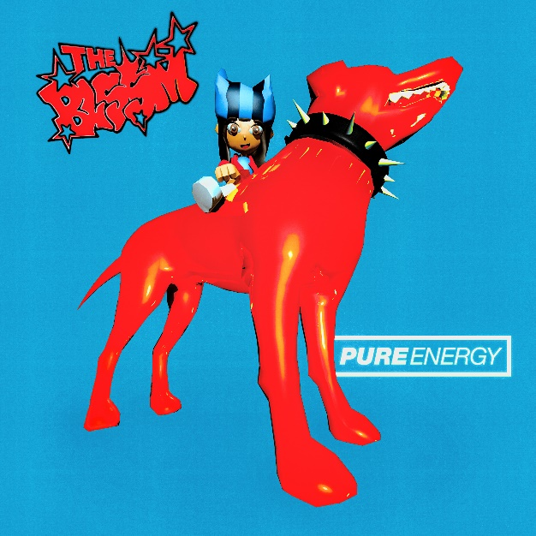
HI-RES ARTWORK HERE
THE BLSSM ON TOUR:
April 29 – Houston, TX @ White Oak *
April 30 – Austin, TX @ Scoot Inn * [SOLD OUT]
May 3 – Ft. Lauderdale, FL @ Rev Live *
May 4 – Orlando, FL @ Plaza Live *
May 6 – Atlanta, GA @ Variety *
May 7 – Asheville, NC @ Orange Peel *
May 9 – Baltimore, MD @ Soundstage *
May 10 – New York, NY @ Terminal 5 *
May 11 – Boston, MA @ Royale * [SOLD OUT]
May 13 – Montreal, QC @ L'Astral * [SOLD OUT]
May 14 – Toronto, ON @ Danforth * [SOLD OUT]
May 16 – Cleveland, OH @ Beachland *
May 18 – Louisville, KY @ Mercury *
May 19 – Nashville, TN @ Basement East *
May 21 – Gulf Shores, AL @ Hangout Music Festival
May 24 – Denver, CO @ Gothic *
May 25 – Salt Lake City, UT @ Depot *
May 27 – Portland, OR @ Wonder *
May 28 – Vancouver, BC @ Commodore *
May 29 – Seattle, WA @ Showbox *
June 17 – Charlotte, NC @ Underground *
June 19 – Washington, D.C. @ 9:30 Club *
June 21 – Pittsburgh, PA @ Mr. Smalls *
June 22 – Cincinnati, OH @ Bogarts *
June 24 – Indianapolis, IN @ Deluxe *
June 25 – St. Louis, MO @ Pageant *
September 16-18 – Las Vegas, NV @ Life Is Beautiful Music & Art Festival
August 5-7 – San Francisco, CA @ Outside Lands Music & Arts Festival
October 1 – Columbia, MD @ All Things Go Music Festival
* Supporting Role Model | Tickets Available HERE
Connect with THE BLSSM:
Instagram
TikTok
YouTube
Twitter
# # #
PRESS CONTACT:
Nathalie Rubin
NathalieRubin@elektra.com

