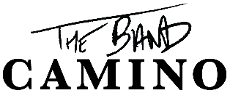

THE BAND CAMINO ANNOUNCES SECOND LEG OF NORTH AMERICAN HEADLINE TOUR DUE TO POPULAR DEMAND
TICKET ON-SALE BEGINS FRIDAY, MARCH 4

LEG 1 OF THE TOUR CAMINO KICKS OFF ON MARCH 23
NEARLY EVERY SHOW IS ALREADY ENTIRELY SOLD OUT, INCLUDING LA, NYC, CHICAGO, + MORE

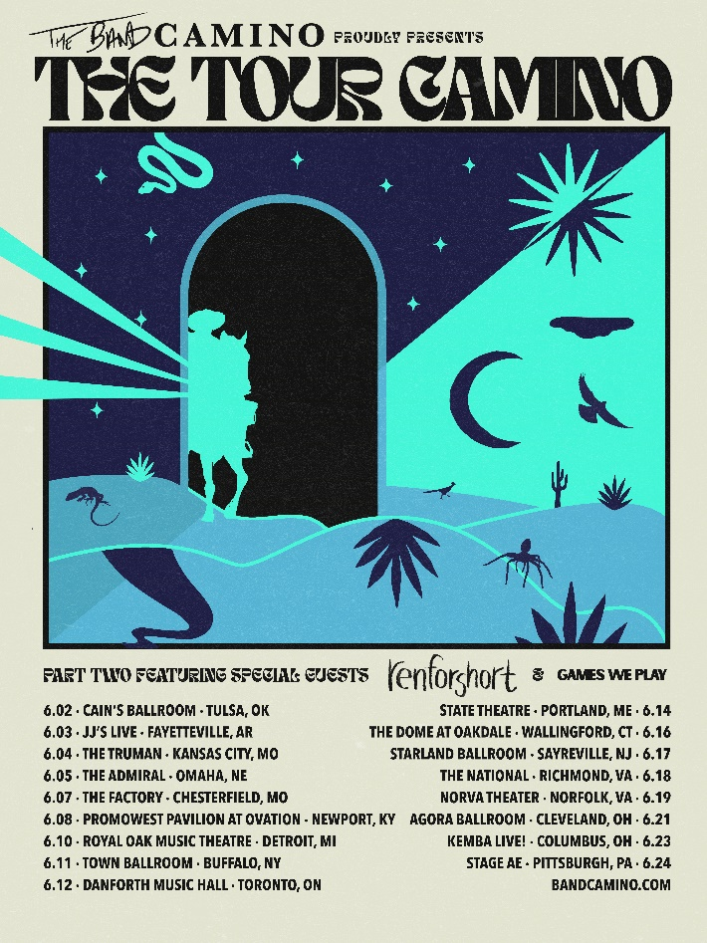
HI-RES ARTWORK AVAILABLE HERE
PRESS ASSETS AVAILABLE HERE

“There is so much in store for this rising rock band” – PEOPLE

“The highly-anticipated album combines '80s synths, punchy hooks, and vibrant anthems that are guaranteed to vibrate across the crowd during live shows.”
– ONES TO WATCH

“…it’s clear that The Band CAMINO’s self-titled debut album will solidify them as music’s next big thing.” – 1883 MAGAZINE

(February 28, 2022) – LOS ANGELES, CA – Due to popular demand, Nashville-based pop/rock trio The Band CAMINO today announced the second leg of THE TOUR CAMINO, which kicks off in Tulsa, OK on Thursday, June 2 and wraps in Pittsburgh, PA on Friday, June 24. The 17-date trek also hits major cities across North America including Detroit, MI, Toronto, ON, and Kansas City, MO, with renforshort and Games We Play providing support for all shows.
The Band CAMINO fan pre-sale begins on Tuesday, March 1 at 10:00am local venue time, with a subsequent Spotify pre-sale starting on Wednesday, March 2 at 10:00am local venue time. The general ticket on-sale also launches on Friday, March 4 at 10:00am local venue time; all tickets are available on The Band CAMINO’s official website.

The first leg of THE TOUR CAMINO commences on Wednesday March 23 in Louisville, KY. Nearly every date of the tour is already entirely sold out, including The Novo in Los Angeles, Terminal 5 in New York City, and the Riviera Theatre in Chicago. The group is touring in support of their celebrated self-titled debut album via dblblk/Elektra Records, which showcased their electrifying, guitar-driven energy and multifaceted soundscape that has garnered a diehard fanbase and cemented their status as one of the most exciting emerging acts in music.
In 2021, the three-piece also made their late-night debut on Jimmy Kimmel Live! – delivering a stellar performance of standout track “1 Last Cigarette” – and provided direct support for Grammy Award® winning country duo Dan + Shay, who handpicked them to open on their U.S arena tour.

THE TOUR CAMINO LEG 1
March 23 - Louisville, KY @ Paristown LOW TICKET WARNING
March 24 - Indianapolis, IN @ Egyptian Room SOLD OUT
March 25 - Chicago, IL @ Riviera Theater SOLD OUT
March 26 - Minneapolis, MN @ The Fillmore SOLD OUT
March 29 - Salt Lake City, UT @ The Complex SOLD OUT
March 31 - Portland, OR @ Roseland Theatre SOLD OUT
April 1 - Seattle, WA @ Showbox Sodo LOW TICKET WARNING
April 3 - Vancouver, BC @ Commodore Ballroom SOLD OUT
April 5 - San Francisco, CA @ Regency Ballroom SOLD OUT
April 6 - Santa Cruz, CA @ Catalyst LOW TICKET WARNING
April 8 - Los Angeles, CA @ The Novo SOLD OUT
April 9 - Santa Ana, CA @ The Observatory SOLD OUT
April 10 - Tempe, AZ @ Marquee Theatre LOW TICKET WARNING
April 12 - Houston, TX @ Warehouse Live LOW TICKET WARNING
April 14 - Dallas, TX @ The Factory in Deep Ellum LOW TICKET WARNING
April 15 - Austin, TX @ ACL Live at Moody Theatre SOLD OUT
April 17 - Birmingham, AL @ Avondale Brewing Co SOLD OUT
April 19 - Orlando, FL @ The Plaza Live SOLD OUT
April 21 - Charlotte, NC @ The Fillmore SOLD OUT
April 22 - Raleigh, NC @ The Ritz SOLD OUT
April 23 - Atlanta, GA @ The Eastern SOLD OUT
April 24 - Atlanta, GA @ The Eastern LOW TICKET WARNING
April 26 - Silver Spring, MD @ The Fillmore SOLD OUT
April 27 - New York, NY @ Terminal 5 SOLD OUT
April 29 - Boston, MA @ House of Blues SOLD OUT
April 30 - Philadelphia, PA @ Franklin Music Hall SOLD OUT
*with flor & Hastings

May 21 - Gulf Shores, AL @ Hangout Music Festival
THE TOUR CAMINO LEG 2
June 2 - Tulsa, OK @ Cains Ballroom
June 3 - Fayetteville, AL @ JJ's Live
June 4 - Kansas City, MO @ The Truman
June 5 - Omaha, NE @ The Admiral
June 7 - Chesterfield, MO @ The Factory
June 8 - Newport, KY @ PromoWest Pavilion at OVATION
June 10 - Royal Oak, MI @ Royal Oak Music Hall
June 11 - Buffalo, NY @ Town Ballroom
June 12 - Toronto, ON @ Danforth Music Hall
June 14 - Portland, ME @ State Theatre
June 16 - Wallingford, CT @ The Dome at Toyota Presents Oakdale
June 17 - Sayreville, NJ @ Starland Ballroom
June 18 - Richmond , VA @ The National
June 19 - Norfolk, VA @ Norva Theater
June 21 - Cleveland , OH @ Agora Ballroom
June 23 - Columbus , OH @ KEMBA! Live - Indoor Music Hall
June 24 - Pittsburgh, PA @ Stage AE
*with renforshort & Games We Play

ABOUT THE BAND CAMINO
With early supporters including Rolling Stone, Billboard (Dubbed “Rock’s Next Big Thing”), People’s “Ones To Watch in 2021,” The Associated Press, LADYGUNN, Paste, Consequence of Sound, American Songwriter, LA Weekly, and more, the band has blazed a permanent trail for themselves in music, garnering 2.5 million monthly Spotify listeners and more than 330 million global streams to date. In addition to selling out multiple headline tours and hitting the major festival circuit with performances in top festivals including Lollapolooza, Forecastle, and Austin City Limits, where they were named a “breakout act” by Grammy.com, the band developed a highly engaged worldwide fanbase. Their growth has been largely stimulated by raw discovery, even catching the attention of Taylor Swift, who included the band’s reflective track “Berenstein” on her “Songs I’m Loving Right Now” playlist in 2018. Their self-titled debut album released in September 2021 showcases the pop-rock trio’s electrifying guitar-driven sound, first introduced on their anthemic EP tryhard in 2019, which spawned fan favorites “Daphne Blue” and “See Through.” Since relocating from Memphis to Nashville in 2018, the band (singers/guitarists Jeffery Jordan and Spencer Stewart, and drummer Garrison Burgess) has been honing their signature ‘Band Camino’ sound, carving a name for themselves at the crossroads of pop and rock music. They made their national television debut performing “1 Last Cigarette” on Jimmy Kimmel Live! and “Underneath My Skin” on The Kelly Clarkson Show.

FOLLOW THE BAND CAMINO
Website | Instagram | Twitter | YouTube

# # #

THE BAND CAMINO MEDIA CONTACTS:
Glenn Fukushima
GlennFukushima@Elektra.com

Ross Anderson
RossAnderson@Elektra.com

Nathalie Rubin
NathalieRubin@Elektra.com

Sydney Worden
SydneyWorden@Elektra.com

