THE BAND CAMINO RELEASES OFFICIAL MUSIC VIDEO FOR “I THINK I LIKE YOU”
WATCH THE NEW VISUAL HERE
THE BAND’S MASSIVE HEADLINE TOUR, THE TOUR CAMINO
IS CURRENTLY UNDERWAY WITH NEARLY ALL DATES SOLD OUT

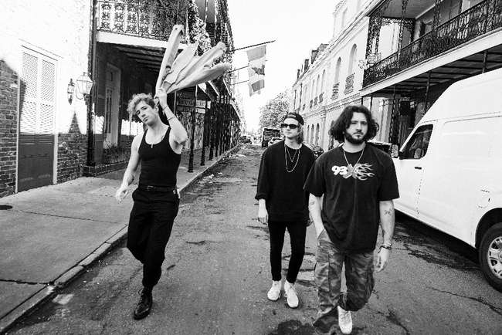
PHOTO CREDIT: JIMMY FONTAINE | HI-RES AVAILABLE HERE
PRESS ASSETS AVAILABLE HERE

(April 13, 2022) – LOS ANGELES, CA – Nashville pop-rock three piece The Band CAMINO have released the official music video to standout track “I Think I Like You,” which appeared on their acclaimed self-titled debut album (Sept. 2021 via dblblk/Elektra Records). The hilarious new visual, directed by Patrick Tracy (Dan + Shay, Halsey), showcases the group on-set at a classic 70s late-night TV show, dubbed the Later Than Late Show. Spencer Stewart (guitar/vocals) stars as the late-night host, while Jeffery Jordan (guitar/vocals) and Garrison Burgess (drums) play the featured guests. Check it out HERE.
In celebration of their debut LP, The Band CAMINO is currently on the first leg of their massive North American headline tour, dubbed THE TOUR CAMINO. The in-demand run of dates hits The Factory in Dallas tomorrow evening and concludes with a sold out show at Philadelphia’s Franklin Music Hall on Saturday, April 30. Labelmates flor and Hastings are providing support on all dates. Nearly every show on leg one is entirely sold out, and due to popular demand, The Band CAMINO announced a second leg of tour dates, which commences on Thursday, June 2 at Cain’s Ballroom in Tulsa and runs through the end of the month. renforshort and Games We Play will serve as the opening acts on all shows. The group will also perform at Hangout Music Festival on Saturday, May 21. The full routing is below, and all tickets are available on The Band CAMINO’s official website.
The Band CAMINO have undoubtedly cemented their status as one of the most exciting rising acts in music, with their live shows underscoring this point. With countless sold out headline concerts and festival appearances under their belt – not to mention an opening slot for Grammy Award® winning country duo Dan + Shay – the band’s live delivery is a must-see. QRO Magazine commented about the tour kickoff in Louisville, “You could feel the excitement in the room… It is very obvious how much The Band CAMINO cares about their fans and how special of a community they have created with their music.” Choose901 also had the chance to check out their Memphis hometown show at The Orpheum Theatre in February, which they called “intimate and exhilarating while clearly displaying the energy and passion they bring to their music.” The outlet also declared, “The Band CAMINO sounds identical, if not better, on stage than they do on their recorded tracks,” and hailed them “increasingly impressive.”

THE TOUR CAMINO LEG 1
March 23 - Louisville, KY @ Paristown SOLD OUT
March 24 - Indianapolis, IN @ Egyptian Room SOLD OUT
March 25 - Chicago, IL @ Riviera Theater SOLD OUT
March 26 - Minneapolis, MN @ The Fillmore SOLD OUT
March 29 - Salt Lake City, UT @ The Complex SOLD OUT
March 31 - Portland, OR @ Roseland Theatre SOLD OUT
April 1 - Seattle, WA @ Showbox Sodo SOLD OUT
April 3 - Vancouver, BC @ Commodore Ballroom SOLD OUT
April 5 - San Francisco, CA @ Regency Ballroom SOLD OUT
April 6 - Santa Cruz, CA @ Catalyst SOLD OUT
April 8 - Los Angeles, CA @ The Novo SOLD OUT
April 9 - Santa Ana, CA @ The Observatory SOLD OUT
April 12 - Houston, TX @ Warehouse Live LOW TICKET WARNING
April 14 - Dallas, TX @ The Factory in Deep Ellum LOW TICKET WARNING
April 15 - Austin, TX @ ACL Live at Moody Theatre SOLD OUT
April 17 - Birmingham, AL @ Avondale Brewing Co SOLD OUT
April 19 - Orlando, FL @ The Plaza Live SOLD OUT
April 21 - Charlotte, NC @ The Fillmore SOLD OUT
April 22 - Raleigh, NC @ The Ritz SOLD OUT
April 23 - Atlanta, GA @ The Eastern SOLD OUT
April 24 - Atlanta, GA @ The Eastern LOW TICKET WARNING
April 26 - Silver Spring, MD @ The Fillmore SOLD OUT
April 27 - New York, NY @ Terminal 5 SOLD OUT
April 29 - Boston, MA @ House of Blues SOLD OUT
April 30 - Philadelphia, PA @ Franklin Music Hall SOLD OUT
*with flor & Hastings

May 21 - Gulf Shores, AL @ Hangout Music Festival
May 30 - Tempe, AZ @ Marquee Theatre (rescheduled)
THE TOUR CAMINO LEG 2
June 2 - Tulsa, OK @ Cains Ballroom
June 3 - Fayetteville, AL @ JJ's Live
June 4 - Kansas City, MO @ The Truman
June 5 - Omaha, NE @ The Admiral
June 7 - Chesterfield, MO @ The Factory
June 8 - Newport, KY @ PromoWest Pavilion at OVATION
June 10 - Royal Oak, MI @ Royal Oak Music Hall
June 11 - Buffalo, NY @ Town Ballroom
June 12 - Toronto, ON @ Danforth Music Hall
June 14 - Portland, ME @ State Theatre
June 16 - Wallingford, CT @ The Dome at Toyota Presents Oakdale
June 17 - Sayreville, NJ @ Starland Ballroom
June 18 - Richmond , VA @ The National
June 19 - Norfolk, VA @ Norva Theater
June 21 - Cleveland , OH @ Agora Ballroom
June 23 - Columbus , OH @ KEMBA! Live - Indoor Music Hall
June 24 - Pittsburgh, PA @ Stage AE
*with renforshort & Games We Play

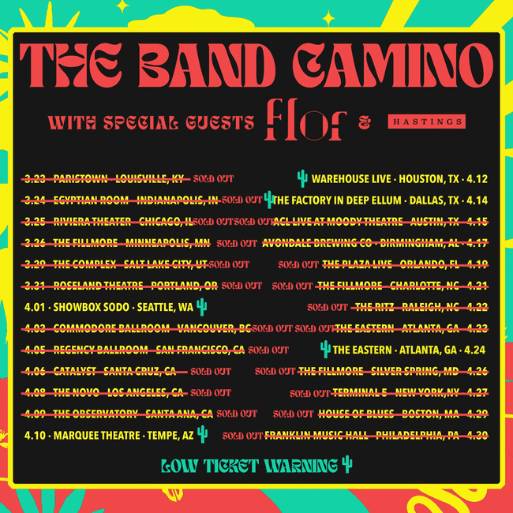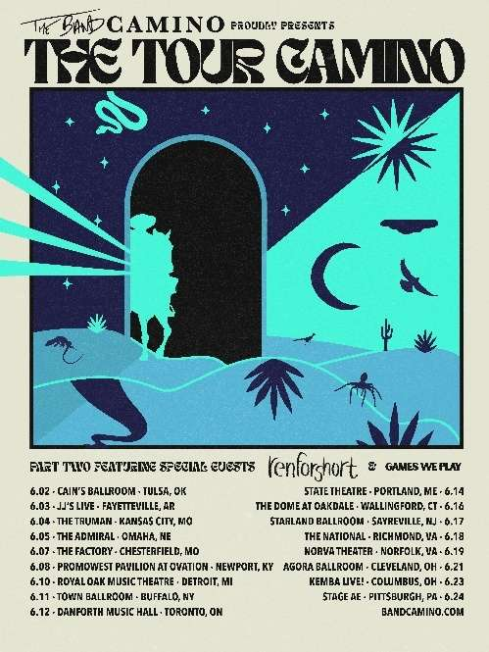

ABOUT THE BAND CAMINO:
With early supporters including Rolling Stone, Billboard (Dubbed “Rock’s Next Big Thing”), People’s “Ones To Watch in 2021,” The Associated Press, LADYGUNN, Paste, Consequence of Sound, American Songwriter, LA Weekly, and more, the band has blazed a permanent trail for themselves in music, garnering 2.5 million monthly Spotify listeners and more than 330 million global streams to date. In addition to selling out multiple headline tours and hitting the major festival circuit with performances in top festivals including Lollapalooza, Forecastle, and Austin City Limits, where they were named a “breakout act” by Grammy.com, the band developed a highly engaged worldwide fanbase. Their growth has been largely stimulated by raw discovery, even catching the attention of Taylor Swift, who included the band’s reflective track “Berenstein” on her “Songs I’m Loving Right Now” playlist in 2018. Their self-titled debut album released in September 2021 showcases the pop-rock trio’s electrifying guitar-driven sound, first introduced on their anthemic EP tryhard in 2019, which spawned fan favorites “Daphne Blue” and “See Through.” Since relocating from Memphis to Nashville in 2018, the band (singers/guitarists Jeffery Jordan and Spencer Stewart, and drummer Garrison Burgess) has been honing their signature ‘Band Camino’ sound, carving a name for themselves at the crossroads of pop and rock music. They made their national television debut performing “1 Last Cigarette” on Jimmy Kimmel Live! and “Underneath My Skin” on The Kelly Clarkson Show.
CRITICAL ACCLAIM FOR THE BAND CAMINO:
“There is so much in store for this rising rock band” – PEOPLE

“…there’s a magnetism to their performance. The Band CAMINO’s confidence evokes a veteran posture that preceded their self-titled debut album” – AMERICAN SONGWRITER

“The highly-anticipated album combines '80s synths, punchy hooks, and vibrant anthems that are guaranteed to vibrate across the crowd during live shows.”
– ONES TO WATCH

“…it’s clear that The Band CAMINO’s self-titled debut album will solidify them as music’s next big thing.” – 1883 MAGAZINE

“…a bright, bold and ​​boisterous debut.” – ALTERNATIVE PRESS

“The Band CAMINO is riding a hot streak…[the album is] a project that finds the band in an upbeat mood, and it's an infectious energy that pervades every track”
– BANDSINTOWN

FOLLOW THE BAND CAMINO
Website | Instagram | Twitter | YouTube

# # #

THE BAND CAMINO MEDIA CONTACTS:
Glenn Fukushima
GlennFukushima@Elektra.com

Ross Anderson
RossAnderson@Elektra.com

Nathalie Rubin
NathalieRubin@Elektra.com

Sydney Worden
SydneyWorden@Elektra.com

