POP-ROCK TRIO THE BAND CAMINO RELEASES HIGHLY ANTICIPATED SELF-TITLED DEBUT ALBUM TODAY VIA DBLBLK/ELEKTRA RECORDS

“THE BAND CAMINO SEIZES 2021 AS THE YEAR THEY BREAK OUT BIG.” - THE ASSOCIATED PRESS

“AS THE ROCK BAND OF THE POP GENERATION, THERE’S A MAGNETISM TO THEIR PERFORMANCE.” - AMERICAN SONGWRITER

THE BAND IS CURRENTLY ON THE ROAD FOR DAN + SHAY’S “THE (ARENA) TOUR”
WHICH KICKED OFF LAST NIGHT IN SOUTH CAROLINA
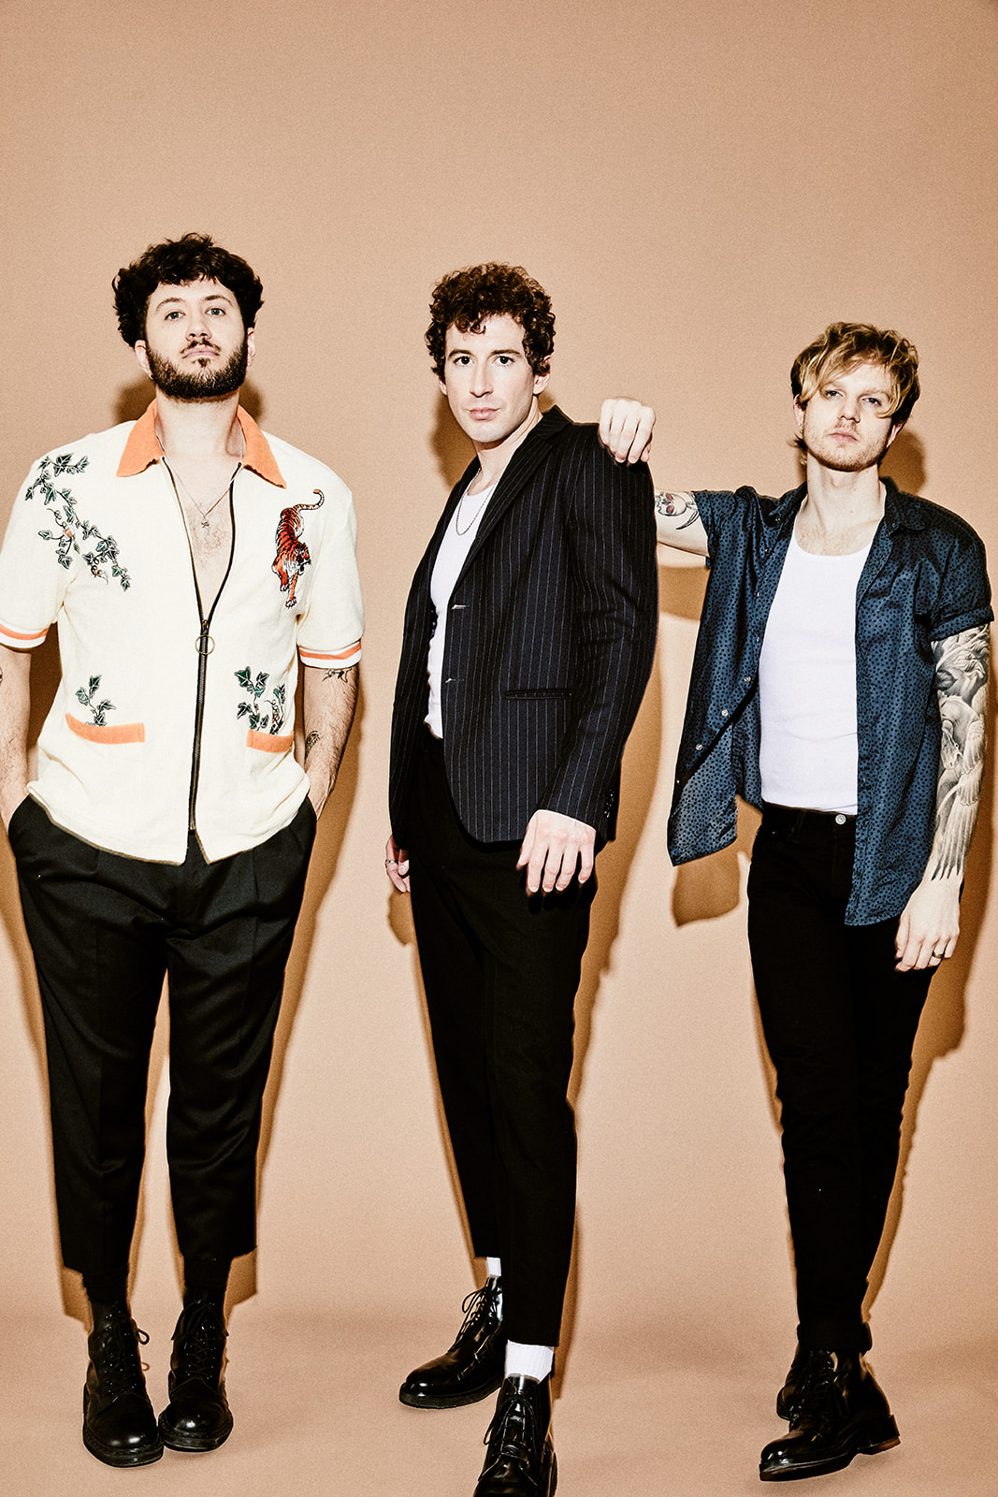
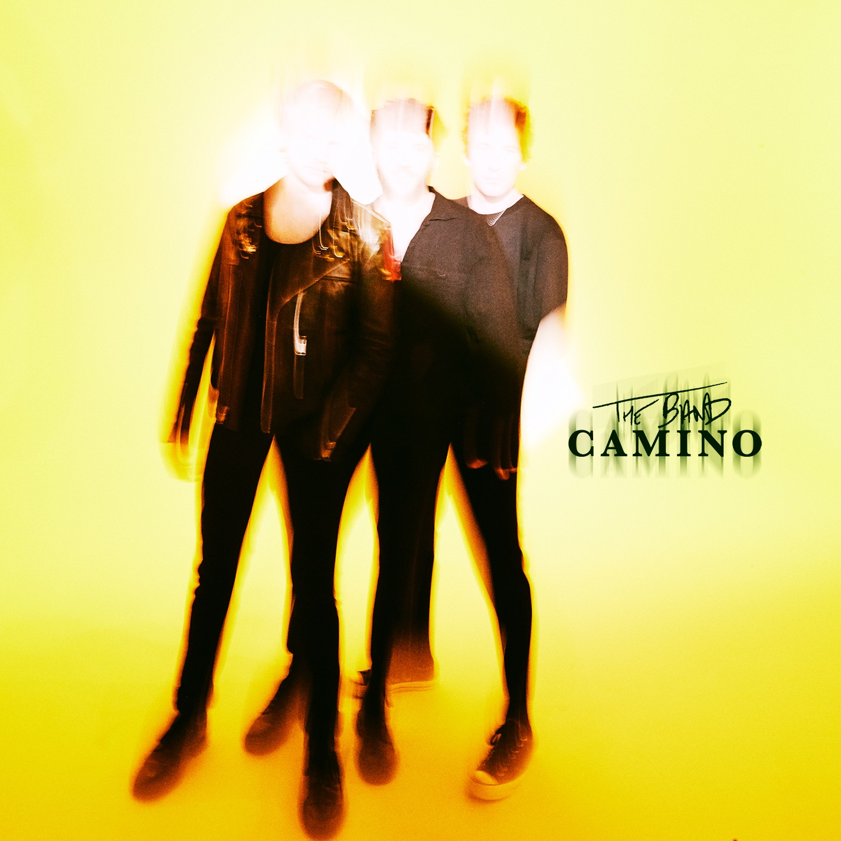
Photo credit: Jimmy Fontaine

LOS ANGELES (September 10, 2021)— The Band Camino drops their much anticipated self-titled debut album today via dblblk/Elektra Records. The long-awaited album showcases the pop-rock trio’s electrifying guitar-driven sound, first introduced on their anthemic EP tryhard in 2019, which spawned fan favorites “Daphne Blue” and “See Through.” Since relocating from Memphis to Nashville in 2018, the band (singers/guitarists Jeffery Jordan and Spencer Stewart, and drummer Garrison Burgess) has been honing their signature ‘Band Camino’ sound, carving a name for themselves at the crossroads of pop and rock music. With irrefutable musical chemistry, captivating lyricism, and a resounding authenticity, the trio comes together on The Band Camino in a way that’s sonically larger than life. The band is currently on the road with country duo Dan + Shay for their 2021 U.S. tour which began yesterday and goes through December 7, hitting Madison Square Garden in NYC, New York on September 16, and STAPLES Center in Los Angeles, California on October 15. Stream The Band Camino - available on all platforms now.

The Band Camino is a 14-track showcase of the group’s multifaceted soundscape that features ‘80s synths in punchy tracks such as “I Think I Like You”; fiery anthems like “Know It All” and “1 Last Cigarette”; heartfelt moments as heard in the introspective “Who Do You Think You Are?”; plus melodic tales of dysfunctional love like “Underneath My Skin." Amongst the guitar-led arena-ready tracks are a number of deeper, emotionally-driven ballads including the goosebump-inducing “Help Me Get Over You” and the acoustic confessional “Sorry Mom.” The album spotlights the band’s ability to juxtapose melancholy lyrics with intoxicating melodies on the kickoff track “EVERYBODYDIES,” and then further amplifies the band’s “don’t take life for granted” sentiment on “Roses” and “Look Up.”

Recorded over a month-long stay at the iconic Sonic Ranch in Tortillo, Texas, where they, as Jeffery puts it, “rode this wave of creativity” alongside producer Jordan Schmidt and executive producer Jameson Roper last fall, the trio was armed with the idea of removing themselves from the rest of the world to focus solely on the music. The Band Camino was cut much like an old school record, playing through each song and recording as they went. Their mentality was to focus on one song each day and then revisit them, allowing time away for fresh perspective and new ears. What transpired was their debut full-length album -- a record which leans into the band’s love for live instrumentation and passion for storytelling through pop music.

The Band Camino has been making a major impact since their start, garnering 2.6 million monthly Spotify listeners and more than 330 million global streams to date. In addition to selling out multiple headline tours and hitting the major festival circuit with performances in top festivals including Lollapolooza, Forecastle, and Austin City Limits, where they were named a “breakout act” by Grammy.com, the band developed a highly engaged worldwide fanbase. Their growth has been largely stimulated by raw discovery, even catching the attention of Taylor Swift, who included the band’s reflective track “Berenstein”on her “Songs I’m Loving Right Now” playlist in 2018.

They recently made their national television debut performing “1 Last Cigarette” on Jimmy Kimmel Live. With early supporters including Rolling Stone, Billboard (Dubbed “Rock’s Next Big Thing”), People’s “Ones To Watch in 2021,” The Associated Press, LADYGUNN, Paste, Consequence of Sound, American Songwriter, LA Weekly, and more, the band has blazed a permanent trail for themselves in music and they are just getting started.

Full ‘The Band Camino’ Tracklist:

- EVERYBODYDIES
- Roses
- Underneath My Skin
- I Think I Like You
- Know It All
- Who Do You Think You Are?
- Sorry Mom
- Just A Phase
- 1 Last Cigarette
- Song About You
- Damage
- Look Up
- Help Me Get Over You
- Get It Your Way

The Band Camino supports Dan + Shay's 2021 “The (Arena) Tour” for their 33-date U.S. tour (dates/venues below). Tickets available HERE.

September 10 | Charlottesville, VA | John Paul Jones Arena
September 11 | Uncasville, CT | Mohegan Sun Arena
September 14 | Philadelphia, PA | Wells Fargo Center
September 16 | New York, NY | Madison Square Garden
September 17 | Pittsburgh, PA | PPG Paints Arena
September 18 | Greensboro, NC | Greensboro Coliseum
September 23 | Louisville, KY | KFC Yum! Center
September 24 | Milwaukee, WI | Fiserv Forum
September 25 | Minneapolis, MN | Target Center
October 1 | Indianapolis, IN | Bankers Life Fieldhouse
October 2 | Chicago, IL | United Center
October 3 | Grand Rapids, MI | Van Andel Arena
October 15 | Los Angeles, CA | STAPLES Center
October 16 | San Diego, CA | Pechanga Arena
October 17 | Glendale, AZ | Gila River Arena
October 20 | San Francisco, CA | Chase Center
October 21 | Sacramento, CA | Golden 1 Center
October 23 | Salt Lake City, UT | Vivint Arena
October 24 | Denver, CO | Ball Arena
October 28 | Portland, OR | Moda Center
October 29 | Tacoma, WA | Tacoma Dome
November 4 | Orlando, FL | Amway Center
November 5 | Atlanta, GA | State Farm Arena
November 12 | Omaha, NE | CHI Health Center
November 13 | Tulsa, OK | BOK Center
November 14 | Kansas City, MO | T-Mobile Center
November 20 | New Orleans, LA | Smoothie King Center
November 21 | Dallas, TX | American Airlines Center
December 3 | Detroit, MI | Little Caesars Arena
December 4 | Hershey, PA | Giant Center
December 5 | Newark, NJ | Prudential Center
December 7 | Boston, MA | TD Garden

For more information on The Band Camino please visit: Instagram | Twitter | YouTube

###

