SAD NIGHT DYNAMITE SHARES NEW SONG & VIDEO

WATCH "KILLSHOT" NOW
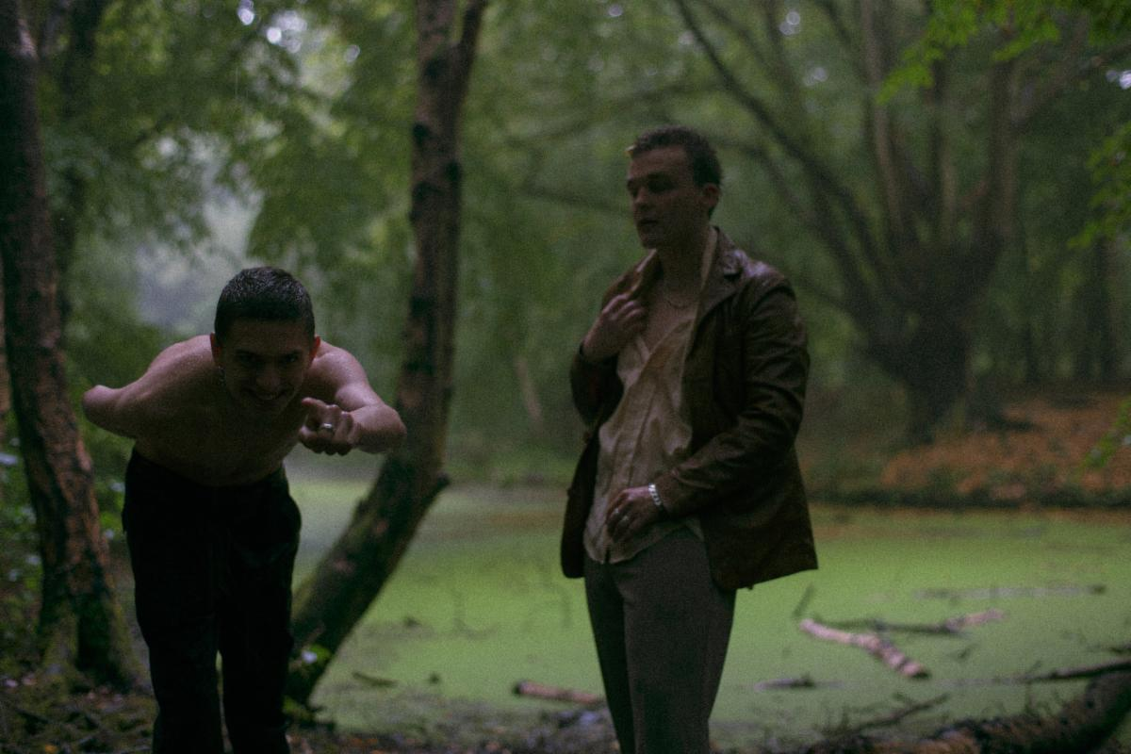

“Killshot"
WATCH: https://youtu.be/EwtTUYnfZkY
LISTEN: https://sadnightdynamite.lnk.to/killshot

What the press is saying about Sad Night Dynamite:

"Points to a career that should be long, fruitful and full of game-changing experimentation"
Complex

"a knack for experimentation and a unique set of skills"
Hypebeast

"A creeping sense of foreboding and unease...it's difficult to pigeonhole their sound, but that's what makes them so exciting"
District

Today, UK-based duo Sad Night Dynamite share the new song and video "Killshot," out now via Elektra Records. The track arrives with a visual counterpart as visceral as the song itself. Directed by Samuel Davis, the video montages together security-style footage that evokes the all-to-real reality of the surveillance state we all live in. The song is the second offering from the duo's forthcoming debut mixtape following "Icy Violence" and arrives after the enigmatic electronic duo introduced themselves with the experimental EP, SND001 (and a surreal short film shot in the Czech countryside).

Barely in their twenties, Sad Night Dynamite draw together a complex mix of sounds and storytelling. In tracks like "Icy Violence" you're as likely to hear a lifelong love of hip-hop meld with classic British bands like The Specials as you are a pair just as enamored by fellow-crate-diggers like The Avalanches as they are the classic cinema scores of Tarantino. All of this comes back to the charged, brother-like friendship of Archie and Josh at the centre of it all: a duo whose formative (and slightly feral) school years eventually saw them start out Sad Night Dynamite online, separated at university. Theirs is a world that's equal parts disruption, disillusionment, and dark humour - what matters for Sad Night Dynamite is that there is, ultimately, still a wonderland to get lost in ("we love artists who build something bigger than themselves: songs to explore and be lived in").

Watch and listen to "Killshot" above and stay tuned for more new music from Sad Night Dynamite coming soon.
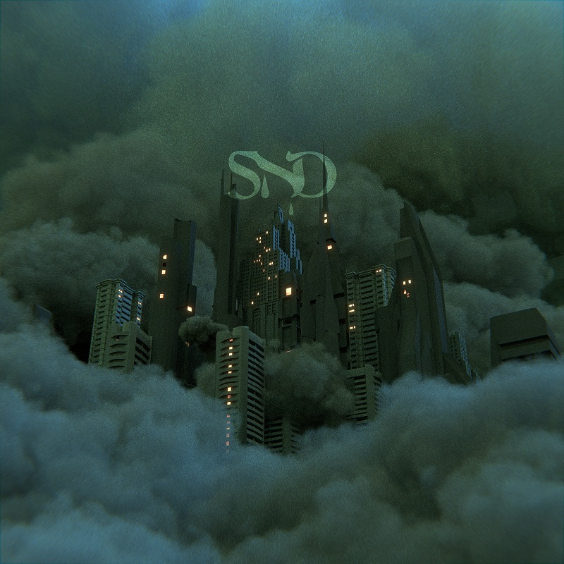

About Elektra Music Group:
Elektra Music Group was launched in 2018 as a stand-alone music company within Warner Music Group. Its roots extend back to 1950, when Jac Holzman launched the iconic Elektra label in his college dorm room. Today, that same entrepreneurial, independent spirit is the driving force behind each of the unique labels that make up the core of the Elektra Music Group: Elektra, Fueled By Ramen, and Roadrunner. The company's adventurous, eclectic roster includes culture-defining artists such as Brandi Carlile, Coheed and Cambria, Fitz and the Tantrums, Gojira, Kaleo, Korn, Panic! At The Disco, Paramore, Slipknot, Sturgill Simpson, Tones and I, Twenty One Pilots, and others.

For Sad Night Dynamite inquires contact Duncan Will at Orienteer -
duncan@orienteer.us

--
Duncan Will
Orienteer
Los Angeles | New York

