BREAKOUT ARTIST RACHEL CHINOURIRI RELEASES STUNNING NEW EP, BETTER OFF WITHOUT
LISTEN HERE

WATCH THE OFFICIAL MUSIC VIDEO FOR STANDOUT TRACK “HAPPY ENDING” HERE

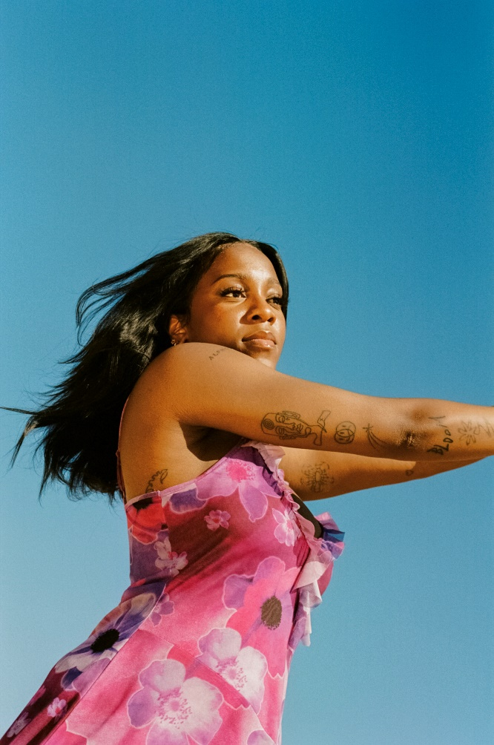
(Photo Credit: Martina Martian)
Download Press Assets HERE

“…one of the warmest, fully enveloping pop introductions in recent memory”
– BILLBOARD
“If the airiness and shimmer of SZA were to meet the grounded grit of Maggie Rogers, it would perhaps sound like Rachel Chinouriri’s latest. ‘All I Ever Asked’ is an easygoing, bright indie-pop offering”
– CONSEQUENCE OF SOUND
“...sounds beautiful and unbelievable” – NYLON

“[‘All I Ever Asked’] is catchy because of its coolness. It chirps and flows in a nonchalant manner, adorned with a swaying beat that sounds perfect underneath Chinouriri’s soaring soprano.” – UPROXX

“The way she sings of emotions, surrounded by shivers of synths and protected by percussion, it’s as if she’s trying to maintain the structures of dried flowers—as they wither with time, her delivery is undoubtedly more precious and precise.” – FLOOD

(May 20, 2022) – LOS ANGELES, CA – London-based alternative indie-pop artist Rachel Chinouriri has released her new EP Better Off Without via Elektra Records, available now on all streaming platforms. Better Off Without features the stunning lead single “All I Ever Asked” along with three brand new tracks, including the instantly-captivating “Happy Ending,” which takes a bittersweet look back at the end of a relationship; the upbeat chorus painting sadness as something more wistful, taking one last look back before stepping into the future. The official music video for “Happy Ending” can also be viewed HERE.

Better Off Without was written at the recent end of Chinouriri’s five-year relationship with her first boyfriend, and the songs came together as a way to reflect, balancing the highs and lows of her new outlook. She explained, “When you’re together five years, you almost think you’re going to get married at some point. People would make jokes; ‘never break up, or she'll write about you.’ I didn’t think I would, but nope — it’s literally all about him, breaking up and realizing that you can be more positive by yourself.”

Chinouriri’s new project is a story of heartbreak, but also of acceptance, knowing exactly who you are and what you want. “Over the four or five years I've been in the industry, I've definitely wandered away from my indie roots, trying to fit in or be cooler or more experimental,” Chinouriri said. “But then I was just kind of like, indie is what I love. Why don't I just go back?” With Better Off Without, Chinouriri continues to establish herself as an artist firmly grounded in the world of indie-pop after continually pushing against being mis-genred as a soul / R&B artist. With this new offering, she hopes that people will listen before they look, putting aside any preconceptions of what a Black artist “should” be.

Chinouriri is currently touring the U.K. on a run of headline shows, which has seen her stop at The Great Escape Festival and on Monday night, will bring the show to London’s EartH Theatre, followed by a string of support dates with Bloc Party, and festival shows this summer including support at Sam Fender’s Finsbury Park show. Chinouriri has previously supported the likes of Celeste, Lianne La Havas and Sam Fender.

The success of her critically lauded 2021 EP Four° In Winter marked out Chinouriri’s capabilities as a stylistic amalgamator, praised across the likes of BBC Radio 1, The Guardian, Dazed, NME, and theneedledrop’s Anthony Fantano, who named the EP his #1 project of 2021, but new project Better Off Without marks a return to her first genre love, balancing the sadness of heartbreak with summery choruses of hope.

RACHEL CHINOURIRI
BETTER OFF WITHOUT EP
AVAILABLE NOW

BETTER OFF WITHOUT TRACK LISTING:
1. All I Ever Asked
2. Happy Ending
3. Better Off Without
4. Fall Right Out Of Love

RACHEL CHINOURIRI ON TOUR:
May 22 – Leeds, U.K. @ Hyde Park Book Club
May 23 – London, U.K. @ EartH Theatre
June 3 – Glasgow, Scotland, U.K. @ Barrowlands *
June 4 – Leeds, U.K. @ O2 Academy *
June 5 – London, U.K. @ Cross The Tracks Festival
June 15 – London, U.K. @ Royal Festival Hall, Southbank Centre ^
June 30 – Gloucester, U.K. @ Barn On The Farm Festival
July 15 – London, U.K. @ Finsbury Park #
August 10 – Newquay, U.K. @ Boardmasters Festival

* - supporting Bloc Party
^ - with The Love Unlimited Synth Orchestra
# - supporting Sam Fender

FOLLOW RACHEL CHINOURIRI:
Instagram | Facebook | Twitter | TikTok | YouTube

# # #

MEDIA CONTACTS:
Nathalie Rubin & Sarah Goldstein
NathalieRubin@elektra.com | SarahGoldstein@elektra.com

