PRATEEK KUHAD ANNOUNCES SIGNING TO ELEKTRA RECORDS
RE-RELEASES BREAKTHROUGH EP cold / mess
WATCH “cold / mess” VIDEO HERE

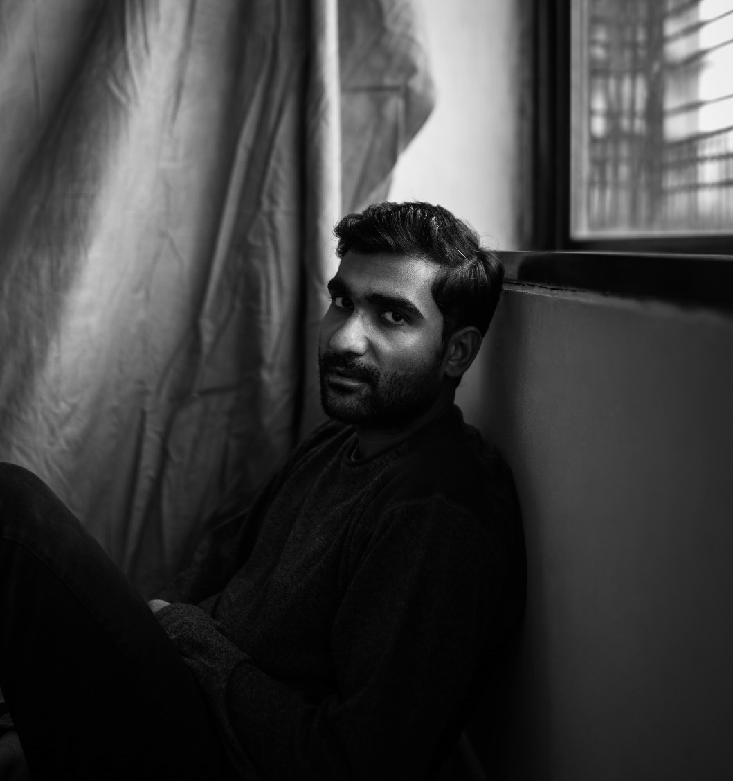
OCTOBER 7TH, 2020 – Critically acclaimed singer-songwriter Prateek Kuhad has announced his signing to Elektra Records. The news is heralded by the re-release of Kuhad’s 2018 breakthrough EP cold / mess, which is available now on all streaming platforms and is accompanied by a powerful visual for the EP’s title track.
Hailed by Rolling Stone India as “one of the country’s leading singer-songwriters,” Prateek Kuhad has taken the rest of the world by storm in recent years, writing and performing in both Hindi and English and garnering a slew of accolades and honors around the globe with his mesmerizing, cinematic songwriting. The singer-songwriter has been described as “Simon and Garfunkel by way of Damian Rice,” and has racked up critical praise from NPR, Vulture, Billboard, and former President Barack Obama, who featured “cold / mess” on his 2019 Songs of the Year playlist.
Growing up in the small city of Jaipur, India, Kuhad’s childhood listening diet consisted primarily of the Indian pop and Bollywood soundtracks that filled the local radio dial, as well as his parents’ CD collection, which contained only limited Western music. A move to New York City for college opened Prateek’s eyes to a new world of music, discovering Elliott Smith and inspiring him to seriously pursue his musical ambitions. While Kuhad has long been a household name in his native country (he became one of Spotify India’s most-streamed artists when the service launched there and the cold/mess EP debuted at #1), 2019 proved to be his breakout year in North America, with a star-making turn at SXSW and a cross-country headline run that culminated with three sold out shows in New York City.
Prateek’s debut album In Tokens and Charms was an instant hit – earning the artist an MTV Europe Music Award, Indie Album of the Year honors from iTunes, and the title of Best Pop Artist at the Radio City Freedom Awards. The album’s opening track, “Oh Love,” captured first place in the prestigious International Songwriting Competition, which previously helped launch artists like Gotye and Passenger to global audiences. Kuhad has sold out auditorium and amphitheater dates across India, landed arena support slots with the likes of Alt-J and Mike Posner, and traveled the world for headline and festival performances in the US, UK, Australia, Singapore, Canada, and France – wrapping 2019 with a 30 date tour across 8 countries and 3 continents and closing out the run with a 9000 capacity show in New Delhi.
(EP art + tracklisting below)

Prateek Kuhad
cold / mess EP
AVAILABLE NOW
Tracklisting:
- with you/for you
- did you/fall apart
- cold/mess
- for your time
- fighter
- 100 words
- cold/mess (edit)

CONNECT WITH PRATEEK KUHAD
www.prateekkuhad.com
YOUTUBE
INSTAGRAM
FACEBOOK
TWITTER

CONTACT:
Sarah Goldstein
SarahGoldstein@elektra.com
212-707-2146

