PRATEEK KUHAD DEBUTS “FAVORITE PEEPS” OFFICIAL VIDEO
WATCH HERE

NEW ALBUM THE WAY THAT LOVERS DO
ARRIVES MAY 20 VIA ELEKTRA RECORDS

NORTH AMERICAN HEADLINE TOUR DATES KICK OFF IN JUNE
NEW DATES ADDED DUE TO POPULAR DEMAND

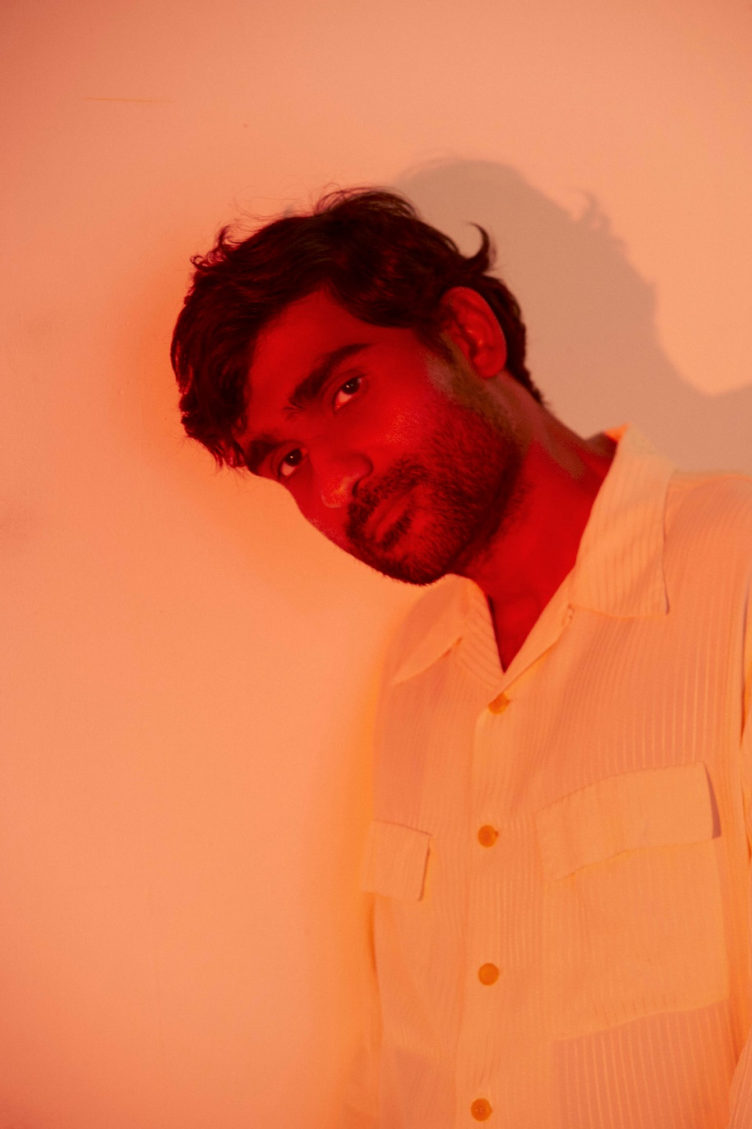
MAY 9, 2022 – Critically acclaimed singer-songwriter Prateek Kuhad has debuted the official music video for “Favorite Peeps,” which is streaming now on his official YouTube channel. The cinematic visual brings to life the story of the deceptively sweet single, depicting the artist’s struggle with anxiety and depression and showcasing how the strength of his relationships have helped carry him through the low points of life. The video was featured this morning on Consequence, who praised the “gentle and nostalgic” track.
Director Pranav Bhasin added, “The film depicts a slow ripening and maturity of our internal struggle. One that all of us go through. One that grows over weeks, is difficult to share, to shake off or escape. A friend being there for you, in silence, makes a difference. Prateek in fact turned out to be a brilliant actor to direct. He revisited memories that would authentically move him, just as he would have whilst building his song.”
The video follows the single’s April release and is the second offering from his upcoming album, The Way That Lovers Do, which is set for arrival on May 20th via Elektra Records. Recorded at Seattle’s secluded Bear Creek Studio with Ryan Hadlock (The Lumineers, Vance Joy), the album features 11 brand-new tracks about human love, friendship, and connectivity. The Way That Lovers Do is available for preorder now via Elektra Records.
In March, Kuhad shared intimate lead single “Just A Word,” which arrived alongside a whimsical music video directed by Alex DiMarco (Khalid, Lauv, Wiz Khalifa). In celebration of the record, Kuhad also announced “The Way That Lovers Do” tour, a North American headline run which kicks off June 2nd in Dallas, TX. The monthlong trek includes a performance at Lodge Room in Los Angeles on June 7th before wrapping up at New York City’s Irving Plaza on June 28th. Kuhad recently announced additional tour dates in San Francisco, Seattle, Toronto, and Boston due to overwhelming demand, which are on sale now. For up-to-date ticketing information, please visit www.prateekkuhad.com.
Last year, Kuhad shared the Shehron Ke Raaz EP – a four-track collection that included an acoustic version of his 2020 breakout hit “Kasoor,” and was heralded by singles “Tere Hi Hum” and the EP’s title track. Kuhad returned to his Indian roots on the project, recording in Bombay and singing in Hindi as he explored the intimate, often hidden worlds that lovers create for themselves. In 2020, the artist announced his signing to Elektra Records, making history as the first solo Indian act to join the storied label. The news was heralded by the re-release of his 2018 breakthrough EP cold / mess, lauded by Atwood Magazine an “an utterly breathtaking, expansive piece of indie folk mastery.” The collection has racked up critical praise from NPR, Vulture, Billboard, Uproxx, and former President Barack Obama, who featured “cold / mess” on his 2019 Songs of the Year playlist.
About Prateek Kuhad:
Hailed by Rolling Stone India as “one of the country’s leading singer-songwriters,” Prateek Kuhad has been quietly carving out a unique role for himself as a globally recognized pop musician from India for just over a decade. Originally from the northern city of Jaipur, Kuhad, who sings in Hindi and English, easily connects with fans of all ages and backgrounds.
Earning comparisons to indie balladeers like Sufjan Stevens and Jose Gonzalez, Kuhad has generated universal praise and accolades for his pop and folk-driven songs about love and desire in all its forms. His third studio album, The Way That Lovers Do, arrives May 20th via Elektra Records and features 11 brand-new tracks about human love, friendship, and connectivity. Recorded at Seattle’s secluded Bear Creek Studio with Ryan Hadlock (The Lumineers, Vance Joy), Kuhad for the first time was writing and recording away from the circle of musicians he was accustomed to being around during the recording process. Ultimately, the process forced him to adapt and learn to work with a fresh set of collaborators, freeing his mind and arriving at Kuhad’s most authentic album to date.
Prateek’s debut album In Tokens and Charms was an instant hit – earning the artist an MTV Europe Music Award, Indie Album of the Year honors from iTunes, and the title of Best Pop Artist at the Radio City Freedom Awards. The album’s opening track, “Oh Love,” captured first place in the prestigious International Songwriting Competition, which previously helped launch artists like Gotye and Passenger to global audiences. Kuhad has sold out auditorium and amphitheater dates across India, landed arena support slots with the likes of Alt-J and Mike Posner, and traveled the world for headline and festival performances in the US, UK, Australia, Singapore, Canada, and France.
(Tour itinerary/Album art/Tracklisting below)

PRATEEK KUHAD
2022 NORTH AMERICAN HEADLINE TOUR DATES
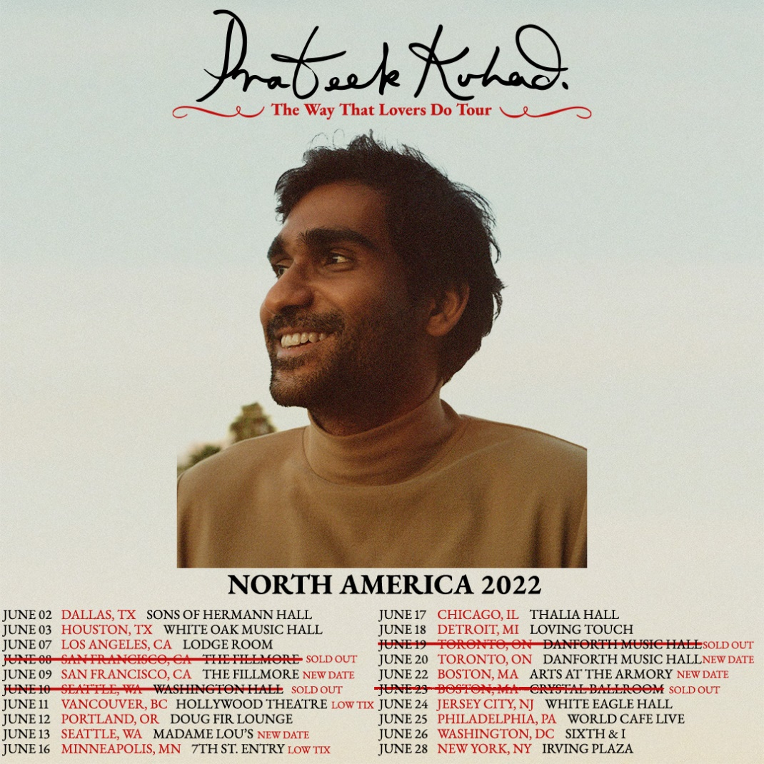
June 2 Dallas, TX Sons of Hermann Hall
June 3 Houston, TX White Oak Music Hall
June 7 Los Angeles, CA Lodge Room
June 8 San Francisco, CA The Fillmore SOLD OUT
June 9 San Francisco, CA The Fillmore
June 10 Seattle, WA Washington Hall SOLD OUT
June 11 Vancouver, BC Hollywood Theatre
June 12 Portland, OR Doug Fir Lounge
June 13 Seattle, WA Madame Lou’s
June 16 Minneapolis, MN 7th St. Entry
June 17 Chicago, IL Thalia Hall
June 18 Detroit, MI Loving Touch
June 19 Toronto, CAN Danforth Music Hall SOLD OUT
June 20 Toronto, CAN Danforth Musis Hall
June 22 Boston, MA Arts At The Armory
June 23 Boston, MA Crystal Ballroom SOLD OUT
June 24 Jersey City, NJ White Eagle Hall
June 25 Philadelphia, PA World Cafe Live
June 26 Washington, DC Sixth & I
June 28 New York, NY Irving Plaza

Prateek Kuhad
The Way That Lovers Do
Available May 20th
PREORDER NOW
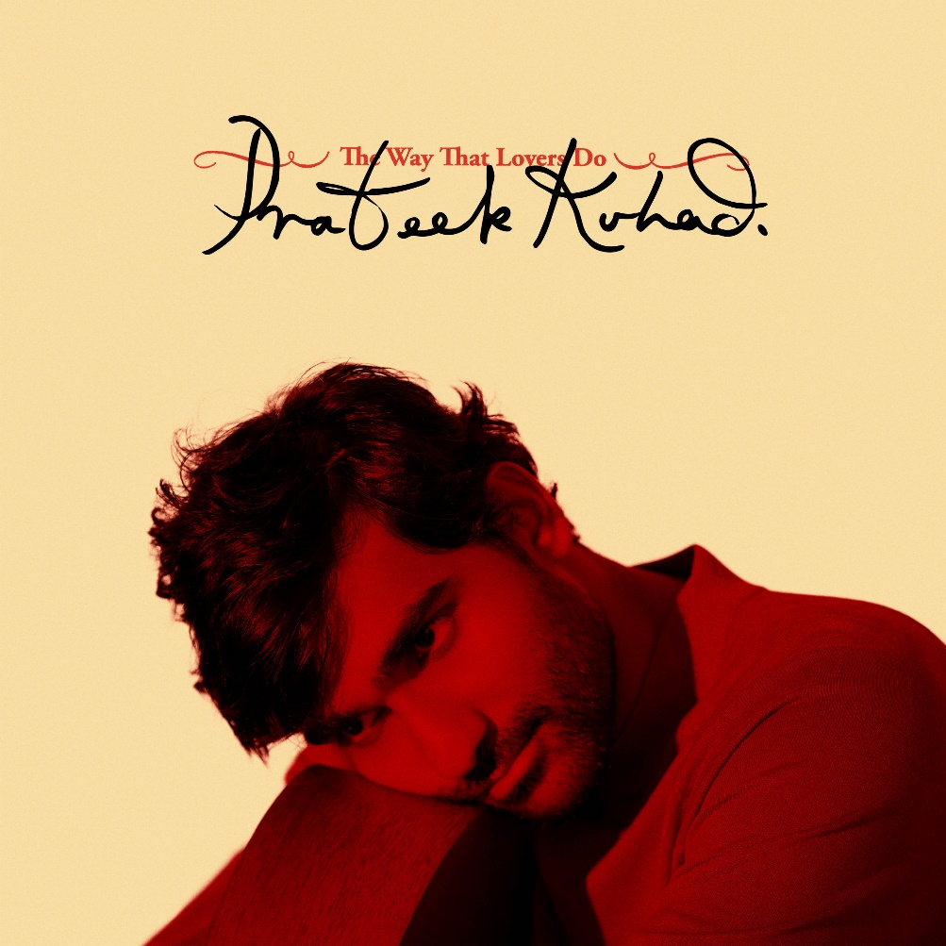

Tracklisting:
- All I Need
- Hollow
- Favorite Peeps
- Co2
- Face
- Just A Word
- Drown
- The Last Time
- Heartbroken
- Bloom
- Full Time Lover

CONNECT WITH PRATEEK KUHAD
www.prateekkuhad.com
YOUTUBE
INSTAGRAM
FACEBOOK
TWITTER

CONTACT:
Sarah Goldstein
SarahGoldstein@elektra.com
212-707-2146

