PmBata Returns with heartbreaking track
“i hate her boyfriend’s face”
LISTEN HERE
WATCH HERE
*most pre-saved song yet*
+initial TikTok teasers reached over 15 million views+
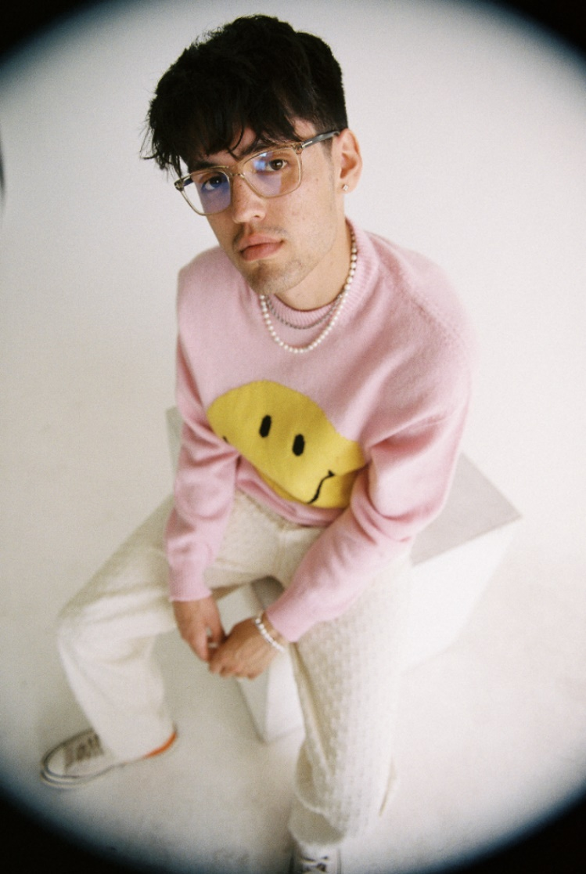
May 13, 2022 – Today, PmBata returns with the self-deprecating track/video “i hate her boyfriend’s face.” The track, which explores the darker side of love and self awareness, takes listeners on a journey through Parker Bata’s mind. “i hate her boyfriend’s face” reflects Parker’s heartbreaking realization that being dependent on someone else's love was compensation for the fact that he didn't love himself. Watch here.
Complete with a hypnotic visual, the budding sensation effectively merges genres and showcases a mesmerizing mix of spirited and fluid wordplay. The music video cinematically portrays Parker’s internal battle, juxtaposing heartfelt experiences with his girlfriend and a bloody boxing match with himself.
Amassing the most pre-saves of any track yet ahead of the release, PmBata created his own viral moment around the track via social media, with combined TikTok teasers reaching over 15 million views.
Between the acoustic guitar stylings and Parker’s crooning vocals, “i hate her boyfriend’s face” is an infectious track about unrequited love, in which the rejection is internal.
“‘i hate her boyfriend’s face’ is about coming to the realization i was dependent on someone else loving me to compensate for the fact that i didn’t love myself.” - Parker Bata
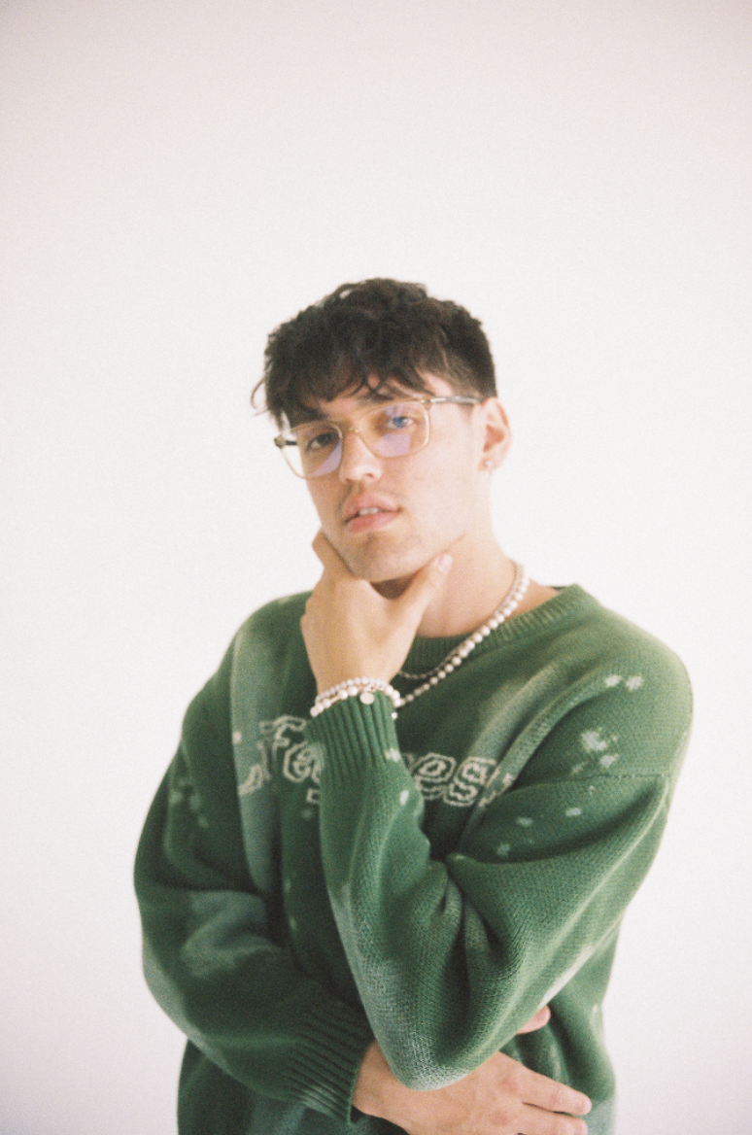
About PmBata
Parker Bata, better known as PmBata, is taking the world by storm with his dynamic flow, stunning fluidity and rhythmic sound. At only 21 years old, PmBata is making waves with his new age Hip Hop that melds old school with new school, defying musical genres and expectations - all while pursuing his college degree. The Kansas City, MO native is a self-taught vocalist and producer. PmBata credits his sonic influences to Mac Miller, Chance the Rapper, and Logic which aided him in crafting his own sound, which he describes as a combination of catchy melodies with hard hitting rhythms with pop and jazz influences.
PmBata recorded and produced many of his early singles and projects while in college at University of Central Missouri, where he is currently studying music tech. These projects include 808 Facades and The Museum. He has since released notable singles like “Nobody Came To My Party”, “Run It Up”, "Down For Real”, and fan favorite “Roadtrip.” Now, with over 150 million global streams, PmBata is ready to embark on the next phase of his musical journey. He has more music coming soon and he has no intention of slowing down.

