FOR IMMEDIATE RELEASE

JULY 22, 2022

**BENDIGO FLETCHER RETURN WITH NEW SINGLE “PTERODACTYL”**

**LISTEN** [**HERE**](https://bendigofletcher.lnk.to/pterodactyl) **| WATCH** [**HERE**](https://youtu.be/mZsX-0SW0VQ)

**PERFORMING AT NEWPORT FOLK FESTIVAL 2022 THIS SUNDAY**

**SUPPORTING MADISON CUNNINGHAM ON NORTH AMERICAN TOUR THIS FALL**

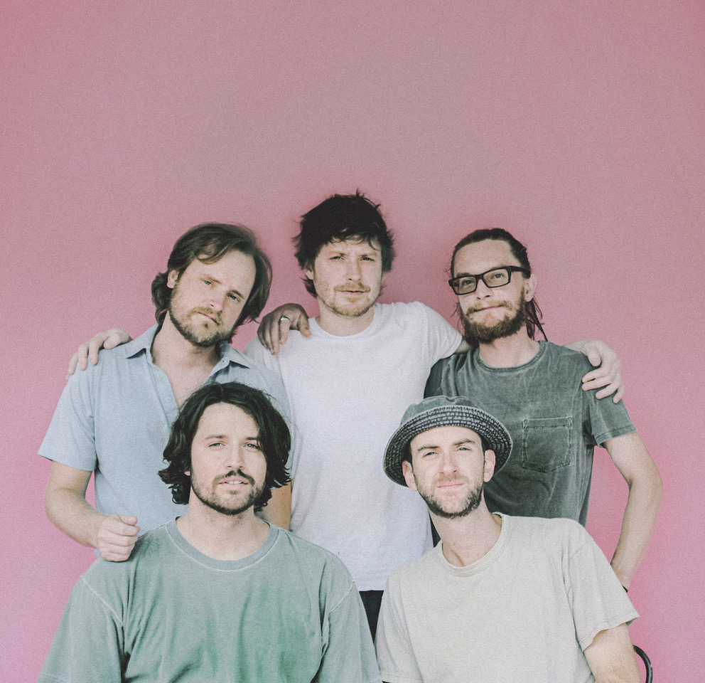

*Photo credit: Tess Fulkerson*

Ahead of their appearance at this weekend’s Newport Folk Festival, Louisville, KY’s **Bendigo Fletcher** have unveiled their brand new single **“**[**Pterodactyl**](https://bendigofletcher.lnk.to/pterodactyl)**”.** The song is available to stream and download beginning today via Elektra Records [HERE](https://bendigofletcher.lnk.to/pterodactyl). Watch a visualizer for the track on the band’s official YouTube channel [HERE](https://youtu.be/mZsX-0SW0VQ).

On “Pterodactyl”, the critically acclaimed quintet continue to perfect their warm patchwork of alternative, Americana, psychedelia, and soul. Working out of Nashville, TN’s Cartoon Moon Studios, the band reunited with producer and original **Wilco/Uncle Tupelo** drummer **Ken Coomer**. Meanwhile, they recruited **Grizzly Bear** bassist **Chris Taylor** to mix the track. Lyrically, “Pterodactyl” draws up a pensive and poetic rumination on the future of a budding romance and the ripple effect one love often invites.

About the song, frontman Ryan Anderson commented, *“‘Pterodactyl’ was a kind of self-soothing progression that gradually bloomed with instrumentation and textures in the studio. The repetitive rhythm feels like walking to the park in my neighborhood and just trying to feel peace. Ultimately, it’s a reflection on the inspiration I take from the feeling of togetherness in both my relationship and in humanity in general.”*

“Pterodactyl” marks Bendigo Fletcher’s first new music since the release of their 2021 debut album [*Fits Of Laughter*](https://bendigofletcher.lnk.to/fitsoflaughter). Highlighted by singles “[Sugar In The Creek](https://www.youtube.com/watch?v=kP9RJnmniDU)” and “[Evergreen](https://youtu.be/anSo2V8XADE)”, the eight-track collection is available [HERE](https://bendigofletcher.lnk.to/fitsoflaughter) via Elektra Records. Beyond amassing millions of streams, the album earned widespread critical acclaim. *FLOOD Magazine* hailed it as  *“Somewhere between the post-Woodstock folk scene of the ‘70s and that decade’s burgeoning hard rock movement*,*”* and *Music Connection* dubbed it, *“Alt-rock, country-flecked folk-rock soaked in LSD*.*” American Songwriter* noted it as *“Denser psych-rock with some remaining elements of Bendigo Fletcher’s drifting folk-Americana roots*”, and *Atwood Magazine* praised “*Fits Of Laughter soars with charming passion.”*

Renowned for their inimitable live performances, Bendigo Fletcher supported the release of *Fits Of Laughter* with extensive headline runs and tours supporting Anderson East, Rainbow Kitten Surprise, and Shakey Graves. This Sunday, Bendigo Fletcher will perform at Newport Folk Festival 2022. Shortly after, they will support Madison Cunningham on a coast-to-coast North American tour, beginning August 4 in Minneapolis, MN at Fine Line Music Café and visiting major markets across U.S. and Canada before concluding on October 22 in Washington, DC at Capital Turnaround. A complete list of upcoming tour dates can be found below. Tickets are available now [HERE](https://www.bendigofletcher.com/).

“Pterodactyl” sets the stage for more new music to come from Bendigo Fletcher later this year.

**BENDIGO FLETCHER**

**“PTERODACTYL”**

**AVAILABLE NOW** [**HERE**](https://bendigofletcher.lnk.to/pterodactyl)

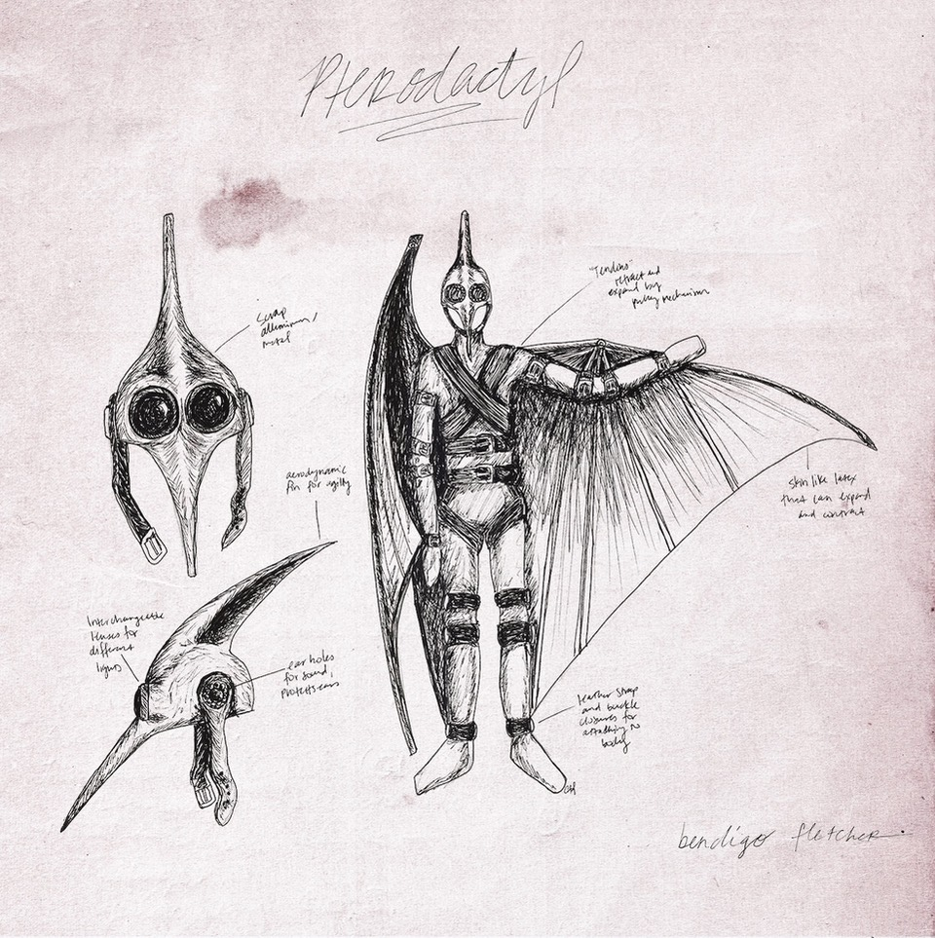

**Bendigo Fletcher Tour Dates**

**Festival Appearances**

July 24, 2022 - Newport, RI - Newport Folk Festival 2022

August 13, 2022 - Waterville, OH - Oliver Hazard Day 2022

September 3, 2022 - Huntington, WV - Huntington Music and Arts 2022

**Supporting Madison Cunningham**

August 4,2022 - Minneapolis, MN -Fine Line Music Café

August 6, 2022 - Madison, WI - Majestic Theatre

September 20, 2022 - Chicago, IL - Thalia Hall

September 21, 2022 - Kansas City, MO - Recordbar

September 23, 2022 - Boulder, CO - Fox Theatre

September 24, 2022 - Salt Lake City, UT - The Urban Lounge

September 26, 2022 - Seattle, WA - The Crocodile

September 27, 2022 - Vancouver, Canada - Biltmore Cabaret

September 28, 2022 - Portland, OR - Wonder Ballroom

September 30, 2022 - San Francisco, CA - August Hall

October 1, 2022 - Los Angeles, CA - Regent Theater DTLA

October 3, 2022 - Tucson, AZ - Club Congress

October 4, 2022 - Santa Fe, NM - Tumbleroot Brewery and Distillery

October 6, 2022 - Oklahoma City, OK - Beer City Music Hall

October 7, 2022 - Dallas, TX - Deep Ellum Art Company

October 8, 2022 - Fayetteville, AR - George’s Majestic Lounge

October 9, 2022 - Houston, TX - White Oak Music Hall

October 12, 2022 - Knoxville, TN - Bijou Theatre

October 13, 2022 - Atlanta, GA - Terminal West

October 15, 2022 - Nashville, TN - Brooklyn Bowl Nashville

October 17, 2022 - Saxapahaw, NC - Haw River Ballroom

October 18, 2022 - Charlottesville, VA - Jefferson Theater

October 20, 2022 - Cambridge, MA - The Sinclair

October 21, 2022 - New York, NY - Webster Hall

October 22, 2022 - Washington, DC - Capital Turnaround

Bendigo Fletcher is: Ryan Anderson (lead vocals, guitar, banjo) - Andrew Shupert (backing vocals, lead guitar) - Evan Wagner (backing vocals, keys, guitar, auxiliary percussion) - Conner Powell (bass) - Chris Weis (drums).

[BendigoFletcher.com](https://nam04.safelinks.protection.outlook.com/?url=http%25253A%25252F%25252Fbendigofletcher.com%25252F&data=04%25257C01%25257CSydneyWorden%252540elektra.com%25257C496651e9ae1c4829030008d95e5ab6bc%25257C8367939002ec4ba1ad3d69da3fdd637e%25257C0%25257C0%25257C637644565979480132%25257CUnknown%25257CTWFpbGZsb3d8eyJWIjoiMC4wLjAwMDAiLCJQIjoiV2luMzIiLCJBTiI6Ik1haWwiLCJXVCI6Mn0%25253D%25257C1000&sdata=DwnjXSoisNE7dEIwJsn0Ol9pXmx3ckFc4n%25252BMPRTyboc%25253D&reserved=0)

[Facebook](https://nam04.safelinks.protection.outlook.com/?url=https%25253A%25252F%25252Fwww.facebook.com%25252Fbendigofletcher%25252F&data=04%25257C01%25257CSydneyWorden%252540elektra.com%25257C496651e9ae1c4829030008d95e5ab6bc%25257C8367939002ec4ba1ad3d69da3fdd637e%25257C0%25257C0%25257C637644565979490127%25257CUnknown%25257CTWFpbGZsb3d8eyJWIjoiMC4wLjAwMDAiLCJQIjoiV2luMzIiLCJBTiI6Ik1haWwiLCJXVCI6Mn0%25253D%25257C1000&sdata=NXO3zPwFKZPGOypH4vElUmn%25252BvEY4oQvxFgbugfmiZYo%25253D&reserved=0) | [Instagram](https://nam04.safelinks.protection.outlook.com/?url=https%25253A%25252F%25252Fwww.instagram.com%25252Fbendigofletcher%25252F%25253Fhl%25253Den&data=04%25257C01%25257CSydneyWorden%252540elektra.com%25257C496651e9ae1c4829030008d95e5ab6bc%25257C8367939002ec4ba1ad3d69da3fdd637e%25257C0%25257C0%25257C637644565979490127%25257CUnknown%25257CTWFpbGZsb3d8eyJWIjoiMC4wLjAwMDAiLCJQIjoiV2luMzIiLCJBTiI6Ik1haWwiLCJXVCI6Mn0%25253D%25257C1000&sdata=ZPbgTr7oOdLZKpc9nJeWq8%25252FlxhP7q8X%25252FdCkY%25252BY35bvQ%25253D&reserved=0) | [Twitter](https://nam04.safelinks.protection.outlook.com/?url=https%25253A%25252F%25252Ftwitter.com%25252Fbendigofletcher%25253Flang%25253Den&data=04%25257C01%25257CSydneyWorden%252540elektra.com%25257C496651e9ae1c4829030008d95e5ab6bc%25257C8367939002ec4ba1ad3d69da3fdd637e%25257C0%25257C0%25257C637644565979490127%25257CUnknown%25257CTWFpbGZsb3d8eyJWIjoiMC4wLjAwMDAiLCJQIjoiV2luMzIiLCJBTiI6Ik1haWwiLCJXVCI6Mn0%25253D%25257C1000&sdata=kJRRkKaOhgjDEezX5MFmnHCsNVdAnsYapraqslfWeZI%25253D&reserved=0) | [YouTube](https://nam04.safelinks.protection.outlook.com/?url=https%25253A%25252F%25252Fwww.youtube.com%25252Fchannel%25252FUCqWvWwv7K8kq3PZnygVG1BA&data=04%25257C01%25257CSydneyWorden%252540elektra.com%25257C496651e9ae1c4829030008d95e5ab6bc%25257C8367939002ec4ba1ad3d69da3fdd637e%25257C0%25257C0%25257C637644565979500120%25257CUnknown%25257CTWFpbGZsb3d8eyJWIjoiMC4wLjAwMDAiLCJQIjoiV2luMzIiLCJBTiI6Ik1haWwiLCJXVCI6Mn0%25253D%25257C1000&sdata=je%25252BQcsx%25252FcO5DWK8iMgiiY1CecLP7inplAOftW9IWaqo%25253D&reserved=0)

**Press contact:**

Collin Citron | [collin.citron@300elektra.com](mailto:collin.citron@300elektra.com)