FOR IMMEDIATE RELEASE
JANUARY 8, 2021

FITZ PERFORMS HIT SINGLE “HEAD UP HIGH”
ON “GOOD MORNING AMERICA” TO KICK OFF 2021

WATCH HERE

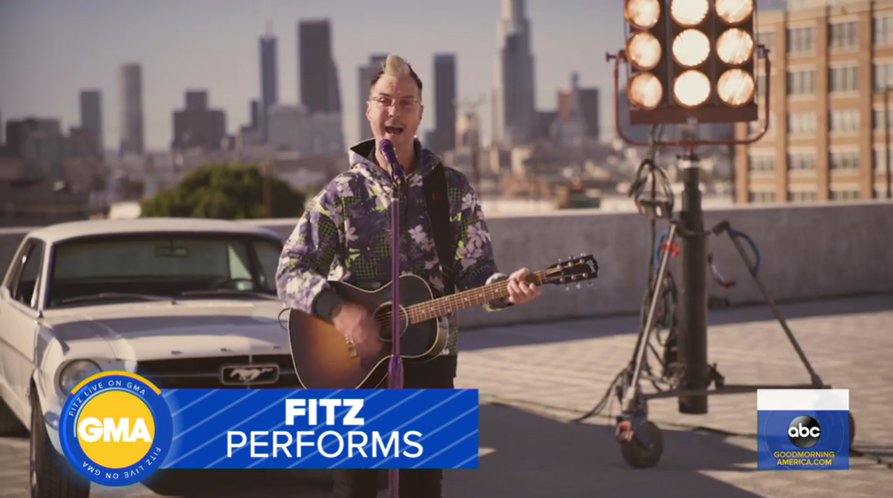

FRONTMAN & NAMESAKE OF MULTIPLATINUM GROUP
FITZ AND THE TANTRUMS SET TO RELEASE DEBUT SOLO FULL LENGTH IN MARCH

“HEAD UP HIGH” (JOHAN LENOX ARRANGEMENT) AVAILABLE TODAY
LISTEN HERE

PRESS ASSETS HERE

Elektra Recording artist FITZ – best known as founder and namesake of LA-based multiplatinum band Fitz and the Tantrums - performed his debut solo single “Head Up High” during a nationally televised appearance on ABC’S “Good Morning America” this morning. Watch HERE. The performance coincides with the arrival of an alternate version of the track, “Head Up High” (Johan Lenox Arrangement), which is available now on all streaming services. Listen HERE.

"Head Up High" - co-produced and co-written by FITZ with Ryan Daly – marked the first-ever solo music from the singer, songwriter, and multi-instrumentalist. Listen HERE. Arriving late last year alongside its dynamic official music video, the song is currently climbing the Top 25 of the Hot AC radio chart. To close out 2020, FITZ appeared on CBS’ “The Late Late Show with James Corden,” performing the hit single for the first time on national television. Written and recorded while quarantined during the current pandemic, “Head Up High” is the title track off of FITZ’s forthcoming debut solo full length, set to arrive in March. More details coming soon.

*****

Since 2008, FITZ a.k.a. Michael Fitzpatrick has galvanized and energized fans around the world as the frontman and namesake of Fitz and the Tantrums. Over the course of four albums, the band has cooked up a series of instantly recognizable and hummable anthems such as the platinum “The Walker,” platinum “Out of My League,” and double-platinum “HandClap.” Amassing billions of streams and attracting praise from People, Billboard, and many more, the group quietly morphed into an arena-ready force, headlining and packing historic venues such as The Forum in Los Angeles, Red Rocks Amphitheatre in Morrison, CO, and more. Not to mention, he lent his voice to collaborations with everyone from Weezer to LL Cool J. After twelve unbelievable years, FITZ did something he’s never done before. The singer, songwriter, and multi-instrumentalist electrified his very first solo music to life—at 50-years-young. On his debut single “Head Up High,” he introduces another side of himself and his artistry, reaching a new apex of his wonderfully unbelievable journey thus far. However, 50 is just the beginning for FITZ as he plans more music and surprises for 2020 and beyond.

# # #

PRESS CONTACT:

Glenn Fukushima (National)
818.238.6833
GlennFukushima@elektra.com

Collin Citron (National)
818.238.6314
CollinCitron@elektra.com

Sydney Worden (Tour/Online)
818.238.6834
SydneyWorden@elektra.com

