BRENDON URIE OF PANIC! AT THE DISCO HONORED BY CITY OF LAS VEGAS WITH THE KEY TO THE CITY

FOUR-TIME NOMINEE PANIC! AT THE DISCO TO PERFORM TWICE AT
THE 2019 BILLBOARD MUSIC AWARDS AIRING MAY 1ST AT 8PM ET/PT ON NBC

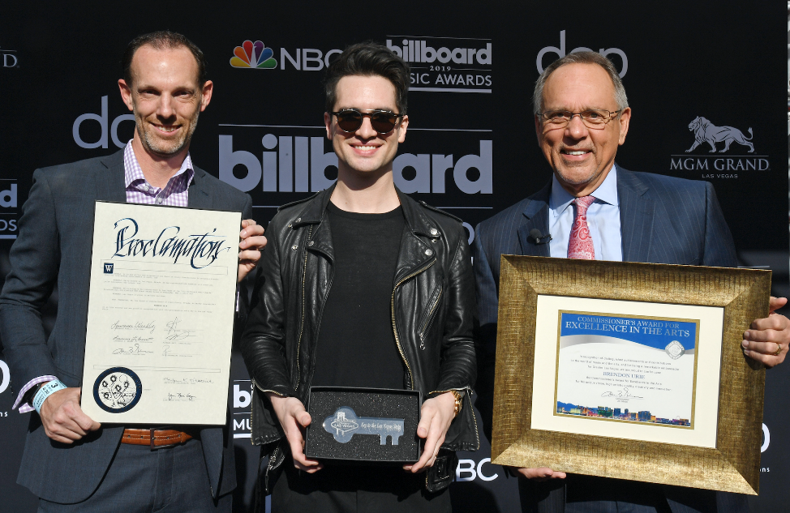

DOWNLOAD PHOTOS HERE - GETTY LINK HERE
Photo Credit: Ethan Miller / Getty Images for dick clark productions

LAS VEGAS, NV, APRIL 30 -- This morning, Las Vegas native and Panic! at the Disco frontman Brendon Urie earned the esteemed honor of receiving the Key to the City of his hometown in recognition of his outstanding achievements in music. Presented to him by Las Vegas Commissioner Jim Gibson on the eve of two highly-anticipated performances at the Billboard Music Awards on Wednesday, May 1 at 8pm ET/PT on NBC, Urie joins the likes of renowned artists like Elvis Presley, Madonna, and Britney Spears who received the honor before him.

Urie has always celebrated his Vegas roots throughout his career, from recording the Grammy nominated band’s platinum-selling second album, Pretty.Odd., at the studio at The Palms to shooting countless videos and photo shoots in his home town including the cover art for the band’s platinum-certified fourth album, Too Weird to Live, Too Rare To Die. Last year, Urie performed a sold out show at the city’s T-Mobile Arena as part of his critically acclaimed Pray For The Wicked Tour as well as a show-stopping set inside the middle of Vegas’s iconic Bellagio Fountain ahead of Game 5 of the 2018 NHL Stanley Cup Finals. Likewise, the Las Vegas Golden Knights currently use Panic!’s “Vegas Lights” as their goal song.

Continuing his dedication to Vegas - Urie, via his Highest Hopes Foundation, is partnering with State Farm and the Boys & Girls Club of Southern Nevada to break ground on a Youth Notes For Notes® recording studio for local children which will open later this year. Urie hopes to help create an environment as supportive as the one he had at Palo Verde High School under the instruction of his music teacher, Mr. Richard Matta. He’s carried the unparalleled spirit of Vegas showmanship with him and this honor culminates with a high profile appearance at this year’s Billboard Music Awards, where the four time nominee will join Taylor Swift on a show-opening performance of her recently unveiled single “ME!” and perform Panic! at the Disco’s latest hit “Hey Look Ma, I Made It.”

BBMA executive producers Mark Bracco and Robert Deaton also received a proclamation, recognizing 20 consecutive years of the show broadcasting from the city of lights with the city declaring Wednesday, May 1, 2019 as “Billboard Music Awards Day” and honoring the show with a “Billboard Music Awards Blvd.” street sign.

The “2019 Billboard Music Awards” are set to air on NBC for the second year in a row and will broadcast from the MGM Grand Garden Arena in Las Vegas on Wednesday, May 1 at 8 p.m. ET/PT. The three-hour telecast will showcase this year’s hottest musical acts, unexpected collaborations and buzzworthy moments. “Billboard Music Awards” nominees and winners are based on key fan interactions with music, including album and digital song sales, streaming, radio airplay, touring and social engagement, tracked by Billboard and its data partners, including Nielsen Music and Next Big Sound. The awards are based on the chart period of March 23, 2018 through March 7, 2019. The “2019 Billboard Music Awards” is produced by dick clark productions. Mark Bracco, Barry Adelman, Kelly Clarkson and Robert Deaton are executive producers.

About Panic! At The Disco
Panic! At The Disco – fronted by Brendon Urie - is a Grammy-nominated, award-winning, internationally acclaimed rock band hailing from Las Vegas. Their latest album, Pray For The Wicked, has been certified gold by the RIAA after scoring their second consecutive #1 debut on the Billboard 200 Chart upon its June 2018 release via Fueled By Ramen/DCD2 Records. Pray For The Wicked is highlighted by the 2x-platinum certified hit “High Hopes,” which not only claimed the top spot across six different Billboard charts, but also simultaneously hit #1 across three different radio formats, including Pop, Alternative, and Hot AC, where it broke the record by topping the chart for 14 weeks, the longest run in 15 years. Panic! At The Disc0 have sold over 1,000,000 tickets in the last year -- selling out over 85 arenas on their global tour, including two nights at London’s renowned The O2.

Pray For The Wicked follows 2016’s GRAMMY-nominated Death Of A Bachelor, which also debuted at #1 on the Billboard 200 Chart and went to become the highest selling rock album and fourth-highest selling album overall released in 2016, according to Nielsen Soundscan. In 2017, Urie took on Broadway, first starring as Charlie Price in the critically acclaimed, TONY Award-winning hit Kinky Boots. The following year, he received his own TONY Award nomination for “Best Original Score Written For Theatre" for “Simple Sponge,” a song he wrote for SpongeBob SquarePants: The Broadway Musical. Outside of music, Urie has founded the Highest Hopes Foundation - an umbrella fund which supports the efforts of non-profit organizations that lead, develop, and advocate support for human rights for all people and communities subject to discrimination or abuse on the basis of gender, race, religion, sexual orientation and gender identity. In June 2018, Urie named GLSEN the foundation’s first beneficiary and pledged $1 million donation to the LGBTQ non-profit.

PRESS INQUIRIES
Nadine Pena - Nadine@crushmusic.com
Glenn Fukushima - GlennFukushima@elektra.com

