PANIC! AT THE DISCO ANNOUNCES VIVA LAS VENGEANCE

SEVENTH STUDIO ALBUM ARRIVES AUGUST 19
VIA FUELED BY RAMEN/DCD2

TITLE TRACK “VIVA LAS VENGEANCE” SONG + VIDEO
OUT NOW
LISTEN HERE / WATCH HERE

40-DATE WORLDWIDE ARENA TOUR REVEALED TODAY
NORTH AMERICAN LEG KICKS OFF SEPTEMBER 8

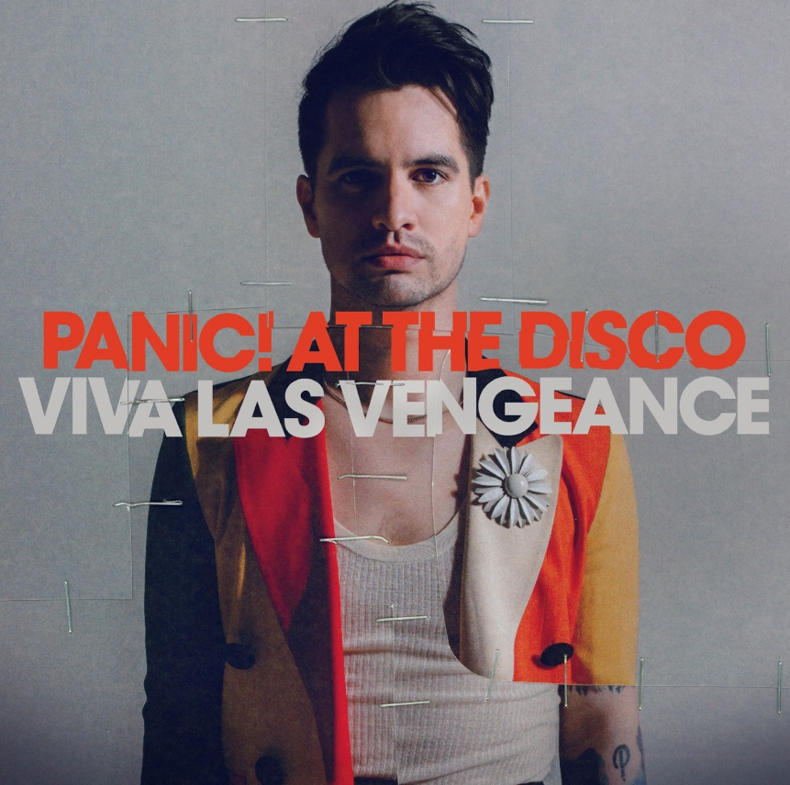
DOWNLOAD PRESS ASSETS HERE

Los Angeles, CA - June 1, 2022 - Today, Grammy-nominated and multi-platinum band, Panic! At The Disco announce their seventh studio album, VIVA LAS VENGEANCE, due August 19th on Fueled by Ramen/DCD2 Records. The upbeat, driving, anthemic title track, out now, kicks off the new era of Panic! At The Disco. The video, directed by frequent Panic collaborator Brendan Walter (“High Hopes”), is out now. WATCH “VIVA LAS VENGEANCE” HERE / LISTEN HERE.

VIVA LAS VENGEANCE shows a change in process for frontman/songwriter Brendon Urie, having cut everything live to tape in Los Angeles alongside his friends and production partners, Jake Sinclair and Mike Viola. The cinematic musical journey is about the fine line between taking advantage of your youth, seizing the day and burning out. The songs take an introspective look into his relationship with his decade plus career including growing up in Las Vegas, love, and fame.

“Viva Las Vengeance is a look back at who I was 17 years ago and who I am now with the fondness I didn't have before. I didn’t realize I was making an album and there was something about the tape machine that kept me honest.” - Brendon Urie

Panic! At The Disco has also announced THE VIVA LAS VENGEANCE TOUR, their global headlining arena run kicking off September 8th in Austin, TX. The world tour will mark the band’s return to iconic venues like NYC’s Madison Square Garden, LA’s Kia Forum, London’s The O2 and more. Special guests include MARINA and Jake Wesley Rogers with Beach Bunny joining on select dates in North America. Tickets for the North American dates will be available to the general public starting Wed., June 8th at 10am local time and tickets for the European shows go on sale to the general public on Fri., June 10th at 10am local. For tour dates and tickets, visit panicatthedisco.com.

$1 from each ticket sold in North America, and $1 Euro/$1 GBP in Europe and the UK will go to the band’s Highest Hopes Foundation, a fund which supports organizations that advocate support for human rights for all people and communities subject to discrimination or abuse on the basis of gender, race, religion, sexual orientation and gender identity.

Verizon will offer an exclusive presale for THE VIVA LAS VENGEANCE TOUR in the U.S through the customer loyalty program Verizon Up. Members will have first access to purchase presale tickets for select shows beginning Thur, June 2nd at 10am local time until Tues, June 7th at 10pm local time. For more details and to sign up, visit Verizon Up.

Citi is the official card of THE VIVA LAS VENGEANCE TOUR in the U.S. Citi cardmembers will have access to presale tickets for select shows beginning Fri, June 3rd at 10am local time until Tues., June 7th at 10pm local time through the Citi Entertainment program. For complete presale details visit www.citientertainment.com.

VIVA LAS VENGEANCE marks the first new music from Panic! At The Disco since the 2018 release of their #1 album, RIAA certified platinum-selling Pray For The Wicked, highlighted by the 5x-platinum smash hit “High Hopes” which simultaneously hit #1 across three different radio formats and broke the Billboard record for most weeks atop the Hot Rock Songs Chart! The hit song was nominated for Top Rock Song at the Billboard Music Awards as well as Favorite Pop Rock Song at the AMAs. The album also featured platinum smashes “Hey Look Ma, I Made It,” and “Say Amen (Saturday Night)”. The band’s 2019 sold-out Pray for the Wicked arena world tour sold over 1 million tickets and received critical praise including, “[Urie’s] got the charisma, musical talent and stamina to be one of music’s longest-lasting leading men,” (Variety), “Brendon Urie embodies on-stage theatrics like few other frontmen,” (SF Weekly), and “From dancing fire to a flying piano, Panic! At The Disco puts on a wild show” (Milwaukee Journal Sentinel).

VIVA LAS VENGEANCE TRACK LISTING
- Viva Las Vengeance
- Middle of a Breakup
- Don’t Let The Light Go Out
- Local God
- Star Spangled Banger
- God Killed Rock And Roll
- Say It Louder
- Sugar Soaker
- Something About Maggie
- Sad Clown
- All By Yourself
- Do It To Death

VIVA LAS VENGEANCE TOUR DATES
9/8/22 - Austin, TX @ Moody Center*
9/10/22 - Houston, TX @ Toyota Center*
9/11/22 - Fort Worth, TX @ Dickies Arena*
9/13/22 - Kansas City, MO @ T-Mobile Center*
9/14/22 - St. Paul, MN @ Xcel Energy Center*
9/16/22 - Milwaukee, WI @ Fiserv Forum^
9/17/22 - Chicago, IL @ United Center^
9/20/22 - Detroit, MI @ Little Caesars Arena^
9/21/22 - Columbus, OH @ Nationwide Arena^
9/23/22 - New York, NY @ Madison Square Garden^
9/25/22 - Toronto, ON @ Scotiabank Arena^
9/27/22 - Montreal, QC @ Bell Centre^
9/28/22 - Boston, MA @ TD Garden^
9/30/22 - Philadelphia, PA @ Wells Fargo Center^
10/1/22 - Washington, DC @ Capital One Arena^
10/2/22 - Raleigh, NC @ PNC Arena^
10/4/22 - Sunrise, FL @ FLA Live Arena^
10/5/22 - Tampa, FL @ Amalie Arena^
10/7/22 - Duluth, GA @ Gas South Arena^
10/8/22 - Nashville, TN @ Bridgestone Arena^
10/9/22 - Saint Louis, MO @ Enterprise Center†
10/11/22 - Denver, CO @ Ball Arena^
10/13/22 - Salt Lake City, UT @ Vivint Smart Home Arena^
10/15/22 - Portland, OR @ Moda Center^
10/16/22 - Seattle, WA @ Climate Pledge Arena†
10/19/22 - Inglewood, CA @ Kia Forum^
10/21/22 - Las Vegas, NV @ T-Mobile Arena^
10/23/22 - Phoenix, AZ @ Footprint Center^
10/25/22 - San Francisco, CA @ Chase Center^
2/20/23 - Vienna, AT @ Wiener Stadthalle
2/21/23 - Munich, DE @ Olympiahalle
2/23/23 - Hamburg, DE @ Barclays Arena
2/24/23 - Cologne, DE @ Lanxess Arena
2/25/23 - Rotterdam, NL @ Rotterdam Ahoy
2/28/23 - Antwerp, BE @ Sportpaleis
3/1/23 - Paris, FR @ AccorHotels Arena
3/3/23 - Glasgow, UK @ OVO Hydro
3/4/23 - Birmingham, UK @ Utilita Arena
3/6/23 - London, UK @ The O2
3/10/23 - Manchester, UK @ AO Arena

^ w/ MARINA & Jake Wesley Rogers
* w/ Beach Bunny & Jake Wesley Rogers
† w/ MARINA & Little Image

About Panic! At The Disco
Formed in Las Vegas, NV in 2004 Panic! At The Disco are a multi-platinum, Grammy-nominated rock band. They released their #1 album "Pray For The Wicked" in 2019 off the heels of their critically acclaimed fifth album, "Death Of A Bachelor.” "DOAB" debuted at #1 on the Billboard 200 Chart and was nominated for Best Rock Album at the 2017 GRAMMY® Awards. The RIAA platinum selling release was the highest selling rock album and fourth-highest selling album released in 2016, according to Nielsen Soundscan. "DOAB" has also spawned RIAA certified gold singles “Hallelujah,” “LA Devotee,” Don’t Threaten Me With A Good Time,” and platinum singles "Death Of A Bachelor,” "Emperor's New Clothes,” and “Victorious." The band’s song “House of Memories” off of DOAB is currently having a TikTok moment with over 2.1 billion views. Panic! At The Disco have been nominated for multiple awards, including the GRAMMYS, Teen Choice Awards, Billboard Music Awards, Alternative Press Music Awards, Kerrang! Awards, VMAs and more. In 2017 Urie made his Broadway debut, first starring as Charlie Price in the critically acclaimed, TONY Award-winning, Broadway hit Kinky Boots. In 2018, he received a TONY Award nomination for “Best Original Score Written For Theatre" for the song he wrote called “Simple Sponge” for SpongeBob SquarePants: The Broadway Musical. Outside of music, Urie founded the Highest Hopes Foundation - an umbrella fund which supports the efforts of non-profit organizations that lead, develop, and advocate support for human rights for all people and communities subject to discrimination or abuse on the basis of gender, race, religion, sexual orientation and gender identity.

For more, please visit:
panicatthedisco.com
facebook.com/panicatthedisco
twitter.com/panicatthedisco
instagram.com/panicatthedisco
youtube.com/panicatthedisco
dcd2records.com
fueledbyramen.com

About Live Nation Entertainment
Live Nation Entertainment (NYSE: LYV) is the world’s leading live entertainment company comprised of global market leaders: Ticketmaster, Live Nation Concerts, and Live Nation Sponsorship. For additional information, visit www.livenationentertainment.com.

Press Contacts

Glenn Fukushima / Elektra Music Group
GlennFukushima@elektra.com

Collin Citron / Elektra Music Group
CollinCitron@elektra.com

Lauren Papapietro / Crush Music
lp@crushmusic.com

Monique Sowinski / Live Nation Concerts
moniquesowinksi@livenation.com

