MEET ME @ THE ALTAR RELEASE OFFICIAL MUSIC VIDEO FOR “NOW OR NEVER”
WATCH HERE

MAJOR LABEL DEBUT EP MODEL CITIZEN AVAILABLE NOW VIA FUELED BY RAMEN

NORTH AMERICAN TOUR SUPPORTING ALL TIME LOW KICKS OFF NEXT WEEK

Photo credit: Lindsey Byrnes

“One of the most exciting young pop bands in the United States” – The FADER

“One of 2021’s most exciting new rock acts” – Rolling Stone

“The members of M.M.A.T.A have a magnetism that goes far beyond their music making” – The New York Times

“Meet Me @ The Altar is the future of pop-punk” – NYLON

“It feels both thrilling and overdue to witness a group like Meet Me @ The Altar” – Consequence

OCTOBER 08, 2021 – Rising pop-punk trio Meet Me @ The Altar have unveiled an official music video for “Now Or Never”. The Dillon Dowdell-directed clip follows a raucous night as the band performs in a diner. Watch it now on Fueled By Ramen’s YouTube channel HERE.

“Now Or Never” appears on Meet Me @ The Altar’s critically acclaimed major label debut EP Model Citizen, which was released in August via Fueled By Ramen. The EP is available to stream and download HERE. Upon its release, Model Citizen earned widespread praise from The New York Times Magazine in a lengthy profile, Consequence who highlighted the band as their Artist of The Month, NPR Music’s All Songs Considered, and more.

The band previewed Model Citizen with the release of lead single “Feel A Thing.” Rolling Stone hailed the song as “a blistering track filled with flurries of double-kick drum hits and crunchy guitar riffs”, and UPROXX touted the track as “a reminder of why pop-punk became so popular in the first place.” Following the release of the EP’s second track, “Brighter Days (Are Before Us),” FLOOD Magazine proclaimed “the punchy single has an optimistic spirit,” while Brooklyn Vegan asserted “it’s got no shortage of huge hooks.”

Last month, Meet Me @ The Altar wrapped a U.S. tour supporting Coheed and Cambria & The Used and appeared at Chicago, IL’s Riot Fest. The band is currently on the road supporting nothing,nowhere., and next week they will embark on a massive North American tour with labelmates All Time Low. A complete list of upcoming live dates can be found HERE.

Crossing state lines and breaking all kinds of boundaries, the group’s members—Edith Johnson [vocals], Téa Campbell [guitar], and Ada Juarez [drums]—initially met online, bonding over the likes of Paramore and Twenty One Pilots and agreeing on a need for more representation in pop punk. Instead of waiting for somebody else to do it, they stepped up and became that representation as three proud women of color playing lightning fast riffs, pounding out double kicks, and chanting huge hooks.

Meet Me @ The Altar announced their Fueled By Ramen signing last October in an exclusive interview with Billboard and unleashed their critically acclaimed major label debut single “Garden.” The song’s music video premiered on The FADER, and “Garden” graced best songs of 2020 lists by NPR Music, The FADER, Refinery 29, and more. Earlier this year, the band debuted the powerful single, “Hit Like A Girl” in partnership with Facebook’s Women’s History Month campaign. Meet Me @ The Altar was named an artist to watch in 2021 by Rolling Stone, NYLON, and more.

MEET ME @ THE ALTAR TOUR DATES
Supporting nothing,nowhere.
October 08, 2021 - Washington, DC - Songbyrd
October 10, 2021 - Nashville, TN - Mercy Lounge
November 15, 2021 - Oklahoma City, OK - 89th Street
November 16, 2021 - Springfield, MO - Outland Ballroom

Supporting All Time Low
October 13, 2021 - Birmingham, AL - Avondale Brewing Company
October 15, 2021 - Richmond, VA - The National
October 16, 2021 - Raleigh, NC - The Ritz
October 17, 2021 - Charlotte, NC - The Fillmore
October 19, 2021 - New Haven, CT - College Street Music Hall
October 20, 2021 - Buffalo, NY - Town Ballroom
October 23, 2021 - Grand Rapids, MI - 20 Monroe Live
October 24, 2021 - Louisville, KY - Paristown Hall
October 27, 2021 - Sioux Falls, SD - The District
October 28, 2021 - Des Moines, IA - Val Air Ballroom
October 30, 2021 - Minneapolis, MN - The Fillmore
October 31, 2021 - Winnipeg, MB - Burton Cummings Theatre
November 02, 2021 - Edmonton, AB - Union Hall
November 03, 2021 - Calgary, AB - MacEwan Hall
November 05, 2021 - Vancouver, BC - Vogue Theatre
November 06, 2021 - Portland, OR - Roseland
November 07, 2021 - Seattle, WA - Showbox SODO
November 10, 2021 - Oakland, CA - Fox Theater
November 11, 2021 - Los Angeles, CA - Hollywood Palladium
November 12, 2021 - San Diego, CA - Humphrey’s

MEET ME @ THE ALTAR
MODEL CITIZEN EP
AVAILABLE NOW
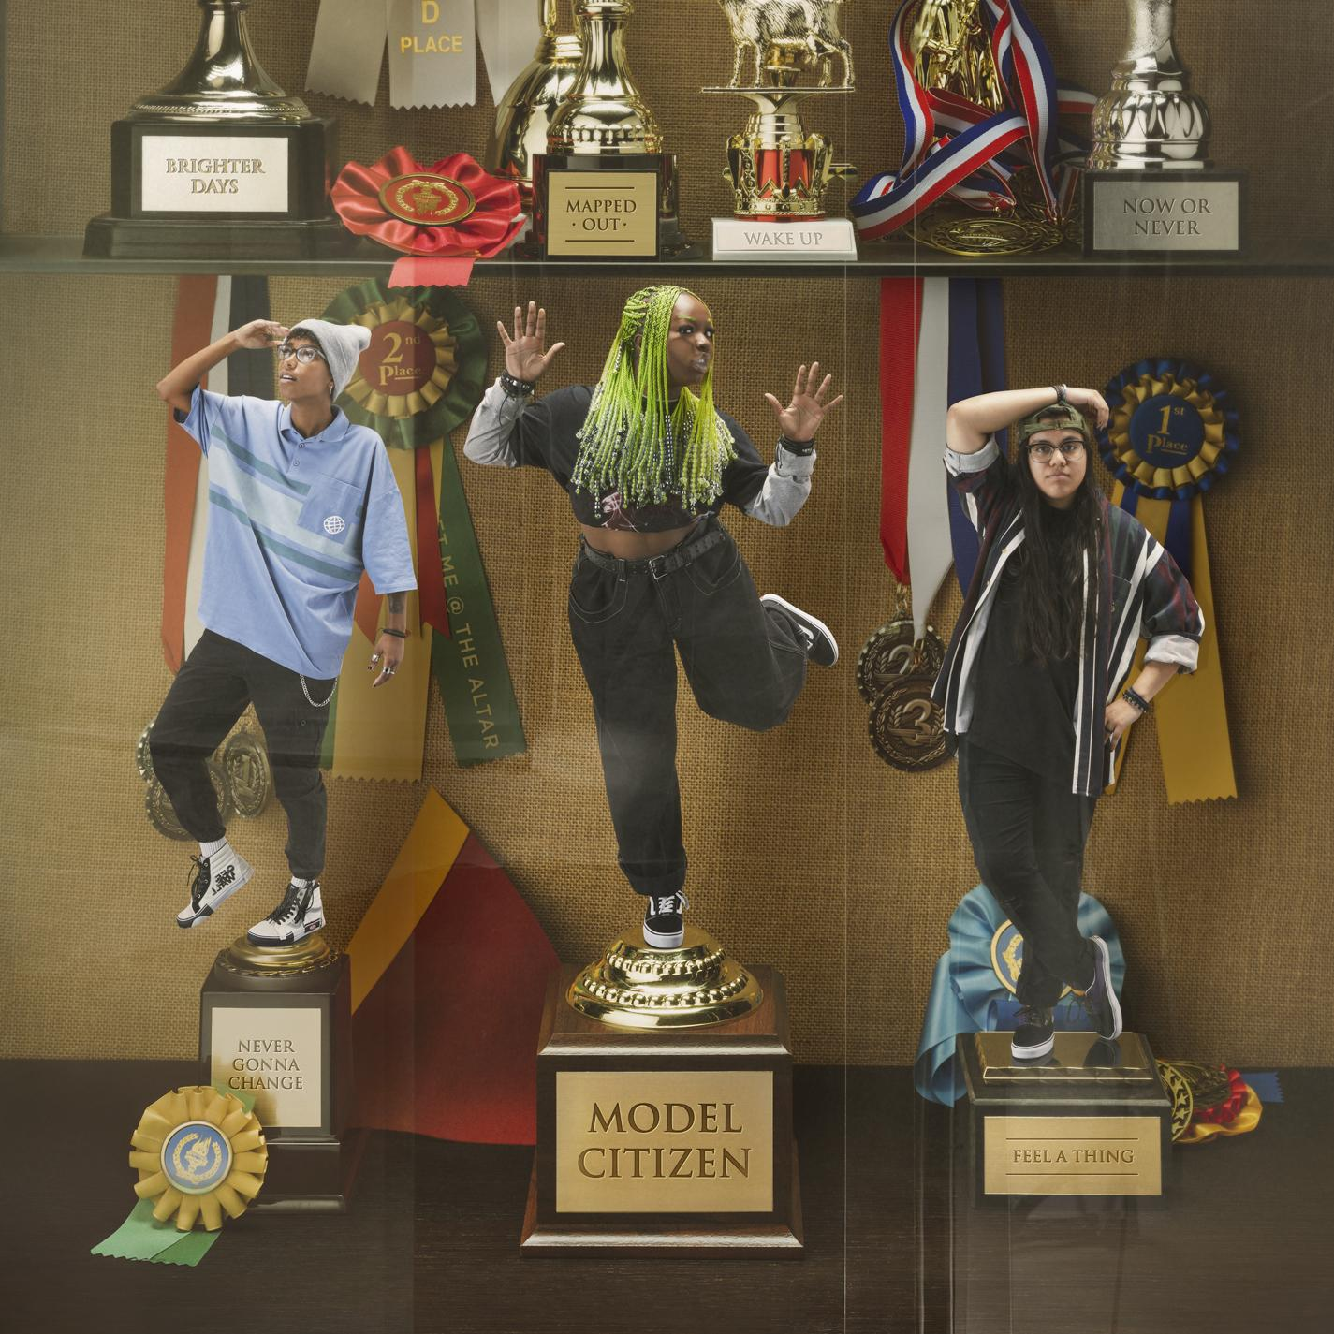

ABOUT MEET ME @ THE ALTAR:
Meet Me @ The Altar present a new musical and cultural paradigm for pop punk. The Florida-based trio—Edith Johnson [vocals], Téa Campbell [guitar], and Ada Juarez [drums]—write the kinds of anthems that you can scream along to at a festival, head-bang to in a club, or sit with while in your feelings at home. The women may have met via YouTube - in true modern-day fashion - but the band shares a classic mission. Flipping the script for rock music and its culture, they bring together elements of Warped Tour-era punk, 2010s pop, and easycore. In 2020, early champions such as Halsey, Alex Gaskarth of All Time Low and Dan “Soupy” Campbell of The Wonder Years came forward as the trio inevitably inked a deal with Fueled By Ramen. On the heels of singles “Garden” and “Hit Like A Girl,” widespread tastemaker praise followed from The FADER, Rolling Stone, Nylon, and Stereogum. Meanwhile, Vulture predicted, “Meet Me @ The Altar make a convincing case that the future of pop-punk is Black, Latina, and female.” While amassing critical acclaim, they tirelessly wrote and recorded their 2021 major label debut EP Model Citizen.

# # #

CONNECT WITH MEET ME @ THE ALTAR
MeetMeAtTheAltar.com
Facebook
Instagram
Twitter
YouTube

Press Contacts:
Collin Citron / CollinCitron@Elektra.com
Sarah Goldstein / SarahGoldstein@Elektra.com

