MEET ME @ THE ALTAR RELEASES ACOUSTIC RECORDING OF MAJOR LABEL DEBUT SINGLE “GARDEN”

OFFICIAL FAN VIDEO NOW STREAMING

LISTEN/WATCH HERE

“One of the most exciting young pop bands in the United States” – The FADER

“One of 2021’s most exciting new rock acts” – Rolling Stone

“Meet Me @ The Altar is the future of pop-punk” – NYLON

“Your new pop punk obsession” – Buzzfeed

FEBRUARY 12, 2021 – Rising pop-punk trio Meet Me @ The Altar have released an acoustic rendition of their major label debut single “Garden”. The release is accompanied by an official fan video, which is streaming now on the Fueled By Ramen official YouTube channel. “Garden (Acoustic)” is available now on all streaming platforms. E

Meet Me @ The Altar announced their Fueled By Ramen signing in an exclusive interview with Billboard and released “Garden” in October of 2020. The critically acclaimed track is available to stream and download now HERE. Watch the song’s vibrant music video, which premiered on The FADER, HERE. “Garden” graced best songs of 2020 lists by NPR Music, The FADER, and Refinery 29, and Meet Me @ The Altar has already been named an artist to watch in 2021 by Rolling Stone, NYLON, and more. The band recently made their livestream debut, performing “Garden” and a selection of fan-favorite tracks during a Wake & Baconate concert on the official Wendy’s Twitter. Watch the performance HERE.

At the time of their signing, the band shared, “We want to be the representation we didn’t have growing up. We hope to encourage young girls, especially black and brown girls like us. We definitely have a different perspective than the average pop punk white dude crying about his girlfriend. Even as a band, we experience the music world in our own way. It gives us an interesting viewpoint that we put into the songs.”

Crossing state lines and breaking all kinds of boundaries, the group’s members—Edith Johnson [vocals], Téa Campbell [guitar], and Ada Juarez [drums]—initially met online, bonding over the likes of Paramore and Twenty One Pilots and agreeing on a need for more representation in pop punk. Instead of waiting for somebody else to do it, they stepped up and became that representation as three proud women of color playing lightning fast riffs, pounding out double kicks, and chanting huge hooks.

Stay tuned for more new music from Meet Me @ The Altar soon.

(Single art below)

MEET ME @ THE ALTAR
“Garden” (Acoustic)
AVAILABLE NOW
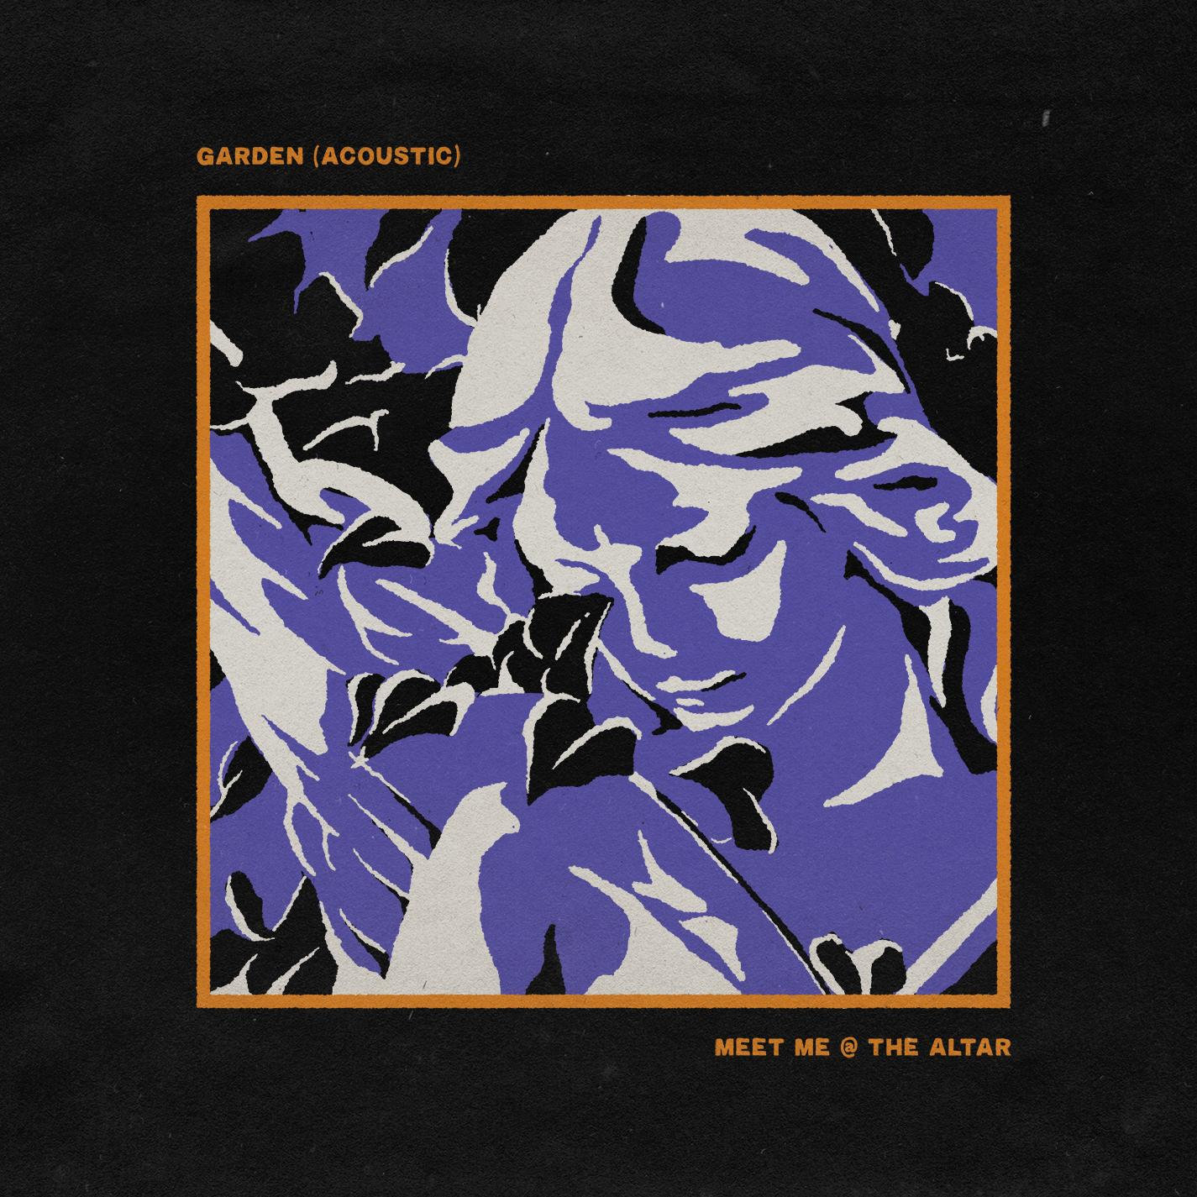

ABOUT MEET ME @ THE ALTAR:
Meet Me @ the Altar present a new musical and cultural paradigm for pop punk. The Florida trio—Edith Johnson [vocals], Téa Campbell [guitar], and Ada Juarez [drums]—certainly rip just as hard as the forbearers who inspired them, but the group also speak from a position rarely, if ever, heard in the genre as proud women of color. With Ada from New Jersey, Téa from Florida, and Edith from Georgia, the three-piece would meet in the Sunshine State and practice for hours nonstop just before gigs, morphing into a formidable force on stage. Booking their own tours, the band canvassed the country to promote their debut Changing States EP in 2018. Dozens of shows endeared them to a growing audience as they continued recording. During 2020, MM@TA’s independent releases turned heads, drawing admiration from Halsey and All Time Low’s Alex Gaskarth, and receiving praise from SPIN, FLOOD Magazine, and more. Now signed to their dream record label, the group kickstarts a revolution with their Fueled By Ramen debut single, “Garden.”

# # #

CONNECT WITH MEET ME @ THE ALTAR
MeetMeAtTheAltar.com
Instagram
Twitter
Facebook
YouTube

Press Contacts:
Collin Citron / CollinCitron@Elektra.com
Sarah Goldstein / SarahGoldstein@Elektra.com

