MAISIE PETERS ENLISTS MATT MALTESE FOR “CATE’S BROTHER (MATT’S VERSION)”
STREAM/DOWNLOAD HERE

CURRENTLY SUPPORTING ED SHEERAN ON THE ‘+ - = ÷ x TOUR’ IN EUROPE

PRESS ASSETS HERE

(June 1st, 2022) - Rising pop singer-songwriter Maisie Peters has unveiled “Cate’s Brother (Matt’s Version)”, a stripped-back rework of her viral track featuring British singer-songwriter Matt Maltese, available now on all streaming platforms. No stranger to a TikTok hit - his own, ‘As The World Caves In’, exploded on the platform during lockdown – Matt joins Maisie to expand the ‘Cate’s Brother’ universe, sharing his response to the original story.

The original version of “Cate’s Brother” arrived last month to critical acclaim and has already cracked 4.7 million streams. Based on a true story, Maisie initially teased the track live from a studio session in February and with an overwhelming response from her fanbase, continued working on the song in real time, sharing everything from Cate’s first listen reaction to debut performances. Upon release, Billboard praised the track as “fantastic” adding “the storytelling beneath the wiry pop-rock production is top-notch” while People declared Maisie as “pop’s next big thing.” Consequence of Sound described the track as “vibrant, playful and fun” and hailed, “If there was ever any doubt that Peters can oscillate between more delicate, introspective tracks over to crowd-ready bops like this, let ‘Cate’s Brother’ be the end of the conversation.”

Having returned home after her sold-out 19-date headline North American tour, which included standout shows at The El Rey and New York’s Webster Hall, Maisie is playing to a further 2.5 million+ people this summer as support on Ed Sheeran’s ‘+ - = ÷ x Tour’ in Europe and working on the follow up to her acclaimed debut album ‘You Signed Up For This’.

Be on the lookout for more from Maisie soon!

MAISIE PETERS
“CATE’S BROTHER (MATT’S VERSION”
AVAILABLE NOW
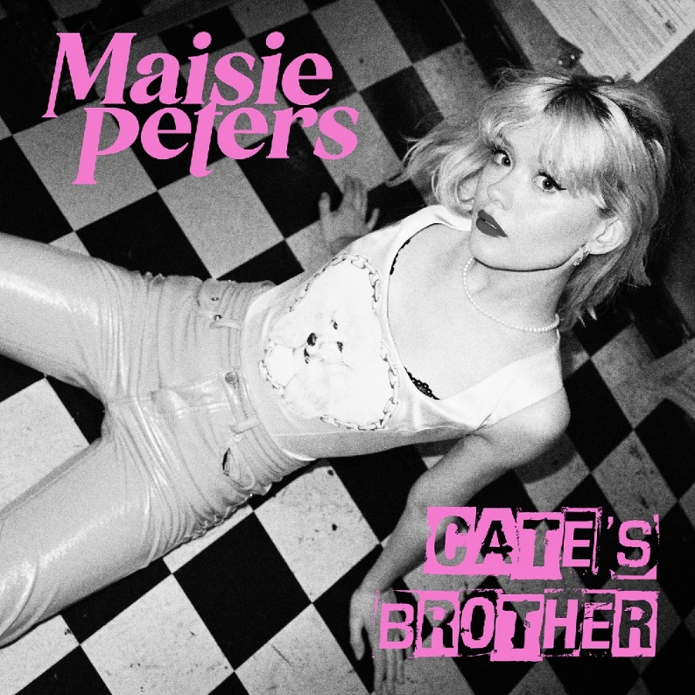

CONNECT WITH MAISIE:
YouTube | Instagram | Twitter | Facebook | TikTok

For more information please contact:
glennfukushima@elektra.com
rossanderson@elektra.com
sydneywordern@elektra.com

