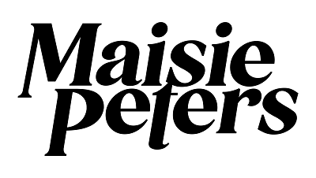
ANNOUNCES 2022 NORTH AMERICAN "YOU SIGNED UP FOR THIS TOUR”

PERFORMS “PSYCHO” ON JIMMY KIMMEL LIVE!

DEBUT ALBUM ‘YOU SIGNED UP FOR THIS’ OUT NOW

DOWNLOAD PRESS ASSETS HERE

“The British pop upstart possesses a remarkable ability to toy with a melody” - Billboard
“Maisie Peters says she wants to make ‘trying hard’ cool and we are totally here for it” - People
“her gift for melody is remarkable” - Sunday Times Culture
“mixes strummed melodies and storytelling to cosmic effect” - Music Week
“one of the most exciting singer-songwriters in the game” - The Independent
“one of those truly authentic talents whose candid, catchy pop numbers are sure to stick in your heart and head” - Notion
“her debut album looks certain to propel her to stardom” - The Telegraph
“‘You Signed Up For This’ might just be the perfect heartbreak album” - CLASH
“Maisie took her time with this one, resulting in an album that could well be timeless” – DIY
“‘You Signed Up For This’ should come packaged with a noise warning, because that deafening din of hype is about to become a sonic boom” – DORK

SEPTEMBER 13, 2021 - Rising British pop singer-songwriter Maisie Peters has announced dates for her first North American headline tour in support of her acclaimed debut album ‘You Signed Up For This.’ The month-long run, deemed the “You Signed Up For This Tour,” kicks off on March 1st at 7th Entry Bar in Minneapolis, MN, visits major markets coast to coast, and concludes on March 31st at the legendary El Rey Theatre in Los Angeles, CA. Pre-sale tickets for the upcoming tour dates will be available starting Monday September 14th at 10:00AM local time with public on sale for all remaining tickets beginning Friday September 17th at 10:00AM local time (full itinerary below). For tickets and more information on Maisie’s upcoming North American tour please visit, www.maisiepeters.co.uk.

Last week, Maisie took the stage at ABC’s Jimmy Kimmel LIVE! for a showstopping performance of her buzzing single “Psycho” which can be viewed HERE.

“Psycho” is featured on Maisie’s adored debut album ‘You Signed Up For This’ which was released this August via Ed Sheeran’s Gingerbread Man Records. ‘You Signed Up For This’ has garnered widespread praise on both sides of the pond with Clash raving “‘You Singed Up For This’ might just be the perfect heartbreak album” and Atwood Magazine describing it as “Timely, yet timeless.” Upon release, it notably bowed at #2 on the UK Official Albums Chart propelled by the success of early singles “Psycho,” “John Hughes Movie,” as well as fan favorites “Brooklyn” and “Volcano.”

With her knack for transforming everyday experiences into vividly written diary-style songs, ‘You Signed Up For This’ is both Maisie’s coming of age story and a love letter to girlhood; penned with the wit, charm and quiet confidence that has seen her ascend from busking on the streets of Brighton, to racking up over half a billion global streams.

Revered for her songwriting, Maisie has spent the past three years honing her craft in sessions across London, LA and Nashville, creating songs for ‘You Signed Up For This’ alongside the likes of Ed Sheeran, Steve Mac, Fred again.., Johnny McDaid, Miranda Cooper, and producers Joe Rubel (Tom Grennan, Benjamin Francis Leftwich), Afterhrs (Niall Horan, GRACEY), Rob Milton (Easy Life, Holly Humberstone) and Brad Ellis (Jorja Smith, Little Mix).

[TOUR ITINERARY / ADMAT BELOW]

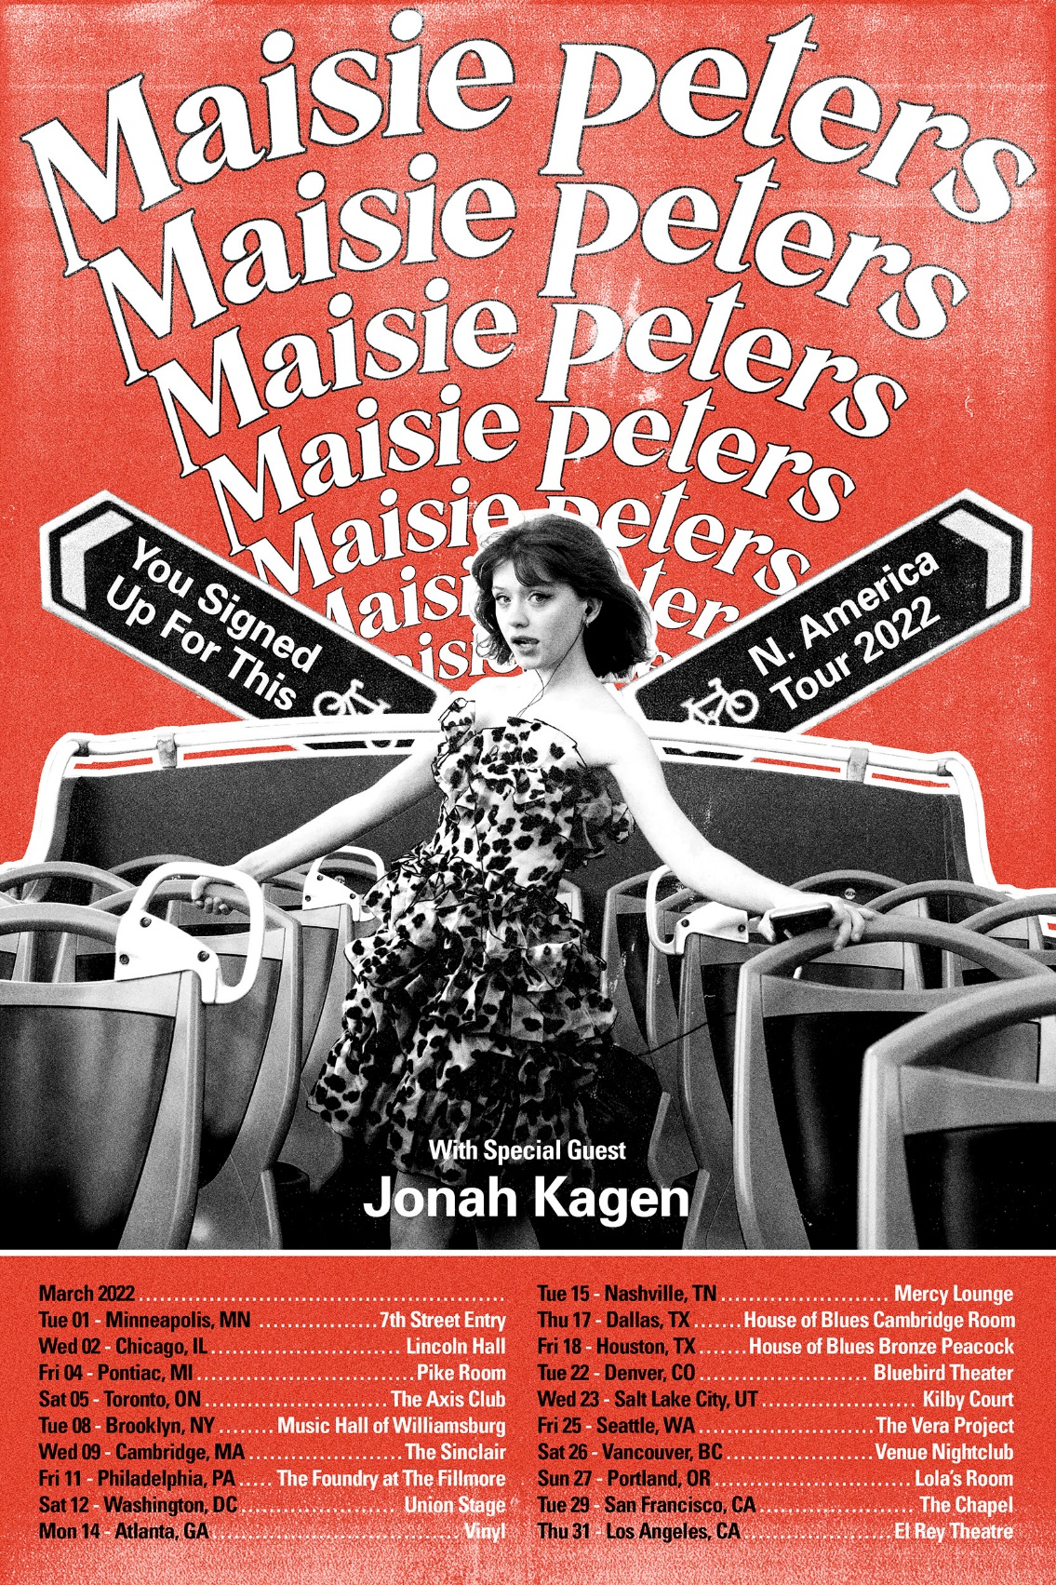

3/1/2022 - Minneapolis, MN - 7th Street Entry
3/2/2022 - Chicago, IL - Lincoln Hall
3/4/2022 - Pontiac, MI - Pike Room
3/5/2022 - Toronto, ON - The Axis Club
3/8/2022 - Brooklyn, NY - Music Hall of Williamsburg
3/9/2022 - Cambridge, MA - The Sinclair
3/11/2022 - Philadelphia, PA - The Foundry at The Fillmore
3/12/2022 - Washington, DC - Union Stage
3/14/2022 - Atlanta, GA - Vinyl
3/15/2022 - Nashville, TN - Mercy Lounge
3/17/2022 - Dallas, TX - House of Blues Cambridge Room
3/18/2022 - Houston, TX - House of Blues Bronze Peacock
3/22/2022 - Denver, CO - Bluebird Theater
3/23/2022 - Salt Lake City, UT - Kilby Court
3/25/2022 - Seattle, WA - The Vera Project
3/26/2022 - Vancouver, BC - Venue Nightclub
3/27/2022 - Portland, OR - Lola’s Room
3/29/2022 - San Francisco, CA - The Chapel
3/31/2022 - Los Angeles, CA - El Rey Theatre

CONNECT WITH MAISIE:
YouTube | Instagram | Twitter | Facebook | TikTok

For more information please contact:
glennfukushima@elektra.com
rossanderson@elektra.com
sydneywordern@elektra.com

