MEET ME @ THE ALTAR TO RELEASE MAJOR LABEL DEBUT EP MODEL CITIZEN ON AUGUST 13 VIA FUELED BY RAMEN

BAND UNVEILS NEW SINGLE AND MUSIC VIDEO “FEEL A THING”
LISTEN/WATCH HERE

NORTH AMERICAN TOUR DATES ANNOUNCED
SUPPORTING COHEED AND CAMBRIA & THE USED THIS SUMMER
SUPPORTING ALL TIME LOW THIS FALL

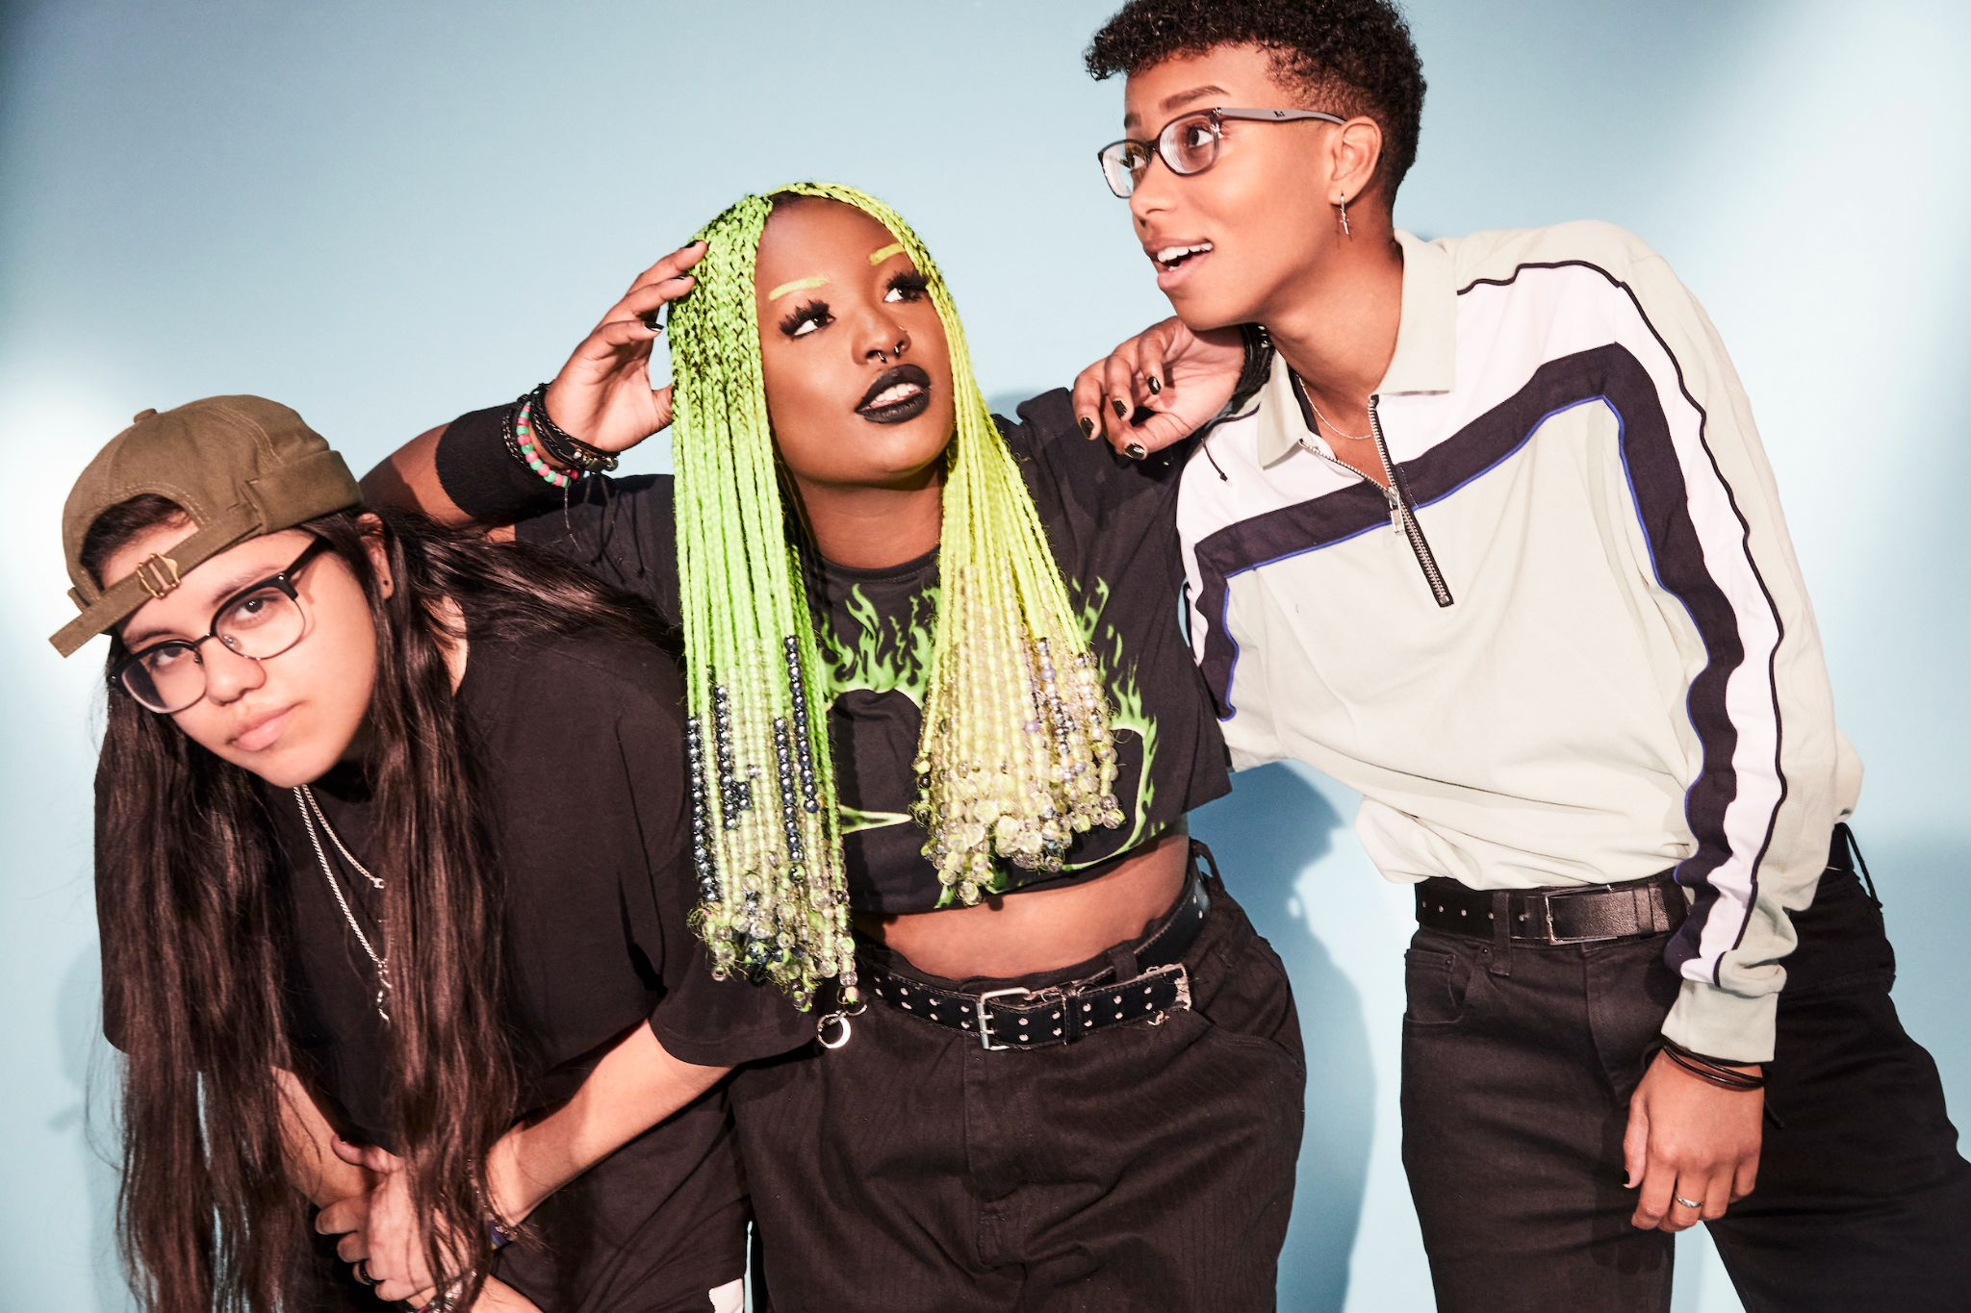
Photo credit: Jimmy Fontaine

“One of the most exciting young pop bands in the United States” - The FADER

“One of 2021’s most exciting new rock acts” - Rolling Stone

“Meet Me @ The Altar is the future of pop-punk” - NYLON

“Your new pop punk obsession” - Buzzfeed

“Some of the most promising, exciting pop-punk in recent memory” - Stereogum

June 16, 2021 – Rising pop-punk trio Meet Me @ The Altar have announced their major label debut EP, Model Citizen. The news is heralded by the release of anthemic single “Feel A Thing,” which is available now on all streaming platforms. The group, whose name was inspired by a mutual love for Mortal Kombat, has their skills put to the test in the track’s official video, which finds them fighting their way out of an arcade game. The video is streaming now on the Fueled By Ramen official YouTube channel. The Model Citizen EP arrives August 13th via Fueled By Ramen and is available for pre-order/pre-save/pre-add HERE (see attached EP art/tracklisting).

“We are SO incredibly excited about Model Citizen being our first major release on Fueled By Ramen – these are absolutely our best songs to date,” the band shared. “Model Citizen was originally a different set of songs, but we decided to throw it all out just days before the EP was due because we knew we could write a more cohesive story with lots of energy. With a heavy easycore influence, we hope Model Citizen knocks everyone out of their seats!”

This summer, Meet Me @ The Altar will embark on a massive U.S. tour supporting Coheed and Cambria & The Used and appear at Chicago, IL’s Riot Fest. In the fall, they will return to the road with labelmates All Time Low and nothing,nowhere. for a tour of North America. A complete list of upcoming live dates can be found HERE.

Meet Me @ The Altar announced their Fueled By Ramen signing last October in an exclusive interview with Billboard and unleashed their critically acclaimed major label debut single “Garden.” The song’s vibrant music video premiered on The FADER, and “Garden” graced best songs of 2020 lists by NPR Music, The FADER, Refinery 29, and more. Earlier this year, the band debuted the powerful single, “Hit Like A Girl” in partnership with Facebook’s Women’s History Month campaign. Meet Me @ The Altar has already been named an artist to watch in 2021 by Rolling Stone, NYLON, and more.

Crossing state lines and breaking all kinds of boundaries, the group’s members—Edith Johnson [vocals], Téa Campbell [guitar], and Ada Juarez [drums]—initially met online, bonding over the likes of Paramore and Twenty One Pilots and agreeing on a need for more representation in pop punk. Instead of waiting for somebody else to do it, they stepped up and became that representation as three proud women of color playing lightning fast riffs, pounding out double kicks, and chanting huge hooks.

Stay tuned for more new music from Meet Me @ The Altar soon.

(Tour dates/EP art/Tracklisting below)

MEET ME @ THE ALTAR
2021 TOUR DATES
8/27-9/24 - supporting Coheed and Cambria & The Used
10/5-10/10 – supporting nothing,nowhere.
10/12-11/12 - supporting All Time Low
# - festival performance

Supporting Coheed and Cambria & The Used
August 27, 2021 - Irvine, CA - FivePoint Amphitheatre
August 28, 2021 - Mesa, AZ - Mesa Amphitheatre
August 30, 2021 - Salt Lake City, UT - The Complex Outdoors
August 31, 2021 - Denver, CO - Levitt Pavilion
September 02, 2021 - Irving, TX - The Pavilion at Toyota Music Factory
September 04, 2021 - Austin, TX - Germania Insurance Amphitheater
September 05, 2021 - The Woodlands, TX - The Cynthia Woods Mitchell Pavilion
September 07, 2021 - Wichita, KS - WAVE
September 08, 2021 - Maryland Heights, MO - Saint Louis Music Park
September 11, 2021 - Columbus, OH - Express Live!
September 12, 2021 - Cleveland, OH - Jacobs Pavilion at Nautica
September 14, 2021 - Cincinnati, OH - The ICON Festival Stage at Smale Park
September 15, 2021 - Indianapolis, IN - TCU Amphitheater at White River State Park
September 17, 2021 - Chicago, IL - Riot Fest #
September 18, 2021 - Worcester, MA - The Palladium
September 19, 2021 - Holmdel, NJ - PNC Bank Arts Center
September 21, 2021 - Baltimore, MD - MECU Pavilion
September 22, 2021 - Raleigh, NC - Red Hat Amphitheater
September 24, 2021 - Jacksonville, FL - Daily’s Place

Supporting nothing,nowhere.
October 05, 2021 – New York, NY – Le Poisson Rouge
October 06, 2021 – Philadelphia, PA – The Foundry
October 08, 2021 – Washington, DC – Songbyrd
October 10, 2021 – Nashville, TN – Mercy Lounge

Supporting All Time Low
October 12, 2021 - New Orleans, LA - Orpheum Theater
October 13, 2021 - Birmingham, AL - Avondale Brewing Company
October 15, 2021 - Richmond, VA - The National
October 16, 2021 - Raleigh, NC - The Ritz
October 17, 2021 - Charlotte, NC - The Fillmore
October 19, 2021 - New Haven, CT - College Street Music Hall
October 20, 2021 - Buffalo, NY - Town Ballroom
October 23, 2021 - Grand Rapids, MI - 20 Monroe Live
October 24, 2021 - Louisville, KY - Paristown Hall
October 27, 2021 - Sioux Falls, SD - The District
October 28, 2021 - Des Moines, IA - Val Air Ballroom
October 30, 2021 - Minneapolis, MN - The Fillmore
October 31, 2021 - Winnipeg, MB - Burton Cummings Theatre
November 02, 2021 - Edmonton, AB - Union Hall
November 03, 2021 - Calgary, AB - MacEwan Hall
November 05, 2021 - Vancouver, BC - Vogue Theatre
November 06, 2021 - Portland, OR - Roseland
November 07, 2021 - Seattle, WA - Showbox SODO
November 10, 2021 - Oakland, CA - Fox Theater
November 11, 2021 - Los Angeles, CA - Hollywood Palladium
November 12, 2021 - San Diego, CA - Humphrey’s

MEET ME @ THE ALTAR
MODEL CITIZEN EP
PRE-ORDER/PRE-SAVE/PRE-ADD NOW
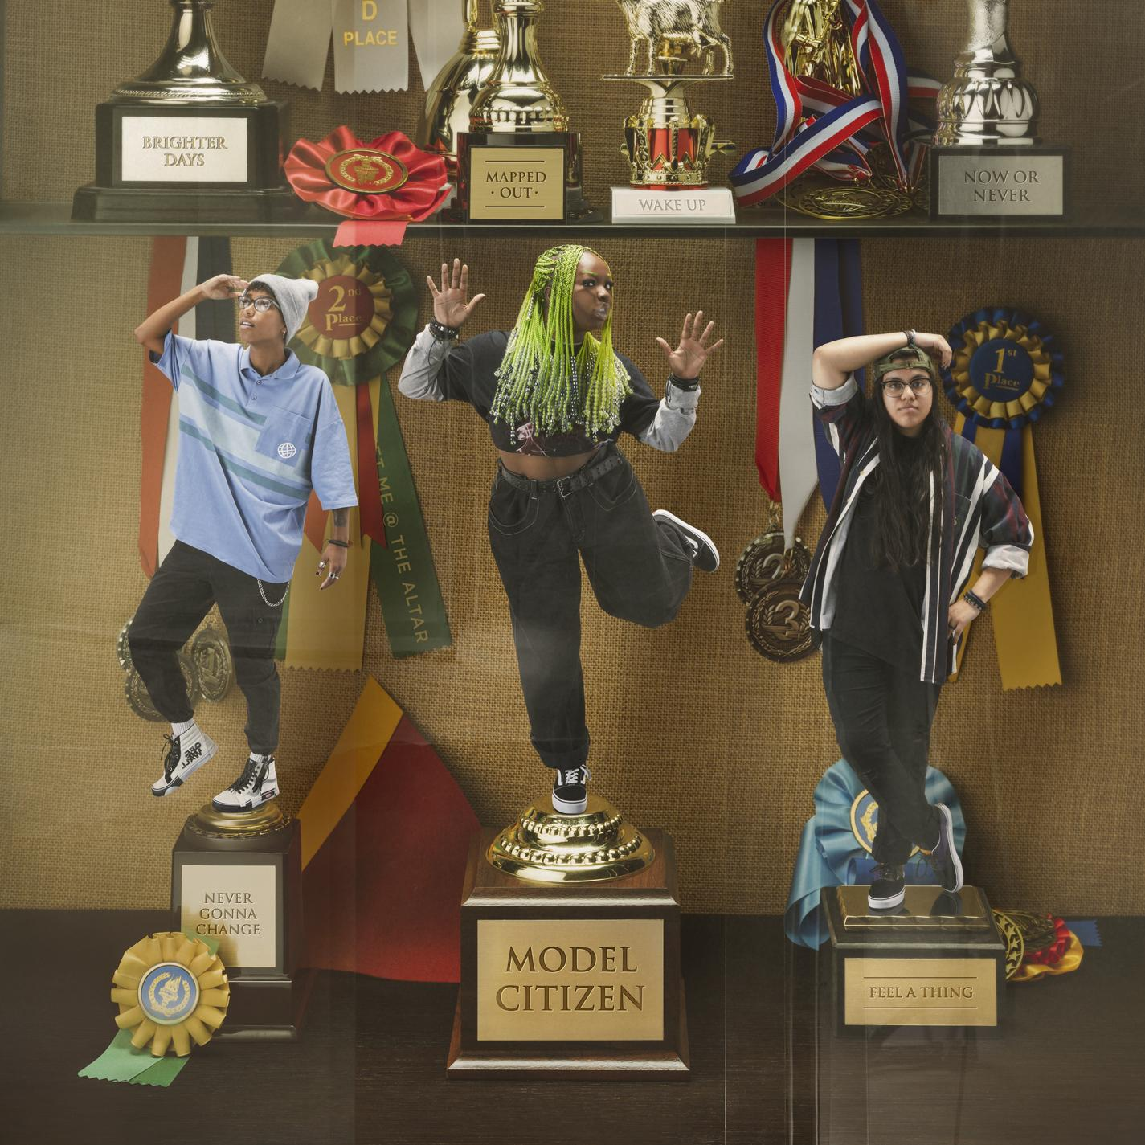

Tracklisting:
1. Feel A Thing
2. Mapped Out
3. Brighter Days (Are Before Us)
4. Now Or Never
5. Never Gonna Change
6. Wake Up

ABOUT MEET ME @ THE ALTAR:
Meet Me @ The Altar present a new musical and cultural paradigm for pop punk. The Florida trio—Edith Johnson [vocals], Téa Campbell [guitar], and Ada Juarez [drums]—certainly rip just as hard as the forbearers who inspired them, but the group also speak from a position rarely, if ever, heard in the genre as proud women of color. With Ada from New Jersey, Téa from Florida, and Edith from Georgia, the three-piece would meet in the Sunshine State and practice for hours nonstop just before gigs, morphing into a formidable force on stage. Booking their own tours, the band canvassed the country to promote their debut Changing States EP in 2018. Dozens of shows endeared them to a growing audience as they continued recording. MM@TA’s independent releases drew admiration from Halsey and All Time Low’s Alex Gaskarth, and landed them a deal with their dream record label Fueled By Ramen. In 2020, the band released their major label debut single “Garden,” and followed up with “Hit Like A Girl'' this spring, earning praise from Rolling Stone, Billboard, The FADER, NPR Music, NYLON, and more.

# # #

CONNECT WITH MEET ME @ THE ALTAR
MeetMeAtTheAltar.com
Facebook
Instagram
Twitter
YouTube

Press Contacts:
Collin Citron / CollinCitron@Elektra.com
Sarah Goldstein / SarahGoldstein@Elektra.com

