MEET ME @ THE ALTAR UNVEIL NEW SINGLE AND VIDEO
“BRIGHTER DAYS (ARE BEFORE US)”
LISTEN HERE | WATCH HERE

MAJOR LABEL DEBUT EP MODEL CITIZEN OUT AUGUST 13 VIA FUELED BY RAMEN
PRE-ORDER/PRE-SAVE/PRE-ADD HERE

U.S. TOUR DATES SUPPORTING COHEED AND CAMBRIA & THE USED
KICK OFF AUGUST 27TH IN IRVINE, CA

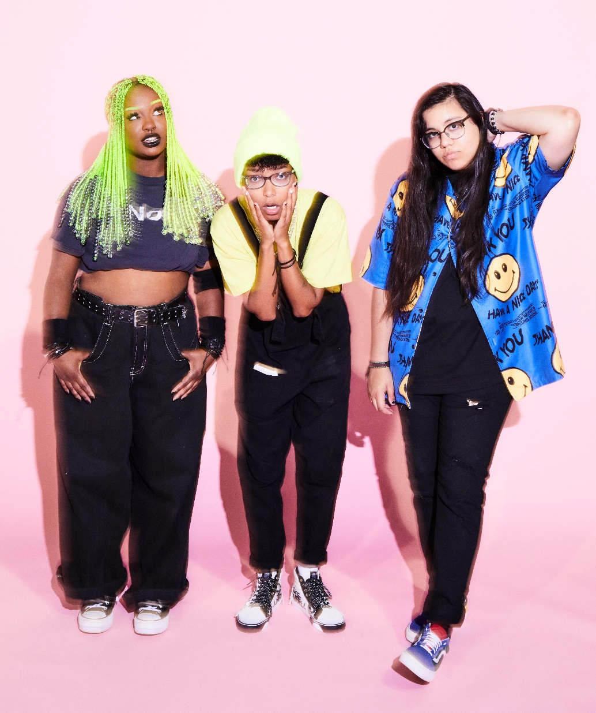
Photo credit: Jimmy Fontaine

“One of the most exciting young pop bands in the United States” – The FADER

“One of 2021’s most exciting new rock acts” – Rolling Stone

“Meet Me @ The Altar is the future of pop-punk” – NYLON

“Your new pop punk obsession” – Buzzfeed

“Some of the most promising, exciting pop-punk in recent memory” – Stereogum

JULY 30, 2021 – Rising pop-punk trio Meet Me @ The Altar have unveiled new single “Brighter Days (Are Before Us),” the latest track from the group’s upcoming major label debut EP Model Citizen. The single is heralded by an official music video, which is streaming now on the Fueled By Ramen official YouTube channel. “Brighter Days (Are Before Us)” is available now on all streaming platforms, with the Model Citizen EP arriving August 13th via Fueled By Ramen.

The band commented, “‘Brighter Days (Are Before Us)’ is one of the ups in life where things are starting to shape up. If our upcoming EP Model Citizen was a movie, ‘Brighter Days’ would be the scene where everything in life is still good right before it all hits the fan. We were so excited to work with a female director, Sydney Ostrander, for the music video and the lighting in the airplane we filmed inside perfectly reflects the meaning of the song.”

Earlier this month, Meet Me @ The Altar shared an acoustic version of lead EP single “Feel A Thing,” featuring additional vocals from early champion Dan Campbell. Upon its release in June, “Feel A Thing” racked up critical praise, with Rolling Stone hailing the single as “a blistering track filled with flurries of double-kick drum hits and crunchy guitar riffs.” The FADER touted the song as “widescreen and anthemic,” while UPROXX declared “Feel A Thing” “a reminder of why pop-punk became so popular in the first place.” Watch the song’s official music video HERE.

This summer, Meet Me @ The Altar will embark on a massive U.S. tour supporting Coheed and Cambria & The Used and appear at Chicago, IL’s Riot Fest. In the fall, they will return to the road with labelmates All Time Low and nothing,nowhere. for a tour of North America. A complete list of upcoming live dates can be found HERE.

Meet Me @ The Altar announced their Fueled By Ramen signing last October in an exclusive interview with Billboard and unleashed their critically acclaimed major label debut single “Garden.” The song’s vibrant music video premiered on The FADER, and “Garden” graced best songs of 2020 lists by NPR Music, The FADER, Refinery 29, and more. Earlier this year, the band debuted the powerful single, “Hit Like A Girl” in partnership with Facebook’s Women’s History Month campaign. Meet Me @ The Altar has already been named an artist to watch in 2021 by Rolling Stone, NYLON, and more.

Crossing state lines and breaking all kinds of boundaries, the group’s members—Edith Johnson [vocals], Téa Campbell [guitar], and Ada Juarez [drums]—initially met online, bonding over the likes of Paramore and Twenty One Pilots and agreeing on a need for more representation in pop punk. Instead of waiting for somebody else to do it, they stepped up and became that representation as three proud women of color playing lightning fast riffs, pounding out double kicks, and chanting huge hooks.

Stay tuned for more new music from Meet Me @ The Altar soon.

(Tour itinerary/EP art/Tracklisting below)

MEET ME @ THE ALTAR
2021 TOUR DATES
8/27-9/24 - supporting Coheed and Cambria & The Used
10/5-10/10 – supporting nothing,nowhere.
10/12-11/12 - supporting All Time Low
# - festival performance

Supporting Coheed and Cambria & The Used
August 27, 2021 - Irvine, CA - FivePoint Amphitheatre
August 28, 2021 - Mesa, AZ - Mesa Amphitheatre
August 30, 2021 - Salt Lake City, UT - The Complex Outdoors
August 31, 2021 - Denver, CO - Levitt Pavilion
September 02, 2021 - Irving, TX - The Pavilion at Toyota Music Factory
September 04, 2021 - Austin, TX - Germania Insurance Amphitheater
September 05, 2021 - The Woodlands, TX - The Cynthia Woods Mitchell Pavilion
September 07, 2021 - Wichita, KS - WAVE
September 08, 2021 - Maryland Heights, MO - Saint Louis Music Park
September 11, 2021 - Columbus, OH - Express Live!
September 12, 2021 - Cleveland, OH - Jacobs Pavilion at Nautica
September 14, 2021 - Cincinnati, OH - The ICON Festival Stage at Smale Park
September 15, 2021 - Indianapolis, IN - TCU Amphitheater at White River State Park
September 17, 2021 - Chicago, IL - Riot Fest #
September 18, 2021 - Worcester, MA - The Palladium
September 19, 2021 - Holmdel, NJ - PNC Bank Arts Center

Supporting nothing,nowhere.
October 05, 2021 – New York, NY – Le Poisson Rouge
October 06, 2021 – Philadelphia, PA – The Foundry
October 08, 2021 – Washington, DC – Songbyrd
October 10, 2021 – Nashville, TN – Mercy Lounge

Supporting All Time Low
October 12, 2021 - New Orleans, LA - Orpheum Theater
October 13, 2021 - Birmingham, AL - Avondale Brewing Company
October 15, 2021 - Richmond, VA - The National
October 16, 2021 - Raleigh, NC - The Ritz
October 17, 2021 - Charlotte, NC - The Fillmore
October 19, 2021 - New Haven, CT - College Street Music Hall
October 20, 2021 - Buffalo, NY - Town Ballroom
October 23, 2021 - Grand Rapids, MI - 20 Monroe Live
October 24, 2021 - Louisville, KY - Paristown Hall
October 27, 2021 - Sioux Falls, SD - The District
October 28, 2021 - Des Moines, IA - Val Air Ballroom
October 30, 2021 - Minneapolis, MN - The Fillmore
October 31, 2021 - Winnipeg, MB - Burton Cummings Theatre
November 02, 2021 - Edmonton, AB - Union Hall
November 03, 2021 - Calgary, AB - MacEwan Hall
November 05, 2021 - Vancouver, BC - Vogue Theatre
November 06, 2021 - Portland, OR - Roseland
November 07, 2021 - Seattle, WA - Showbox SODO
November 10, 2021 - Oakland, CA - Fox Theater
November 11, 2021 - Los Angeles, CA - Hollywood Palladium
November 12, 2021 - San Diego, CA - Humphrey’s
MEET ME @ THE ALTAR
MODEL CITIZEN EP
PRE-ORDER/PRE-SAVE/PRE-ADD NOW
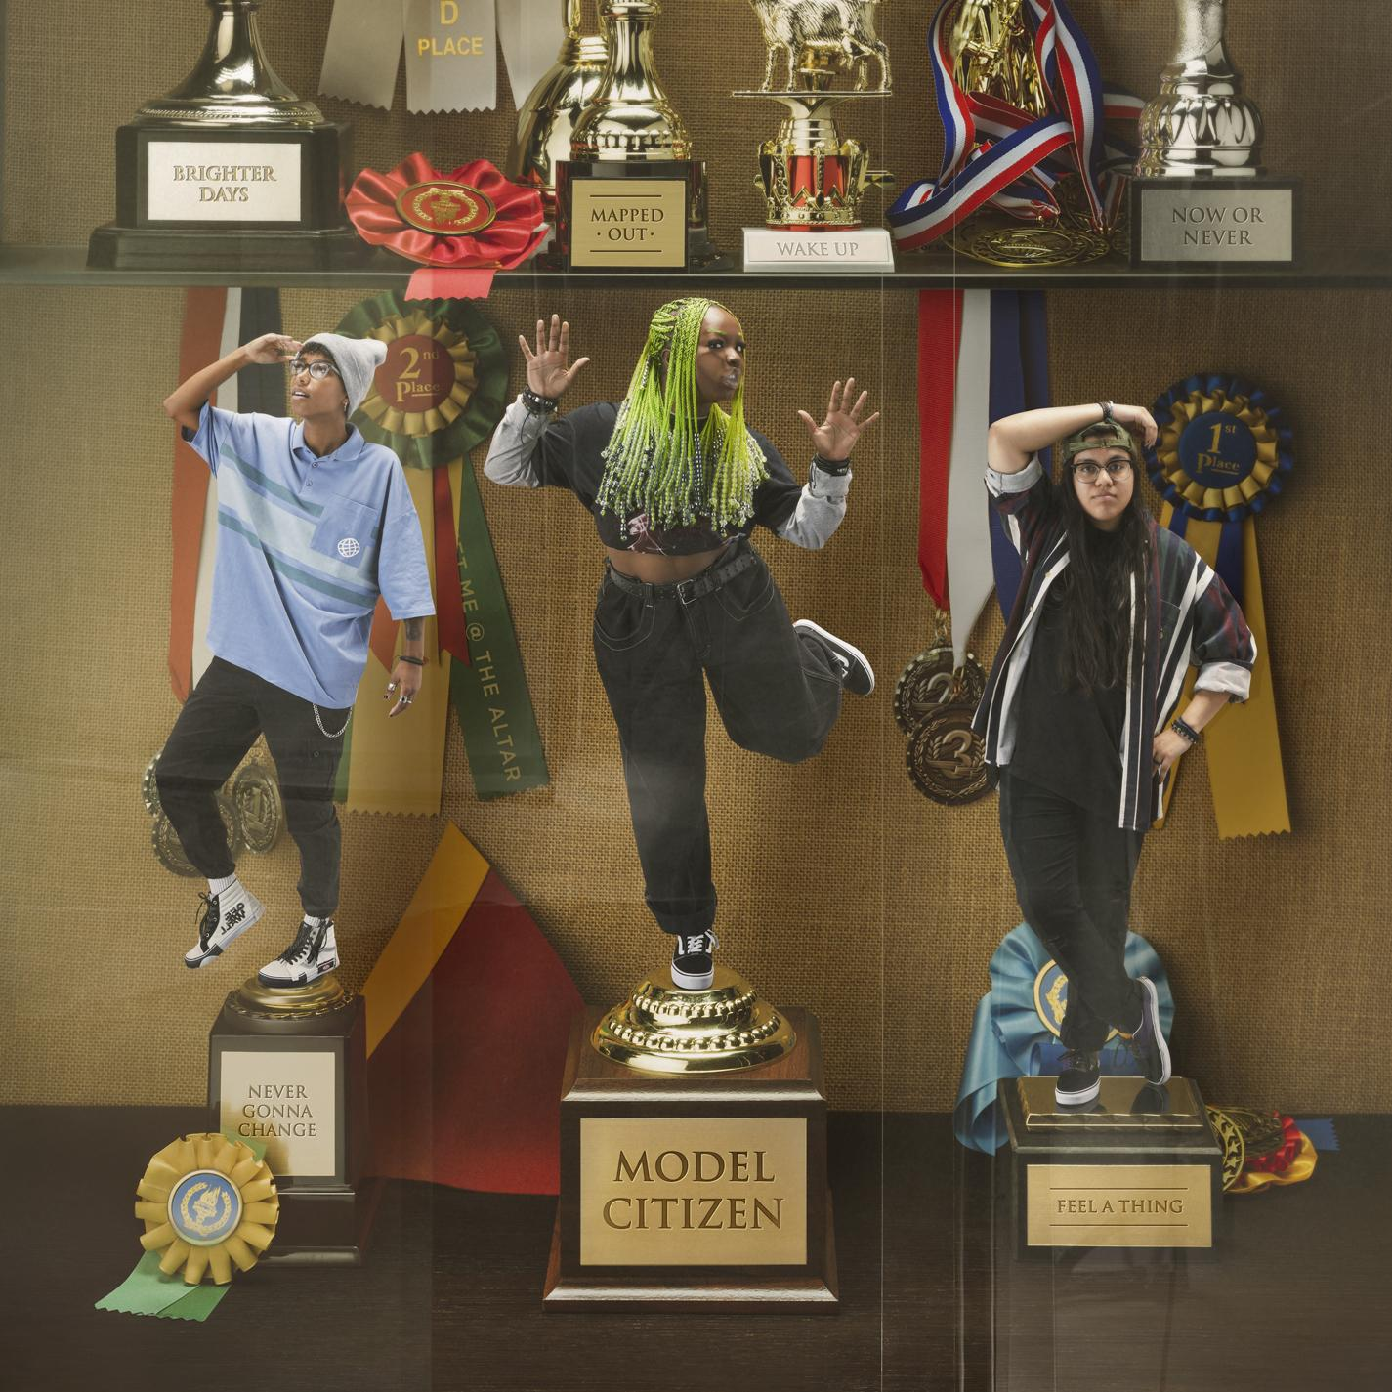

Tracklisting:
1. Feel A Thing
2. Mapped Out
3. Brighter Days (Are Before Us)
4. Now Or Never
5. Never Gonna Change
6. Wake Up

ABOUT MEET ME @ THE ALTAR:
Meet Me @ The Altar present a new musical and cultural paradigm for pop punk. The Florida-based trio—Edith Johnson [vocals], Téa Campbell [guitar], and Ada Juarez [drums]—write the kinds of anthems that you can scream along to at a festival, head-bang to in a club, or sit with while in your feelings at home. The women may have met via YouTube - in true modern-day fashion - but the band shares a classic mission. Flipping the script for rock music and its culture, they bring together elements of Warped Tour-era punk, 2010s pop, and easycore. In 2020, early champions such as Halsey, Alex Gaskarth of All Time Low and Dan “Soupy” Campbell of The Wonder Years came forward as the trio inevitably inked a deal with Fueled By Ramen. On the heels of singles “Garden” and “Hit Like A Girl,” widespread tastemaker praise followed from The FADER, Rolling Stone, Nylon, and Stereogum. Meanwhile, Vulture predicted, “Meet Me @ The Altar make a convincing case that the future of pop-punk is Black, Latina, and female.” While amassing critical acclaim, they tirelessly wrote and recorded what would become their 2021 EP Model Citizen [Fueled By Ramen], set for arrival on August 13th.

# # #

CONNECT WITH MEET ME @ THE ALTAR
MeetMeAtTheAltar.com
Facebook
Instagram
Twitter
YouTube

Press Contacts:
Collin Citron / CollinCitron@Elektra.com
Sarah Goldstein / SarahGoldstein@Elektra.com

