MOTIONLESS IN WHITE
SHARE COVER OF THE KILLERS’ “SOMEBODY TOLD ME”

OFFICIAL VISUALIZER FOR THE TRACK STREAMING NOW

ANOTHER LIFE / ETERNALLY YOURS: MOTION PICTURE COLLECTION EP OUT NOW

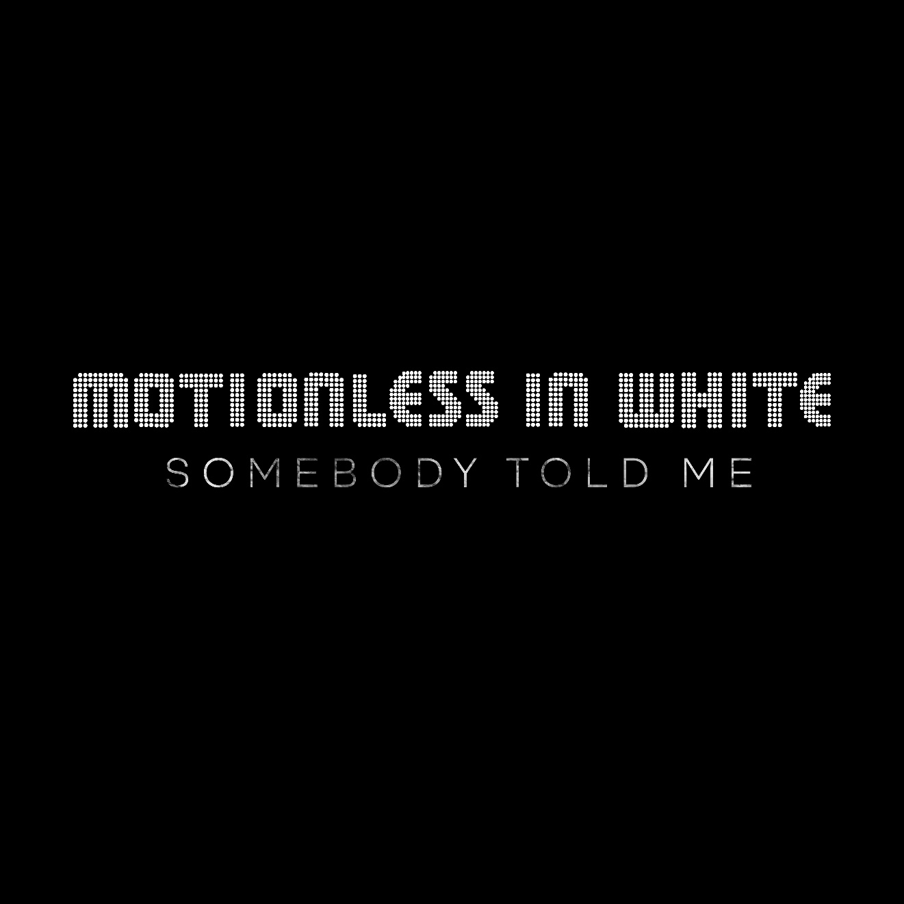

MOTIONLESS IN WHITE – “SOMEBODY TOLD ME” (THE KILLERS COVER)
DSPS: https://motionlessinwhite.lnk.to/stm
YOUTUBE: https://youtu.be/RYazu20DUzc
SEPTEMBER 9, 2020 - Motionless In White have shared a cover of The Killers’ “Somebody Told Me” which is available now on all streaming platforms with an official visualizer streaming on the band’s YouTube channel.
The band’s frontman Chris Motionless elaborated on the cover explaining, “During quarantine we wanted to continue to see what new projects we could push ourselves to create. We’ve always wanted to take a shot at covering an iconic alternative song, and “Somebody Told Me” has always been one of those tracks that oozes pure energy, and has crazy good hooks that we felt we could transform into a great rock version. We are very happy to present this cover as one of the projects birthed out of the Covid down time and hope it’s fun for all fans to check out and tap their feet too."
The new cover follows the recent release of Motionless In White’s Another Life / Eternally Yours: Motion Picture Collection EP, which was produced by Justin Deblieck and mixed by Steve Sopchak. The EP is available now on all streaming platforms.
For the EP, the acclaimed Scranton, PA band reconstructed, reimagined, and reinvigorated two fan favorite singles: “Another Life” and “Eternally Yours.” Additionally, they included brand new cinematic instrumental tracks for both. For this big screen-worthy interpretation of “Another Life,” they recruited dark pop Estonian artist Kerli to contribute an emotionally charged vocal. Over a bed of orchestral strings and sparse piano, frontman Chris Motionless locks into a haunting and hypnotic duet with her. The official music video offers a ghostly counterpoint and alternate view of the original as well. View it HERE.
Meanwhile, Motionless In White enlisted Australian vocalist Crystal Joilena to join this nocturnal take of “Eternally Yours.” Classically inspired piano cuts through swells of strings as the vocals reach heavenly heights on a solemn promise. Punctuated by lasers and galactic vignettes, the accompanying visual complements the song’s otherworldly energy.
A highlight of the group’s latest album DISGUISE [Roadrunner Records], the original “Another Life” ascended to the Top 15 at Active Rock Radio, becoming their highest-charting single to date. It has notably gathered 9.5 million views on the official music video, not to mention, Beartooth frontman Caleb Shomo recently remixed “Another Life.”
Motionless In White stormed into 2020 in support of their latest album DISGUISE. Available now at all DSPs and at www.motionlessinwhite.net, DISGUISE made an explosive chart debut upon release, debuting at #4 on Billboard’s “Top Album Sales” chart while also claiming #2 on the “Hard Rock Albums” chart, and #27 on the SoundScan/Billboard 200 -- Motionless In White’s third consecutive Top 30 entry on the overall chart. DISGUISE is highlighted by a series of stellar singles, including “Brand New Numb,” “Undead Ahead 2: The Tale Of The Midnight Ride,” and “Disguise,” the latter joined by a haunting companion video directed by frequent collaborators Jeremy Danger & Travis Shinn and streaming HERE. In addition, “Another Life” was joined by an official visual, directed by Max Moore and is streaming now via Motionless In White’s official YouTube channel HERE.
###

MOTIONLESS IN WHITE ONLINE:
https://www.motionlessinwhite.net
https://www.facebook.com/motionlessinwhite
https://twitter.com/MIWband
https://www.instagram.com/miwband/
https://www.youtube.com/user/motionless1234

