MOTIONLESS IN WHITE
SHARE NEW SINGLE & MUSIC VIDEO – “MASTERPIECE”

NEW ALBUM SCORING THE END OF THE WORLD ARRIVES JUNE 10TH

ALBUM PRE-ORDERS AVAILABLE NOW

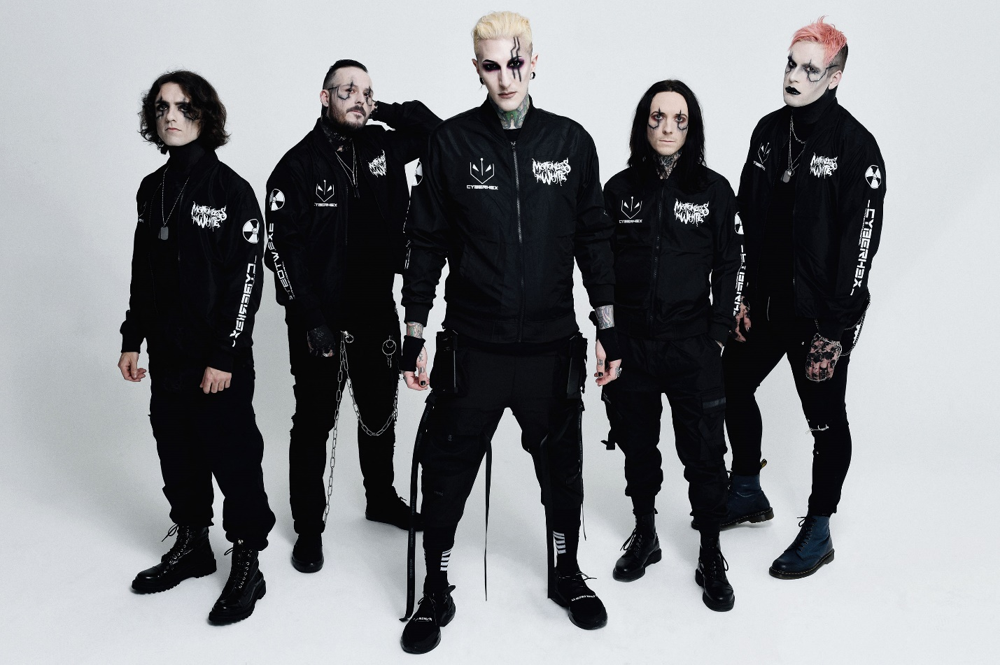
PHOTO CREDIT: @ROCKCANDYPHOTO

APRIL 14, 2022 – Roadrunner Records band Motionless In White have unveiled a brand new single entitled “Masterpiece,” which is available today on all streaming platforms and accompanied by an official music video directed by Max Moore—streaming on the band’s official YouTube channel. The new song impacts Active Rock radio today and paves the way for the band’s widely anticipated new full-length album, Scoring The End of the World, set for release on June 10, 2022. The forthcoming album is available to pre-save on all streaming platforms today with exclusive merch bundles available for pre-order in the band’s official store [album art / tracklist below].

Vocalist Chris Motionless elaborated on “Masterpiece” noting, “‘Masterpiece’ is a song which I feel embodies the raw and brutally honest nature of what makes Motionless In White. It took me many years to fully recognize that these are the types of songs that truly are the lifeblood of the relationship between the band and our fans. There is something really powerful and magical in being able to write a song that not only expresses your own deepest emotions and feelings, but to write something that may express the feelings of those who find it hard to articulate their own at times. It is on another level of special. In my own experience as a listener, these types of songs have always offered comfort amidst the pain, and ‘Masterpiece’ is my way of returning that energy back to the universe for others to potentially find and carry with them. We’re all going through something dark in our heads on a daily basis, so why not go through it together?”

“Masterpiece” hinges on ominous clean guitars as vocalist Chris Motionless delivers a heart-wrenching refrain asking, “So how do I apologize and put the tears back in your eyes?” In the visual, the band delivers a performance in an abandoned home, sifting through discarded memories of a past life before a final blaze burns it all down.

Building on the anticipation for Scoring The End of the World, the band dropped the album’s first single “Cyberhex” last month. The track’s official music video directed by the band’s guitarist Ricky Olson and Logan Beaver quickly trended Top 10 on YouTube and has since amassed over 2.2 million views.

Scoring The End of the World fully encompasses the expanse of the band’s dynamic, deep, and dark vision, and marks the band’s first full-length body of work in three years since 2019’s Disguise. The latter has quietly made a major impact on rock music and culture. The single “Another Life” stands out as their most-streamed song ever with over 23 million YouTube views on the music video. The record claimed a spot on Loudwire’s “50 Best Metal Albums of 2019,” plus it ignited the creative renaissance that would set the stage for the statement-making Scoring The End of the World.

Motionless In White are currently out on a massive triple co-headline North American tour. Deemed the Trinity Of Terror Tour, the run features the unholy triumvirate of Motionless In White, Black Veil Brides and Ice Nine Kills and marks the first time ever that fans get to see all three bands on the same stage each night [full itinerary below]. The coast-to-coast outing, which will see the three bands alternating closing sets each night and will continue through a final performance at Norfolk’s Chartway Arena on April 27th. For tickets and more information, visit www.trinityofterrortour.com.
About Motionless In White:
In 2006, Motionless In White materialized out of Scranton, PA with an inimitable conjuration of sharp metallic rock, nocturnal industrial, magnetic melodies, and larger-than-life visual imagery. The quintet—Chris Motionless [Vocals], Ricky Olson [Guitar], Ryan Sitkowski [guitar], Vinny Mauro [drums], and Justin Morrow [bass]—quietly clawed their way to the forefront of hard rock, gathering nearly half-a-billion cumulative streams and views to date. Following the success of Creatures [2010] and Infamous [2012], Reincarnate [2014] sunk its teeth into the Top 10 of the Billboard Top 200, bowing at #9 and capturing #1 on the Top Rock Albums Chart. Both Graveyard Shift [2017] and Disguise [2019] cracked the Top 5 of the Top Hard Rock Albums Chart and Top Rock Albums Chart. The latter yielded the band’s biggest hit to date, “Another Life,” followed by “Brand New Numb” and “Disguise.” Along the way, they sold out headline tours and supported everyone from Slipknot and Korn to Breaking Benjamin. Not to mention, Motionless In White have collaborated with Jonathan Davis of Korn, Maria Brink of In This Moment, Dani Filth of Cradle of Filth, Tim Sköld of KMFDM, Caleb Shomo of Beartooth, and more. The five-piece kept busy throughout 2020 with the Deadstream event performance of Creatures for its decade-anniversary, a cover of The Killers’ “Somebody Told Me,” and the standalone single “Creatures X: To The Grave.” Once again, Motionless In White return to the studio and the road in 2021 as they perfect the poetically pummeling sound they patented.

[album art / tracklist / tour itinerary below]

MOTIONLESS IN WHITE
SCORING THE END OF THE WORLD

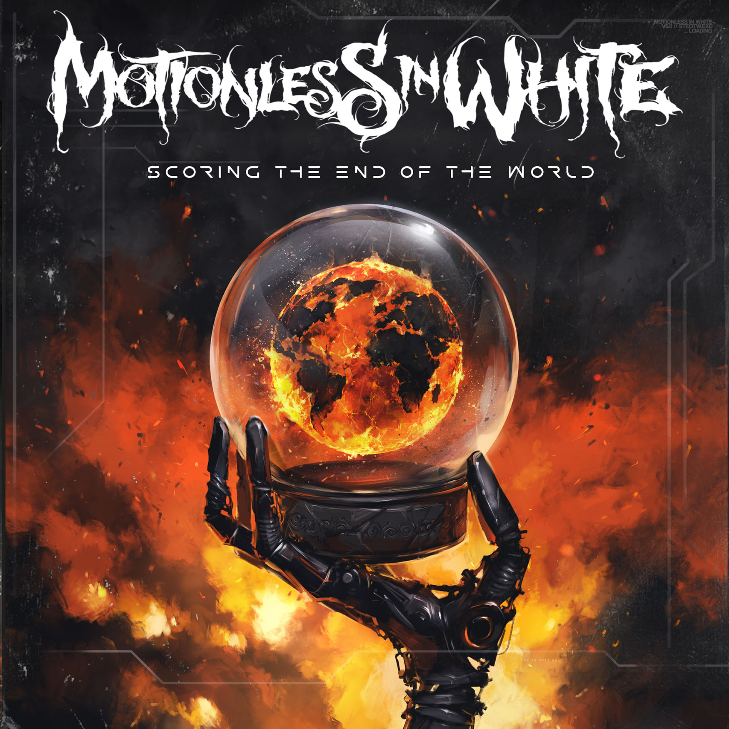

1. Meltdown
2. Sign Of Life
3. Werewolf
4. Porcelain
5. Slaughterhouse (Feat: Bryan Garris)
6. Masterpiece
7. Cause Of Death
8. We Become The Night
9. Burned At Both Ends 2
10. Broadcasting From Beyond The Grave: Corpse Nation
11. Cyberhex
12. Red, White & Boom (Feat: Caleb Shomo)
13. Scoring The End Of The World (Feat: Mick Gordon)

MOTIONLESS IN WHITE
NORTH AMERICAN TOUR DATES
3/17 – 4/27 - TRINITY OF TERROR TOUR

4/07 - Pittsburgh, PA - UPMC Events Center
4/08 - Indianapolis, IN - The Pavilion at Pan Am
4/09 - Pikeville, KY - Appalachian Wireless Arena
4/11 - Buffalo, NY - Buffalo Riverworks
4/13 - Wallingford, CT - The Dome
4/14 - Portland, ME - Cross Insurance Arena
4/15 - Huntington, NY - Paramount Theater
4/16 - Philadelphia, PA - The Fillmore
4/19 - Birmingham, AL - Avondale Brewing Company
4/21 - St. Augustine, FL - Saint Augustine Amphitheatre*
4/22 - Tampa, FL - Amalie Arena*
4/23 - Orlando, FL - Central Florida Fairground*
4/24 - Myrtle Beach, SC - House of Blues
4/26 - Charlotte, NC – Fillmore
4/27 - Norfolk, VA - Chartway Arena
7/16 - Cadott, WI - Rock Fest**
10/22 - Las Vegas, NV - When We Were Young**
10/23 - Las Vegas, NV - When We Were Young**
10/29 - Las Vegas, NV - When We Were Young**

*Radio Show
** Festival

###

MOTIONLESS IN WHITE ONLINE:
https://www.motionlessinwhite.net
https://www.facebook.com/motionlessinwhite
https://twitter.com/MIWband
https://www.instagram.com/miwband/
https://www.youtube.com/user/motionless1234

