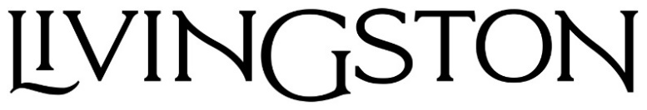
DEBUTS NEW SINGLE “MESSAGE IN A BOTTLE”

NEW EP AN UNLIKELY ORIGIN STORY
AVAILABLE NOW

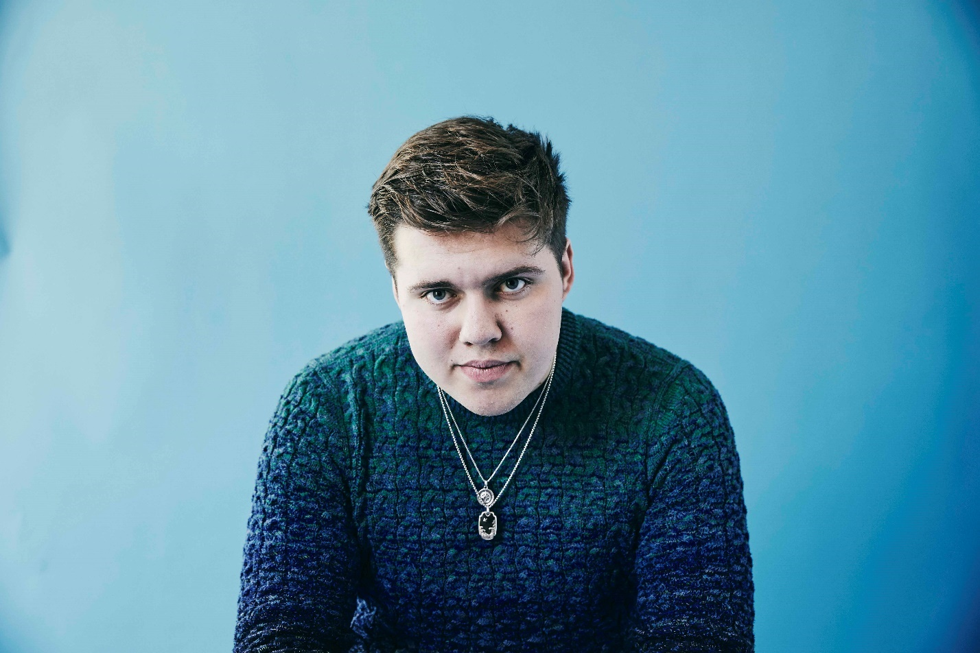

AUGUST 18, 2021 – Fresh off the release of his EP, An Unlikely Origin Story, Elektra Records artist Livingston has debuted new single “Message In A Bottle.” The track is available now on all streaming platforms.
Livingston elaborated on the single, adding, “There are times when I waste so much potential thinking about what could have been – what I could have changed, what I would have said differently. I wanted to write a song about what it would feel like to let that go – to say one statement of closure and make peace with the change.”
Earlier this summer, Livingston shared new EP An Unlikely Origin Story and made his live performance debut, supporting Fitz and the Tantrums on select dates. The EP was heralded by singles “The Giver,” “Hercules,” and “Superkid.” “Hercules” – a song about fearing change and embracing vulnerability – was co-produced by Jorgen Odegard (Justin Bieber, Yungblud, Quinn XCII, Imagine Dragons) and co-written by Odegard and Chloe George. The track followed December single “Superkid,” which is accompanied by a powerful visual written and directed by Livingston himself. Livingston has racked up over 40 million streams on DSPs and nearly 2 million followers on Tik Tok in only a year – cementing his status as an artist on the rise. An Unlikely Origin Story EP is available now on all streaming platforms.
Last year, the self-taught singer, songwriter, producer and engineer shared his debut EP Lighthouse, praised as “uplifting and inspiring” by PopularTV and earning Livingston the title of “pop star in the making” from Ones To Watch. The eight-track collection is available now at all DSPs via Elektra Records and features standout track “Carnival” in addition to singles “Home,” “Say The Word,” and “Fairytale” – the latter of which was shared by Billboard alongside the artist’s Elektra Records signing announcement.
Growing up in Denton, Texas, Livingston was faced with bullying, anxiety, and relentless self-doubt. Throughout his childhood, he struggled to fit in and faced a constant battle to find his place in the world – finally finding the connection and understanding he sought when he poured his feelings of loneliness, isolation and inadequacy into song. Drawing inspiration for his “orchestral cinematic pop” from a wide range of artists in pop, hip hop and film scores, Livingston combines instantly memorable melodies with sweeping orchestral compositions and is first and foremost driven by honest storytelling.

[Single art below]

###

LIVINGSTON
“Message In A Bottle”
AVAILABLE NOW

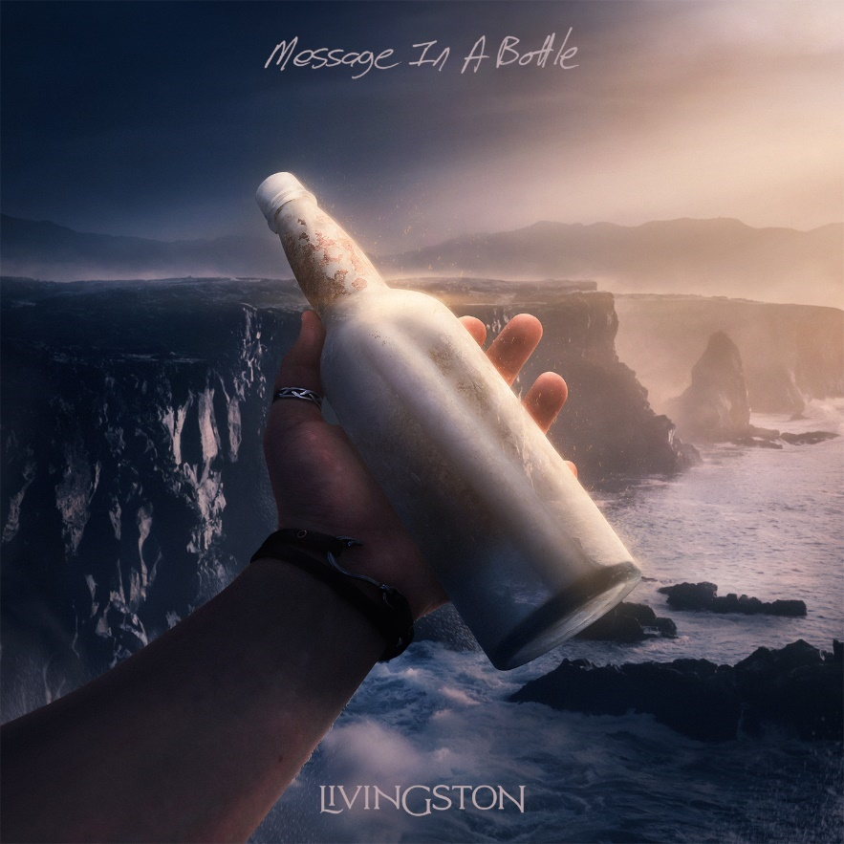

CONNECT WITH Livingston
www.livingstonofficial.com
TIK TOK
YOUTUBE
INSTAGRAM
TWITTER
FACEBOOK

CONTACT:
Sarah Goldstein
SarahGoldstein@elektra.com
212-707-2146

