SHARES NEW SINGLE “HERCULES”

NEW EP AN UNLIKELY ORIGIN STORY ARRIVING THIS YEAR

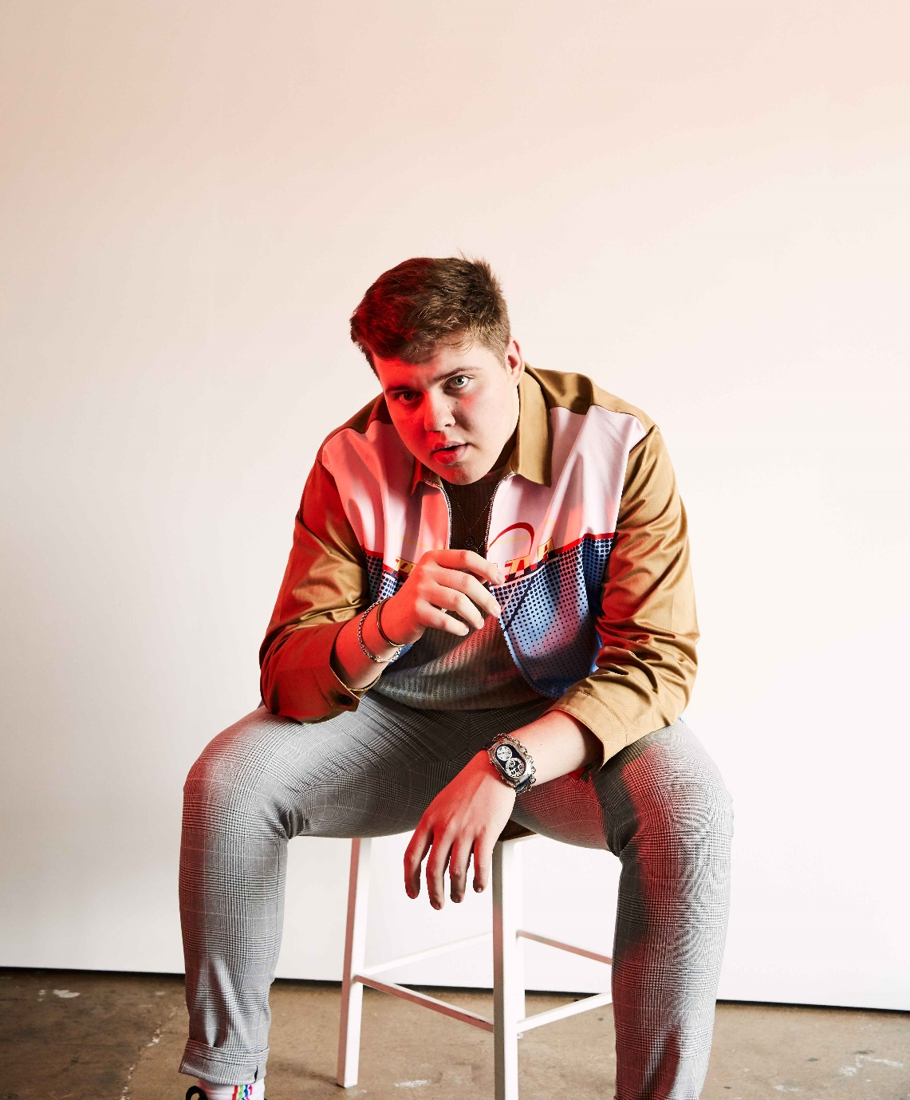

FEBRUARY 10, 2021 – Elektra Records recording artist Livingston has debuted “Hercules,” the second single from his upcoming EP, An Unlikely Origin Story. A song about fearing change and embracing vulnerability, “Hercules” was co-produced by Jorgen Odegard (Justin Bieber, Yungblud, Quinn XCII, Imagine Dragons) and co-written by Odegard and Chloe George. “Hercules” is available now on all streaming platforms, with the accompanying lyric video now streaming on Livingston’s official YouTube channel.
Livingston expanded on the track, "‘Hercules’ is a song about fearing change and not wanting to lose myself due to the shifts in the scenery and people around me. My first EP was written around experiences in my youth and my identity struggles as a teenager; this song is about looking forward and toward a message of self-acceptance and embracing my vulnerability as an eighteen-year-old artist. I loved writing this song that jumps between pure confidence and true insecurity – trying to display everything we wish we were to others but being unsure about who we are to ourselves. Working with Jorgen and Chloe on this song opened my eyes to a new writing and production space that felt really inspiring to take this next step with my music.”
In December, Livingston debuted “Superkid,” the first taste of music from his upcoming EP An Unlikely Origin Story, slated for release in 2021. The track is accompanied by a powerful visual written and directed by Livingston himself, which finds the artist inhabiting multiple characters who influenced the artist throughout his life. Each Livingston release further cements his status as an artist on the rise – racking up over 20 million streams on DSPs and 1.5 million followers on Tik Tok—including 60 million channel views—all in less than year.
Earlier this summer, the self-taught singer, songwriter, producer and engineer shared his debut EP Lighthouse, praised as “uplifting and inspiring” by PopularTV and earning Livingston the title of “pop star in the making” from Ones To Watch. The eight-track collection is available now at all DSPs via Elektra Records and features standout track “Carnival” in addition to singles “Home,” “Say The Word,” and “Fairytale” – the latter of which was shared by Billboard alongside the artist’s Elektra Records signing announcement.
Growing up in Denton, Texas, Livingston was faced with bullying, anxiety, and relentless self-doubt. Throughout his childhood, he struggled to fit in and faced a constant battle to find his place in the world – finally finding the connection and understanding he sought when he poured his feelings of loneliness, isolation and inadequacy into song. Drawing inspiration for his “orchestral cinematic pop” from a wide range of artists in pop, hip hop and film scores, Livingston combines instantly memorable melodies with sweeping orchestral compositions and is first and foremost driven by honest storytelling.

[EP Art Below]

LIVINGSTON
“HERCULES”
AVAILABLE NOW
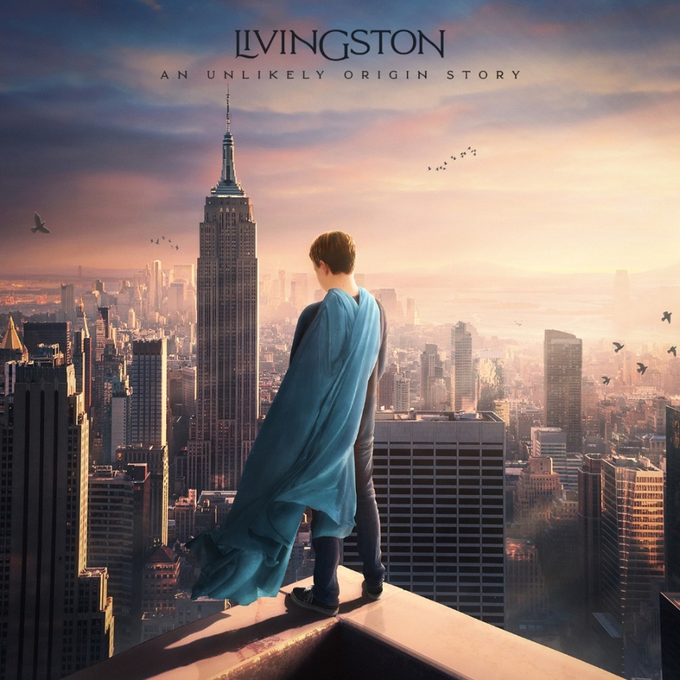

CONNECT WITH Livingston
www.livingstonofficial.com
TIK TOK
YOUTUBE
INSTAGRAM
TWITTER
FACEBOOK

CONTACT:
Sarah Goldstein
SarahGoldstein@elektra.com
212-707-2146

