**HASTINGS RETURNS WITH NEW SINGLE “CHAPSTICK”**

**OFFICIAL LYRIC VIDEO STREAMING NOW** [**HERE**](https://nam04.safelinks.protection.outlook.com/?url=https%3A%2F%2Fyoutu.be%2F2kSMRNWSHGY&data=04%7C01%7CSydneyWorden%40elektra.com%7Ccaa65cc1de844667766b08d993d1f025%7C8367939002ec4ba1ad3d69da3fdd637e%7C0%7C0%7C637703352188552652%7CUnknown%7CTWFpbGZsb3d8eyJWIjoiMC4wLjAwMDAiLCJQIjoiV2luMzIiLCJBTiI6Ik1haWwiLCJXVCI6Mn0%3D%7C1000&sdata=gRWrf4SMqxw0dt2QIjIBoREmZO2DvW8tNKDPxiqftK4%3D&reserved=0)

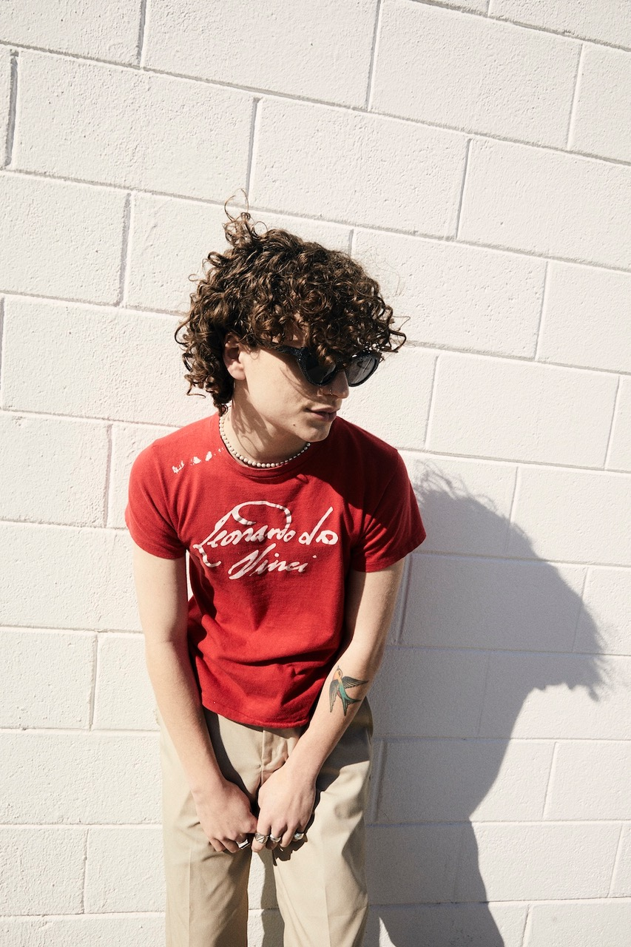

*Photo credit: Jimmy Fontaine*

**OCTOBER 20, 2021** - Nashville-based singer, songwriter, and producer **Hastings** has returned with his brand new single “**Chapstick.**” The catchy, captivating track is accompanied by a lyric video which is streaming now on Hastings’s official YouTube channel [HERE](https://nam04.safelinks.protection.outlook.com/?url=https%3A%2F%2Fyoutu.be%2F2kSMRNWSHGY&data=04%7C01%7CSydneyWorden%40elektra.com%7Ccaa65cc1de844667766b08d993d1f025%7C8367939002ec4ba1ad3d69da3fdd637e%7C0%7C0%7C637703352188562658%7CUnknown%7CTWFpbGZsb3d8eyJWIjoiMC4wLjAwMDAiLCJQIjoiV2luMzIiLCJBTiI6Ik1haWwiLCJXVCI6Mn0%3D%7C1000&sdata=T9MWF%2B4lVielq%2FERj%2FwpKhWXVE%2FNgfaxST9H6I%2BopAY%3D&reserved=0). “Chapstick” is available now on all streaming platforms [HERE](https://nam04.safelinks.protection.outlook.com/?url=https%3A%2F%2Fhastings.lnk.to%2FChapstick&data=04%7C01%7CSydneyWorden%40elektra.com%7Ccaa65cc1de844667766b08d993d1f025%7C8367939002ec4ba1ad3d69da3fdd637e%7C0%7C0%7C637703352188572645%7CUnknown%7CTWFpbGZsb3d8eyJWIjoiMC4wLjAwMDAiLCJQIjoiV2luMzIiLCJBTiI6Ik1haWwiLCJXVCI6Mn0%3D%7C1000&sdata=tzFqSI2uaDMSxkYuxWswPvzFfIzcXEDNaS6sprqgNck%3D&reserved=0) via DBLBLK Records.

“I still remember the day I wrote ‘Chapstick’ with my friends, and the feeling we had while writing it was surreal,” Hastings shared. “It's always had this energy about it that has become a standard for me, and playing it live makes it that much more exciting.”

“Chapstick” follows Hastings’s debut single “[Heart’s Not In It](https://nam04.safelinks.protection.outlook.com/?url=https%3A%2F%2Fyoutu.be%2F-_plBkmVJOI&data=04%7C01%7CSydneyWorden%40elektra.com%7Ccaa65cc1de844667766b08d993d1f025%7C8367939002ec4ba1ad3d69da3fdd637e%7C0%7C0%7C637703352188572645%7CUnknown%7CTWFpbGZsb3d8eyJWIjoiMC4wLjAwMDAiLCJQIjoiV2luMzIiLCJBTiI6Ik1haWwiLCJXVCI6Mn0%3D%7C1000&sdata=8xQl23i3yV93AGYqubuDNOKtKM2A7FmWoxNrCvIgePk%3D&reserved=0),” which was released in August to immediate acclaim. ***Billboard*** applauded, “‘Heart’s Not In It’ shows off his easy, immediate melodicism… the interplay between a looped guitar riff and thwacking synths explodes into a glorious pop sing-along.” ***Teen Vogue***highlighted the track in their Best New Music list, praising, “Hastings shows restraint in his debut single,” while ***The Honey Pop*** proclaimed “We have a feeling you’re going to be hearing his name for a long time.” “Heart’s Not In It” is available to stream and download now [HERE](https://nam04.safelinks.protection.outlook.com/?url=https%3A%2F%2Fhastings.lnk.to%2FHeartsNotInItAW&data=04%7C01%7CSydneyWorden%40elektra.com%7Ccaa65cc1de844667766b08d993d1f025%7C8367939002ec4ba1ad3d69da3fdd637e%7C0%7C0%7C637703352188582635%7CUnknown%7CTWFpbGZsb3d8eyJWIjoiMC4wLjAwMDAiLCJQIjoiV2luMzIiLCJBTiI6Ik1haWwiLCJXVCI6Mn0%3D%7C1000&sdata=kwkZSGFjDFZ%2FWHZ6Nu0f8i%2FqxMw5xW5QydmQ692OspY%3D&reserved=0). Watch the track’s lyric video [HERE](https://nam04.safelinks.protection.outlook.com/?url=https%3A%2F%2Fyoutu.be%2F-_plBkmVJOI&data=04%7C01%7CSydneyWorden%40elektra.com%7Ccaa65cc1de844667766b08d993d1f025%7C8367939002ec4ba1ad3d69da3fdd637e%7C0%7C0%7C637703352188582635%7CUnknown%7CTWFpbGZsb3d8eyJWIjoiMC4wLjAwMDAiLCJQIjoiV2luMzIiLCJBTiI6Ik1haWwiLCJXVCI6Mn0%3D%7C1000&sdata=kp5oOE1JtMXJmA27xcaaWJTGWst41phwPl%2B%2BdNN4kHc%3D&reserved=0).

Last month, Hastings made his live debut, supporting The Band CAMINO at New York City’s Bowery Ballroom. The Band CAMINO also welcomed Hastings onstage to perform “Roses”, which he co-wrote, at their recent headline show at Nashville, TN’s famed Ryman Auditorium. Watch [HERE](https://nam04.safelinks.protection.outlook.com/?url=https%3A%2F%2Fwww.instagram.com%2Fp%2FCUNs-7MrJn6%2F&data=04%7C01%7CSydneyWorden%40elektra.com%7Ccaa65cc1de844667766b08d993d1f025%7C8367939002ec4ba1ad3d69da3fdd637e%7C0%7C0%7C637703352188592646%7CUnknown%7CTWFpbGZsb3d8eyJWIjoiMC4wLjAwMDAiLCJQIjoiV2luMzIiLCJBTiI6Ik1haWwiLCJXVCI6Mn0%3D%7C1000&sdata=yG1IGvJP4j64glHXLto28siksEQA6KTAWufVu%2BI%2BhaA%3D&reserved=0).

Stay tuned for more from Hastings soon.

**About Hastings:**

Every once in a while, you’ll hear a song that nudges you to walk across the room and introduce yourself to a stranger, FaceTime your ex, or even change your life. Hastings strives to make those kinds of songs. The Nashville-based singer, songwriter, multi-instrumentalist, and producer couples straightforward lyrical eloquence with guitar-shaped soundscapes and traffic-stopping vocal acrobatics. Growing up between Florida, Michigan, and Tennessee, he cut his teeth by playing drums on his father’s worship team at the age of three before learning guitar and piano. After getting his drivers license at 16-years-old, he asked his parents to let him move to Nashville to pursue music - and his dad tossed him the keys. Hastings integrated himself into the city’s scene slowly but surely, in between finishing his GED. During 2018, he serendipitously met Garrison Burgess of The Band CAMINO and wound-up living with him and spending countless hours writing and recording together. Behind the scenes, he co-wrote the single “Roses” for The Band CAMINO and “Don’t Blame Me” for Kingston Hythe. Simultaneously, his solo demos caught the attention of DBLBLK Records. Now, he presents a sharp and scorching signature style on a series of singles led by “Heart’s Not In It” and “Chapstick”.

**HASTINGS**

**“Chapstick”**

**AVAILABLE NOW** [**HERE**](https://nam04.safelinks.protection.outlook.com/?url=https%3A%2F%2Fhastings.lnk.to%2FChapstick&data=04%7C01%7CSydneyWorden%40elektra.com%7Ccaa65cc1de844667766b08d993d1f025%7C8367939002ec4ba1ad3d69da3fdd637e%7C0%7C0%7C637703352188592646%7CUnknown%7CTWFpbGZsb3d8eyJWIjoiMC4wLjAwMDAiLCJQIjoiV2luMzIiLCJBTiI6Ik1haWwiLCJXVCI6Mn0%3D%7C1000&sdata=bLlYKrG3pFHALkiSK%2FCSyLr6bbCKweYudYv9Wz6QIx0%3D&reserved=0)

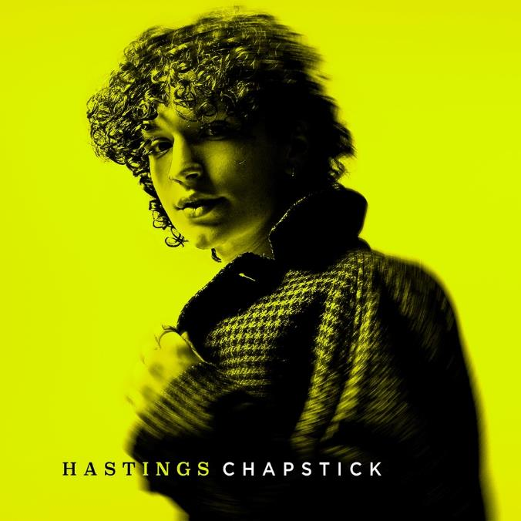

**CONNECT WITH HASTINGS**

[Website](https://nam04.safelinks.protection.outlook.com/?url=https%3A%2F%2Fwww.imhastings.com%2F&data=04%7C01%7CSydneyWorden%40elektra.com%7Ccaa65cc1de844667766b08d993d1f025%7C8367939002ec4ba1ad3d69da3fdd637e%7C0%7C0%7C637703352188602624%7CUnknown%7CTWFpbGZsb3d8eyJWIjoiMC4wLjAwMDAiLCJQIjoiV2luMzIiLCJBTiI6Ik1haWwiLCJXVCI6Mn0%3D%7C1000&sdata=pu0%2BWjs1DfWrTaauDAXbc4elGQ%2FPER4RRJbLbJyqiYA%3D&reserved=0)

[Instagram](https://nam04.safelinks.protection.outlook.com/?url=https%3A%2F%2Fwww.instagram.com%2Fimhastings%2F&data=04%7C01%7CSydneyWorden%40elektra.com%7Ccaa65cc1de844667766b08d993d1f025%7C8367939002ec4ba1ad3d69da3fdd637e%7C0%7C0%7C637703352188602624%7CUnknown%7CTWFpbGZsb3d8eyJWIjoiMC4wLjAwMDAiLCJQIjoiV2luMzIiLCJBTiI6Ik1haWwiLCJXVCI6Mn0%3D%7C1000&sdata=5DKgPKsynwLNjg%2BWIrXC3aYl5grM0AT8gtIXXY%2FgGYY%3D&reserved=0)

[YouTube](https://nam04.safelinks.protection.outlook.com/?url=https%3A%2F%2Fwww.youtube.com%2Fchannel%2FUCOiD5tZQ6MlNjom-eGCsgXA%2Ffeatured&data=04%7C01%7CSydneyWorden%40elektra.com%7Ccaa65cc1de844667766b08d993d1f025%7C8367939002ec4ba1ad3d69da3fdd637e%7C0%7C0%7C637703352188612620%7CUnknown%7CTWFpbGZsb3d8eyJWIjoiMC4wLjAwMDAiLCJQIjoiV2luMzIiLCJBTiI6Ik1haWwiLCJXVCI6Mn0%3D%7C1000&sdata=jWWYDBIc1%2F%2B3StTCc7SwQz9Q8E4T9ubABeujYoEs%2B9M%3D&reserved=0)

[Twitter](https://nam04.safelinks.protection.outlook.com/?url=https%3A%2F%2Ftwitter.com%2Fimhastingss&data=04%7C01%7CSydneyWorden%40elektra.com%7Ccaa65cc1de844667766b08d993d1f025%7C8367939002ec4ba1ad3d69da3fdd637e%7C0%7C0%7C637703352188612620%7CUnknown%7CTWFpbGZsb3d8eyJWIjoiMC4wLjAwMDAiLCJQIjoiV2luMzIiLCJBTiI6Ik1haWwiLCJXVCI6Mn0%3D%7C1000&sdata=Tr6lTKbqjTrGHOjEw%2FhNUOIVze0zN0aiNDcbhjlK2J4%3D&reserved=0)

[TikTok](https://nam04.safelinks.protection.outlook.com/?url=https%3A%2F%2Fwww.tiktok.com%2F%40imhastingss%3F&data=04%7C01%7CSydneyWorden%40elektra.com%7Ccaa65cc1de844667766b08d993d1f025%7C8367939002ec4ba1ad3d69da3fdd637e%7C0%7C0%7C637703352188622610%7CUnknown%7CTWFpbGZsb3d8eyJWIjoiMC4wLjAwMDAiLCJQIjoiV2luMzIiLCJBTiI6Ik1haWwiLCJXVCI6Mn0%3D%7C1000&sdata=L%2Fw4jdMytbT%2FBpAHvBpyHDU%2F%2BxsNErHm8iNdl5F8Yuc%3D&reserved=0)

**For all press inquiries, please contact:**Sarah Goldstein - [sarahgoldstein@elektra.com](mailto:sarahgoldstein@elektra.com)  
Collin Citron - [collincitron@elektra.com](mailto:collincitron@elektra.com)