**HASTINGS RELEASES DEBUT SELF-TITLED EP**

**INCLUDES NEW SINGLE “BLANK ME”**

**OFFICIAL LYRIC VIDEO** [**STREAMING NOW**](https://nam04.safelinks.protection.outlook.com/?url=https%3A%2F%2Fyoutu.be%2FBQzDV0a5z_I&data=04%7C01%7CSydneyWorden%40elektra.com%7C40debdd8ee324ea772c208d9b671eb60%7C8367939002ec4ba1ad3d69da3fdd637e%7C0%7C0%7C637741422672822081%7CUnknown%7CTWFpbGZsb3d8eyJWIjoiMC4wLjAwMDAiLCJQIjoiV2luMzIiLCJBTiI6Ik1haWwiLCJXVCI6Mn0%3D%7C3000&sdata=0kGP3gcMDnNyKVY7mvIqYgU2iYpeFoAIX3Y21HpomrU%3D&reserved=0)

**SET TO SUPPORT THE BAND CAMINO ON 2022 NORTH AMERICAN TOUR**

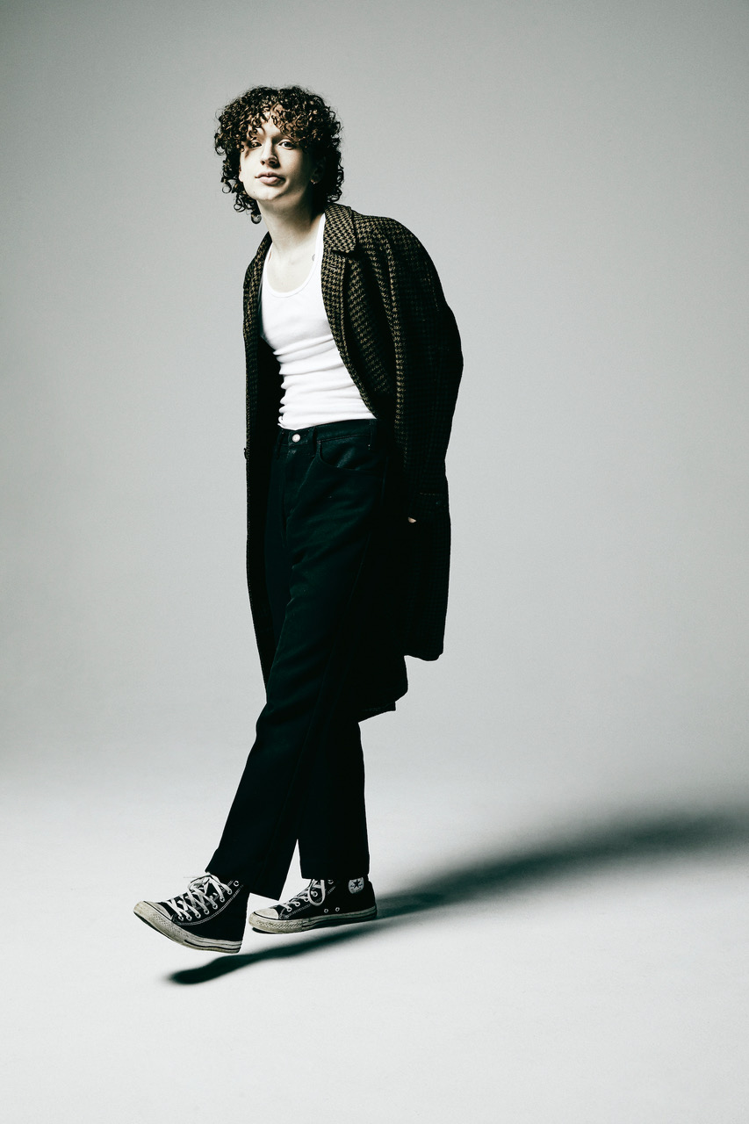

*Photo credit: Jimmy Fontaine*

**DECEMBER 03, 2021** - Rising Nashville-based singer, songwriter, and producer **Hastings** has released his self-titled debut, ***Hastings* EP**. It is available now on all streaming platforms [**HERE**](https://nam04.safelinks.protection.outlook.com/?url=https%3A%2F%2Fhastings.lnk.to%2FHastings&data=04%7C01%7CSydneyWorden%40elektra.com%7C40debdd8ee324ea772c208d9b671eb60%7C8367939002ec4ba1ad3d69da3fdd637e%7C0%7C0%7C637741422672822081%7CUnknown%7CTWFpbGZsb3d8eyJWIjoiMC4wLjAwMDAiLCJQIjoiV2luMzIiLCJBTiI6Ik1haWwiLCJXVCI6Mn0%3D%7C3000&sdata=H7t1JWMugEmnctdHgal4FixNZ4AwV0mCKXjNvFa%2BONE%3D&reserved=0) via DBLBLK Records. The six track collection is highlighted by Hastings’s brand new single “[Blank Me](https://nam04.safelinks.protection.outlook.com/?url=https%3A%2F%2Fyoutu.be%2FBQzDV0a5z_I&data=04%7C01%7CSydneyWorden%40elektra.com%7C40debdd8ee324ea772c208d9b671eb60%7C8367939002ec4ba1ad3d69da3fdd637e%7C0%7C0%7C637741422672822081%7CUnknown%7CTWFpbGZsb3d8eyJWIjoiMC4wLjAwMDAiLCJQIjoiV2luMzIiLCJBTiI6Ik1haWwiLCJXVCI6Mn0%3D%7C3000&sdata=0kGP3gcMDnNyKVY7mvIqYgU2iYpeFoAIX3Y21HpomrU%3D&reserved=0),” which was released earlier this week and is available now alongside an [official lyric video](https://nam04.safelinks.protection.outlook.com/?url=https%3A%2F%2Fyoutu.be%2FBQzDV0a5z_I&data=04%7C01%7CSydneyWorden%40elektra.com%7C40debdd8ee324ea772c208d9b671eb60%7C8367939002ec4ba1ad3d69da3fdd637e%7C0%7C0%7C637741422672822081%7CUnknown%7CTWFpbGZsb3d8eyJWIjoiMC4wLjAwMDAiLCJQIjoiV2luMzIiLCJBTiI6Ik1haWwiLCJXVCI6Mn0%3D%7C3000&sdata=0kGP3gcMDnNyKVY7mvIqYgU2iYpeFoAIX3Y21HpomrU%3D&reserved=0).

“I always knew what I wanted to do, but I didn’t know how to get there,” Hastings shares. “I’ve found my way with this music though. I know what my sound is and who I am. At the end of the day, I’m a kid who has no idea what he’s doing, but he’s doing what he loves. Honestly, I’m going to throw a period on that and let the songs do the rest of the talking.”

Hastings began rolling out the EP with the August release of his first-ever single “[Heart’s Not In It](https://nam04.safelinks.protection.outlook.com/?url=https%3A%2F%2Fhastings.lnk.to%2Fheartsnotinit&data=04%7C01%7CSydneyWorden%40elektra.com%7C40debdd8ee324ea772c208d9b671eb60%7C8367939002ec4ba1ad3d69da3fdd637e%7C0%7C0%7C637741422672822081%7CUnknown%7CTWFpbGZsb3d8eyJWIjoiMC4wLjAwMDAiLCJQIjoiV2luMzIiLCJBTiI6Ik1haWwiLCJXVCI6Mn0%3D%7C3000&sdata=a%2FdJI7BSW1jaA2Mywlc4sxJLm6SvXTQ1NGoBiJMXmCw%3D&reserved=0)”. The track arrived to immediate critical praise, with *Billboard* applauding, “‘Heart’s Not In It’ shows off his easy, immediate melodicism… the interplay between a looped guitar riff and thwacking synths explodes into a glorious pop sing-along.” *Teen Vogue*praised the “funky, guitar-based track” in their Best New Music list, while *The Honey Pop* proclaimed, “We have a feeling you’re going to be hearing his name for a long time.” In October, he returned with “[Chapstick](https://nam04.safelinks.protection.outlook.com/?url=https%3A%2F%2Fhastings.lnk.to%2FChapstick&data=04%7C01%7CSydneyWorden%40elektra.com%7C40debdd8ee324ea772c208d9b671eb60%7C8367939002ec4ba1ad3d69da3fdd637e%7C0%7C0%7C637741422672978322%7CUnknown%7CTWFpbGZsb3d8eyJWIjoiMC4wLjAwMDAiLCJQIjoiV2luMzIiLCJBTiI6Ik1haWwiLCJXVCI6Mn0%3D%7C3000&sdata=h2HYsX3AuxwIywkI%2BA5vllY2Mc4lDfDED3fgGPOONRk%3D&reserved=0),” which has already amassed nearly half-a-million total streams and was championed by *Sweety High* for its “irresistible chorus.”

In September, Hastings made his live debut, supporting The Band CAMINO at New York City’s Bowery Ballroom. The Band CAMINO also welcomed Hastings onstage to perform “Roses”, which he co-wrote, at their recent headline show at Nashville, TN’s famed Ryman Auditorium. Watch [HERE](https://nam04.safelinks.protection.outlook.com/?url=https%25253A%25252F%25252Fwww.instagram.com%25252Fp%25252FCUNs-7MrJn6%25252F&data=04%25257C01%25257CSydneyWorden%252540elektra.com%25257Ccaa65cc1de844667766b08d993d1f025%25257C8367939002ec4ba1ad3d69da3fdd637e%25257C0%25257C0%25257C637703352188592646%25257CUnknown%25257CTWFpbGZsb3d8eyJWIjoiMC4wLjAwMDAiLCJQIjoiV2luMzIiLCJBTiI6Ik1haWwiLCJXVCI6Mn0%25253D%25257C1000&sdata=yG1IGvJP4j64glHXLto28siksEQA6KTAWufVu%25252BI%25252BhaA%25253D&reserved=0).

Next up, Hastings will hit the road supporting The Band CAMINO alongside special guest flor in spring of 2022. The five-week tour kicks off in Louisville, KY at Old Forester’s Paristown Hall on March 23, making stops at The Novo in Los Angeles and New York City’s Terminal 5 before concluding in Philadelphia, PA at Franklin Music Hall on April 30. The full confirmed itinerary is below. Tickets are available now [HERE](https://nam04.safelinks.protection.outlook.com/?url=https%3A%2F%2Fwww.imhastings.com%2Ftour&data=04%7C01%7CSydneyWorden%40elektra.com%7C40debdd8ee324ea772c208d9b671eb60%7C8367939002ec4ba1ad3d69da3fdd637e%7C0%7C0%7C637741422672978322%7CUnknown%7CTWFpbGZsb3d8eyJWIjoiMC4wLjAwMDAiLCJQIjoiV2luMzIiLCJBTiI6Ik1haWwiLCJXVCI6Mn0%3D%7C3000&sdata=fZ9D0kXUklHYl4wLD1CN9VQAUFTp3V5IqOKQYIBPE2Q%3D&reserved=0).

Stay tuned for more from Hastings soon.

**Tour Dates:**

March 23, 2022 - Louisville, KY - Old Forester’s Paristown Hall

March 24, 2022 - Indianapolis, IN - Egyptian Room at Old National Centre

March 25, 2022 - Chicago, IL - Riviera Theatre

March 26, 2022 - Minneapolis, MN - The Fillmore

March 29, 2022 - Salt Lake City, UT - The Complex

March 31, 2022 - Portland, OR - Roseland Theater

April 01, 2022 - Seattle, WA - The Showbox

April 03, 2022 - Vancouver, BC - Commodore Ballroom

April 05, 2022 - San Francisco, CA - The Regency Ballroom

April 06, 2022 - Santa Cruz, CA - Catalyst

April 08, 2022 - Los Angeles, CA - The Novo by Microsoft

April 09, 2022 - Santa Ana, CA - Observatory

April 10, 2022 - Tempe, AZ - Marquee Theatre

April 12, 2022 - Houston, TX - Warehouse Live

April 14, 2022 - Dallas, TX - The Factory in Deep Ellum

April 15, 2022 - Austin, TX - ACL Live at The Moody Theatre

April 17, 2022 - Birmingham, AL - Avondale Brewing Co

April 19, 2022 - Orlando, FL - The Plaza Live

April 21, 2022 - Charlotte, NC - The Fillmore Charlotte

April 22, 2022 - Raleigh, NC - The Ritz

April 23, 2022 - Atlanta, GA - The Eastern

April 24, 2022 - Atlanta, GA - The Eastern

April 26, 2022 - Silver Springs, MD - The Fillmore

April 27, 2022 - New York, NY - Terminal 5

April 29, 2022 - Boston, MA - House of Blues Boston

April 30, 2022 - Philadelphia, PA - Franklin Music Hall

**About Hastings:**

Every once in a while, you’ll hear a song that nudges you to walk across the room and introduce yourself to a stranger, FaceTime your ex, or even change your life. Hastings strives to make those kinds of songs. The Nashville-based singer, songwriter, multi-instrumentalist, and producer couples straightforward lyrical eloquence with guitar-shaped soundscapes and traffic-stopping vocal acrobatics. Growing up between Florida, Michigan, and Tennessee, he cut his teeth by playing drums on his father’s worship team at the age of three before learning guitar and piano. After getting his drivers license at 16-years-old, he asked his parents to let him move to Nashville to pursue music - and his dad tossed him the keys. Hastings integrated himself into the city’s scene slowly but surely, in between finishing his GED. During 2018, he serendipitously met Garrison Burgess of The Band CAMINO and wound-up living with him and spending countless hours writing and recording together. Behind the scenes, he co-wrote the single “Roses” for The Band CAMINO and “Don’t Blame Me” for Kingston Hythe. Simultaneously, his solo demos caught the attention of DBLBLK Records. Now, he presents a sharp and scorching signature style on his debut *Hastings* EP.

**HASTINGS**

***HASTINGS* EP**

[**AVAILABLE NOW**](https://nam04.safelinks.protection.outlook.com/?url=https%3A%2F%2Fhastings.lnk.to%2FHastings&data=04%7C01%7CSydneyWorden%40elektra.com%7C40debdd8ee324ea772c208d9b671eb60%7C8367939002ec4ba1ad3d69da3fdd637e%7C0%7C0%7C637741422672978322%7CUnknown%7CTWFpbGZsb3d8eyJWIjoiMC4wLjAwMDAiLCJQIjoiV2luMzIiLCJBTiI6Ik1haWwiLCJXVCI6Mn0%3D%7C3000&sdata=fcf3DVlO8Uu%2FYSZGTBvSx%2B9IRlpRuG2Fho4p04FkUqc%3D&reserved=0)

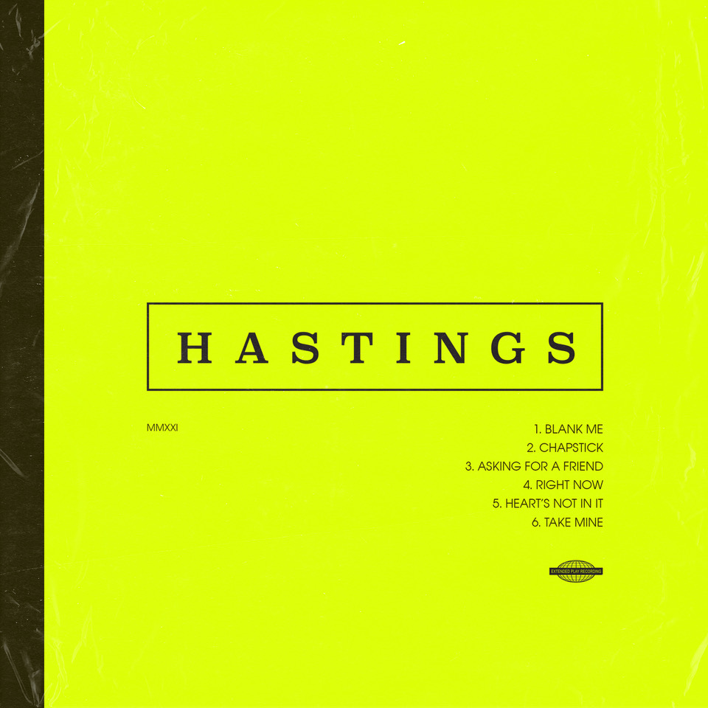

TRACKLISTING:

1. Blank Me
2. Chapstick
3. Asking For A Friend
4. Right Now
5. Heart’s Not In It
6. Take Mine

**CONNECT WITH HASTINGS**

[Website](https://nam04.safelinks.protection.outlook.com/?url=https%25253A%25252F%25252Fwww.imhastings.com%25252F&data=04%25257C01%25257CSydneyWorden%252540elektra.com%25257Ccaa65cc1de844667766b08d993d1f025%25257C8367939002ec4ba1ad3d69da3fdd637e%25257C0%25257C0%25257C637703352188602624%25257CUnknown%25257CTWFpbGZsb3d8eyJWIjoiMC4wLjAwMDAiLCJQIjoiV2luMzIiLCJBTiI6Ik1haWwiLCJXVCI6Mn0%25253D%25257C1000&sdata=pu0%25252BWjs1DfWrTaauDAXbc4elGQ%25252FPER4RRJbLbJyqiYA%25253D&reserved=0)

[Instagram](https://nam04.safelinks.protection.outlook.com/?url=https%25253A%25252F%25252Fwww.instagram.com%25252Fimhastings%25252F&data=04%25257C01%25257CSydneyWorden%252540elektra.com%25257Ccaa65cc1de844667766b08d993d1f025%25257C8367939002ec4ba1ad3d69da3fdd637e%25257C0%25257C0%25257C637703352188602624%25257CUnknown%25257CTWFpbGZsb3d8eyJWIjoiMC4wLjAwMDAiLCJQIjoiV2luMzIiLCJBTiI6Ik1haWwiLCJXVCI6Mn0%25253D%25257C1000&sdata=5DKgPKsynwLNjg%25252BWIrXC3aYl5grM0AT8gtIXXY%25252FgGYY%25253D&reserved=0)

[YouTube](https://nam04.safelinks.protection.outlook.com/?url=https%25253A%25252F%25252Fwww.youtube.com%25252Fchannel%25252FUCOiD5tZQ6MlNjom-eGCsgXA%25252Ffeatured&data=04%25257C01%25257CSydneyWorden%252540elektra.com%25257Ccaa65cc1de844667766b08d993d1f025%25257C8367939002ec4ba1ad3d69da3fdd637e%25257C0%25257C0%25257C637703352188612620%25257CUnknown%25257CTWFpbGZsb3d8eyJWIjoiMC4wLjAwMDAiLCJQIjoiV2luMzIiLCJBTiI6Ik1haWwiLCJXVCI6Mn0%25253D%25257C1000&sdata=jWWYDBIc1%25252F%25252B3StTCc7SwQz9Q8E4T9ubABeujYoEs%25252B9M%25253D&reserved=0)

[Twitter](https://nam04.safelinks.protection.outlook.com/?url=https%25253A%25252F%25252Ftwitter.com%25252Fimhastingss&data=04%25257C01%25257CSydneyWorden%252540elektra.com%25257Ccaa65cc1de844667766b08d993d1f025%25257C8367939002ec4ba1ad3d69da3fdd637e%25257C0%25257C0%25257C637703352188612620%25257CUnknown%25257CTWFpbGZsb3d8eyJWIjoiMC4wLjAwMDAiLCJQIjoiV2luMzIiLCJBTiI6Ik1haWwiLCJXVCI6Mn0%25253D%25257C1000&sdata=Tr6lTKbqjTrGHOjEw%25252FhNUOIVze0zN0aiNDcbhjlK2J4%25253D&reserved=0)

[TikTok](https://nam04.safelinks.protection.outlook.com/?url=https%25253A%25252F%25252Fwww.tiktok.com%25252F%252540imhastingss%25253F&data=04%25257C01%25257CSydneyWorden%252540elektra.com%25257Ccaa65cc1de844667766b08d993d1f025%25257C8367939002ec4ba1ad3d69da3fdd637e%25257C0%25257C0%25257C637703352188622610%25257CUnknown%25257CTWFpbGZsb3d8eyJWIjoiMC4wLjAwMDAiLCJQIjoiV2luMzIiLCJBTiI6Ik1haWwiLCJXVCI6Mn0%25253D%25257C1000&sdata=L%25252Fw4jdMytbT%25252FBpAHvBpyHDU%25252F%25252BxsNErHm8iNdl5F8Yuc%25253D&reserved=0)

**For all press inquiries, please contact:**

Sarah Goldstein - [sarahgoldstein@elektra.com](mailto:sarahgoldstein@elektra.com)

Collin Citron - [collincitron@elektra.com](mailto:collincitron@elektra.com)