GAMES WE PLAY SIGNS TO
FUELED BY RAMEN & DCD2 RECORDS

RELEASES MUSIC VIDEO FOR BREAKOUT SINGLE “I HOPE YOU’RE HAPPY”
WATCH HERE

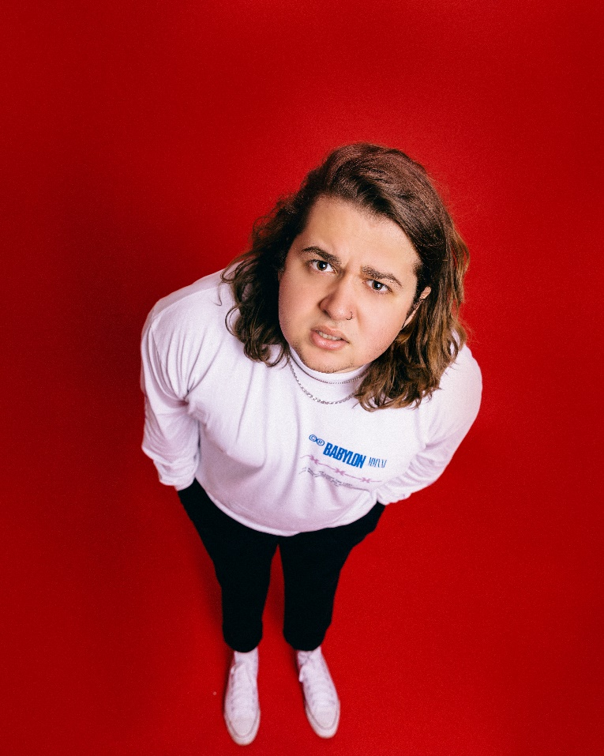
Photo credit: Alice Baxley
DOWNLOAD HI-RED PRESS IMAGE HERE

May 19, 2022 — Miami-born and Los Angeles-based singer, songwriter, multi-instrumentalist, producer, and pop-punk provocateur Games We Play (a.k.a. Emmyn Calleiro) has signed to Fueled By Ramen and DCD2 Records. In tandem with the announcement, he just unveiled the official music video for his viral breakout single “I Hope You’re Happy”. Watch the video on Fueled By Ramen’s YouTube channel HERE, and stream/download “I Hope You’re Happy” HERE.
About the signing, DCD2 Records Founder and Fall Out Boy bassist and visionary Pete Wentz commented, “In a time where the world seems to get so much serotonin funded by a committee of likes and comments on social media platforms, true authenticity is scarce but invaluable. This is what drew me to Games We Play—it’s all there—cohesive, funny, sad—self-aware and ambitious all folded inside of true punk rock hooks. It feels like a throwback, but from the future.”
Emmyn added, “My whole team—Johnny Minardi (Fueled By Ramen), manager Nano, and Pete—are all DIY hardcore pop punk kids. They all understand the place I was in a couple of months before this happened. My dad was in a band, and I love people who grew up in the same scene. Once I met Johnny, I was like, ‘He’s my friend!’ Then, Pete and I hit off instantly, and he’s a genuine friend now. They don’t want me to be anything I’m not. They want me to be me. I can’t wait for everybody to hear the new music I have coming!”
The video for “I Hope You’re Happy” bottles the breezy energy of the track into a clever complementary visual. Emmyn’s contagious enthusiasm, bold personality, and hilarious sense of humor come to life on screen as the magnetic pop-punk refrain resounds with chantable turn-of-the-century bliss.
This weekend, Games We Play will embark on a run of dates supporting Point North. Next month, he will hit the road supporting The Band CAMINO on the second leg of their The Tour Camino across North America. The 17-city trek kicks off on June 2 at Cain’s Ballroom in Tulsa, OK, visits major markets on the East Coast and Midwest, and concludes at Stage AE in Pittsburgh on June 24, 2022. A complete list of upcoming tour dates can be found below,
Stay tuned for more from Games We Play soon.

GAMES WE PLAY TOUR DATES
Supporting Point North
May 22, 2022 - Phoenix, AZ - Valley Bar
May 26, 2022 - San Antonio, TX - Paper Tiger
May 30, 2022 - Houston, TX - The Secret Group

Supporting The Band Camino
June 02, 2022 - Tulsa, OK - Cain’s Ballroom
June 03, 2022 - Fayetteville, AR - JJ’s Live
June 04, 2022 - Kansas City, MO - The Truman
June 05, 2022 - Omaha, NE - The Admiral Theater
June 07, 2022 - Chesterfield, MO - The Factory
June 08, 2022 - Newport, KY - PromoWest Pavilion at Ovation
June 10, 2022 - Detroit, MI - Royal Oak Music Theatre
June 11, 2022 - Buffalo, NY - Town Ballroom
June 12, 2022 - Toronto, ON - The Danforth Music Hall
June 14, 2022 - Portland, ME - State Theatre
June 16, 2022 - Wallingford, CT - Toyota Oakdale Theatre
June 17, 2022 - Sayreville, NJ - Starland Ballroom
June 18, 2022 - Richmond, VA - The National
June 19, 2022 - Norfolk, VA - The Norva
June 21, 2022 - Cleveland, OH - Agora Theater & Ballroom
June 23, 2022 - Columbus, OH - KEMBA Live!
June 24, 2022 - Pittsburgh, PA - Stage AE

Festival Dates
May 28, 2022 - Arlington, TX - So What?! Music Fest
July 23, 2022 - Gonzalez, TX - Guadalupe River
September 10, 2022 - Pittsburgh, PA - Four Chords Music Festival
September 23, 2022 - Birmingham, AL - Furnace Fest

ABOUT GAMES WE PLAY:
Practically predestined to play pop punk, Games We Play a.k.a. Emmyn Calleiro sings the kinds of hooks you text your ex (and not because you still care or anything!) and rotates between instruments with quiet confidence. The Miami-born and Los Angeles-based singer, songwriter, multi-instrumentalist, and producer turns up with an upbeat and undeniable sound—like a one-man Warped Tour, but with a propensity for 21st century virality. He’s not afraid to be honest about his ups and downs, representing the feelings of every kid (and adult) who doesn’t have it easy. After falling in love with pop punk by way of Blink-182, Emmyn learned bass and drums in church as he simultaneously perfected his guitar and vocal skills. Dropping out in eighth grade, mom and dad even let him fly to New York at 15-years-old for his first recording session. Eventually, the family relocated to Nashville where Emmyn could focus on music. Games We Play made waves with the Senior Year EP during 2018. Getting married and moving in with his wife Dani, she pushed him to go all out. In 2021, he unleashed “Deadbeat” and organically attracted an audience on TikTok with a series of highly candid and utterly hilarious posts. A preview for the hyper-charged punkified banger “I Hope You’re Happy” exploded, amassing millions of views, and leading to a record deal with Fueled By Ramen/DCD2 Records.

Instagram | Twitter | Facebook | YouTube | TikTok

Press contacts:
Collin Citron / collincitron@elektra.com
Sydney Worden / sydneyworden@elektra.com

