FOR IMMEDIATE RELEASE
MARCH 19, 2021

FITZ UNVEILS “CONGRATULATIONS” (FEATURING BRYCE VINE)
LISTEN HERE

DEBUT SOLO ALBUM “HEAD UP HIGH” ARRIVES EVERYWHERE ON MARCH 26TH
AVAILABLE FOR PRE-ORDER NOW

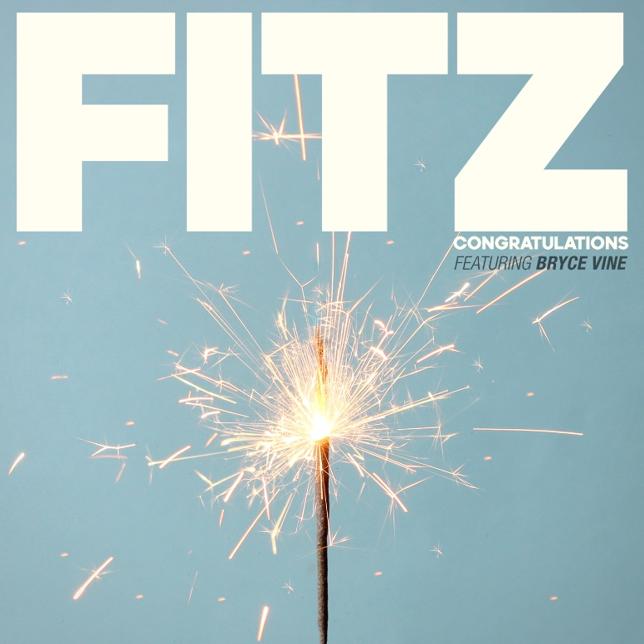

PRESS ASSETS HERE

Elektra recording artist FITZ – best known as founder and namesake of multiplatinum band Fitz and the Tantrums – has today unveiled a brand new track titled “Congratulations” featuring multi-platinum pop/hip-hop maverick Bryce Vine. Listen HERE. The effervescent song comes in advance of FITZ’s much-anticipated debut solo full length “HEAD UP HIGH,” which arrives everywhere on March 26th and is available now for pre-order.

Late last year, FITZ released his first-ever solo music in the form of the forthcoming album’s lead single, "Head Up High." The infectious track - co-produced and co-written by FITZ with Ryan Daly - was accompanied by its dynamic official music video, and made its national television debut on CBS’ “The Late Late Show with James Corden,” followed by an appearance on ABC’s “Good Morning America” to kick off 2021.

Going solo was never something that he had seriously considered, but, after a headlining tour with Fitz and the Tantrums was cut short due to the global pandemic, FITZ found himself back at home under lockdown. A casual songwriting session that had been previously scheduled with co-writer and co-producer Ryan Daly switched from an in-person meeting to Zoom, and the results surprisingly became the seeds for what would become a complete album in the form of “HEAD UP HIGH.”

Look out for more exciting FITZ news to be announced soon.

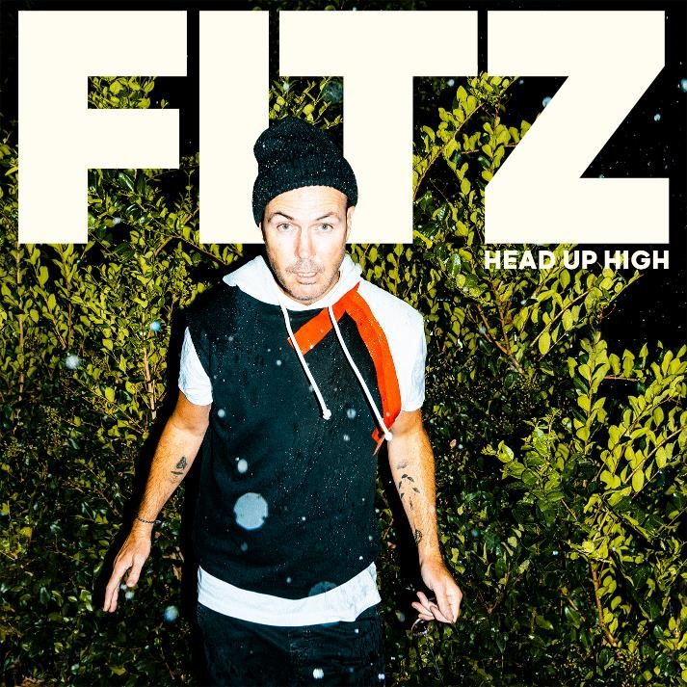
“HEAD UP HIGH” TRACKLISTING
1. Head Up High
2. Spaceman
3. Congratulations
4. Still Cool
5. Jump
6. I Need a Dancefloor
7. The List
8. Somebody Sometimes
9. Slowdown
10. Speed
11. Piñata
12. House Party
13. Little Champion
14. Zig Zag

*****

About FITZ
Since 2008, FITZ a.k.a. Michael Fitzpatrick has galvanized and energized fans around the world as the frontman and namesake of Fitz and the Tantrums. Over the course of four albums, the band has cooked up a series of instantly recognizable and hummable anthems such as the platinum “The Walker,” platinum “Out of My League,” and double-platinum “HandClap.” Amassing billions of streams and attracting praise from People, Billboard, and many more, the group quietly morphed into an arena-ready force, headlining and packing historic venues such as The Forum in Los Angeles, Red Rocks Amphitheatre in Morrison, CO, and more. Not to mention, he lent his voice to collaborations with everyone from Weezer to LL Cool J. After twelve unbelievable years, FITZ did something he’s never done before. The singer, songwriter, and multi-instrumentalist electrified his very first solo music to life—at 50-years-young. On his debut single “Head Up High,” he introduces another side of himself and his artistry, reaching a new apex of his wonderfully unbelievable journey thus far. However, 50 is just the beginning for FITZ as he plans more music and surprises for 2021 and beyond.

About Bryce Vine
Distilling nimble wordplay, hyper-charged hooks, and intimate guitars into genre-less and timeless songcraft, Bryce Vine leaves his stamp on pop music and culture. Since emerging in 2013, the Los Angeles-based multi-platinum singer, songwriter, producer, and guitarist has quietly built a devoted audience with EPs such as Lazy Fair (2014) and Night Circus (2016). However, he popped off on an international scale with the double-platinum smash “Drew Barrymore.” It paved the way for the platinum “La La Land” [feat. YG] and his first full-length in 2019, Carnival. And when the world shut down in 2020, Bryce also looked inward and released the contemplative EP Problems. Along the way, he attracted widespread acclaim from Bustle, Billboard, Teen Vogue, American Songwriter, VIBE, Flaunt and more, with TIME declaring “Bryce Vine is the epitome of low-key cool.” In addition to tallying over 1 billion total streams, he delivered a series of unforgettable performances on Late Night with Seth Meyers, Jimmy Kimmel LIVE!, Wendy Williams, The Kelly Clarkson Show, The Late Late Show with James Corden, Live with Kelly and Ryan, Good Morning America, and more.

# # #

FITZ PRESS CONTACT:

Glenn Fukushima (National)
818.238.6833
GlennFukushima@elektra.com

Collin Citron (National)
818.238.6314
CollinCitron@elektra.com

Sydney Worden (Tour/Online)
818.238.6834
SydneyWorden@elektra.com

BRYCE VINE PRESS CONTACT:

Ceri Roberts (National)
404-409-1806
Ceri.Roberts@warnerrecords.com

