FOR IMMEDIATE RELEASE
September 20, 2019

FITZ AND THE TANTRUMS RELEASE HIGHLY ANTICIPATED NEW ALBUM
“ALL THE FEELS”

DOWNLOAD/STREAM HERE

MULTI-PLATINUM GROUP ANNOUNCES ALL THE FEELS
WINTER 2020 HEADLINE TOUR
PRE-SALE TICKETS AVAILABLE STARTING TUESDAY, SEPTEMBER 24TH
GENERAL ON SALE BEGINS FRIDAY, SEPTEMBER 27TH

NEW SINGLE “I JUST WANNA SHINE” MAKES ITS
NATIONALLY TELEVISED DEBUT ON THE OUTDOOR STAGE
AT JIMMY KIMMEL LIVE!

WATCH HERE

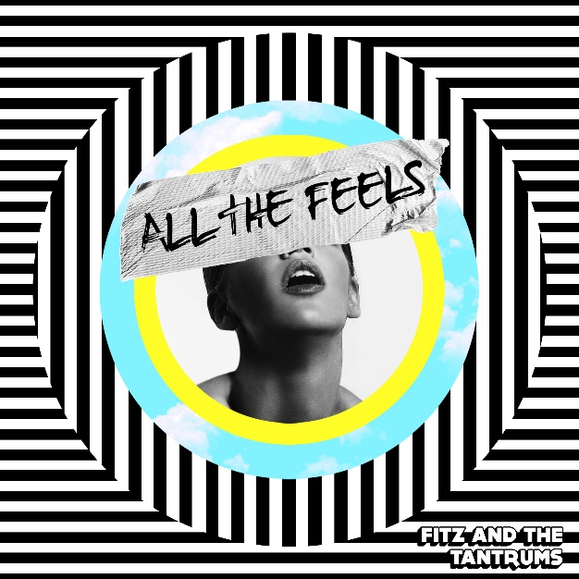

PRESS ASSETS HERE

Elektra recording group Fitz and the Tantrums have released their highly anticipated new album “ALL THE FEELS”. The album is available to stream and download now HERE. Limited edition merch bundles are available exclusively in the band’s online store HERE. Fitz and the Tantrums celebrated the album’s release by performing "I Just Wanna Shine” and "All The Feels” on the outdoor stage at ABC’s Jimmy Kimmel Live!.

Fitz and the Tantrums have also announced a 2020 headline tour, in support of their new album with Twin XL opening. The cross-country trek will kick off on February 7 and wrap on March 13. Pre-sale tickets will be available beginning Tuesday, September 24 at 8:00am local time, and general on-sale begins Friday, September 27th at 10:00am local time. Full itinerary below. For more details, please visit www.fitzandthetantrums.com.

Citi is the official presale credit card of the Fitz and The Tantrums Tour. As such, Citi cardmembers will have access to purchase presale tickets beginning Tuesday, September 24th at 8am local time until Thursday, September 26th at 10pm local time through Citi EntertainmentSM. For complete presale details visit www.citientertainment.com.

“There is power in talking about these things that we all feel like anxiety, depression, and insecurity, but also hopefulness, love and wanting to be more connected, this is the journey that we walked to make the album All The Feels,” says co-vocalist Michael “Fitz” Fitzpatrick.

Fitz and the Tantrums began sharing music from the album with the Spring release of “123456”. The song has already been featured in high profile spots on MLB Network and was highlighted in the recent Netflix film “Otherhood.” The band also treated fans to an early listen of tracks “OCD”, “I Need Help!”, and “All The Feels” around their massive co-headline tour with labelmates Young The Giant, which wrapped last month and included a special homecoming show at The Forum in Los Angeles. Current single “I Just Wanna Shine” is climbing at Alternative radio and was just featured in Walmart’s official back-to-school campaign on both TV and online.

“ALL THE FEELS” follows Fitz and the Tantrums’ 2016’s acclaimed self-titled album, which featured the band’s biggest hit to date, “HandClap.” The global smash has logged more than 400 MILLION worldwide streams while enjoying top 5 chart success at multi-format radio outlets nationwide. Likewise, the 2x-Platinum certified song’s official companion video has amassed more than 80 MILLION views to date on YouTube alone.

###

Multi-platinum artists Fitz and the Tantrums have quickly grown from independent upstarts to bonafide hitmakers. The LA-based band have released their much-anticipated, fourth full length album “ALL THE FEELS,” featuring lead single “123456.” “ALL THE FEELS” follows the band’s 2016 release “FITZ AND THE TANTRUMS,” which spawned the group’s biggest hit to date, “HandClap.” The RIAA-certified 2x Platinum single went top 5 on both the Hot AC and Alternative Radio charts, and also enjoyed major airplay across the country at Top 40. The band has brought the infectious energy of their live shows to the small screen, with nationally televised performances of “HandClap” on ABC’s “Dancing With The Stars,” “Good Morning America,” and “Jimmy Kimmel Live!,” NBC’s “TODAY,” “Tonight Show Starring Jimmy Fallon,” “America’s Got Talent,” and Macy’s Thanksgiving Day Parade, and the syndicated “Ellen DeGeneres Show” among others.

Fitz and the Tantrums’ eponymous album followed their breakout major label debut, “MORE THAN JUST A DREAM,” which featured back-to-back Platinum-certified, #1 Alternative Radio singles in “The Walker” and “Out Of My League.” Both singles also enjoyed Top 15 success at Hot AC. The band has performed countless, sold out headlining shows and is always a standout at music festivals around the world, including Coachella, Bonnaroo, Lollapalooza, Austin City Limits, and more.

Fitz and the Tantrums are: Michael “Fitz” Fitzpatrick (vocals), Noelle Scaggs (vocals), James King (saxophone, flute), Jeremy Ruzumna (keyboards), Joseph Karnes (bass), and John Wicks (drums, percussion).

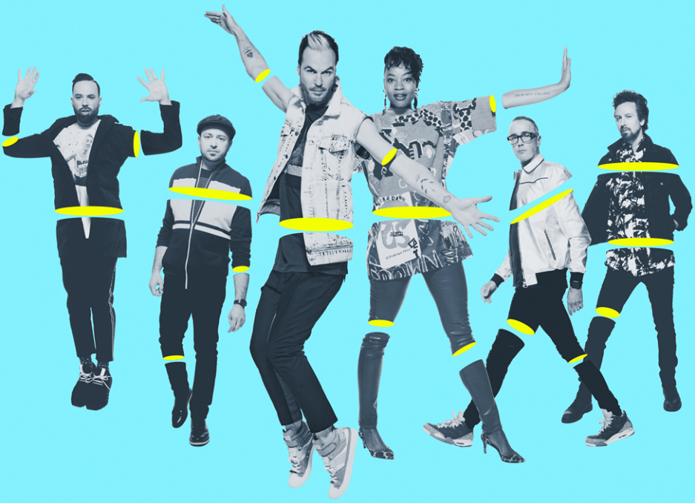

FITZ AND THE TANTRUMS
ALL THE FEELS WINTER TOUR 2020
With Twin XL

FEBRUARY
7 Newkirk, OK First Council Casino
8 Catoosa, OK The Joint at Hard Rock Hotel & Casino Tulsa
9 Dallas, TX House of Blues Dallas
11 Columbia, SC The Senate
12 Greensboro, NC Piedmont Hall
14 Washington, DC The Anthem
15 Atlantic City, NJ Sound Waves Theater at Hard Rock Hotel & Casino
16 Stroudsburg, PA Sherman Theater
18 Long Island, NY The Paramount
21 Mashantucket, CT Grand Theater at Foxwoods Resort Casino
22 Niagara Falls, ON, CAN Avalon Theatre at Niagara Fallsview Casino
23 Toronto, ON, CAN Danforth Music Hall
26 Clifton Park, NY Upstate Concert Hall
28 Chicago, IL The Riviera Theater
29 Madison, WI The Sylvee

MARCH
1 Grand Rapids, MI 20 Monroe Live
3 St. Louis, MO The Pageant
4 Kansas City, MO Uptown Theater
6 Lincoln, NE Bourbon Theater
7 Deadwood, SD Deadwood Mountain Grand
9 Grand Junction, CO Avalon Theatre
11 Sacramento, CA Ace of Spades
12 Redding, CA Redding Civic Auditorium
13 Ventura, CA The Majestic Ventura Theater

“ALL THE FEELS” TRACK LISTING

1. All The Feels
2. 123456
3. I Just Wanna Shine
4. Ain’t Nobody But Me
5. I Need Help!
6. Don’t Ever Let Em
7. Basement
8. Ready or Not
9. OCD
10. SuperMagik
11. Belladonna*
12. Stop
13. Dark Days
14. Hands Up
15. Kiss The Sky*
16. Maybe Yes
17. Livin’ For The Weekend*

*appears on digital release only

###

Connect with FITZ AND THE TANTRUMS:
Official Site | Official Instagram | Official Facebook | Official Twitter| Official YouTube

PRESS CONTACTS:

Glenn Fukushima (National)
GlennFukushima@elektra.com

Collin Citron (National)
CollinCitron@elektra.com

Sarah Goldstein (Tour/Online)
SarahGoldstein@elektra.com

