FOR IMMEDIATE RELEASE
JUNE 10, 2022

FITZ AND THE TANTRUMS RETURN WITH SUMMERY
NEW SINGLE AND MUSIC VIDEO “SWAY”
LISTEN HERE | WATCH HERE

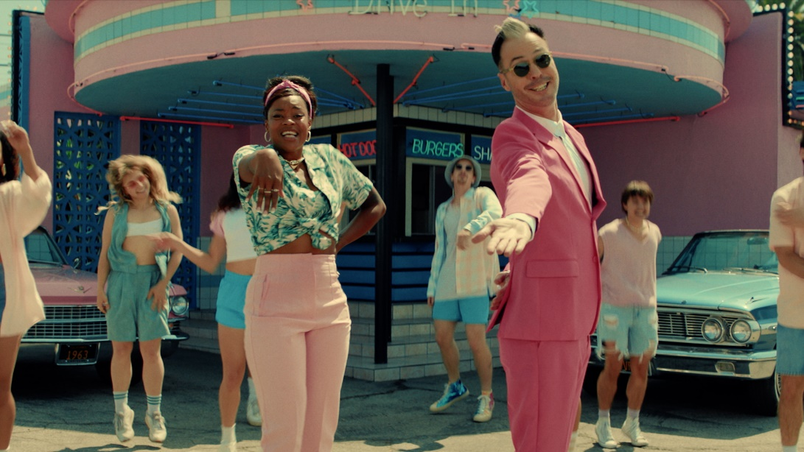
PRESS ASSETS HERE

TICKETS FOR SUMMER CO-HEADLINE TOURS WITH ST. PAUL & THE BROKEN BONES, AND ANDY GRAMMAR AVAILABLE HERE

Multi-Platinum band Fitz and The Tantrums have returned with their brand new single “Sway”. The infectious, upbeat track is available to stream and download beginning today HERE via Elektra Records. The band has also unveiled an accompanying summer-ready music video for the song, directed by Taylor Kelly. Watch it on their official YouTube channel HERE. “Sway” notably marks the group’s first new music in three years, and follows their 2019 album All the Feels.

Regarding “Sway,” frontman Michael “Fitz” Fitzpatrick said, “Since the beginning, we’ve always set out to get people up on their feet, smiling and dancing when they hear our music. ‘Sway’ felt like it had that special sauce when we were making it in the studio, and we’re already seeing the song work its magic when we play it live. We’re so excited to share it as our first new single in years. So, to all you summer lovers…this one is for you!”

“Sway” storms out of the gate with a dancefloor-ready bass line and builds towards yet another undeniable hook from the group as Fitz calls out to “summer lovers” everywhere. The music video projects this spirit on-screen. Nodding to fifties style with just the right amount of futuristic sheen, the visual is highlighted by showstopping choreography to compliment the song’s irresistible energy.

“Sway” sets the stage for more new music to come from Fitz and The Tantrums later this year.

The song also kicks off what promises to be an unforgettable summer for the Los Angeles collective. Fitz and The Tantrums are currently on the road for a co-headline run alongside St. Paul & the Broken Bones. The tour kicked off earlier this month and will wrap on June 25 in Council Bluffs, IA.

Next month, Fitz and The Tantrums will embark on a co-headline summer tour of amphitheaters and arenas with Andy Grammar. “The Wrong Party Tour” will kick off in Key West, FL on July 29, visit US cities coast-to-coast, and wrap on August 27 with a hometown show at Los Angeles’s Greek Theatre. A complete list of upcoming live dates can be found below. For ticket information, visit www.fitzandthetantrums.com.

The LA-based band has been busy working on new material to follow up 2019’s All the Feels, which featured the top 10 hit “I Just Wanna Shine” and was supported by national television appearances on Jimmy Kimmel LIVE!, Good Morning America, and Live with Kelly and Ryan. In 2021, Fitz and The Tantrums’ frontman Michael “Fitz” Fitzpatrick released his first-ever solo album Head Up High under the moniker FITZ. FITZ performed the album’s infectious title track on The Ellen DeGeneres Show, The Late Late Show with James Corden, and Good Morning America.

Stay tuned for more from Fitz and The Tantrums very soon.

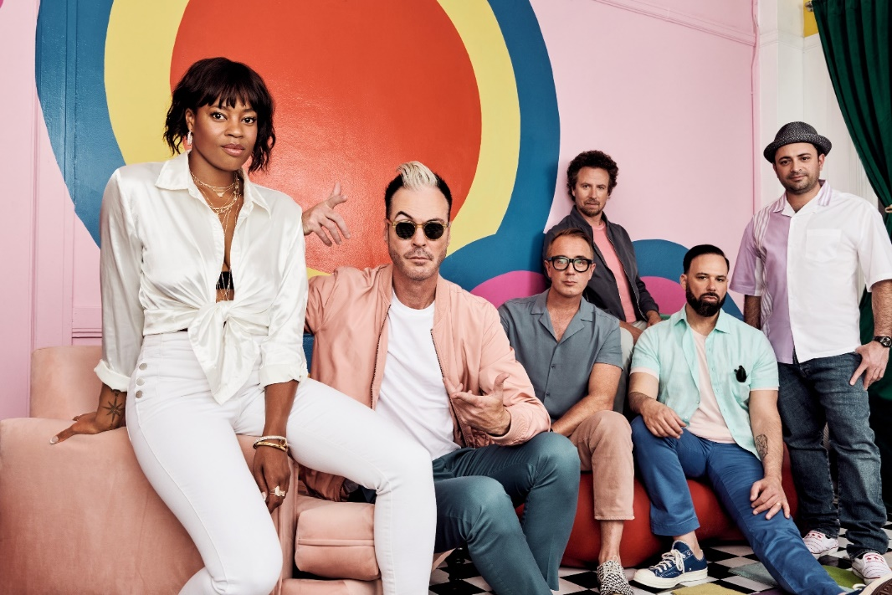
Photo Credit: Lindsey Byrnes

FITZ AND THE TANTRUMS TOUR DATES
Co-headlining with St. Paul & the Broken Bones
June 10, 2022 - New Haven, CT - Westville Music Bowl
June 11, 2022 - Asbury Park, NJ - The Stone Pony Summer Stage
June 12, 2022 - Bethlehem, PA - Levitt Pavilion SteelStacks
June 14, 2022 - Canandaigua, NY - Constellation Brands Marvin Sands Performing Arts Center (CMAC)
June 15, 2022 - Cleveland, OH - Jacobs Pavilion at Nautica
June 17, 2022 - Kettering, OH - Fraze Pavilion
June 18, 2022 - Indianapolis, IN - TCU Amphitheater at White River State Park
June 21, 2022 - Kansas City, MO - GrindersKC
June 23, 2022 - Rogers, AR - Walmart Arkansas Music Pavilion
June 24, 2022 - Des Moines, IA - The Lauridsen Amphitheater at Water Works Park
June 25, 2022 - Council Bluffs, IA - Harrah’s Council Bluffs – Stir Concert Cove

Co-headlining with Andy Grammar
July 29, 2022 - Key West, FL - Key West Ampitheater
July 30, 2022 - Orlando, FL - Hard Rock Live Orlando
July 31, 2022 - Tampa, FL - Seminole Hard Rock Hotel & Casino Tampa
August 2, 2022 - Cary, NC - Koka Booth Amphitheatre
August 3, 2022 - Vienna, VA - Wolf Trap
August 4, 2022 - New York, NY - Summerstage in Central Park
August 6, 2022 - Boston, MA - Leader Bank Pavilion
August 9, 2022 - Selbyville, DE - The Freeman Arts Pavilion
August 11, 2022 - Interlochen, MI - Interlochen Center for the Arts
August 12, 2022 - Aurora, IL - Riveredge Park
August 13, 2022 - Saint Paul, MN - Palace Theatre
August 14, 2022 - St. Louis, MO - Saint Louis Music Park
August 17, 2022 - Vail, CO - Gerald R. Ford Amphiteater
August 18, 2022 - Sandy, UT - Sandy Amphiteater
August 20, 2022 - Nampa, ID - Ford Idaho Center - Amphitheater
August 21, 2022 - Woodinville, WA - Chateau Ste. Michelle
August 22, 2022 - Bonner, MT - KettleHouse Ampitheater
August 23, 2022 - Forest Grove, OR - Grand Lodge
August 25, 2022 - Saratoga, CA - The Mountain Winery
August 26, 2022 - Rohnert Park, CA - Green Music Center
August 27, 2022 - Los Angeles, CA - Greek Theatre

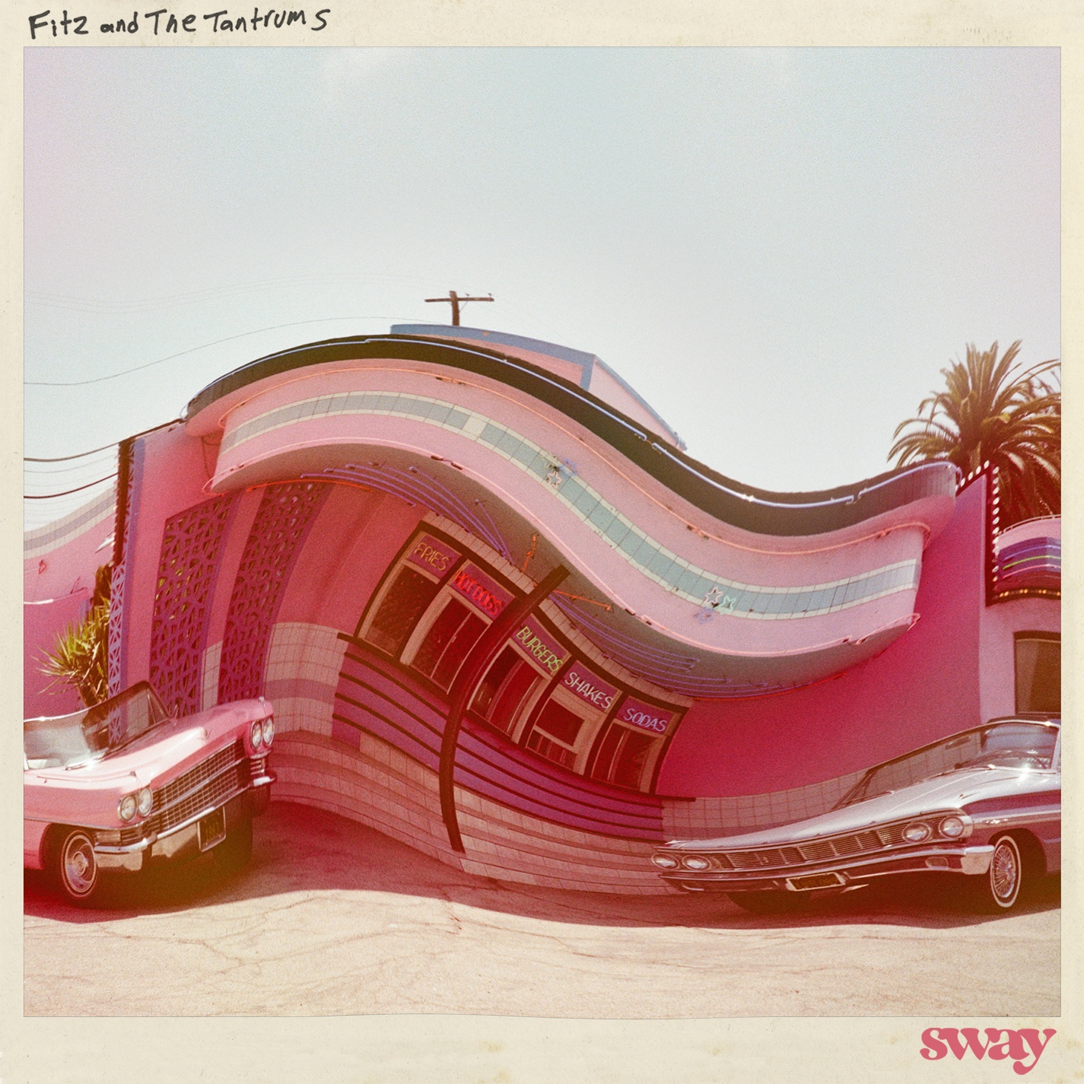

ABOUT FITZ AND THE TANTRUMS:
Multi-platinum artists Fitz and The Tantrums have energized popular music and culture with a series of unshakable, undeniable, and ubiquitous anthems and albums. Since 2008, the Los Angeles collective have magnified the scope of pop with a dash of indie, a dose of soul, and a whole lot of dancefloor-ready bounce. Their catalog spans fan favorite records such as Pickin’ up the Pieces [2010], More Than Just A Dream [2013], the gold-certified Fitz and The Tantrums [2016], and All the Feels [2019]. Along the way, they’ve impressively tallied just shy of 4 billion streams and counting powered by enduring hits such as the triple-platinum “HandClap,” platinum “Out of My League” and “The Walker,” and gold “Moneygrabber.” As an inescapable presence, their music has notably coursed through the mainstream conversation, soundtracking films on NETFLIX and campaigns for CVS Wellness, Sunchips, Sofi, Xfinity, Walmart, Norwegian Cruise Line, Lays, and Wells Fargo, to name a few. Beyond standout performances everywhere from Coachella and Bonaroo to numerous late-night television shows, they’ve consistently sold out some of the most iconic venues in the world, including The Forum and Red Rocks Amphitheatre. Not to mention, they’ve incited the applause from Rolling Stone, Billboard, People, and more. In 2021, Fitz and The Tantrums frontman Michael “Fitz” Fitzpatrick released his first-ever solo album Head Up High under the moniker FITZ. Meanwhile, co-lead vocalist Noelle Scaggs founded Diversify The Stage to help foster more diverse, inclusive, equitable, and accessible concerts, events, and touring workforces for historically marginalized and underrepresented communities. Fitz and The Tantrums once again leap forward with their bold, bright, and buoyant 2022 single “Sway,” a massive co-headline tour with Andy Grammer, and more surprises to come.

Fitz and The Tantrums are: Michael “Fitz” Fitzpatrick (vocals), Noelle Scaggs (vocals), James King (saxophone, flute), Jeremy Ruzumna (keyboards), Joseph Karnes (bass), and John Wicks (drums, percussion).
https://www.fitzandthetantrums.com/
Facebook | Instagram | Twitter | YouTube | TikTok

# # #

PRESS CONTACT:

Glenn Fukushima (National)
GlennFukushima@elektra.com

Collin Citron (National)
CollinCitron@elektra.com

Sydney Worden (Tour/Online)
SydneyWorden@elektra.com

