FOR IMMEDIATE RELEASE
JANUARY 18, 2022

FITZ AND THE TANTRUMS ANNOUNCE SUMMER 2022 TOUR

MULTIPLATINUM BAND SET TO EMBARK ON CO-HEADLINING RUN ALONGSIDE ST. PAUL AND THE BROKEN BONES

DATES KICK OFF JUNE 1 IN ASHEVILLE, NC

TICKET PRE-SALES BEGIN TOMORROW, JANUARY 19
GENERAL ON-SALE STARTS THIS FRIDAY, JANUARY 21

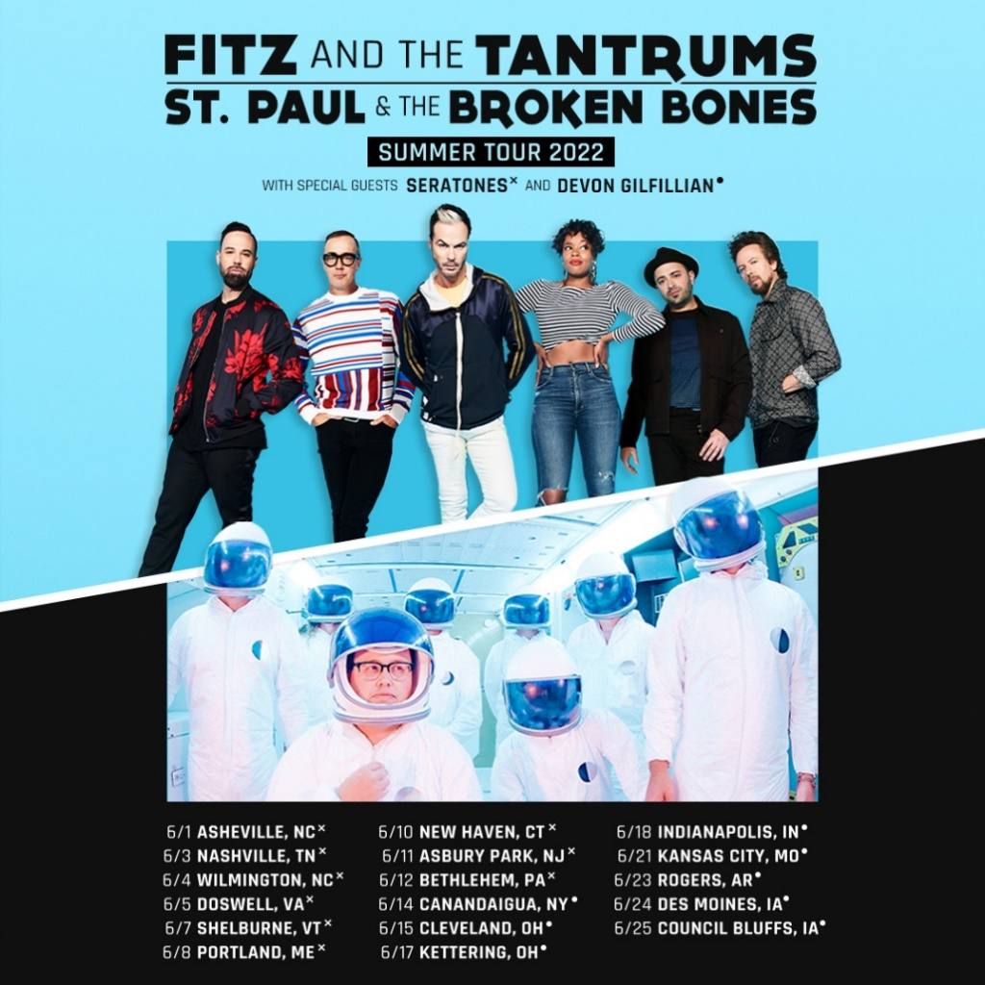

PRESS ASSETS HERE

Multiplatinum band Fitz and the Tantrums have announced touring plans for summer 2022. The run of dates – co-headlined with St. Paul and the Broken Bones – are set to kick off in Asheville, NC, on June 1 (full itinerary below). Support on the first leg comes from Seratones; the second leg will feature Devon Gilfilian. Ticket pre-sales will begin tomorrow, January 19, at 10am local time, with general on-sale starting this Friday, January 21, at 10am local time. For more information, please visit www.fitzandthetantrums.com.

Fitz and the Tantrums frontman Michael “Fitz” Fitzpatrick said: “We’re so excited to hit the road again. More than ever, we appreciate the awesome power of live music and the joy that it brings. We can’t wait to sing, dance, and celebrate with all of you.”

The LA-based band has been busy working on new material to follow up 2019’s “ALL THE FEELS,” which featured the top 10 hit “I Just Wanna Shine” and was supported by national television appearances on “Jimmy Kimmel LIVE!,” “Good Morning America,” and “Live with Kelly and Ryan.” In 2021, Fitz and the Tantrums’ frontman released his first-ever solo album “HEAD UP HIGH” under the moniker FITZ. FITZ performed the album’s infectious title track on the “The Ellen DeGeneres Show,” “The Late Late Show with James Corden,” and “Good Morning America.”

Stay tuned for more from Fitz and the Tantrums soon.

TOUR DATES
Co-headlining with St. Paul and the Broken Bones
Support from Seratones (June 1st – 12th) and Devon Gilfilian (June 14th – 25th)

June 1 Asheville, NC Rabbit Rabbit
June 3 Nashville, TN Ascend Amphitheater
June 4 Wilmington, NC Live Oak Bank Pavilion at Riverfront Park
June 5 Doswell, VA After Hours Concerts at The Meadow Event Park
June 7 Shelburne, VT Shelburne Museum – The Green
June 8 Portland, ME State Theatre Summer Concert Series at Thompson’s Point
June 10 New Haven, CT Westville Music Bowl
June 11 Asbury Park, NJ The Stone Pony Summer Stage
June 12 Bethlehem, PA Levitt Pavilion SteelStacks
June 14 Canandaigua, NY Constellation Brands Marvin Sands Performing Arts Center
(CMAC)
June 15 Cleveland, OH Jacobs Pavilion at Nautica
June 17 Kettering, OH Fraze Pavilion
June 18 Indianapolis, IN TCU Amphitheater at White River State Park
June 21 Kansas City, MO GrindersKC
June 23 Rogers, AR Walmart Arkansas Music Pavilion
June 24 Des Moines, IA The Lauridsen Amphitheater at Water Works Park
June 25 Council Bluffs, IA Harrah’s Council Bluffs – Stir Concert Cove

ABOUT FITZ AND THE TANTRUMS:

Over the course of four, full length albums, multi-platinum artists Fitz and the Tantrums have grown from independent upstarts to bonafide hitmakers. Beginning with their 2010 debut album “PICKIN’ UP THE PIECES” and it’s gold-certified single “Moneygrabber,” the LA-based sextet built a rabid fanbase with their infectious music and energetic live shows, which landed them a coveted spot on the Coachella Music and Arts Festival lineup. The band’s major label debut “MORE THAN JUST A DREAM” arrived in 2013 and spawned back-to-back platinum certified singles in “Out Of My League” and “The Walker.” Following that breakout success, Fitz and the Tantrums returned with their 2016 release “FITZ AND THE TANTRUMS,” which featured their biggest hit to date, the double-platinum certified “HandClap.” Continuing their streak of hits, 2019’s “ALL THE FEELS” was highlighted by the top 10 smash “I Just Wanna Shine.” Amassing billions of streams and attracting praise from Rolling Stone, Billboard, and more, the group has morphed into an arena-ready force, performing countless, sold out headlining shows and marque music festivals around the world.

Fitz and the Tantrums are: Michael “Fitz” Fitzpatrick (vocals), Noelle Scaggs (vocals), James King (saxophone, flute), Jeremy Ruzumna (keyboards), Joseph Karnes (bass), and John Wicks (drums, percussion).

# # #

PRESS CONTACT:

Glenn Fukushima (National)
818.238.6833
GlennFukushima@elektra.com

Collin Citron (National)
818.238.6314
CollinCitron@elektra.com

Sydney Worden (Tour/Online)
818.238.6834
SydneyWorden@elektra.com

