ERIKA SIROLA ANNOUNCES DEBUT EP WHO?
OUT AUGUST 5TH VIA ELEKTRA RECORDS

SHARES BRAND NEW SINGLE AND OFFICIAL MUSIC VIDEO
“ALL IN MY HEAD”
LISTEN HERE | WATCH HERE
DOWNLOAD PRESS ASSETS HERE
JULY 14, 2022 - 23-year-old Finland native Erika Sirola has announced her debut EP, Who?. The four-track collection is set to arrive August 5th via Elektra Records and is available for presave now.
To celebrate the announcement, Sirola has unveiled her brand new single “All In My Head,” available now on all streaming platforms. The track arrives alongside a cinematic music video directed by Nico Poalillo, which is streaming now on Erika’s official YouTube channel. Written in London when Sirola was just 18, “All In My Head” is an ineffably catchy piece of alt-pop, unfolding in lush yet jagged textures and choir-like harmonies as she confesses her insecurity with a potent candor.
Sirola commented, “‘All In My Head’ was written in London back in 2017, so I was a mere 18 years old. My head was most certainly not all there – I was very confused as to who I was and what I wanted out of myself, my music and my life. The song is from the mind and heart of a very different individual and it’s clear when listening, but it marks and represents a significant step to who I have become. It marked a time of solidifying my sense of purpose of creating art to writing music. Looking back at it now, I am grateful to be able to see how scared I was to take risks in my creativity. I’m excited to see what others take from the song and how differently they will react and respond.”
Last month, the artist announced her signing to Elektra Records and shared debut single “End Of The Day.” The news was shared exclusively via Consequence, who raved, “‘End Of The Day’ embodies Sirola’s unique voice. Starting as a soft-spoken piano ballad, it soon falls into a world of dramatic synth pads and a drumbeat that sounds like it’s ripped from a club hit — all without losing its emotionality.” Early Rising attested, “Sirola’s sultry, strong, and raw vocal abilities are incredibly captivating from the moment the song begins, floating whimsically over the lovesick soundscape. Sirola has the innate ability to turn pain into something beautiful…Her creativity knows no bounds, and this song is just the beginning,” while MUD Magazine declared “Erika Sirola's debut single gives us the most beautiful combination of profound lyricism with a freshly unique sound.”
Opening in stark simplicity then slowly building to a glorious whirlwind of fast and frantic beats, “End Of The Day” tilts heartbreak into something strangely sublime. The single is available now on all streaming services and is accompanied by a captivating performance video directed by Nico Paolillo, which is streaming on Erika’s official YouTube channel. In addition to being a longtime piano player, guitarist, and clothing designer, Sirola is also a talented visual artist and designed the EP’s mixed-media art.
About Erika Sirola:
For Erika Sirola, the act of creating is an impulse as natural as breathing. Growing up in Helsinki (and spending most summers with her mother’s family in Canada), Sirola first discovered the power of alchemizing pain into art as a young child. A songwriter since the age of eight, the 23-year-old Finland native landed her first record deal at 12 and spent much of her late adolescence and early adulthood living in such far-flung cities as L.A. and Berlin and London, gradually shaping a singular musical identity informed by everything from art-pop to techno to the more esoteric edges of folk, jazz and experimental music. Newly signed to Elektra Records, Sirola centers the beguiling vocal presence she first brought as a featured artist on Robin Schulz’s 2018 smash hit “Speechless” to make her debut with upcoming EP Who?, arriving August 5th and offering a dazzling first glimpse at the wild expanse of her creativity.

ERIKA SIROLA
WHO? EP
PRESAVE NOW
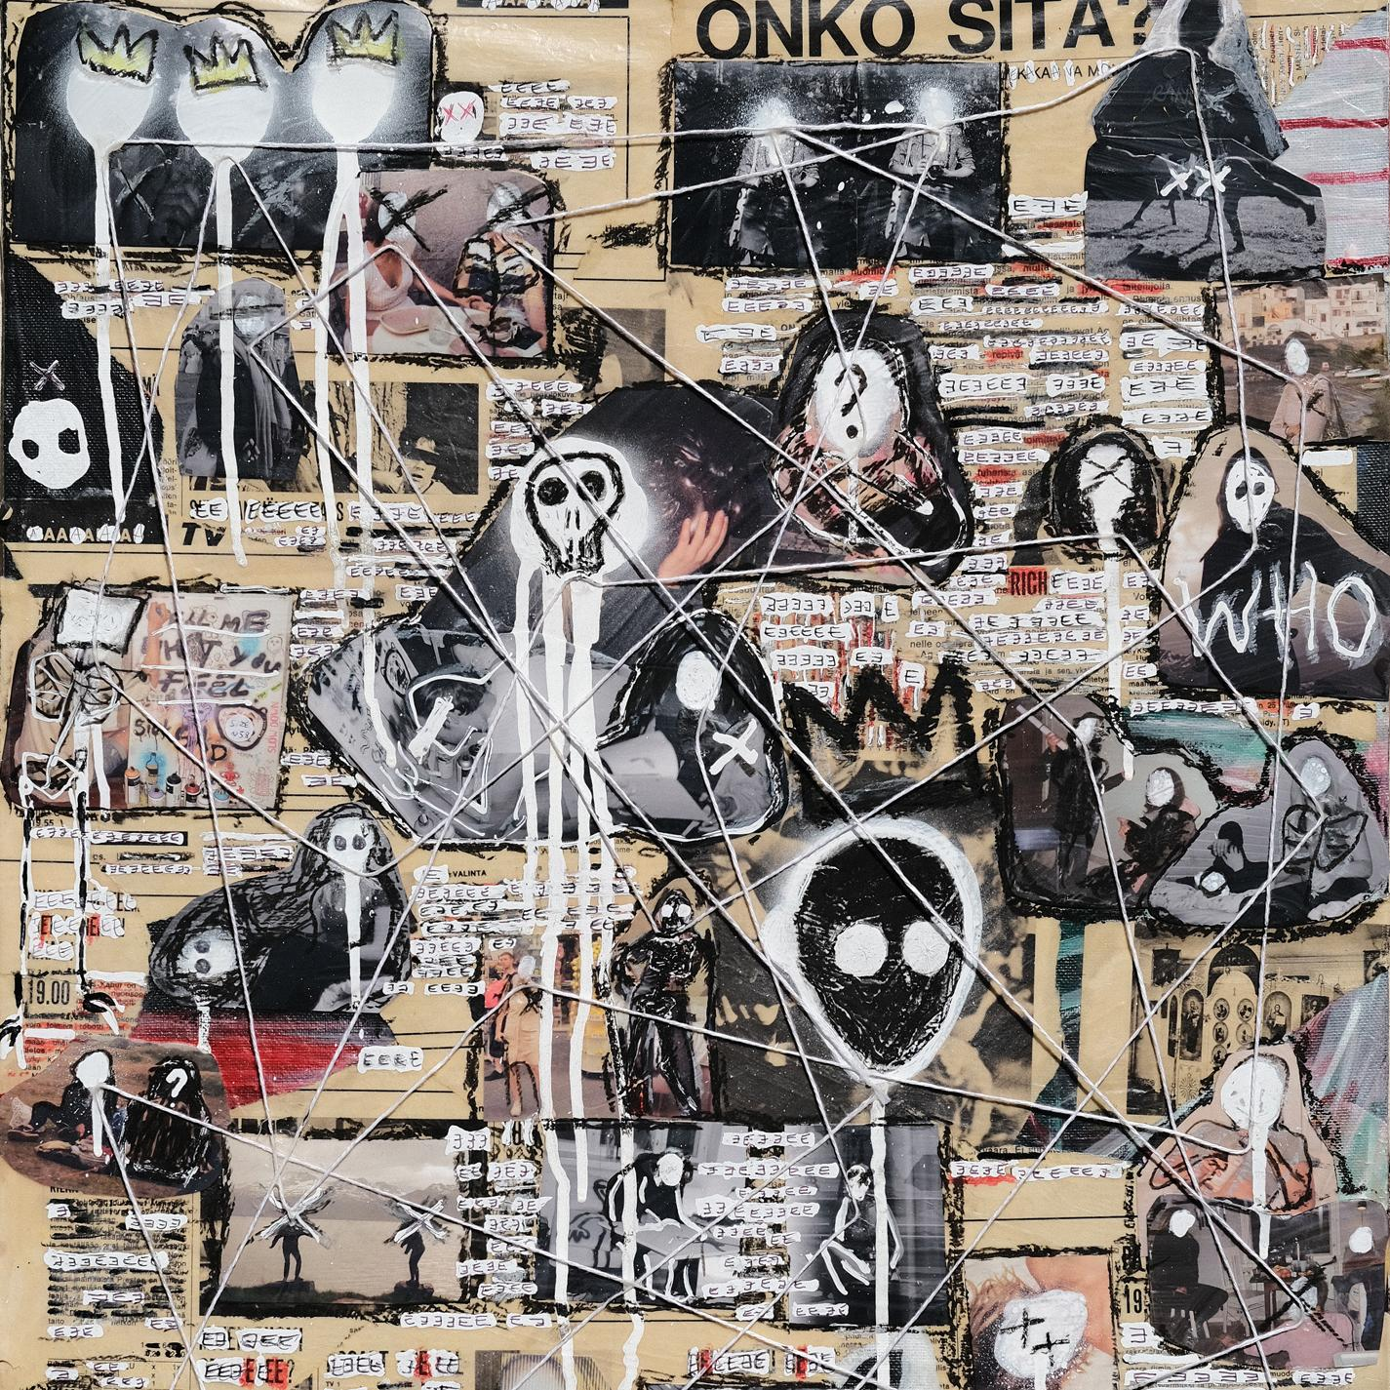
TRACKLISTING
1. All in My Head
2. End of the Day
3. Souvenir
4. A Little More

CONNECT WITH ERIKA SIROLA
Website
Instagram
YouTube
TikTok
Twitter

PRESS CONTACTS:
Sarah Goldstein - sarahgoldstein@elektra.com
Sydney Worden - sydneyworden@elektra.com

