COHEED AND CAMBRIA
ANNOUNCES NEW ALBUM VAXIS II: A WINDOW OF THE WAKING MIND
REVEAL ALBUM ART & TRACK LIST

LIMITED EDITION DELUXE BOX SET AVAILABLE FOR PRE-ORDER TODAY

NEW SINGLES “SHOULDERS” & “RISE, NAIANASHA (CUT THE CORD)” STREAMING NOW

“THE GREAT DESTROYER TOUR" WITH SPECIAL GUESTS SHEER MAG BEGINS FEBRUARY 16TH

VAXIS II: A WINDOW OF THE WAKING MIND ARRIVES MAY 27TH

PHOTO CREDIT: ALEXANDRA GAVILLET

JANUARY 14, 2022 – Coheed and Cambria has announced details of their widely anticipated new album, Vaxis II: A Window of the Waking Mind [album art & track list below]. The ambitious thirteen track epic was produced by the band’s own Claudio Sanchez and Zakk Cervini, and will be released worldwide on May 27th.

Today the band has launched pre-orders for the album on DSPs and for the collection’s deeply immersive Vaxis II: A Window of the Waking Mind Limited Edition Deluxe Box Set.

Vaxis II: A Window of the Waking Mind welcomes us back to “The Amory Wars” as the 2nd installment of the five-part “Vaxis” arc about a couple on the run from tyrannical forces and their mysterious new addition. The album’s limited edition deluxe box set [packaging shot below] includes the exclusive 96-page illustrated hardcover novel “A Window of the Waking Mind” which was developed by Sanchez and written by his wife Chondra Echert with strikingly realistic color artwork by Chase Stone. The 9” x 12” box set also houses an exclusive Quintillan Speaker Containment Unit Lamp (approx. 8” diameter), a 3-panel fold out poster of expanded album cover art, and the A Window of the Waking Mind Black Card which will allow all card holders early access to tickets and early entry to Coheed and Cambria headline dates. All box sets will also come with a CD copy and download of Vaxis II: A Window of the Waking Mind along with an official Certificate of Authenticity. Furthermore, fans who pre-order the limited edition box set before January 23rd, will receive autographed copies and have their name included within the pages of the accompanying illustrated hardcover novel. For more information on Vaxis II: A Window of the Waking Mind Limited Edition Deluxe Box Set, visit www.coheedandcambria.com.

Named one of REVOLVER’s “Most Anticipated Albums of 2022,” Vaxis II: A Window of the Waking Mind includes the recently released singles “Rise, Naianasha (Cut The Cord)” and “Shoulders,” the latter of which vaulted into the Top 10 at Active Rock Radio, marking the group’s career highest radio chart position to date. “(It) masterfully pairs heavy metal-infused riffs with sweeping, melodic vocals in a way that only Coheed can,” declared MTV who placed “Shoulders” in their 2021 Favorites round-up. “Coheed and Cambria are back, and they’re heavy as ever,” asserted Billboard, with Guitar World attesting “Coheed and Cambria have come out swinging.” Brooklyn Vegan observed, “It finds the band embracing their love of classic heavy metal riffage, before exploding into the kind of soaring chorus that Coheed have been churning out since day one… they sound pretty damn inspired.”

Coheed and Cambria will celebrate the forthcoming LP with “The Great Destroyer Tour,” a U.S. headline run which will feature support from special guests Sheer Mag. The coast-to-coast trek is set to get underway on February 16th with a sold out show at the legendary Pappy & Harriet’s in Pioneertown, CA and will continue through mid-March giving audiences an opportunity to see the band live in intimate clubs across the U.S. [tour itinerary below]. For tickets and more information on the “The Great Destroyer Tour,” visit www.coheedandcambria.com.

For the last 20 years, Coheed and Cambria have continuously broken the mold of what a rock band can be, forging their own path and building a universe around their music unlike any other. Whether it is in the way their genre-spanning approach to songwriting has allowed them to bridge worlds without being contained to one, or the multifaceted story arc of their albums and comic book series which mark the longest running concept story in music, Coheed and Cambria have consistently shaped new standards, never conformed. Comprised of Claudio Sanchez (Vocals / Guitar), Travis Stever (Guitar), Josh Eppard (Drums) and Zach Cooper (Bass) the band has gripped listeners and press around the globe with their visionary compositions and conceptual mastery. In 2018, Coheed and Cambria made a stunning debut with their album Vaxis I: The Unheavenly Creatures, which debuted at #1 on Billboard’s “Hard Rock Albums” chart, #6 current sales and Top 15 on the “Billboard 200” chart.

[ALBUM ART + TRACK LIST / BOX SET IMAGE / TOUR ITINERARY BELOW]

COHEED AND CAMBRIA
VAXIS II: A WINDOW OF THE WAKING MIND

- The Embers of Fire
- Beautiful Losers
- Comatose
- Shoulders
- A Disappearing Act
- Love Murder One
- Blood
- The Liars Club
- Bad Man
- Our Love
- Ladders of Supremacy
- Rise, Naianasha (Cut the Cord)
- Window of the Waking Mind

COHEED AND CAMBRIA
VAXIS II: A WINDOW OF THE WAKING MIND LIMITED EDITION BOX SET

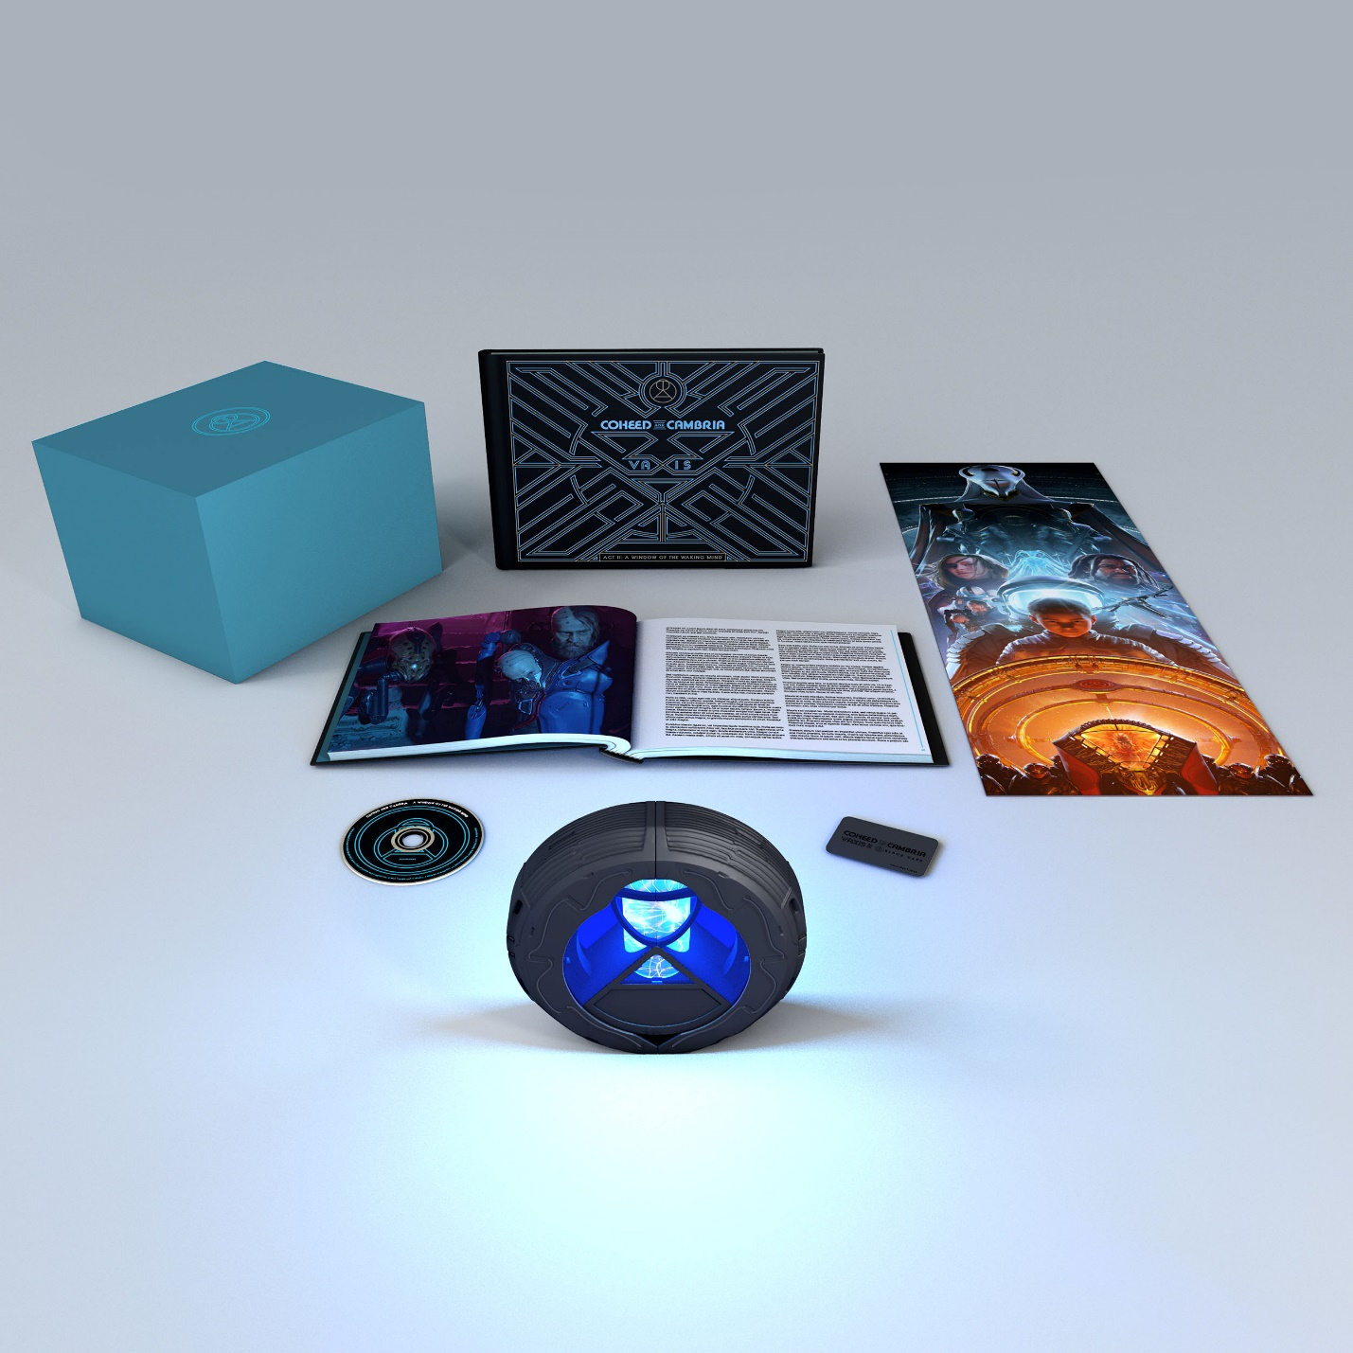

COHEED AND CAMBRIA
“THE GREAT DESTROYER TOUR”
WITH SPECIAL GUESTS SHEER MAG

Feb 16 - Pappy and Harriet’s - Pioneertown, CA (SOLD OUT)
Feb 17 - Brooklyn Bowl - Las Vegas, NV
Feb 19 - El Rey Theatre - Albuquerque, NM
Feb 20 - Rialto Theatre - Tucson, AZ
Feb 22 - Diamond Ballroom - Oklahoma City
Feb 23 - The Soundstage at Graceland - Memphis, TN
Feb 25 - Mars Music Hall - Huntsville, AL
Feb 26 - The Fillmore - New Orleans, LA
Feb 28 - The Mill & Mine - Knoxville, TN
Mar 01 - The Signal - Chattanooga, TN
Mar 02 - The Orange Peel - Asheville, NC
Mar 04 - The NorVa - Norfolk, VA
Mar 05 - The National - Richmond, VA
Mar 06 - PromoWest Pavilion at OVATION - Newport, KY
Mar 08 - Uptown Theater - Kansas City, MO
Mar 09 - The Sylvee - Madison, WI
Mar 11 - Clyde Theatre - Fort Wayne, IN
Mar 13 - GLC Live at 20 Monroe - Grand Rapids, M
Mar 14 - Main Street Armory - Rochester, NY
Mar 15 - Empire Live - Albany, NY
Mar 17 - Fete Music Hall - Providence, RI (SOLD OUT)
Mar 18 - College Street Music Hall - New Haven, CT
Mar 19 - XL Live - Harrisburg, PA (SOLD OUT)

CONNECT WITH COHEED AND CAMBRIA:
Facebook / Twitter / Instagram / YouTube / Website

