CODE ORANGE ANNOUNCE “UNDER THE SKIN” LIVESTREAM EVENT

FULL BAND PERFORMANCE TO STREAM JULY 30TH ON TWITCH

NEW LP UNDERNEATH STAKES IT CLAIM AS ONE OF 2020’S TOP ALBUMS

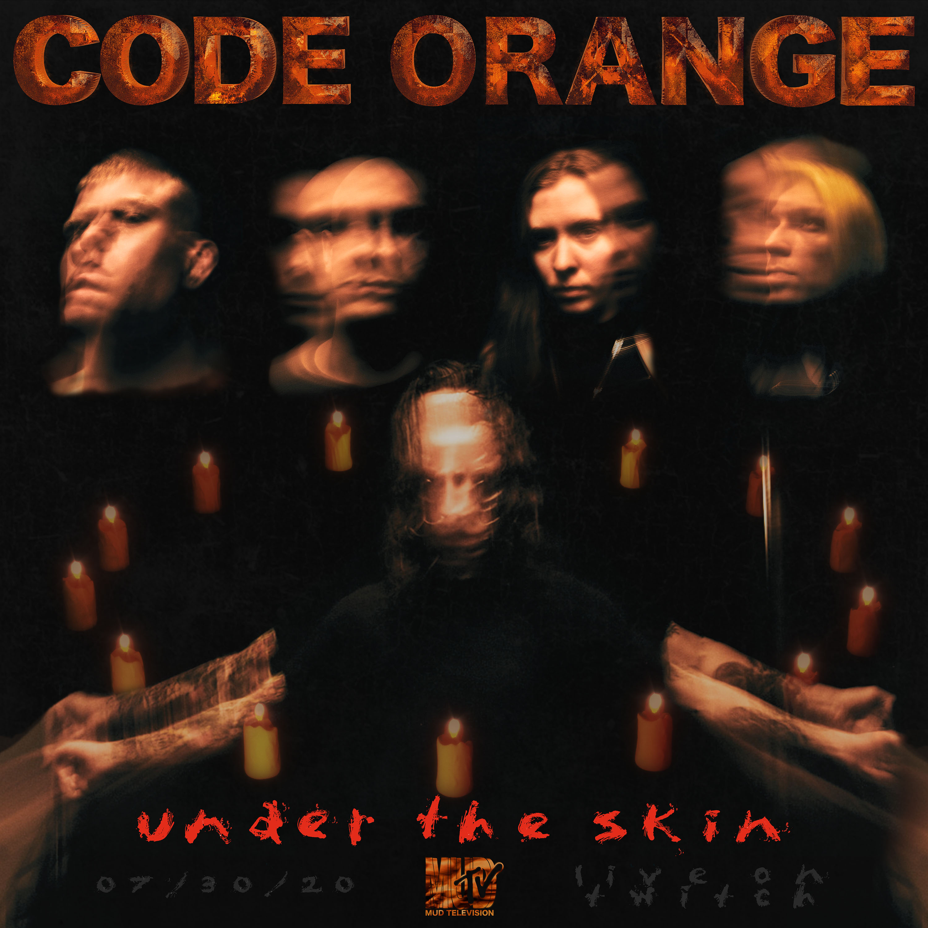

JUNE 30, 2020 – GRAMMY nominated band Code Orange have announced “UNDER THE SKIN,” a brand-new livestream event, which follows their groundbreaking empty venue record release show livestream, “LAST ONES LEFT: In Fear of The End.” Set to broadcast live via Code Orange’s Twitch channel on July 30th, “UNDER THE SKIN” will see Code Orange delivering a full band, stripped down and reimagined presentation of tracks spanning their entire catalogue. Conceptually akin to classic MTV Unplugged performances, but with nightmarish digital twists and turns, “UNDER THE SKIN” will broadcast live from The Theatre Factory in Pittsburgh, Pennsylvania. The band teased the announcement with an animated video piece last night following their bi-weekly Twitch livestream series, “YOU AND YOU ALONE.” Exclusive merch along with a new limited-edition vinyl pressing of Code Orange’s new LP, UNDERNEATH, will be available during the livestream event via Code Orange’s Webstore.

Earlier this year Code Orange’s revolutionary hour-long livestream, “LAST ONES LEFT: IN FEAR OF THE END,” saw the band delivering a powerful performance interspersed with cinematic imagery to nearly 13,000 concurrent viewers, with it quickly trending Top 15 on Twitter in the United States.
The band’s new album UNDERNEATH is available now on all streaming platforms, and features the singles - “Swallowing The Rabbit Whole,” “Underneath,” and “Sulfur Surrounding.” Produced by Code Orange’s Jami Morgan and Nick Raskulinecz with co-producer Will Yip, UNDERNEATH features additional programming from Chris Vrenna, and was mixed by Yip and Code Orange’s Eric ‘Shade’ Balderose. UNDERNEATH has already staked its claim as one of the year’s top album earning “Best of 2020 So Far” accolades” from: Rolling Stone, The Guardian, Stereogum, Revolver, Consequence of Sound, Kerrang!, Metal Hammer and more. NPR declared “[it] devours a body of extreme sounds — sludge, noise, metallic hardcore, doom, grunge, industrial and whatever else it takes to make the mosh pit swarm — to make uncompromisingly chaotic metal.” Stereogum detailed UNDERNEATH as “a conceptual piece about online poisoning…” adding, “the experience of hearing it on headphones is akin to getting torn limb from limb by cybernetic terminators,” while the The FADER attested, “Code Orange sound like no other metal band around right now. Underneath is their shot at the stars.” The UK’s Metal Hammer gave UNDERNEATH a perfect 10 out of 10 album review, hailing the LP as “a 1,000 ft neon signpost for the rest of the metal world to follow, the first classic record of the decade.” Kerrang! awarded UNDERNEATH a flawless 5K review declaring the album, “one of the most powerful, cathartic, creatively satisfying and bruisingly heavy records of its age,” with Rolling Stone praising Code Orange’s, “cutting melodies and the group’s balance of industrial rattle and shock-treatment guitar riffs.” Revolver affirmed, “The record is one of the most colossal and best sounding hardcore-adjacent albums of all time.”
Code Orange recently made headlines in the professional wrestling world with their performance of “Underneath” at this summer’s NXT Takeover: In Your House event. The band previously released “Let Me In,” their official entrance theme for WWE Superstar ‘The Fiend’ Bray Wyatt, and featured at WWE’s NXT TakeOver: Brooklyn III performing a rendition of wrestler Aleister Black's entrance theme alongside Incendiary’s Brendan Garrone.
Comprised of Jami Morgan (Drums / Vocals), Eric ‘Shade’ Balderose (Electronics / Guitar / Vocals), Reba Meyers (Guitar / Vocals), Dominic Landolina (Guitar) and Joe Goldman (Bass), Code Orange flipped the heavy music world on its head with their breakthrough album FOREVER, a collection that masterfully mixed hardcore aggression with urgent industrial textures, earning the band a breakthrough GRAMMY nomination and top placement on several “Best of 2017” lists including: Rolling Stone’s “20 Best Metal Albums of 2017,” Revolver’s “20 Best Albums of 2017,” and The Independent’s “Top 20 Rock & Metal Albums of 2017.” FOREVER was followed by the 2018 release of THE HURT WILL GO ON, a digital EP featuring “3 Knives” and “The Hunt” Feat. Corey Taylor, as well as “The Hurt Will Go On” (Shade Remix), an official remix of Code Orange’s “Hurt Goes On” helmed by the band’s guitarist and vocalist Shade. More recently the Code Orange has collaborated with a wide array of artists, co-producing Injury Reserve’s “HPNGC” Feat. JPEGMAFIA, serving up a pair of remixes for alt-J’s “Hit Me Like That Snare” and “Adeline,” and guesting on Amnesia Scanner’s “AS Flat.”
[Album Art / Tracklist Below]
###

CODE ORANGE
UNDERNEATH
Album Artwork / Tracklist

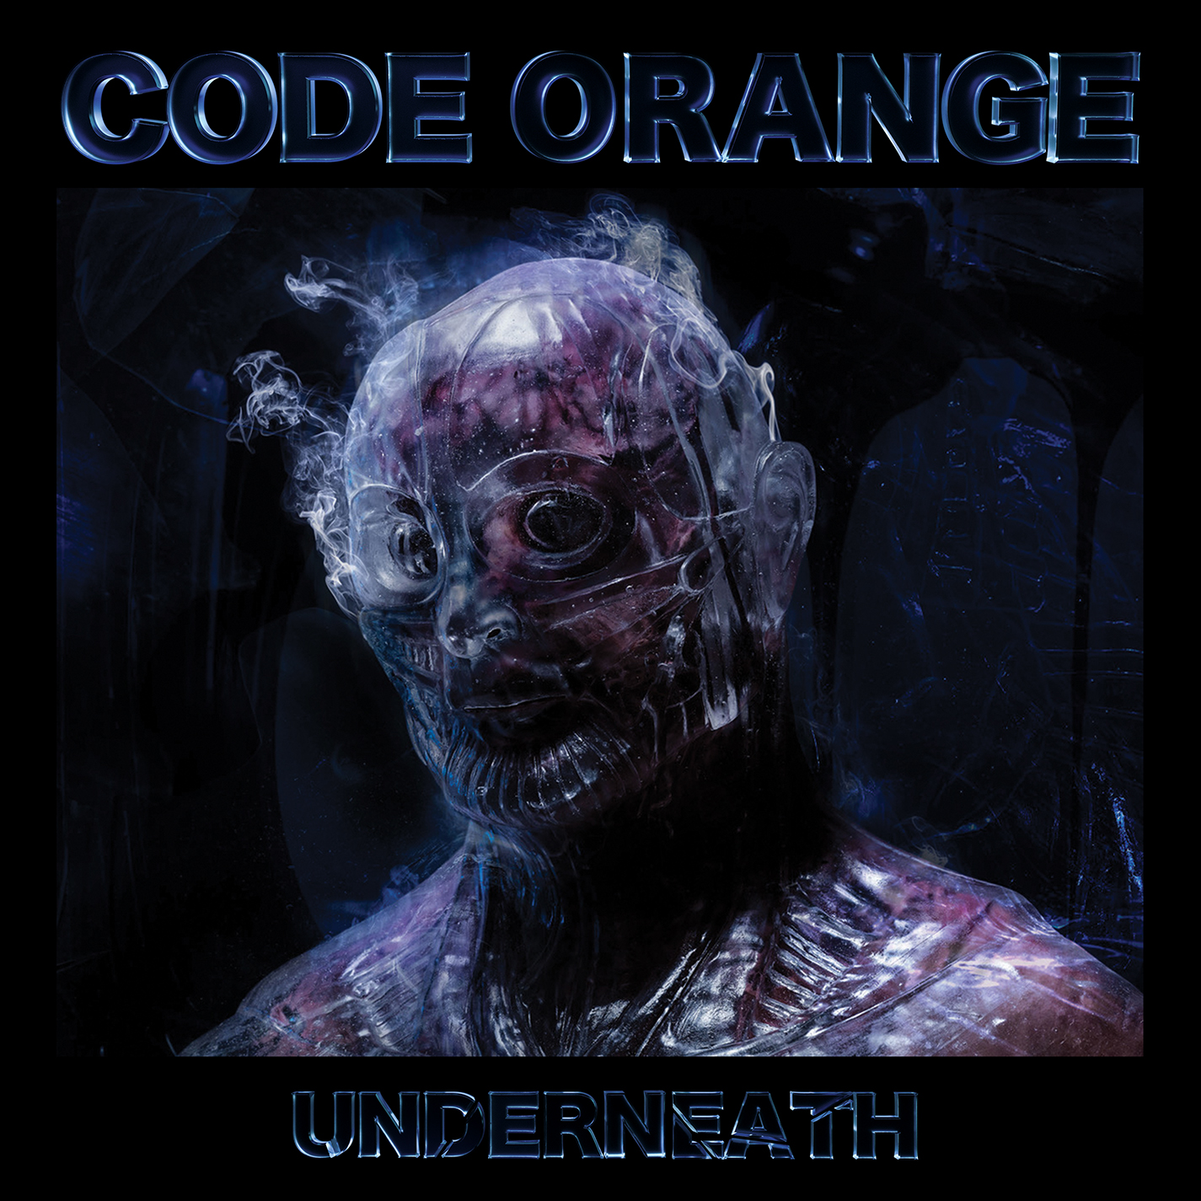
- (deeperthanbefore)
- Swallowing the Rabbit Whole
- In Fear
- You and You Alone
- Who I Am
- Cold.Metal.Place
- Sulfur Surrounding
- The Easy Way
- Erasure Scan
- Last Ones Left
- Autumn and Carbine
- Back Inside the Glass
- A Sliver
- Underneath

Connect with Code Orange:
WEBSITE
FACEBOOK
INSTAGRAM
TWITTER
YOUTUBE
SPOTIFY
APPLE MUSIC
AMAZON

Code Orange Press Contact:
Ross Anderson
RossAnderson@elektra.com

