COHEED AND CAMBRIA
SET DATES FOR NEVERENDER NWFT TOUR 2020

PERFORMING 2007 CLASSIC NO WORLD FOR TOMORROW IN ITS ENTIRETY

CHON TO PROVIDE DIRECT SUPPORT

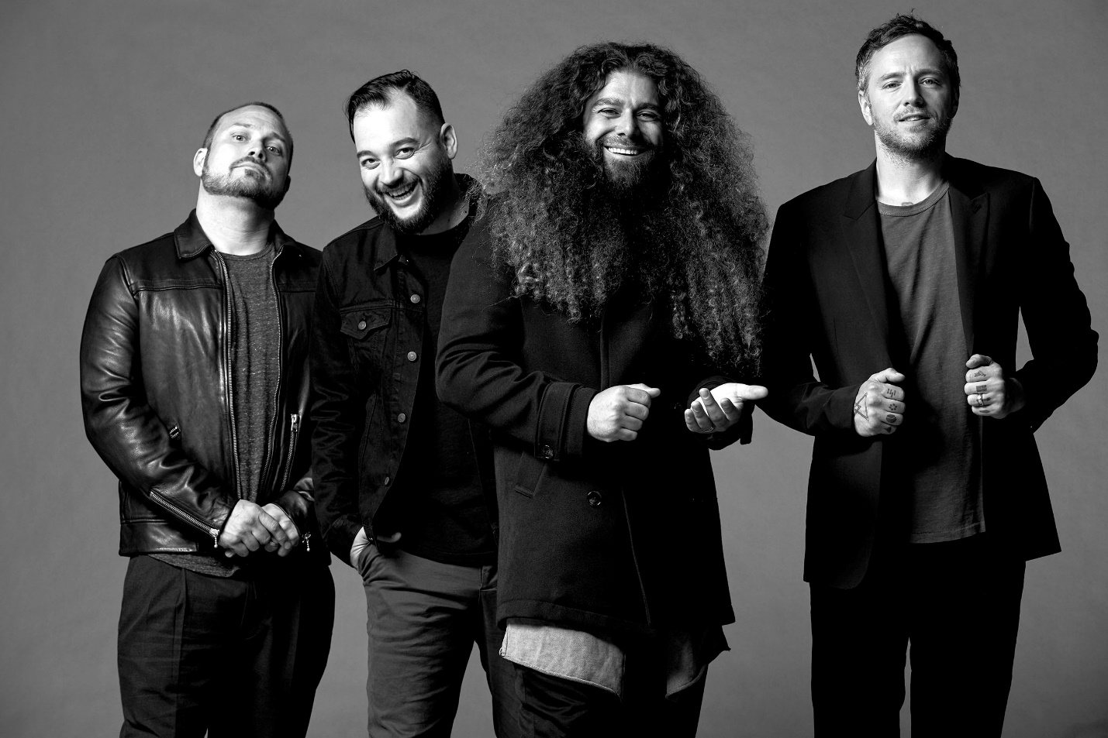

February 04, 2020 – Modern progressive rock band Coheed and Cambria will return to the road for the 40-plus date Neverender NWFT Tour in 2020. Continuing the popular Neverender Tour series, the group will perform their 2007 fourth studio album, Good Apollo, I’m Burning Star IV, Volume II: No World For Tomorrow, in its entirety. Additionally, fans can expect performances of Coheed and Cambria classics as well other essential material from the band’s expansive catalogue.

The first leg of the Neverender NWFT Tour launches May 5th in Austin, TX at ACL Live at the Moody Theater, visits major markets in the Midwest and West Coast, and concludes May 31st at Brooklyn Bowl in Las Vegas, NV. Meanwhile, the second leg canvases the East Coast, South, and Mid-Atlantic, kicking off August 30 at The Royal Oak Theater in Royal Oak, MI. Tickets go on sale this Friday, Feb 7 at 10am local time, with a special fan pre-sale beginning Wednesday Feb 5 also at 10am. Check out the full itinerary below. Instrumental powerhouse Chon serves as direct support on most dates. For tickets and more information, visit www.coheedandcambria.com.

Thirteen years ago, No World for Tomorrow closed out the band’s original sci-fi narrative, The Amory Wars, in epic fashion. Upon release, it bowed at #6 on the Billboard Top 200 as the band’s second consecutive Top 10 debut on the respective chart. Meanwhile, album single “Running Free” soared to the Top 20 on the Alternative Rock Chart, while “Feathers” and “Mother Superior” stand out as fan favorites. Iconic Foo Fighters drummer Taylor Hawkins notably recorded drums for the album.

In 2008, Coheed and Cambria hosted the original Neverender as a historic four-night stand in New York, Chicago, Los Angeles, and London which saw them play their first four albums in full, one per evening. This gave birth to the Neverender Tour. Since then the band has brought these records to life in intimate venues and delivered an immersive audio-visual experience befitting of each respective narrative. Neverender: NWFT marks the fourth and potentially final Neverender Tour, giving gravity to the proceedings.

Claudio Sanchez elaborated on the tour, stating, “Neverender is a special chance for us to celebrate the milestones that have made us Coheed and Cambria. And while the title of this chapter may suggest the end, I would like to think this and past Neverenders will help inform how we approach this ritual in the future.”

In other Coheed and Cambria news, the No World for Tomorrow comic series is slated to arrive in late 2020 via Boom! Studios.

Comprised of Claudio Sanchez (Vocals / Guitar), Travis Stever (Guitar), Josh Eppard (Drums) and Zach Cooper (Bass), Coheed and Cambria have gripped listeners and press around the globe with their visionary compositions and conceptual mastery. This past October Coheed and Cambria made a stunning return with their new album THE UNHEAVENLY CREATURES, which debuted at #1 on Billboard’s “Hard Rock Albums” chart, #6 current sales and Top 15 on the “Billboard 200” chart. Boasting 15 songs over 78 minutes, THE UNHEAVENLY CREATURES marked Coheed and Cambria’s furious return to concept albums, the ‘First Act’ in a brand-new story arc set within the backdrop of The Amory Wars universe. The acclaimed record is highlighted by standout tracks “The Gutter,” “Unheavenly Creatures,” “The Dark Sentencer” (premiered by Marvel Studios) and “Old Flames,” the latter of which features an official music video directed by Charles “Chas” Todd. The cinematic clip features striking choreography masterminded by Broadway luminary Jon Rua who is known for his roles in the 12-time Tony nominated Spongebob Squarepants and the Tony & Grammy Award Winning hit musical Hamilton. Sanchez also just announced in an interview with Kerrang! that he had just inked a collaboration with Neca Toys for a line of action figures featuring characters from The Amory Wars universe.

COHEED AND CAMBRIA NEVERENDER NWFT Tour
ALL DATES WITH CHON
May 05 2020 - ACL Live at the Moody Theater - Austin, TX
May 06 2020 - The Aztec Theatre - San Antonio, TX
May 08 2020 - Revention Music Center - Houston, TX
May 09 2020 - Bomb Factory - Dallas, TX
May 10 2020 - Diamond Ballroom - Oklahoma City, OK
May 12 2020 - The Van Buren - Phoenix, AZ
May 13 2020 - Riverside Municipal Auditorium - Riverside, CA
May 15 2020 - The Wiltern - Los Angeles, CA
May 16 2020 - Fox Theater - Oakland, CA
May 17 2020 - Redding Civic Auditorium - Redding, CA
May 19 2020 - Showbox SoDo - Seattle, WA
May 20 2020 - Roseland Theater - Portland, OR
May 21 2020 - The Commodore Ballroom - Vancouver, BC, Canada
May 23 2020 - The Palace Theatre - Calgary, AB, Canada
May 24 2020 - Knitting Factory Concert House - Spokane, WA
May 25 2020 - The Wilma - Missoula, MT
May 27 2020 - Knitting Factory Concert House - Boise, ID
May 28 2020 - The Union Event Center - Salt Lake City, UT
May 29 2020 - The Mission Ballroom - Denver, CO
MAY 31 2020 – Brooklyn Bowl – Las Vegas, NV

Aug 30 2020 - Royal Oak Theatre - Royal Oak, MI
Sep 01 2020 - The Pageant - Saint Louis, MO
Sep 02 2020 - Uptown Theater - Kansas City, MO
Sep 04 2020 - Harrah's Council Bluffs - Stir Concert Cove - Council Bluffs, IA
Sep 05 2020 - Palace Theatre - Saint Paul, MN
Sep 06 2020 - The Sylvee - Madison, WI
Sep 08 2020 - Agora Theatre - Cleveland, OH
Sep 09 2020 - Sweetwater Performance Pavilion - Fort Wayne, IN
Sep 15 2020 - The Anthem - Washington, DC
Sep 16 2020 - The Rooftop at Pier 17 - New York, NY
Sep 19 2020 - The Palladium Outdoors - Worcester, MA*
Sep 20 2020 - The Metropolitan Opera House - Philadelphia, PA
Sep 22 2020 - The Norva - Norfolk, VA
Sep 23 2020 - The Orange Peel – Outdoor Stage - Asheville, NC
Sep 25 2020 - Coca-Cola Roxy - Atlanta, GA
Sep 26 2020 - The Fillmore at Harrah's New Orleans - New Orleans, LA
Sep 27 2020 - Marathon Music Works - Nashville, TN
Sep 29 2020 - Florida Theatre - Jacksonville, FL
Sep 30 2020 - Hard Rock Live Orlando - Orlando, FL
Oct 02 2020 - The Fillmore Miami Beach at The Jackie Gleason Center - Miami Beach, FL
Oct 03 2020 - Jannus Live - Saint Petersburg, FL

For more information on Coheed and Cambria, visit:
www.coheedandcambria.com
www.facebook.com/coheedandcambria
www.twitter.com/Coheed
www.instagram.com/coheedandcambria
www.youtube.com/user/OfficialCoheed

